DAX Extends Gains in Five Wave Diagonal Formation

The short-term Elliott Wave analysis for the DAX Index indicates it is nearing the completion of a cycle from its April 2025 low, unfolding as wave (5). From the June 19 low, wave (5) has developed as an ending diagonal Elliott Wave structure. The rally from this low saw wave 1 peak at 24639.1, followed by a wave 2 pullback concluding at 23284.67. The Index then advanced in wave 3, structured as a five-wave impulse. From the wave 2 low, wave ((i)) reached 23785.24, with a corrective dip in wave ((ii)) at 23383.84. The subsequent wave ((iii)) climbed to 24524.11, followed by a wave ((iv)) retracement to 24269.94. The final wave ((v)) culminated at 24771.34, completing wave 3.
Wave 4 unfolded as a double zigzag structure. From the wave 3 high, wave ((w)) declined to 23986.93, wave ((x)) rebounded to 24339.27, and wave ((y)) fell to 23682.73, finalizing wave 4. The Index has since turned upward in wave 5. From the wave 4 low, wave ((i)) reached 24384.24. A wave ((ii)) pullback is expected to correct the cycle from the October 17 low before the Index resumes its ascent. As long as the pivot at 23682.73 holds, pullbacks should attract buyers in a 3, 7, or 11 swing, supporting further upside in the near term.

DAX Latest 1-Hour Elliott Wave Chart From 10.23.2025

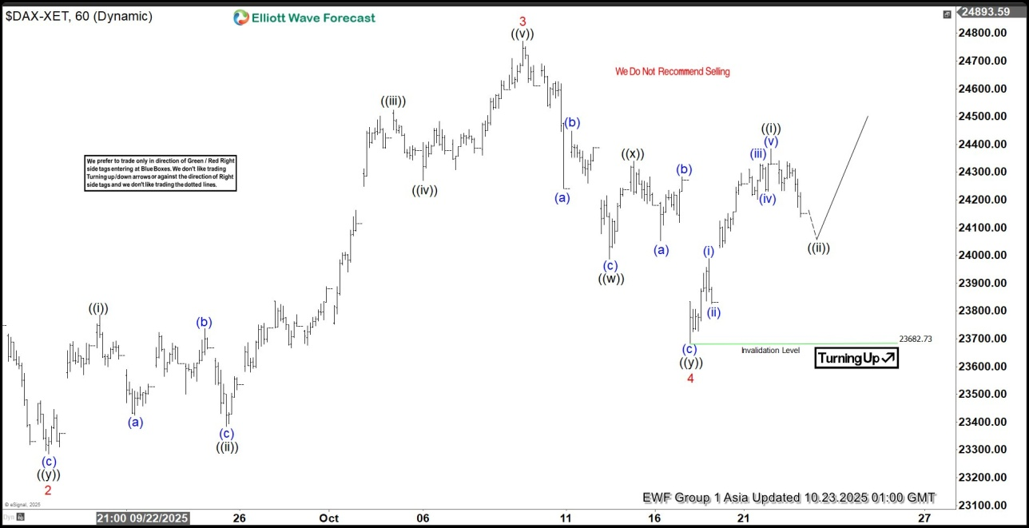

DAX Elliott Wave Video:

