Daily Analysis on Gold: Friday 26 July 2024
“In the short term, what impact could we expect on Gold's price following the increase in the US advanced GDP?”

Yesterday (Thursday, 25 July 2024), there was a release of the US economic data, which is the Advance GDP for the Second Quarter of 2024. That was an increase of 1.4% from the previous quarter.

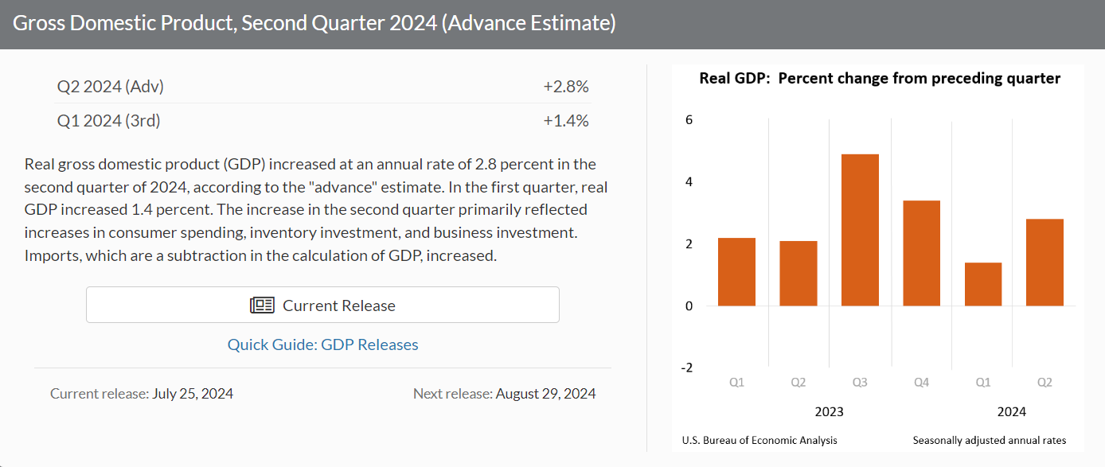
Source from: U.S. Bureau of Economic Analysis

Although this data wasn’t the most accurate compared to the Final GDP (3rd), it could impact the market’s sentiment in the short term.

The aggressive increase in GDP primarily reflected the possibility of an increase in the inflation rate, which could lead the Fed to decide to hold the interest rate.
XAUUSD 1 Hour Timeframe

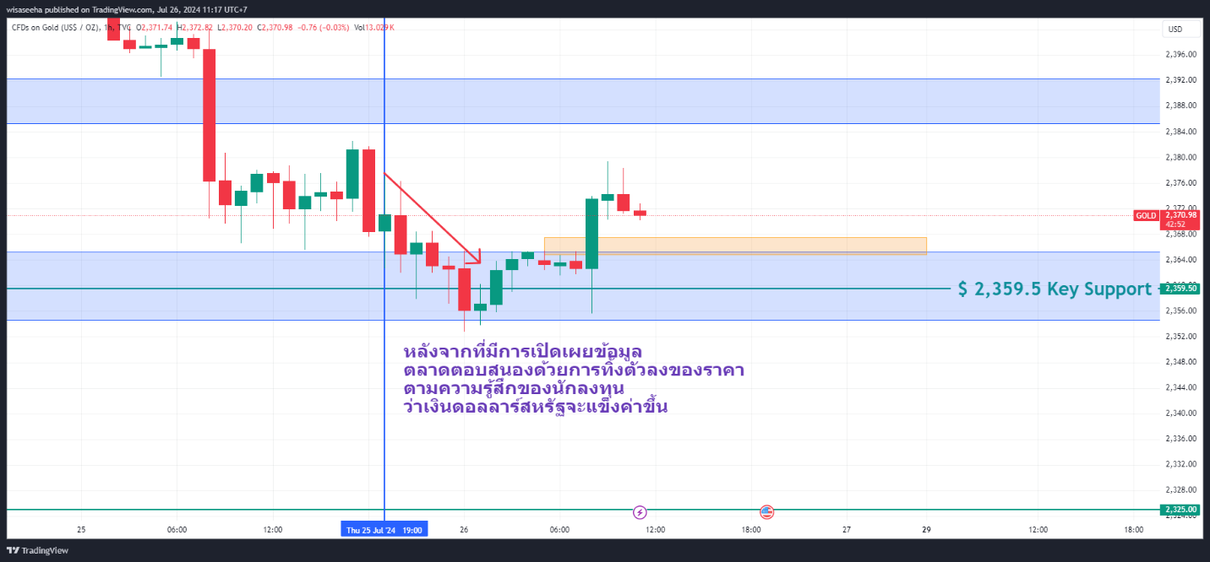
After the data was released, the market reacted by decreasing in price due to the sentiment that the US dollar would strengthen.

In contrast, in his recent speech, Federal Reserve Chair Jerome Powell mentioned that the Fed would be willing to cut the interest rate before returning to the 2% target in order to maintain the labor market situation.

The initial GDP estimate may indicate economic growth, supporting spending in the labor market.

However, the unemployment rate and claims data since May 2024 didn't show a positive sign for the labor market, potentially prompting the Fed to cut rates.

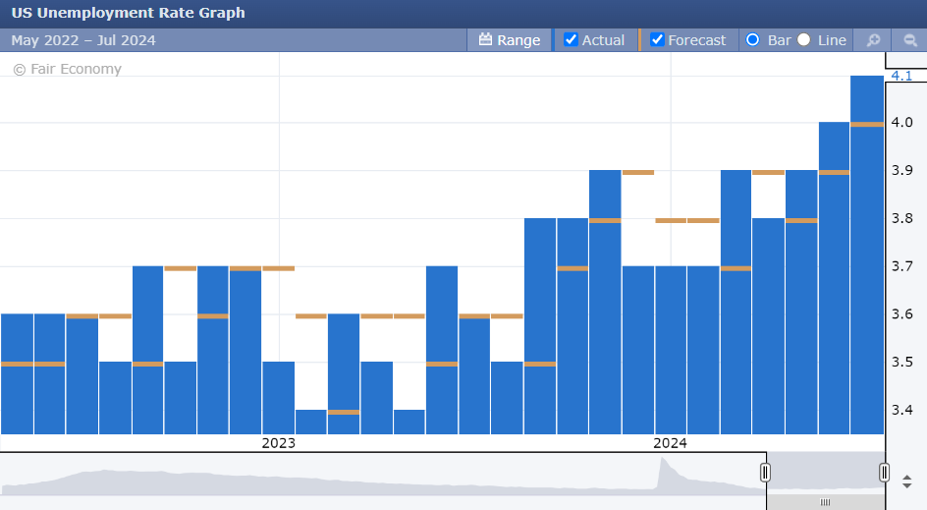

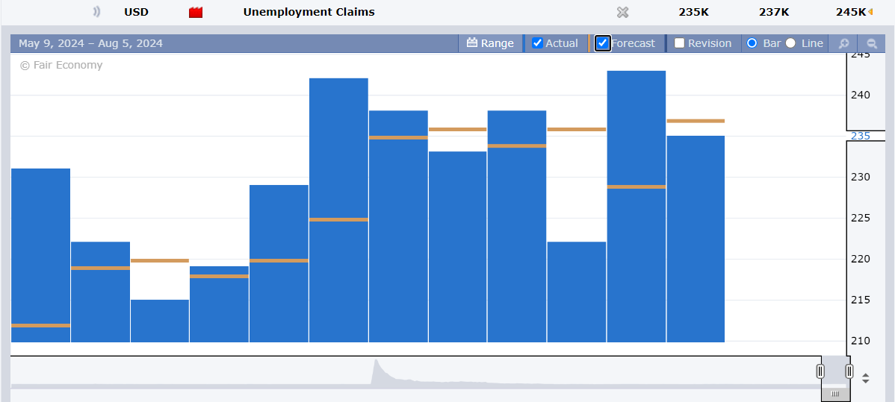

That's why we observed a bullish reversal in price action (1.) and a resurgence in buying momentum from the 2359.5 Key Support (2.).
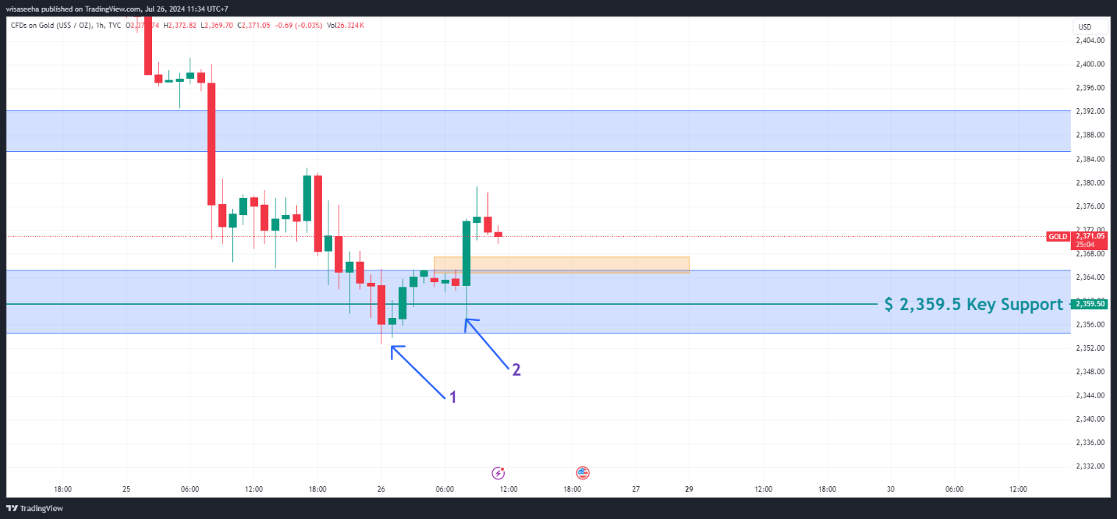

How to execute the trade

From the fundamental analysis, we expect the price of gold to rise, at least up to the key resistance area around the 2,300 level.

XAUUSD 4 Hours Timeframe

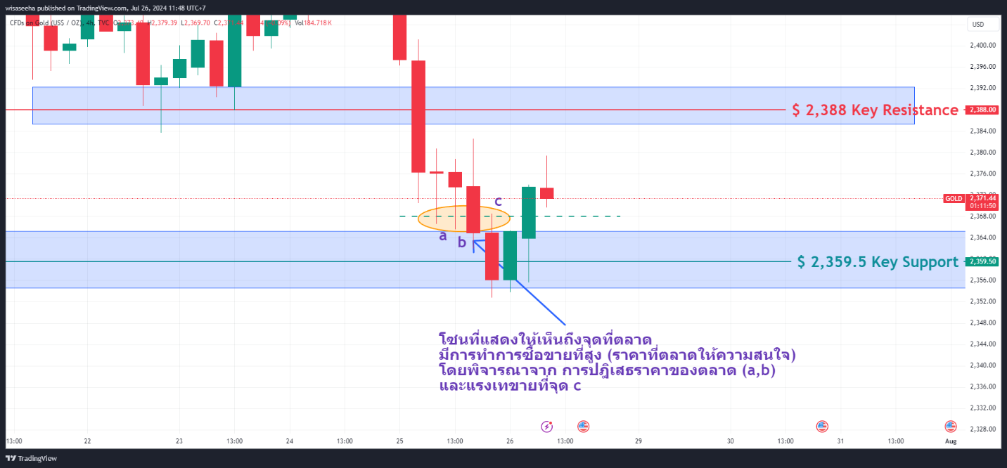
The zone indicates where the market is located and the level of trading activity. It reflects the prices that the market is interested in by considering the rejection of market prices (a,b) and selling pressure at point c.

If we open the 4-hour timeframe chart, we can spot the price zone around 2,368 that the market was interested in.

XAUUSD 1 Hour Timeframe

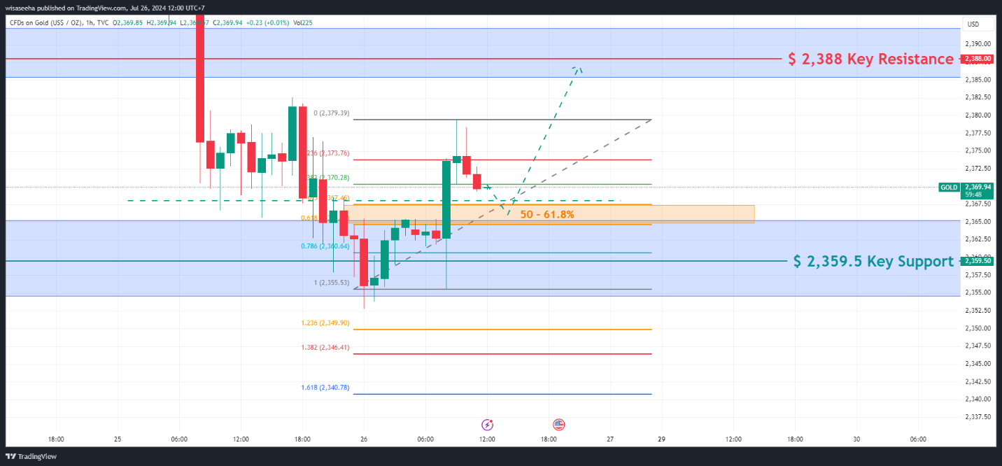
On the hourly timeframe, using the Fibonacci tool, we can observe that the 50-61.8% retracement, which is the golden ratio, aligns closely with the 2,368 market's interest point.

Thus, to initiate a trade with a buy position, we will wait until the price reaches the 50-61.8% zone and forms a reference swing low, which we can use to determine the stop-loss level. And the take-profit level may be placed around the 2,388 level.

Get ready for an amazing trading experience with the ThinkTraders trading account. Gain direct access to Tradingview and a lot of effective features to supercharge your trading journey. Click this link to open your account now!
https://web.thinktrader.com/account/login?lang=th&_gl=1*dzd739*_gcl_au*MTYzMTU0NDI4NS4xNzE5Nzk2OTMy

Please note that investments in CFDs contain risks. Investors are advised to thoroughly examine the products before making any decisions.

