SIGNIFICANCE OF HISTOGRAMS ON M15 AND H1 TIMEFRAMES

The GANN 9 alert is the most important alert or the brain of the system.
Most of the times this alert will pinpoint the exact candle for entry.
This histogram will represent Gann 9 trend on higher timeframes so you don’t have to wait for higher timeframe candle to close before taking a trade. This is for traders who like to trade in the direction of higher timeframes

There are 2 histograms on M15
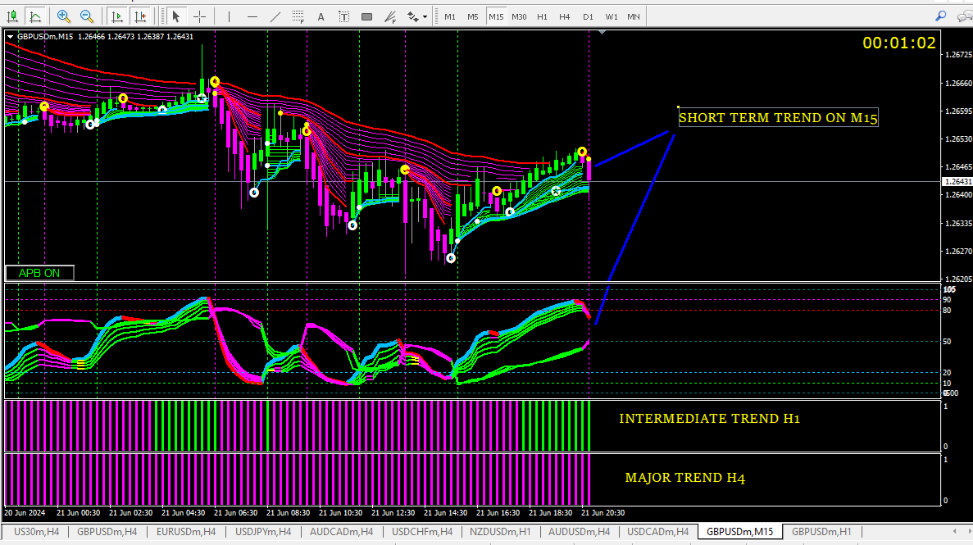
As we are looking for Gann 9 alerts on H1 which is 4 candles of M15
9*4 = 36. H1 trend = Gann 36 which is “INTERMEDIATE TREND REVERSAL” alert
Similarly, H4 trend = Gann 144 which is long term or “MAJOR TREND REVERSAL” alert.
And the universal rule applies. “Enter at the close of the candle when all indicator colours agree”

H4 and above the trend is already established. But similar histogram can be added if required uusing the formula explained above.

H1 charts there is only one histogram.
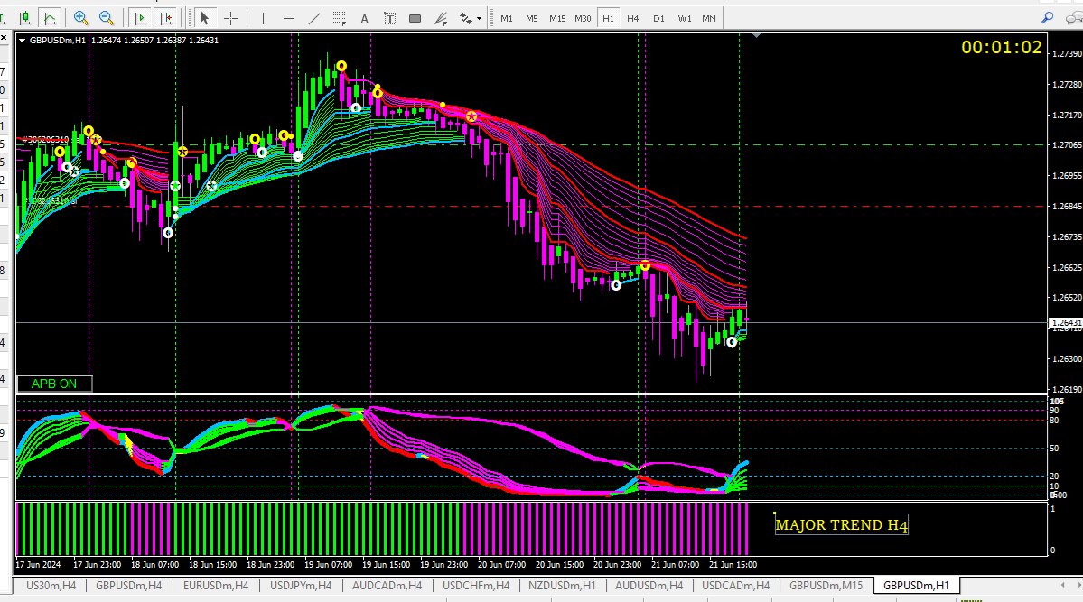
This histogram represents Gann 9 trend on H4.
Again 4 H1 candles on H4. 9*4 = 36.
Histogram is Gann 36. And “MAJOR TREND REVERSAL” alert.

