Our criteria of breakout is:
Breakout: candle closing above TE 51 (star in circle)
Breakdown candle closing below TE 51 (star in circle)
Let us analyze this chart:
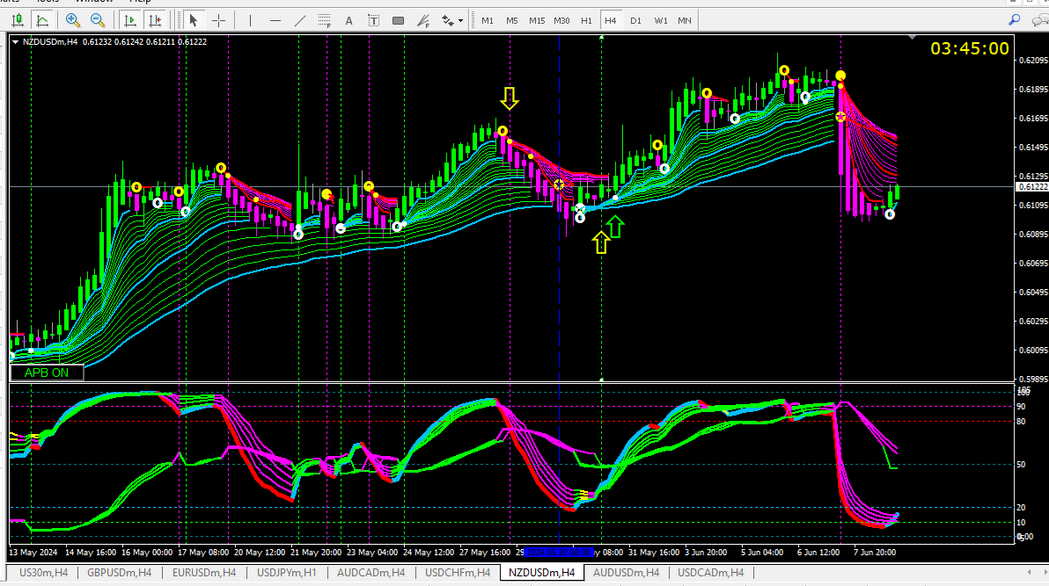
The overall trend is up. But between the yellow arrows there is a false breakdown (the price travelled beyond TE 51 but travelled back into the Guppy lines) After the second arrow the uptrend resumed.
Our trend envelope lines also act as dynamic support and resistance. Above the second yellow arrow you see red/magenta resistance lines. We will consider uptrend has resumed only if the candle closes above these resistance lines. Long entry on the lime up arrow is valid.
Our universal rule: "Enter trade when all indicators are of the same color."

