APB INTERPRETATION:
STRONG BULLISH APB: Lime body and lime upper wick. No lower wick.
BULLISH APB: Lime body and lime upper and lower wicks.
BEARISH APB: opposite of bullish.
NO TREND APB: Any other combination of colors.
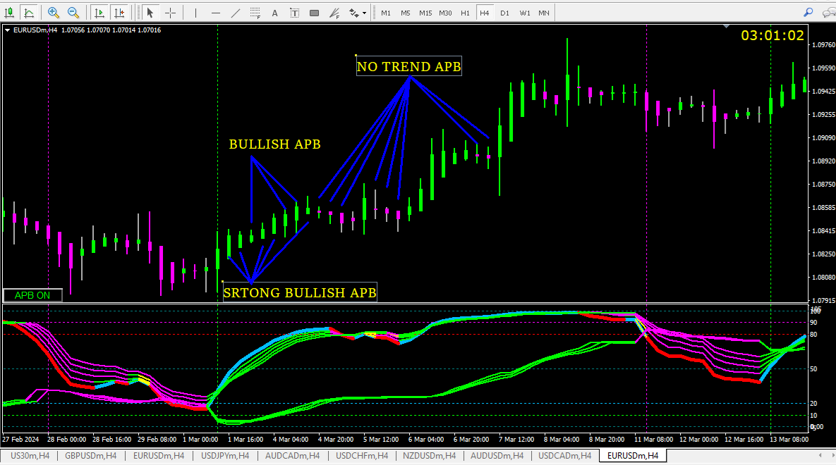

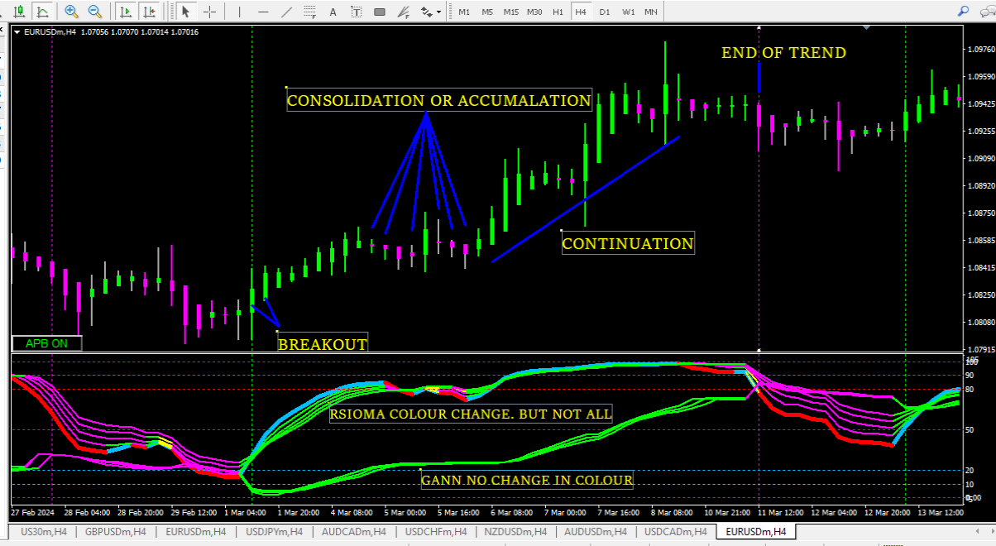The above pic shows our entry (Gann lime vertical line) and exit (Gann magenta vertical line).
Let us decode the whole move and see how all indicators complement each other.
- Breakout:
Gann TREND REVERSAL BUY alert.
All indicators lime.
APB bullish and strong bullish.
Blue rsioma crossed all lime.

- Consolidation:
All APB no trend candles.
Rsioma color change in few but not all.
No color change in Gann lines.

- Continuation:
All indicators and APB lime,

- End of Trend:
APB bearish candlel
All indicators change color.
Gann TREND REVERSAL SELL alert.

