RSIOMA INTERPRETATION:
We are using 5 rsioma lines in sub window.
8,9,10,11,12. There are no alerts on rsioma, and alerts are not required. Rsioma does not repaint.
8 is deepskyblue / red. The lines are thicker than others.
Rest are lime/magenta.
For us, RSIOMA is a momentum indicator.
If blue rsioma crosses above lime and angled up, it’s a strong bullish momentum.
If red crosses below all magenta lines and angled down, its strong bearish momentum.
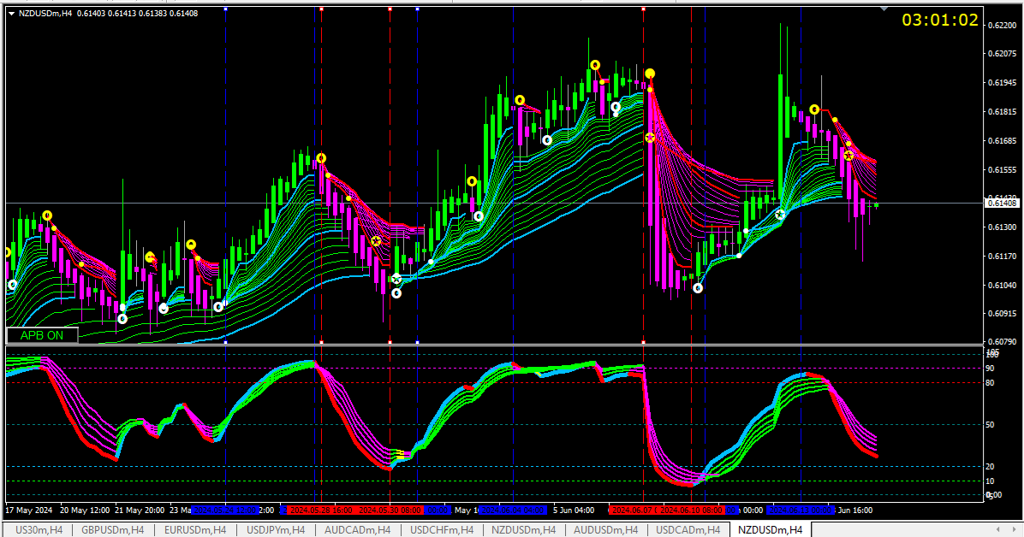
Notice the area between blue lines is strong uptrend and between red lines is strong downtrend.
Note the cross of rsioma 8 in all instances. This cross is very important when we enter the trade. If the alert candle shows rsioma cross it is a high probability trade. If the APB candle is also bullish/bearish (lime body and wick, no lower wick. And vice versa) it becomes a very high probability trade.
In such trades the low of the APB entry candle is rarely breached and it is very safe to put your stoploss at the low if this candle.

If the rsioma become flat, either the trend is exhausted, or it is consolidation and there are chances of reversal. This is a good period to exit your positions.
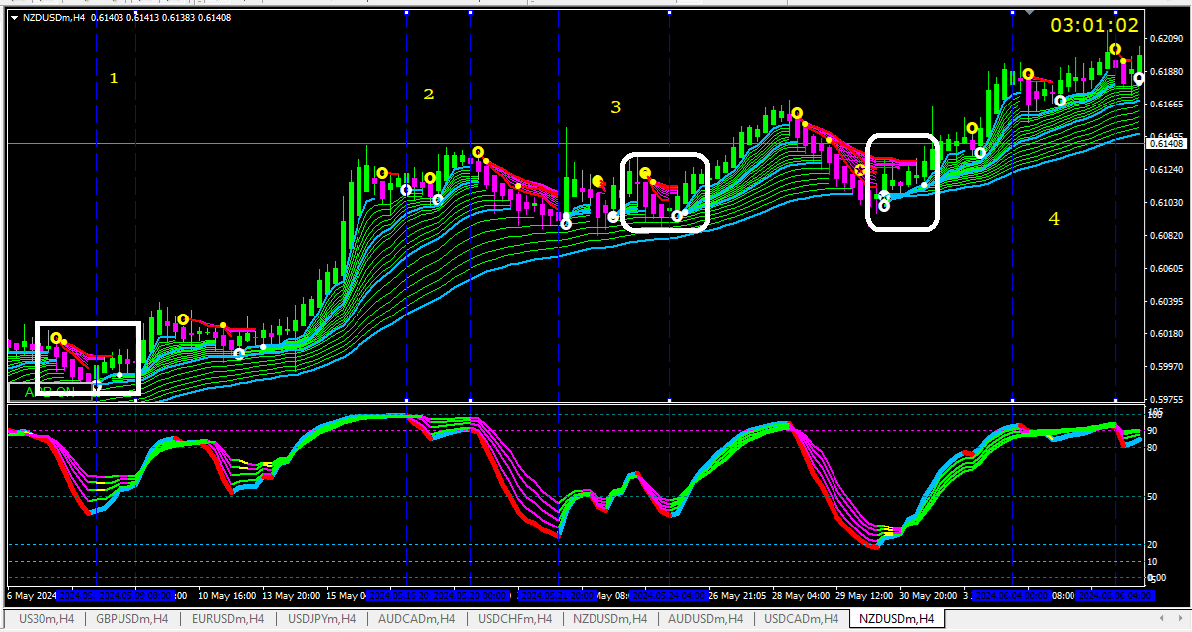
Notice the four areas marked, rsioma flat and no cross. Consolidation. Preferably do not trade these areas until there is rsioma cross.
The more charts you observe during live market the easier it will be to identify these areas.
Consolidation can also be identified when the candles are placed between the guppy lines (white rectangles in the pic)
The rsioma is optimised in such a way that at the end of consolidation you will notice rsioma cross.

The alignment of rsioma is also important.
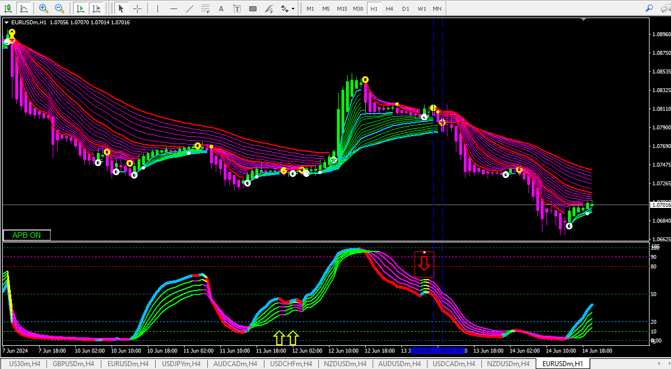
Notice the yellow arrows. The rsioma have changed to red/magenta, but the uptrend is intact.
Notice the red arrow. The rsioma have changed to blue/lime yellow for a couple of candles only but the downtrend is intact.
(The first blue line would have generated a PBC SELL alert, but we don’t trade that as per our rules. But the second blue vertical line with TREND REVERSAL SELL alert was a perfect candle to take a short position.)

Second important role of rsioma is identify the over bought and over sold regions.
Above 80 is over bought and below 20 is oversold. Remember that rsioma can remain in these regions for many candles.
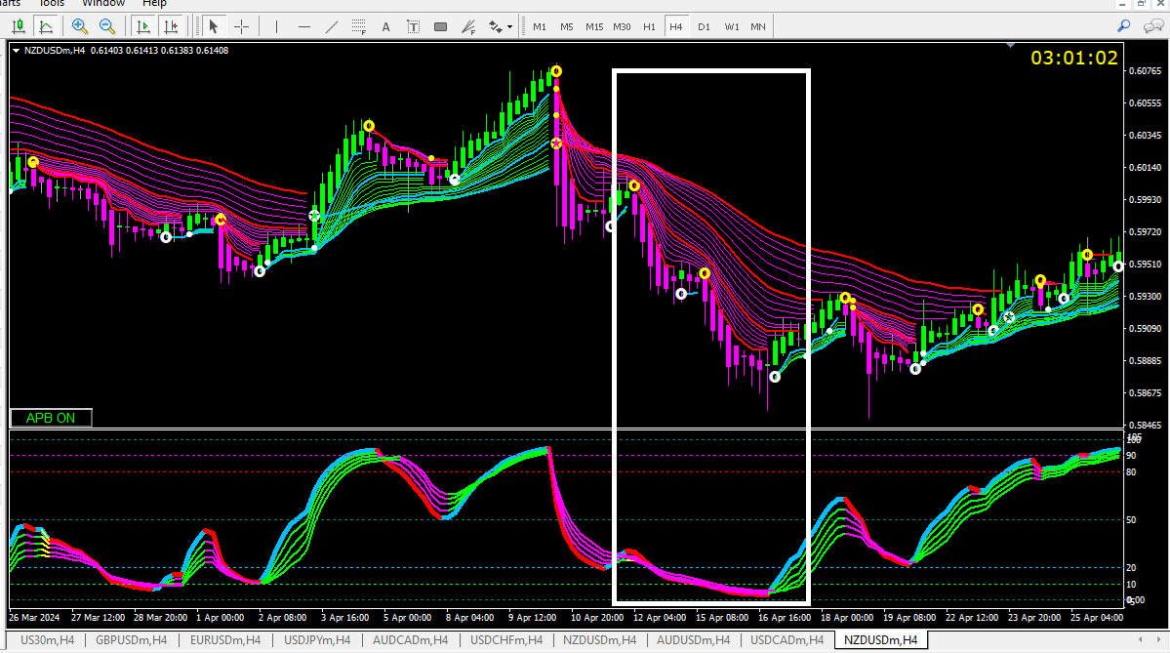
I don’t recommend taking fresh positions when rsioma is in this zone. Best entries are when rsioma is around 50 line.

Our interest is when rsioma is leaving this zone which indicates the top/bottom is formed for that time frame and either a major pullback is expected, or a trend reversal is possible.
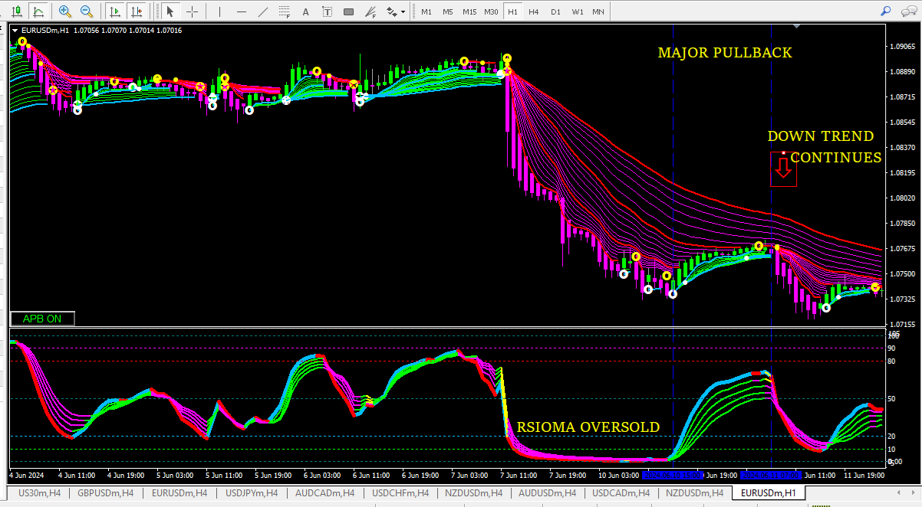

CONCLUSION:
RSIOMA cross is most important criteria while entering a trade.
Don’t take fresh positions when rsioma is in overbought or oversold zones.
If rsioma change colour but remain aligned the trend is intact.

