Clairvoyant Journal
A trading system

“I am a consistently successful trader”

***
The market is a descriptive spiral from the etheric observation of God. The holographic characteristic that resembles the whole and natural phenomena reverberated throughout and through in the environment. This diagonal circular flow of a helix is perceptible as a logarithm indicating growth. This indicator grows in and outward; on any magnification scale by the factor of the first-class proportion of conception, the Fibonacci sequence. These sequential trends and retracements are representations of the Philo pattern of affinity that made up the consensus value through the agreement of God as mankind.
As traders; we people, have the only ability required to unfold the markets of impermanence, we have to demonstrate this position in any market sector that we are involved in with other human beings in this celestial process of the creation of the candle stick – the neutral representation of human activity
This demonstration is shown by an execution from a trading account with a legally registered broker who represents us the trader(s) at that execution level in the sphere of time- value as the market place of any asset class.
At present, all sectors are traded with quantifiable methods that deduce the size of the position that is taken by the trader relative to their account balance in ratio or percentage terms with potentially unlimited limits of monetary satisfaction or fulfilment
The perpetually objective market information that is it given off by meta trader is significant; as soon as it is interpreted in the correct way. The market can never be perfected only risk but this system defines trading opportunities in black and white terms or conditions. As mediocre as it seems
A single system, a strategy which includes an abundance of market slants.

The strategy description is as follows- buy high and sell low on support and resistance above and below exponential moving average cross price level

- A buy signal description is = buy high on support at exponential moving average cross price level
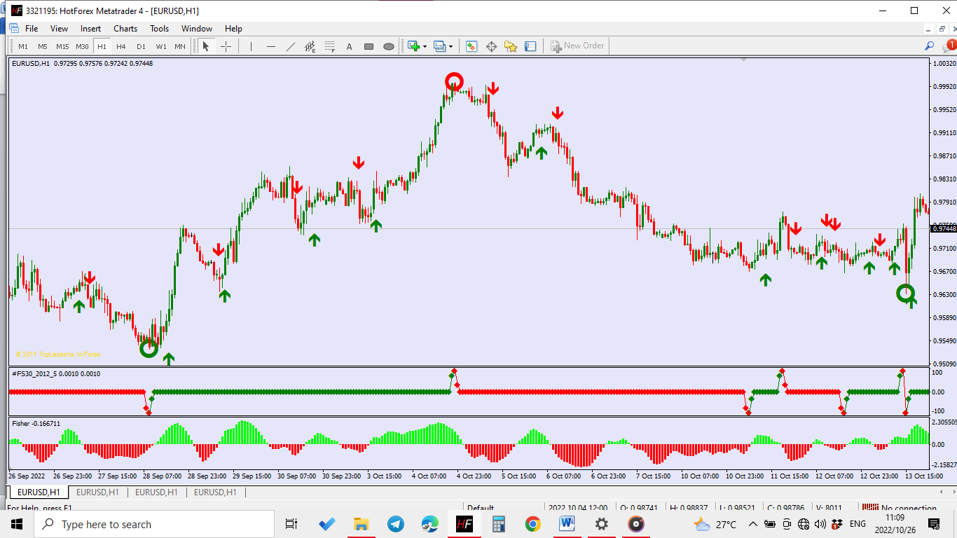
- A sell signal description is = sell low on resistance below exponential moving average cross price level

Indicators are important and play the major role in the system that has to be followed
Edged trades - Fill out a blank Sheet of conviction for every trade as a journaling mechanism. (For any system this does not have to be this system but any system or strategy)
I ideally define the exit points through the Fibonacci retracement tool
- Fibonacci retracement tool to risk and reward ratio table
Fibonacci entrance level | Fibonacci targets
 | 161.8 | 261.8 | 423.6
61.8 | 2.618 | 4.236 | 6.854
50 | 3.236 | 5.236 | 8.472
38.2 | 4.236 | 6.853 | 11.089
23.6 | 6.856 | 11.093 | 17.949

Breakeven ratio of risk to reward =
*161.8=
At price level of 161.8 I make 2.618 on a trade of Fibonacci level of 61.8
At price level of 161.8 I make 3.236 on a trade of Fibonacci level of 50
At price level of 161.8 I make 4.236 on a trade of Fibonacci level of 38.2
At price level of 161.8 I make 6.856 on a trade of Fibonacci level of 23.6
*261.8=
At price level of 261.8 I make 4.236 on a trade of Fibonacci level of 61.8
At price level of 261.8 I make 5.236 on a trade of Fibonacci level of 50
At price level of 261.8 I make 6.853 on a trade of Fibonacci level of 38.2
At price level of 261.8 I make 11.093 on a trade of Fibonacci level of 23.6
*423.6 =
At price level of 423.6 I make 6.854 on a trade of Fibonacci level of 61.8
At price level of 423.6 I make 8.472 on a trade of Fibonacci level of 50
At price level of 423.6 I make 11.089 on a trade of Fibonacci level of 38.2
At price level of 423.6 I make 17.949 on a trade of Fibonacci level of 23.6
Q- But how do I find such a trade in the market? A – By finding it.
Defining an edge – The initial trade on the market
The edge is depended upon four (4) indicators that assimilate into a single temple that throws out signals to the trader, including signals that are not suitable for trading
The list and names of the indicators are
- Exponential moving average cross over arrow
- Brilliant reversals
- Fisher_Yur4ik
- #FS30
The indicators are amalgamated into a single template. The textbook strategy is that which is in the same direction of the recognised dominating trend of the given leveraged market
The submission and outward display of a favourable juncture for trading through assembled interdependent structures that have formed a whole of which is run through a formal mechanical acknowledgment process , displayed and written as data is what I call an edge
This edge is a model that runs through a series of scenarios and requires the human being to test the worthiness of the likely outcome to choose and select the most profitable items in the market to purchase into or sell out of
The amalgamated model of indicators, the template, ushers out a sequence of prognosis as value increases and decreases in the value scale
The pertinent data is utilised to calculate the possible future value from a given value level of consensus relative to the future value in the market space at present
In all circumstances, purchasing takes place at levels where there is purchasing support in the market and buy orders are activated effectively at a plane of value which clearly depicts a break out; an occurrence where the value of a security rises after a period of stagnation in a price band known as a support zone which will keep increasing value until a resisted value area is reached
Similarly In all circumstances as in purchasing, selling takes place at levels where there is purchasing resistance in the market and sell orders are activated effectively at a plane of value which clearly depicts a break out, a price level of the value of a security falls after a period of stagnation in a price band known as the resistance zone which will keep lowering value until a supported value is reached perhaps by buyers becoming sellers thus going out of the market leaving room for price to correct itself due to the order flow thus giving sellers more capacity to lower price by adding on to the selling force as expressed thoughts

The indicators
Three out of four indicators have proven themselves to be repainting indicators as other traders have claimed them to be. An advantage to us is the exponential moving average arrow which depicts the price level suitable to trade into as that level shows the overall bias on that timeframe which is selected to analyse in or come up with logical conclusions in
- Exponential moving average cross over arrow (Repaints a few times if at all)
Moving average – A time period series that has each value/ data point adjusted (smoothed) from its original values. A variety of weighting functions can be used to tailor the moving average. An exponential applies stronger (multiplicative factors to place more importance) weights to more recent data in the series. Exponential moving averages react therefore more quickly to short-term fluctuations in price. Moving averages are typically a lagging indicator as opposed to a leading indicator used in fundamental models of finance
SELL BUY
- 6 and 18 MA cross over; normally at the candle stick close
- Brilliant reversals
This is a repainting indicator – The brilliant reversal indicator is a repainting indicator which is very useful, once dry, when used along with the none-repainting exponential moving average crossover arrow. Similar to watching paint dry it is necessary to wait a period before demonstrating a faithful position in the market place. The area where a double colour brilliant reversal shows is where there is the most bias of the next price level. The brilliant reversal dries on the very highest price level and the very lowest price level in a given period move
The configurations of this custom indicator – Brilliant Reversal are as follows – Common /tab- Tick “Allow DLL Imports” “Allow external expert imports”
Input Tab
Under variable column are 3 cells, under value column are 3 cells

- Small bar count – 36
- Medium bar count – 60
- Big bar count – 156

Colours tab
I realized and concluded that the writer of the brilliant reversal set the display of the indicator into 3 sets of settings. This to show the least significant highs and lows to the most significant highs and lows according to what he scaled as bar counts
- Small bar counts- 0- bull setting colour 1-Bear setting colour
- Medium bar count – 2 Bull setting colour 3 – Bear setting colour
- Big bar count – 4 Bull setting colour 5 – Bear setting colour

Under the colours tab under the colour column I modified the setting to none for ‘colour’ from 0-3 and width to ‘1’ for width from 0-3
The colour and width setting of big-bar-count are to:
- 4 Bull setting colour column to ‘green’ width to 5
- 5 Bear setting colour column to crimson – width to 5
The reason, the benefit and the implications of this are that the trader will not recognise variation, small and medium bar counts which are variation to our edge. Holding this will possibly allow the trader to hold for longer and enter a few times due to the less unneeded data
‘Visualization tab’ – All timeframes tick box has been selected and the ‘Show in the Data window’ tick box has been selected

BUY 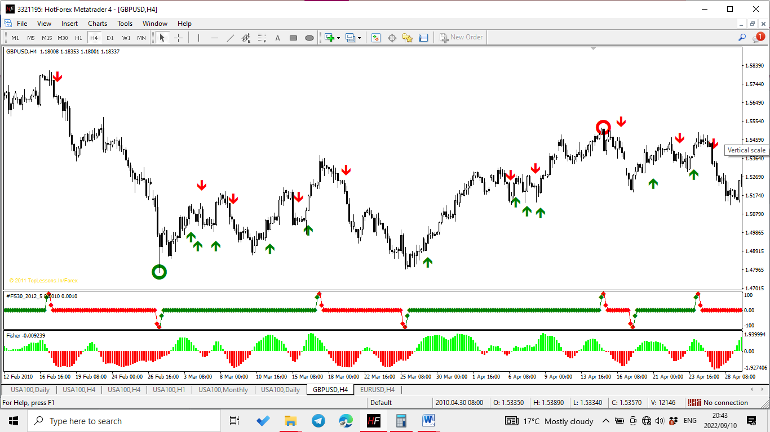 SELL
- Fisher_Yur4ik
The fisher custom indicator, like the “#FS30_2012_5” - Custom indicator is an oddly repainting indicator. The writer, though I do not know why, input a range of -2.71141 fixed minimum – and 2.3798 fixed maximum. From what I interpret from the data the histogram depicts a bullish trend move as above 0.00 and above positive figures the unselected fixed maximum limit as lime green bars. A bearish trend-move as below 0.00 and below negative figures the unselected fixed maximum tick box. The bearish trend move depiction is set to Red bars
Common Tab
Both allow DLL imports and Allow external expert imports
Inputs tab
Variable column has one column and value has one column
Variable | Value
Period | 10

Fixed minimum -2.0035(not selected) Fixed maximum 1.9484 (not selected)
The colours tab
The colour setting has a window of 4 columns and four Rows he first column and row are for heading and colour counting. I have/re-settled the level to colour count to colour none and width to ‘1’
Colour counts are relevant. To of level 0 and level 1 which occupy a Row each of their own
# | Colour | Width | Style
0 | Red | 2 | 0
1 | Lime | 2 | 0

Levels Tab
There are no levels specified for this custom indicator.
Visualization Tab
Both the All timeframes and show in the Date Window have to be selected.

- #FS30
The colour counts are the main indicators by matter of differentiation between red and green per candle stick. At times, up to six to four candle sticks may cause the indicator to repaint.
“Common _Tab”
Both tick boxes Allowed DLL imports and Allow external expert imports are both selected. Fixed minimum selection is ticked and set to -100 as the default and the fixed maximum selection is also ticked and set to 100
“Colours Tab”
There are 4 columns and 5 Rows. Each column for #, colour, width, Style
# | Colour | Width | Style
0 | Green | 0 | 0
1 | Red | 0 | 0
2 | Green | 0 | 0
3 | Red | 0 | 0

Count 0 and count 1 are for the diamond shape that shows the sentiment at every candle stick, which is why it repaints at times due to price action that may be happening at any time scale and price range level from the perspective of the observer. Count 2 and count 3 are for the linear string that threads together the diamond shapes that indicates the trend direction by colour
“Levels Tab”
There are no default levels in/under this tab
“Visualization Tab”
The ‘All time-frames’ tick box has been selected, the show in the Data window has been selected
Taking profit / closing a trade
*Before exiting a trade, I go to the higher timeframe to confirm a change in direction through oscillators, if the higher timeframe(s) doesn’t show a change in direction, I hold until the desired level is reached or until a trend change is self-evident.
Oscillator - a device for producing alternating current: a radio frequency or audio-frequency generator
- A price indicator used by traders to analyse patterns that cycle or oscillate between bands or in a limited range about a longer term trend. Oscillators deduce information such as whether prices are moving strongly in a particular direction (momentum) or whether they are over bought or oversold.

Bibliography
Author, U. (0000). Candle stick Patterns for day trading. *****: N/A.
Author, U. (0000). Elliot wave principles complete. ****: n/a.
Author, U. (0000). Price action Patterns. ****: N/A.
Baba, M. (0000). God Speaks. ****: n/a.
Caplan, R. A. (0000). Kaballah Meditation and Prophecy. ****: n/a.
Douglas, M. (1990). The disciplined trader developing winning attituedes. New York: New York institute of finance.
Forexcandlesticksmadeeasy.com. (0000). Forex Candle sticks Made easy. ****: N/A.
FxOneVision. (0000). Chart patterns. ****: FxOne Vision.
Hamma, M. (0000). The candle stick trading bible. ****: n/a.
Investopedia. (0000). Correlation. ****: n/a.
Marshall, K., & Moubray, R. (0000). Practical Fibonacci Methods for forex trading. ****: n/a.
Saremo, M. (0000). Trendline breakout trading strategy. ****: n/a.
Saremo, M. (0000). Trendline strategy. ****: n/a.
Services, W. A. (0000). Your personality and successful trading. ****: WindsorAdvisory Services.
team, T. m. (0000). 3 Things your broker doesn't want you to know. ****: TMLT.
Webster, M. (1872). Webster's Dictionary. ***: Meriam Webster inc.
Week, F. (2021). Fin week. Johannesburg: n/a.
Wuite, R. (2009). The South African Dictionary of finance. Northcliff: Rollerbird Press.
Zwaleski, P. (0000). Kabbbalah of the golden Dawn. ****: n/a.

