12/12/2021
MONTHLY: Keep an eye on NOV Low level to confirm bias for bullish or bearish
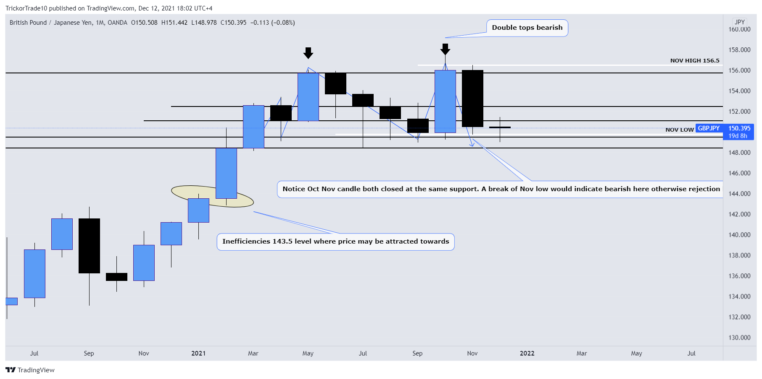
Weekly: Everything on weekly indicates bearish. But price may want to break this 151 resistance to come to the inefficiencies at 153.5. So keep an eye on 151 resistance.
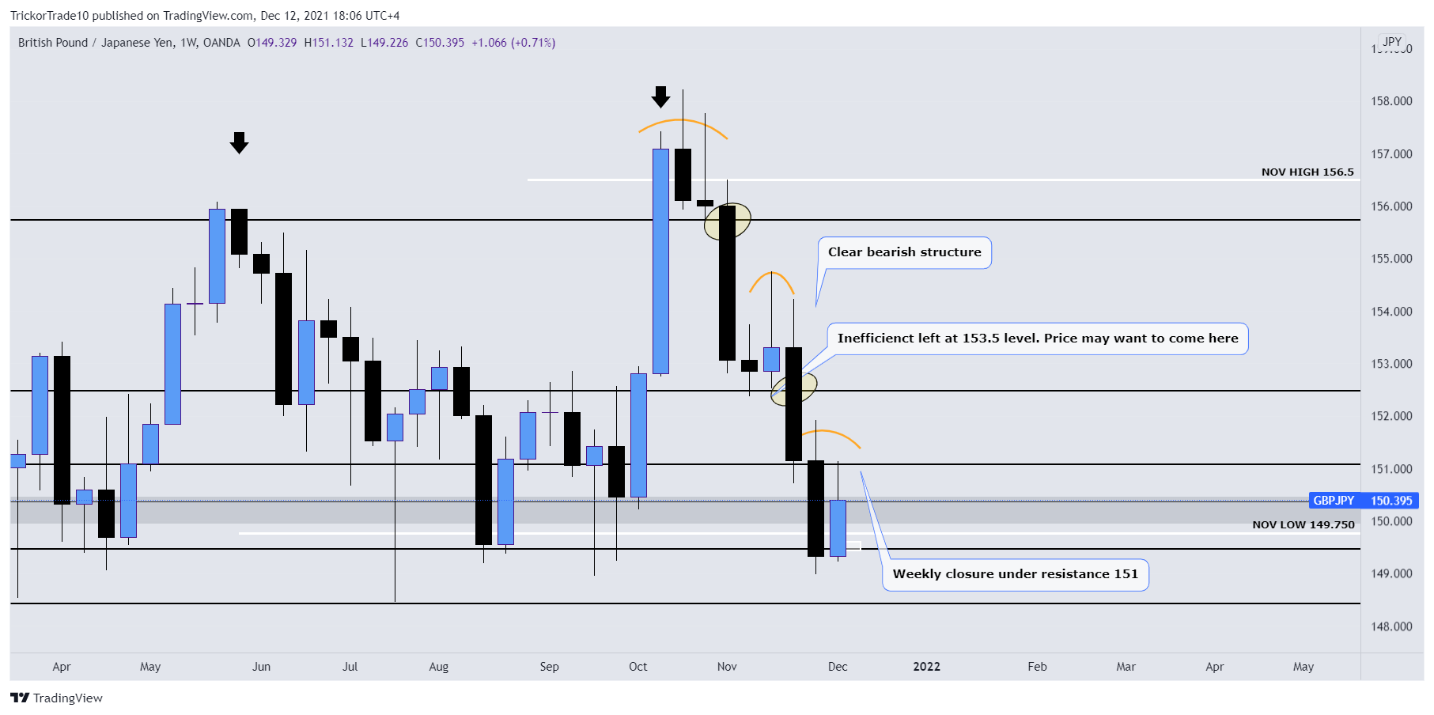

DAILY: Daily indicates bearish structure with consolidation. Previous few daily candles indicate bullish momentum coming in. But I would wait for break of 151 resistance to go long. Remember going long now is a counter trend until the last lower high is filled which is where the inefficiency. Once it goes past that level its confirmed bullish structure. This now is a counter trend longs so I would use lower risk. Patiently wait for confirmations for bullish bias.
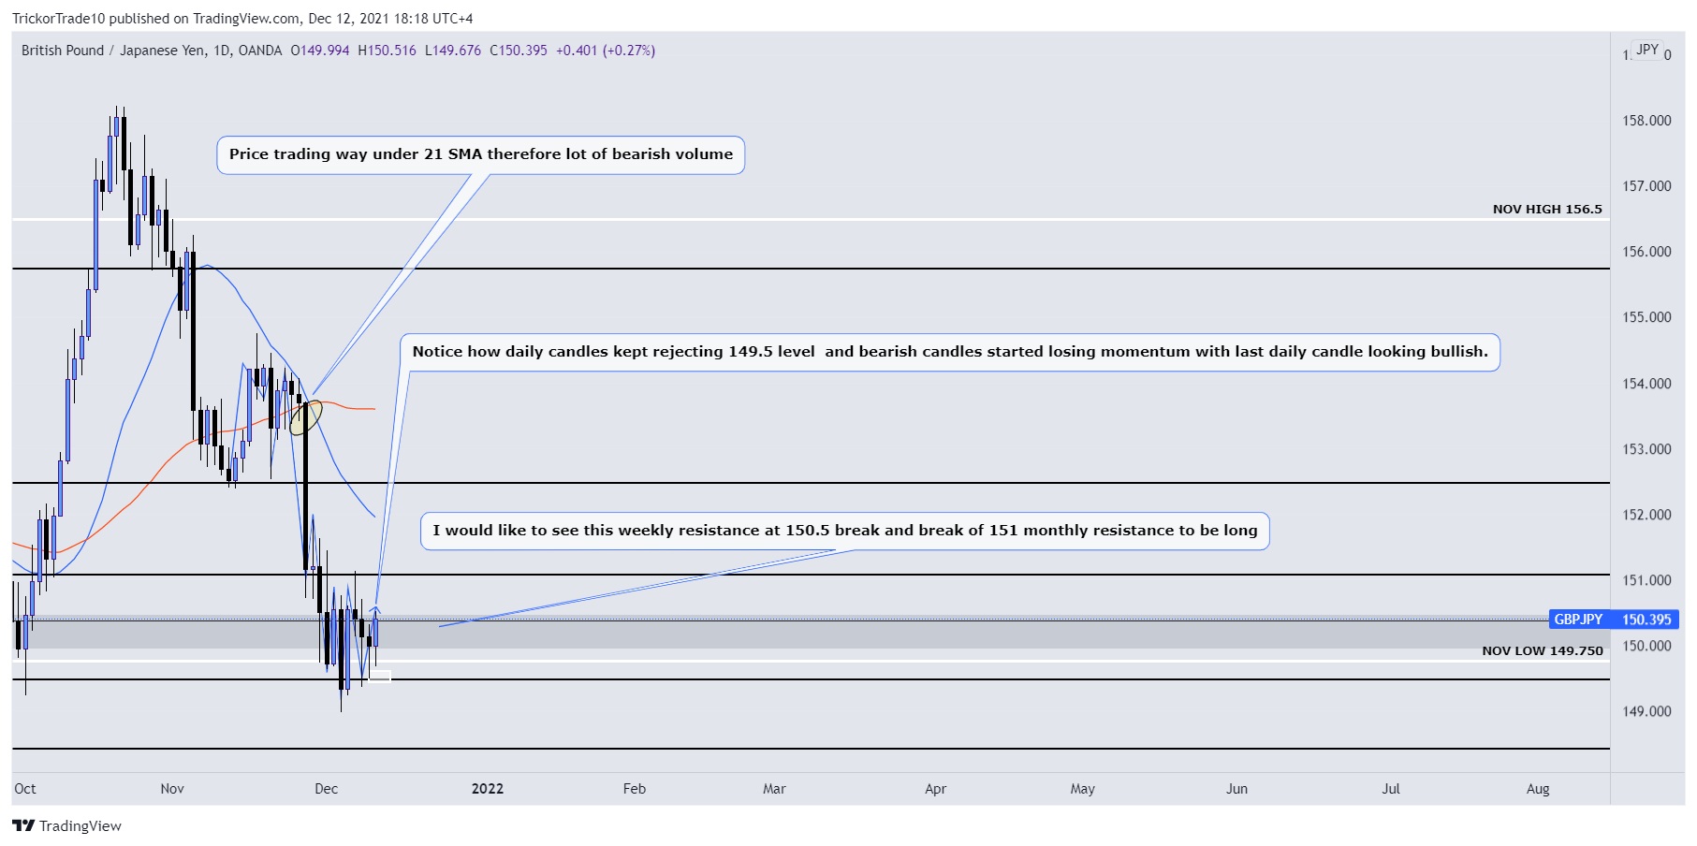
H4: Price indicates bullish but wait for break of resistance.
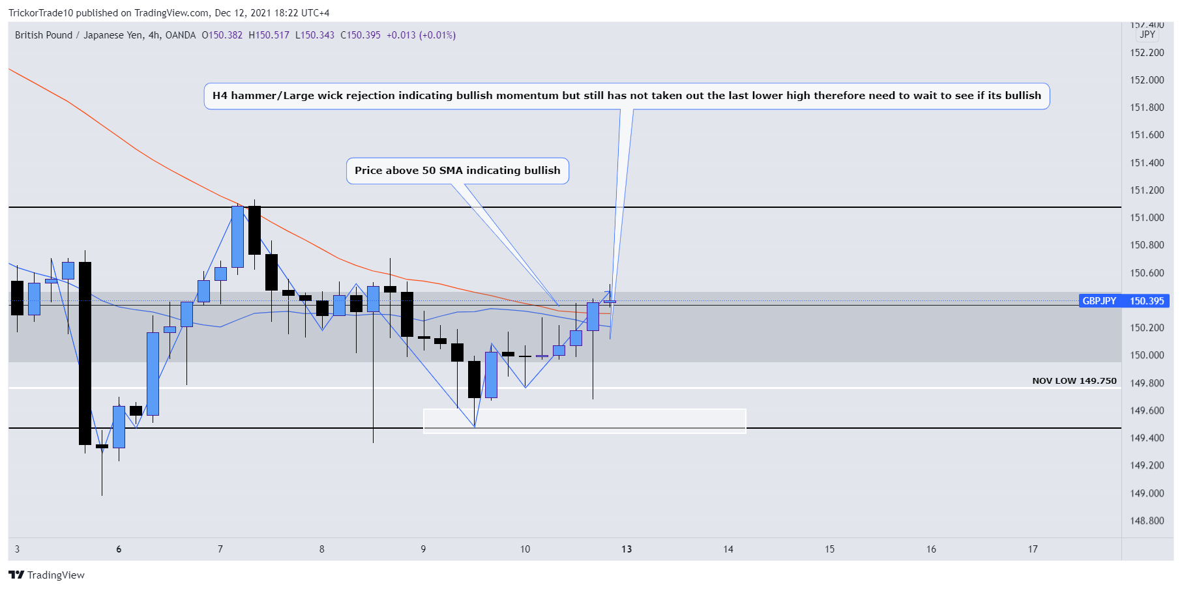
All time frames indicate bullish but wait for confirmations.

