12/12/2021
MONTHLY: Bearish structure bearish Nov candle. Only thing to see is if it goes bullish to fill up inefficiencies left by Nov candle.
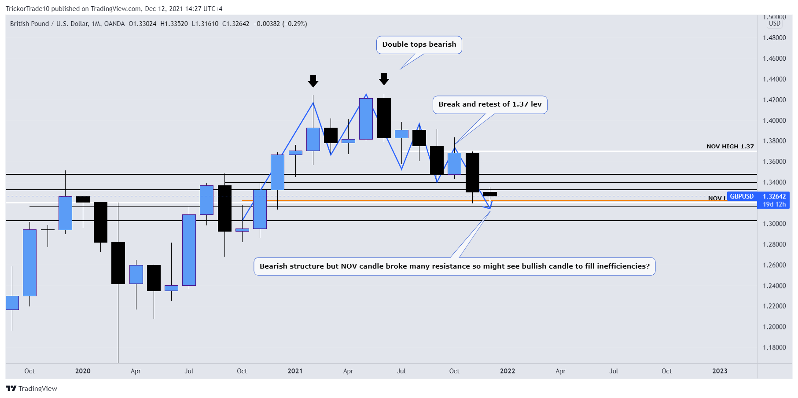
Weekly: Weekly closure shows bullish indication. Structure clear bearish but there are inefficiencies left that price may want to go to fill. Keep an eye on 1.33 level if it breaks and 1.34 inefficiencies.
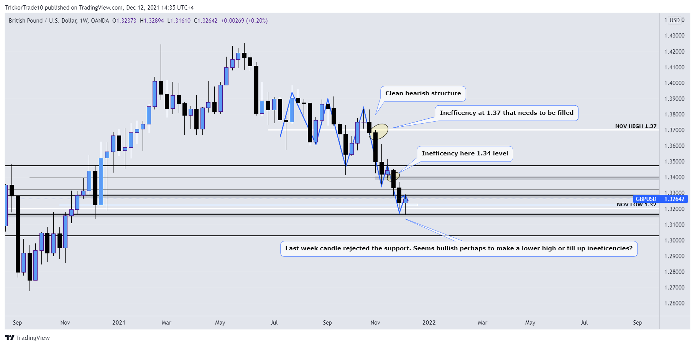

Daily: Daily indicates bullish momentum. Taking longs now is counter trend trading. Trend switch happens if 1.34 level is filled and still continues bullish then I will look for longs or I would take lower risk longs for counter trends. Keep an eye on 1.33 level breaking which would indicate bullish bias at least till 1.34 level. If we 1.33 level reject hence forming double tops I would look at shorts there.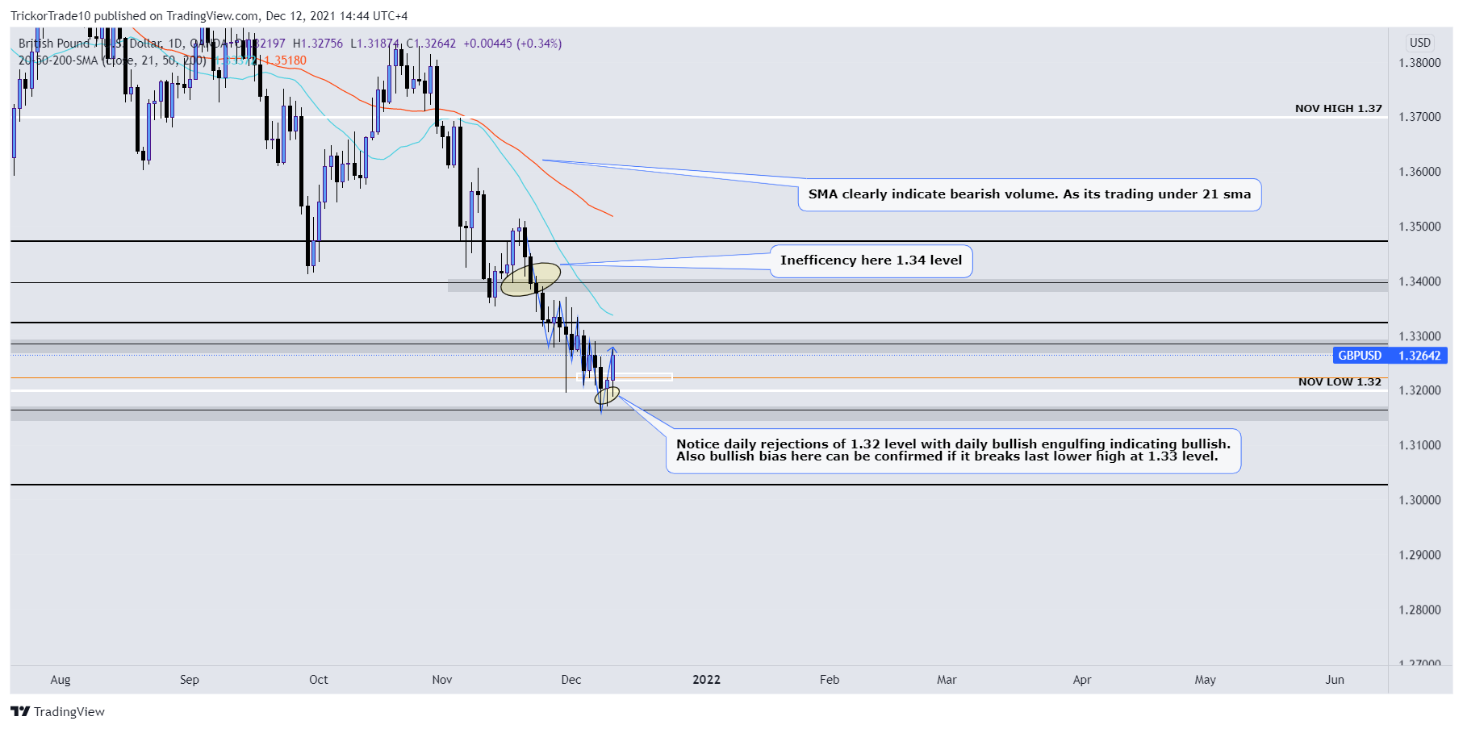
H4: Bullish
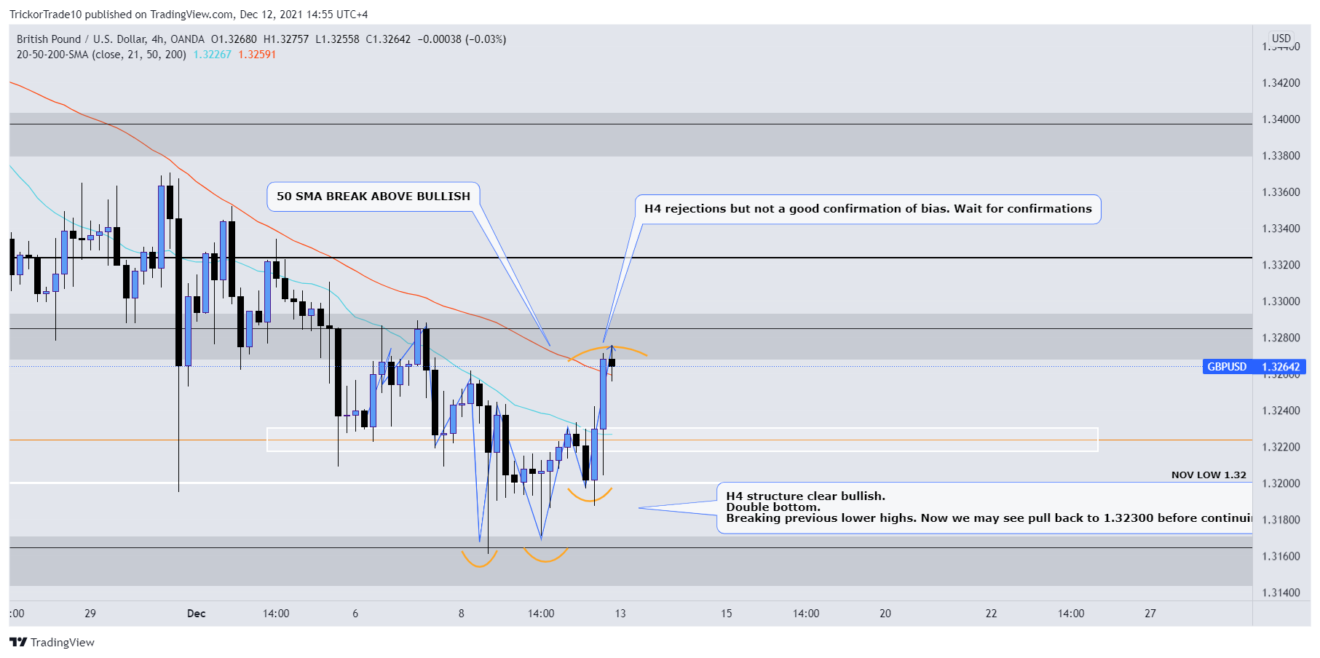
All time frames indicate bullish momentum.

