TRADING ENTIES .
Here's a mechanical strategy (trading plan) that anyone can follow based on the setups in this thread. Feel free to do anything with it, edit it. It's fully open to suggestions and changes. I am certain it can be improved upon. I will try dig out some further annotated chart examples but this thread is already packed full of examples. Many of Shahab8b's trades are similar to the 3 setups scenarios below. Now we can all trade like him. 
The Confluence Method v1.0
The Confluence Method is a mechanical strategy that aims to capitalise on a W1/D1/H4 chart scenario (trend, range and counter trend) with a precision entry using multiple confluence factors. Most setups involve directly entering at round numbers (RN) and setting TP on opposing RN. It can be used on all 28 FX pairs and aims to provide the user with the ability to trade successfully in most market conditions. Make sure to demo in advance before taking any new strategy to a live account.
I have not included Risk Profile (i.e. risk % per trade or total account exposure) That is trader specific but I would suggest starting with 0.25% per trade and work up to 1% as confidence grows, and max 3-5% open total. In many setups your entries will have zero DD, but best keep the position sizing based on 25 or 30 pips.
This strategy requires a foundational grasp of Supply Demand zone concepts, Support and Resistance, Fibonacci levels and False Breakouts.
Chart structure:
• Supply or Demand zone (SD)
• Support & Resistance (SR)
• False Breakout (FB)
• First Time Back (FTB) – The first touch of an SD zone or Round Number.
Confluence factors:
• Round Number (RN) and 0.5RN (0.25RN Majors only).
• Fibonacci levels (Fib) 38.2 / 50 / 61.8 / 76.4.
• Trendline (TL) and chart patterns / Elliot Wave (EW) (optional - advanced).
• Oscillator Divergence (RSI/Stochastics/MACD) - (optional - advanced).
Trend Retracement setups: (Low frequency - High RR) *There is a routine intraday version of this setup*
• Identification of W1/D1/H4 trend direction.
• Identification of retracement confluence factors visible on D1/H4/H1.
• Entries placed directly on RN /0.5RN with either SR/SD/Fib/TL present at the level. (more confluence = more confidence).
• Stop Loss - Fixed 25/30 pips or behind SD zone (Break even at 25 pips)
• TP at opposing RN at 100 pips or 200+ pips (user preference).
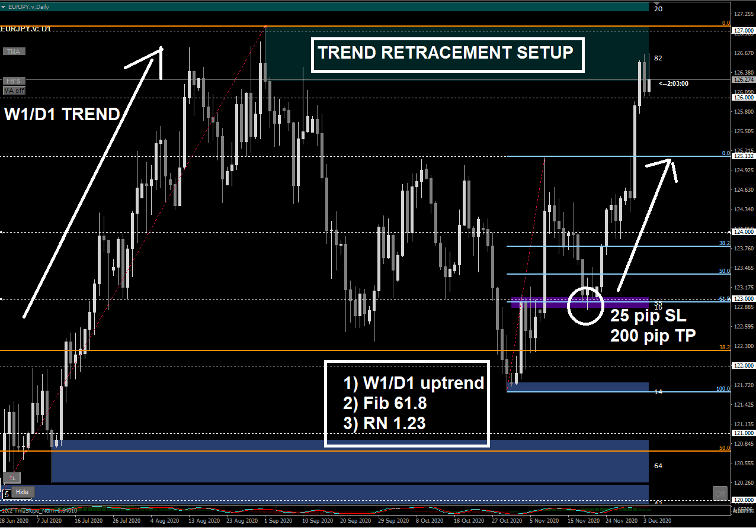

Range setups: (Medium Frequency - Medium RR)
• Identification of D1/H4 sideways range.
• Identification of RN/SD/FB at both edges of the range.
• Entries placed directly on RN with SD zone or FB present.
• Stop Loss - Fixed 25/30 pips or behind SD zone (Break even at 25 pips).
• TP at opposing RN 100 pips or opposing range SD zone.
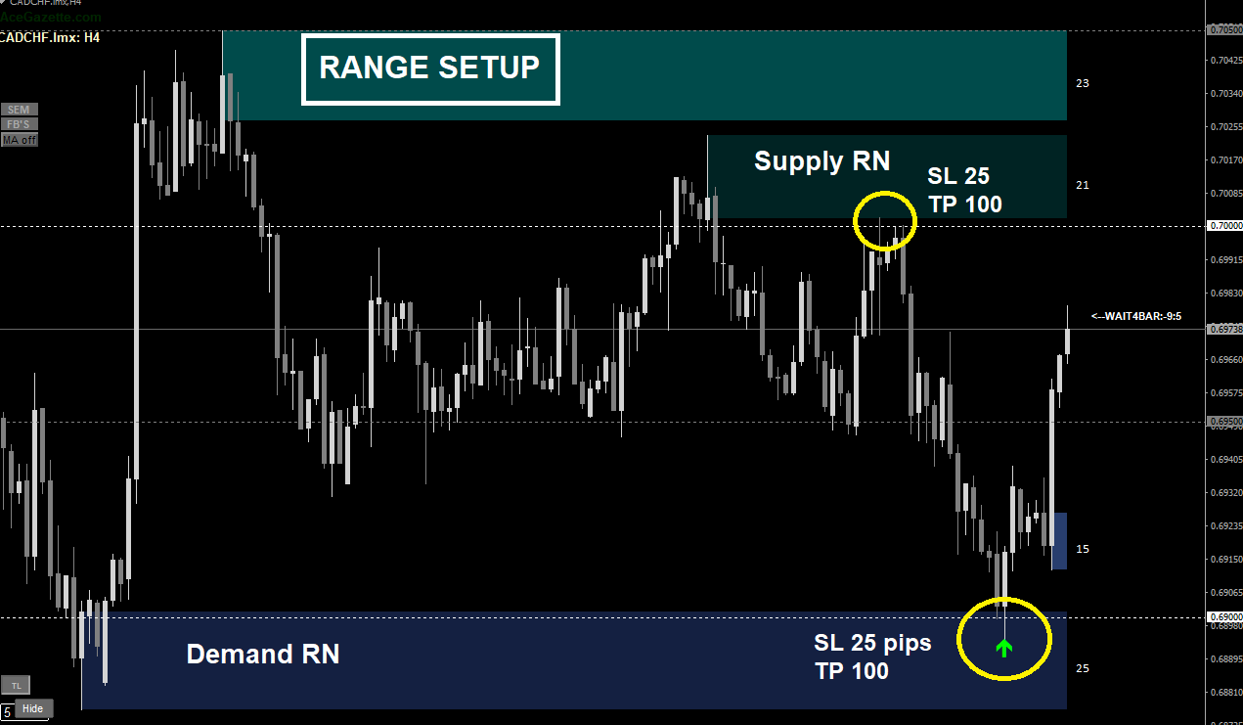
RN Counter Trend Setups: (High Frequency - lower RR) *These setups occasionally evolve into high RR reversals*
• Identification of approaching RN.
• Identification of distant SD zone or FB level. Or identification a smaller fresh FB level created in front of the RN at arrival. (See chart).
• Entries on RN (FTB only).
• Stop Loss- Fixed 25/30 pips (Break even set at 25 pips).
• TP or partial TP at 50 or 100 pips for counter trend reversals. I recommend holding a 50% partial.


