Trade Examples – Tuesday 18 August
GBP/JPY – LONG - Entry – 139.04 / SL – 138.80 / TP – 139.50
60 Min Chart – Price forms a base. Minor Divergence. Good break of EMA (Resistance). Now had to wait for 5 Min SAR’s Flip entry.

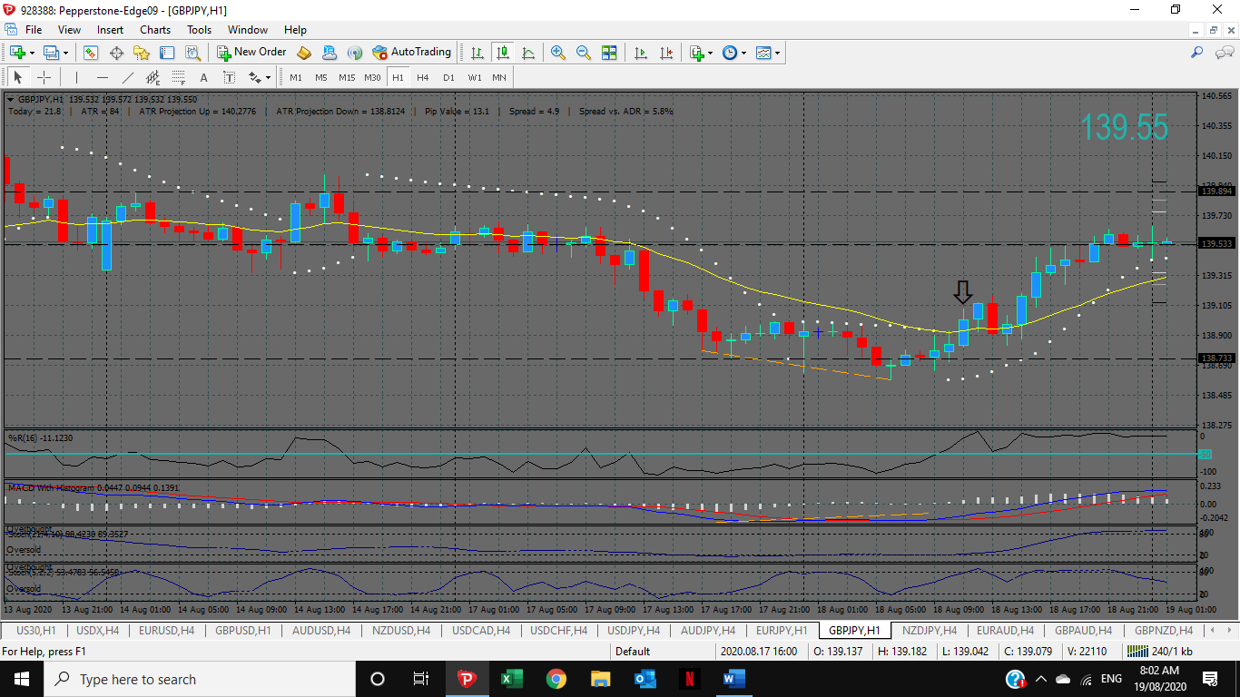

5 Min Chart – SAR’s Flip. Yellow dotted line is the 60 Min Candle close as per the 60 Min Chart above. This took a few hours to get going. I got the SAR’s Flip + I got a trendline break as well. An easy 45 Pips; you just had to be patient AND all set up from the 60 Min Chart.

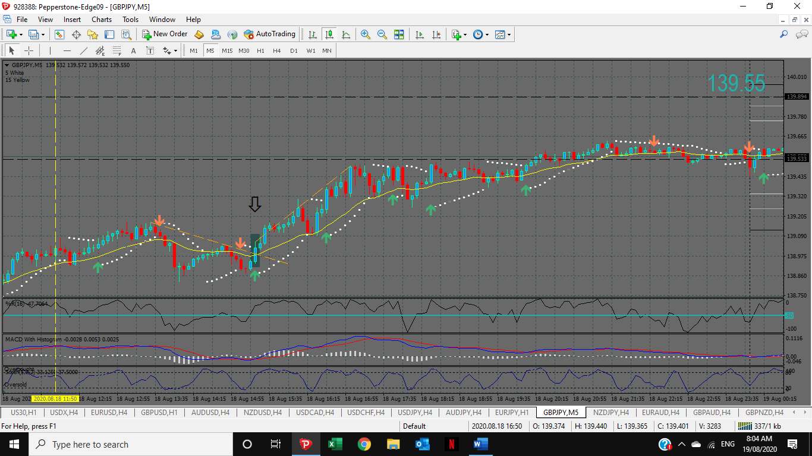

NZDP/JPY – LONG - Entry – 69.47 / SL – 69.27 / TP – 69.65
60 Min Chart – Price forms a base. Good break of EMA (Resistance). Now had to wait for 5 Min SAR’s Flip entry.

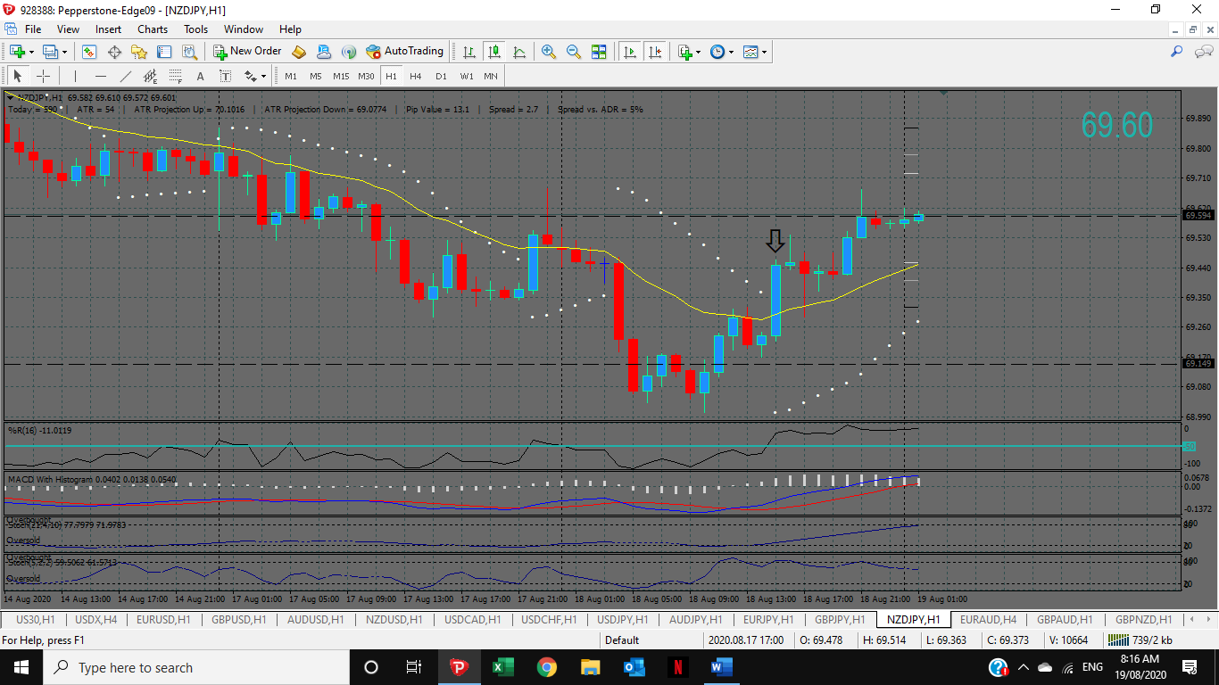

5 Min Chart – SAR’s flip. Yellow dotted line is the 60 Min Candle close as per the 60 Min Chart above. Trendline break. Note the W%16 went > 50 on the previous 5Min candle close, but good enough for me.



