GBP/AUD Trade – August 12th
60 Min – Price is clearly down. Note how price was staggering “up the hill” towards resistance like an exhausted drunk? Look at the first Bearish closed candle after resistance. Good clue about price action? Price then tumbles down the hill, breaks the EMA and SAR’s and W%16 all tune Bearish. Reckon we are selling?
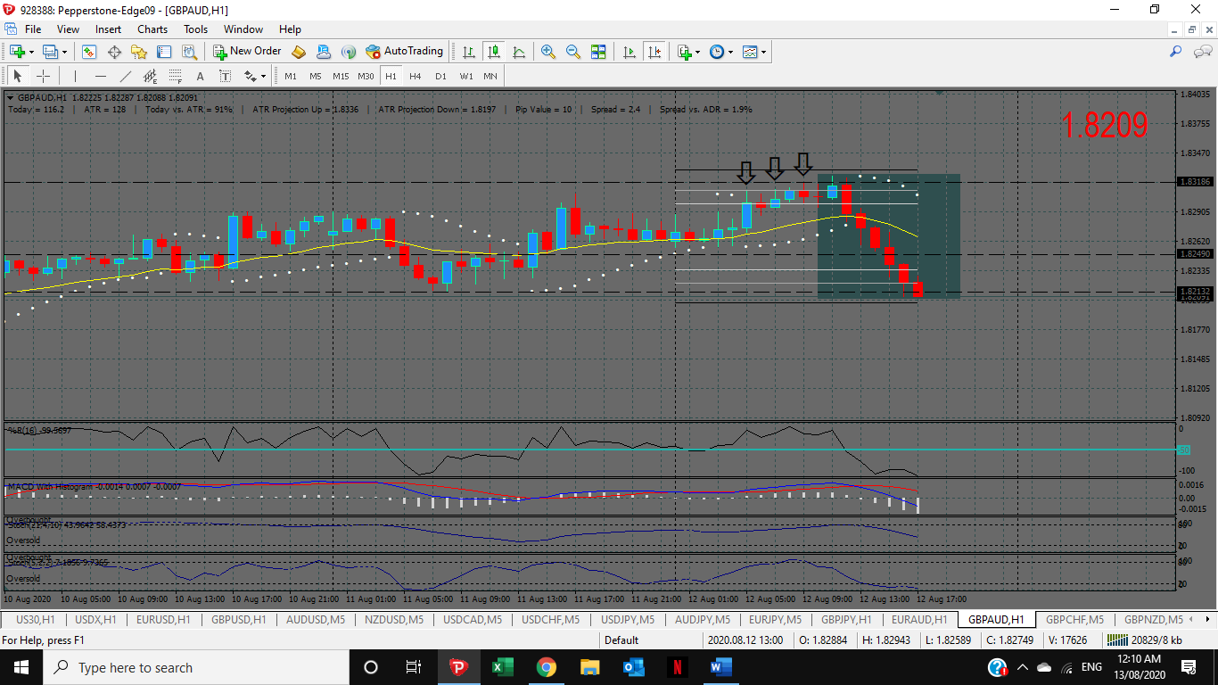
5 Min – Check out the fractal at Support (arrows). Highlighted candle gives the SAR’s flip and away she sailed.
Entry was 1.8240. Exit was 1.8212. Easy 28 Pips and price was never drawn down. You just needed patience to wait for the set up.


