NZD/JPY Example – 11 August 2020
60 Min Candle Filter – The “arrowed” candle is the 60 Min closed candle that breaks through the EMA; which is acting as resistance. Note the SAR’s indicator and W%16 have also turned Bullish. Now go and hunt for a 5 Min entry based on Rocky Point’s system (see below).
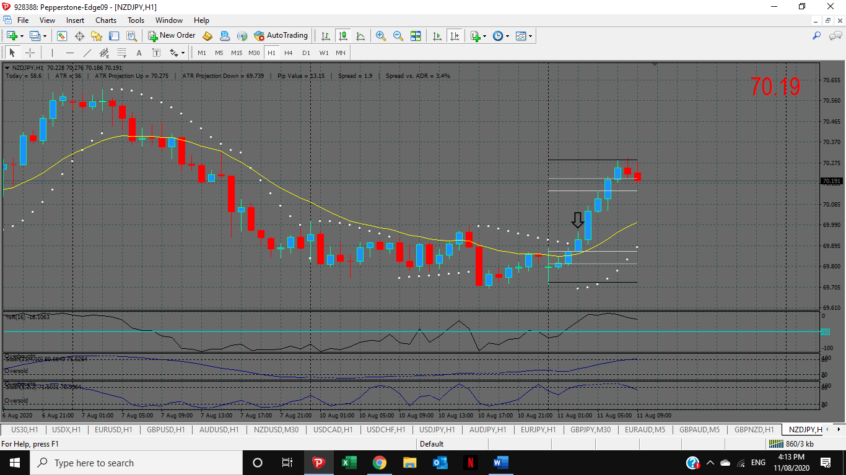
5 Min SAR Flip – The Yellow vertical line is the 60 Min candle close as per the above chart. Now check out the Green highlighted candle (with arrow). Can you see the SAR’s flip? SAR goes from Bearish to Bullish; W%16 goes from under to over and of course the 5 min candle close takes out the previous flat fractal.


