EUR/USD Trade Example – 17 June
Take direction from the 60 Min Chart.
60 Min – Price cycles down from prior day. Highlighted candle breaks Support and closes strongly under the EMA’s. Everything points Short. Now hunt for an entry off the 5Min Chart BUT only after structure is broken. Let’s assume for the sake of comparison that the highlighted candle closed Bullish and above the EMA’s with the 10 EMA crossing the 20 EMA. Now I am only thinking Long, not Short.
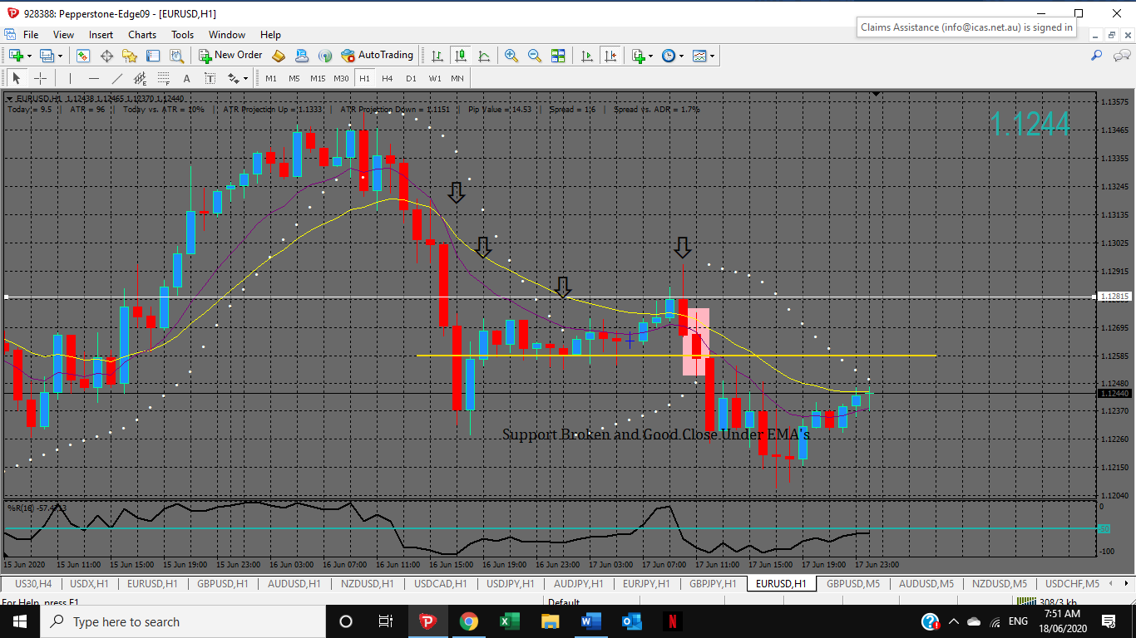
5 Min – 3 opportunities to enter after 60 Min structure is broken. I personally like to see Price retrace within the EMA’s and set up a 1-2-3 pattern. Signal to enter follows this 1-2-3 set up when the Rocky Point indicators align.
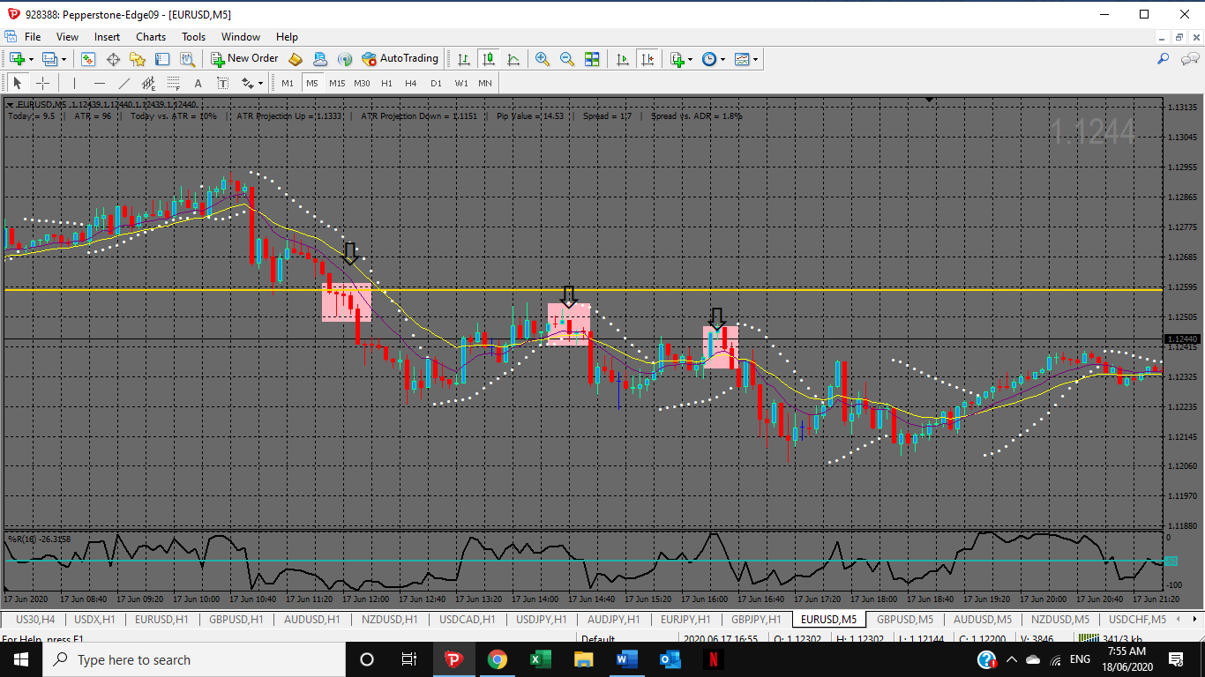
USD/JPY
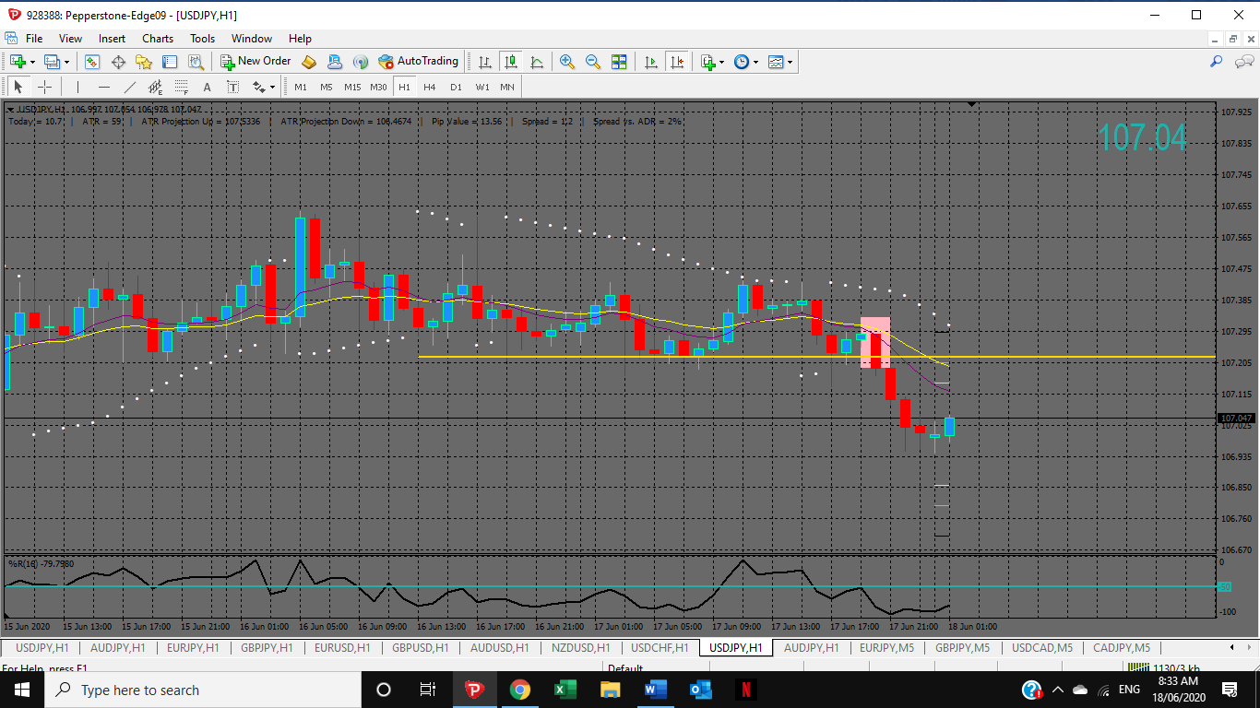
EUR/JPY
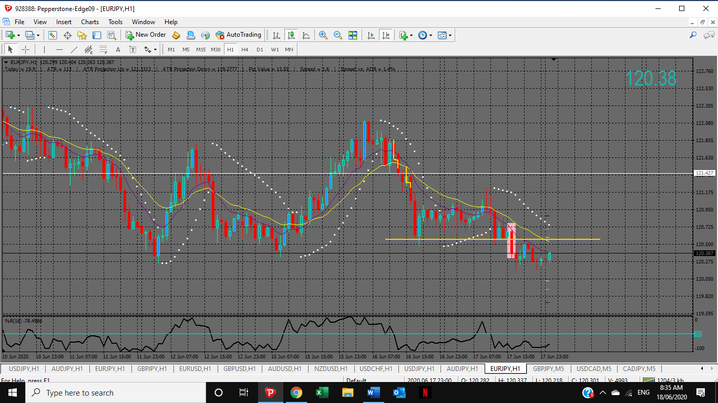

USA/CAD
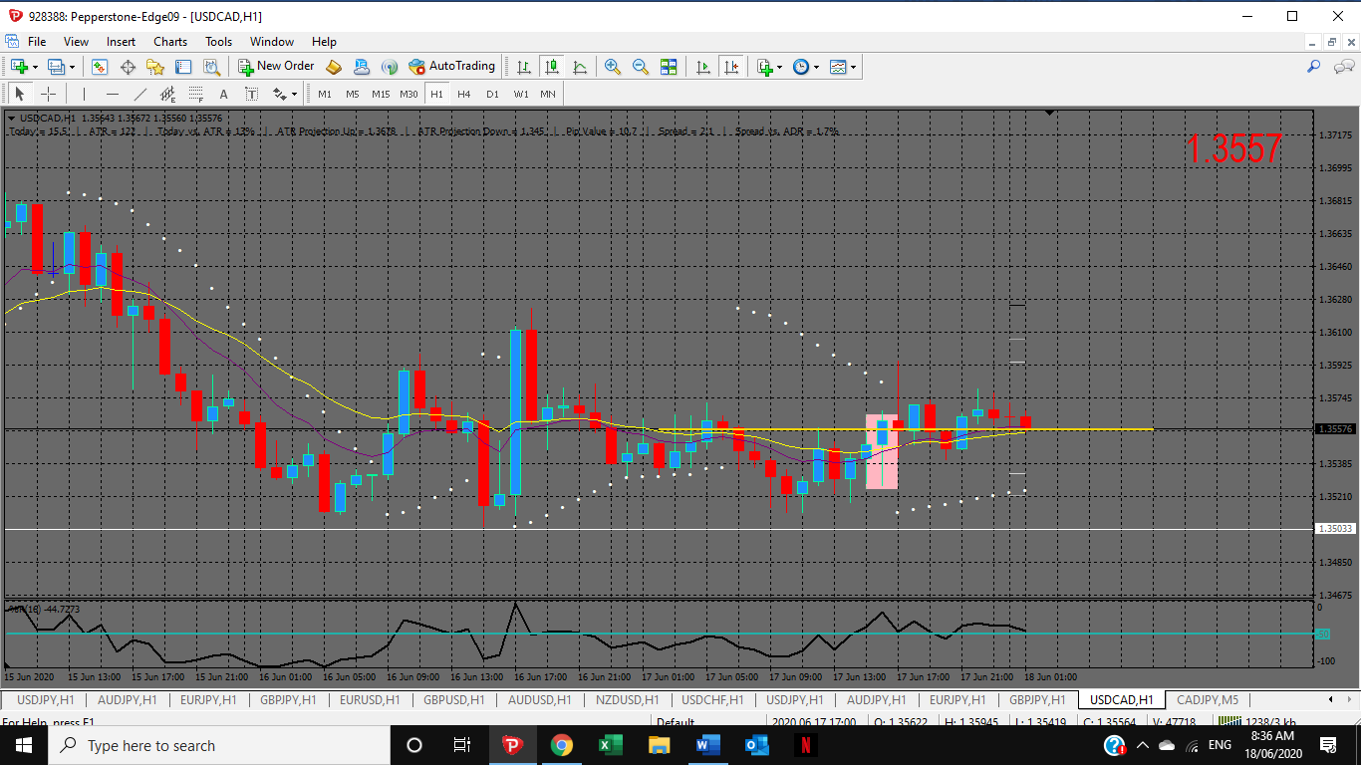
CAD/JPY


