- Post 29,720
- Cleanup
- Quote
- Aug 22, 2016 9:48am
-  JonnyPip
- Joined Nov 2012 | Status: Member | 338 Posts
UsdCad may also be setting up in a similar way
If we get a pullback to the 21ema in the 4h and a bounce, we should be looking at a move somewhere up to around the 1.300/365/89 ma's
Price reached the target in the 1h, now I expect a little bit of a pullback and for the move to be made in the 4h time frame at some point.
Let's wait and see

Attached Image (click to enlarge)
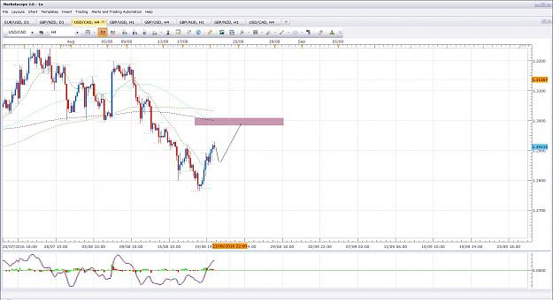
- Aug 22, 2016 10:16am
- JonnyPip
- Joined Nov 2012 | Status: Member | 338 Posts
EurGbp Potential Opportunity
Price has broken the 200sma in the 1h, it could give a nice move down to around the 365 ema/ .85500 level.
There is a similar set up which looks to be forming in the GbpChf 1h as well which leads me to think the GBPUSD move might not be on the cards just yet as both these pairs are suggesting potential short term GBP strength. It may still go though is the USD shows real strength, hard to say.
Attached Image (click to enlarge)
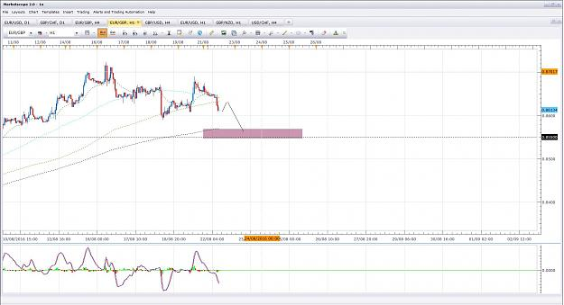

- Post 29,722
- Cleanup
- Quote
- Aug 22, 2016 10:18am
- JonnyPip
- Joined Nov 2012 | Status: Member | 338 Posts
GbpChf Potential Opportunity
Attached Image (click to enlarge)
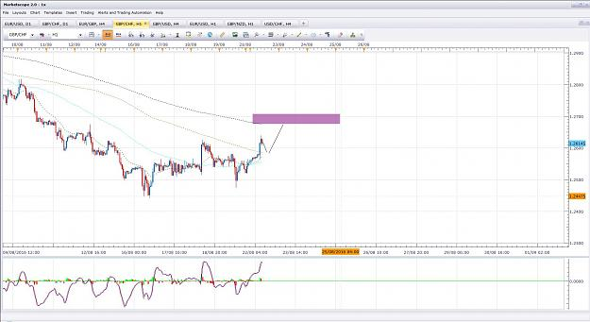

- Post 29,723
- Cleanup
- Quote
- Aug 22, 2016 10:45am
- JonnyPip
- Joined Nov 2012 | Status: Member | 338 Posts
Quoting timster
{quote} Hi JP! Sorry I think you may have misread my request (or perhaps I didn't explain myself correctly). Thanks for responding with so much detail. I've actually been trading for many years (however not as successfully as I would like). Ive discovered this thread during the last few days and it looks interesting. Was hoping that you may have some suggestions on where to start with this particular trading strategy. I agree with all the points you raised in your response. i agree with the patience recommendation very true! I will do as you suggested...
Hey Timster,
Ok that's great news as even if you have been trading for a few years but not profitably, your eye is still being trained to see the way the market moves. So when you learn something you will usually be able to see it much faster than someone who hasn't spent any time in front of the charts. So years of trading unsuccessfully are not actually wasted years I can assure you.
Regards a specific post, I really can't pick any one particular post out in regards to importance as they are all important and also connected. For example, you could read about profit targets but if you haven't read the bit about entries it doesn't help. If you read the part about entries AND profit targets, but not the part which explains the market rhythm and where to take the entries, then again you can still be making entries at the wrong time and therefore the profit target is also irrelevant as well.
So it is because of this interconnection between the principles that I find hard to point to any one piece within the thread. Personally I would just start from the top of the list and work down through the listed posts and lessons which explain pretty much everything you need to know.
Sorry I can't be more specific, hopefully this makes sense.
- Aug 23, 2016 7:48am
- JonnyPip
- Joined Nov 2012 | Status: Member | 338 Posts
Potential Opportunity CADJPY
Pullback to 21ema, move to round number.
Attached Image (click to enlarge)
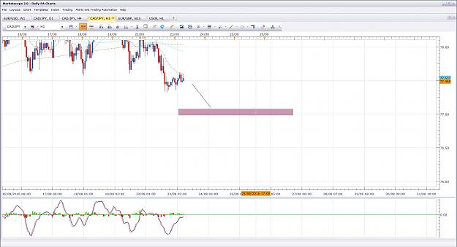

- Post 29,732
- Cleanup
- Quote
- Aug 23, 2016 8:17am
- JonnyPip
- Joined Nov 2012 | Status: Member | 338 Posts
Potential Opportunity AudCad (finally)
Price has broken above the 21ema which is exactly what we have been waiting for.
4h MACD rhythm suggests a move higher to the 89sma from here.
Lets see how it sets up
P.s
See second chart for why it is NOT a good idea to trade divergence! This is why you trade the market rhythm and not the MACD. The market rhythm is King here.
I will only take very specific counter trend moves and it will be based on the movements with the 4h candle itself. Trading counter trend will generally destroy your account if you are a new/inexperienced trader. Cutting out counter trend trades can, in many cases, make the difference between being unprofitable and profitable for traders.
Hope this helps
Attached Images (click to enlarge)
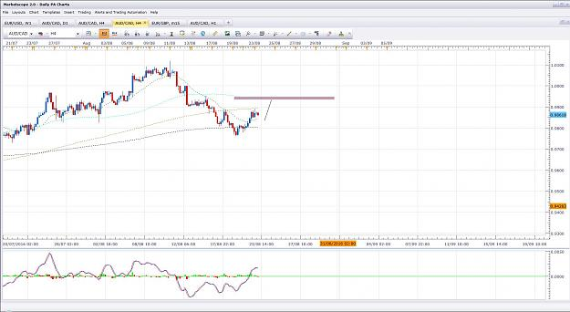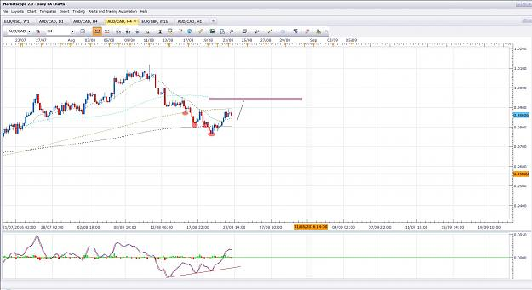

- Post 29,733
- Cleanup
- Quote
- Aug 23, 2016 11:05am
- JonnyPip
- Joined Nov 2012 | Status: Member | 338 Posts
EurUsd Potential Opportunity
I am keeping an eye on this pair for a possible move down to the 1.1250 round level/200sma area.
If price breaks below the 21ema/89sma and pulls back, it could set up nicely for a move down towards the round level/200sma.
Lets see how it plays out
Attached Image (click to enlarge)
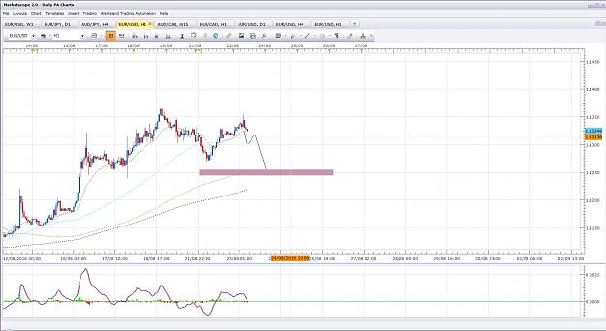

- Post 29,734
- Cleanup
- Quote
- Aug 23, 2016 4:44pm
- JonnyPip
- Joined Nov 2012 | Status: Member | 338 Posts
EurAud Potential Opportunity
Price has pulled back to the 21ema and 365 ema (after breaking through), might get a chance to trade it back to the top/round number
Lets see how it plays out
Attached Image (click to enlarge)
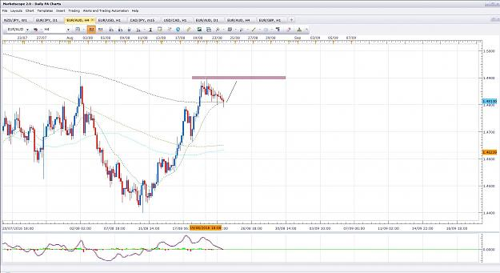

- Post 29,735
- Cleanup
- Quote
- Aug 23, 2016 4:50pm
- JonnyPip
- Joined Nov 2012 | Status: Member | 338 Posts
EurGbp Update
Trade 1 = + 56 pips
Trade 2 = + 34 pips
Total = + 90 pips
Attached Image (click to enlarge)
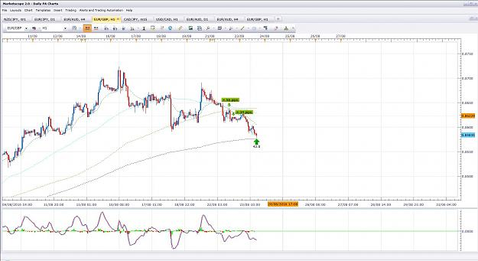
- Aug 24, 2016 6:49pm
- JonnyPip
- Joined Nov 2012 | Status: Member | 338 Posts
EurUsd Update
Made the move as outlined in my previous post, unfortunately I have had some issues with my computer this week so missed some trades, this was one of them.
Hoping others got something out of it though
Attached Image (click to enlarge)
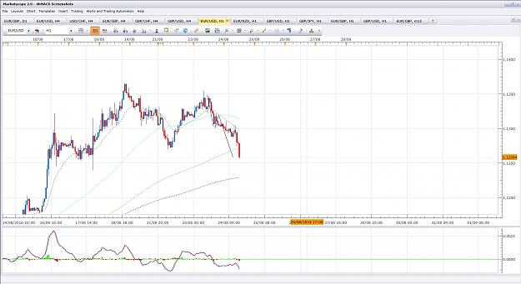

- Post 29,739
- Cleanup
- Quote
- Aug 24, 2016 6:52pm
- JonnyPip
- Joined Nov 2012 | Status: Member | 338 Posts
UsdChf Update
Rhythm - Break 21ema and 89sma, pullback, move to 365ema
Trade 1 = + 68 pips
Trade 2 = + 45 pips
Total = + 133 pips
Attached Image (click to enlarge)
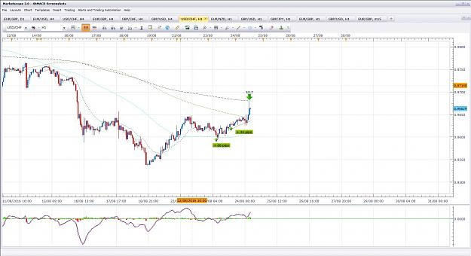
- Aug 30, 2016 8:26am
- JonnyPip
- Joined Nov 2012 | Status: Member | 338 Posts
EurUsd Potential Opportunity
Attached Image (click to enlarge)
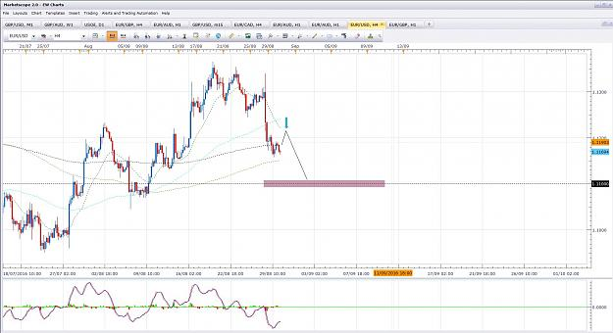

- Post 29,756
- Cleanup
- Quote
- Aug 30, 2016 8:29am
- JonnyPip
- Joined Nov 2012 | Status: Member | 338 Posts
GbpNzd Potential Opportunity
Break 21ema/89sma, move to round level / 200 sma
Attached Image (click to enlarge)
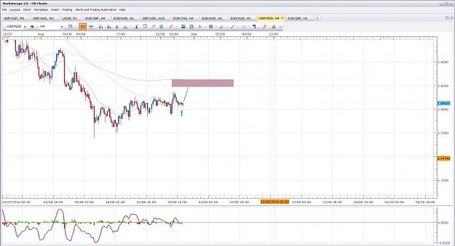

- Post 29,757
- Cleanup
- Quote
- Aug 30, 2016 8:36am
- JonnyPip
- Joined Nov 2012 | Status: Member | 338 Posts
AUDJPY Potential Opportunity
Break 21ema/89sma, pullback, move to round level/200/365 ma's
Attached Image (click to enlarge)
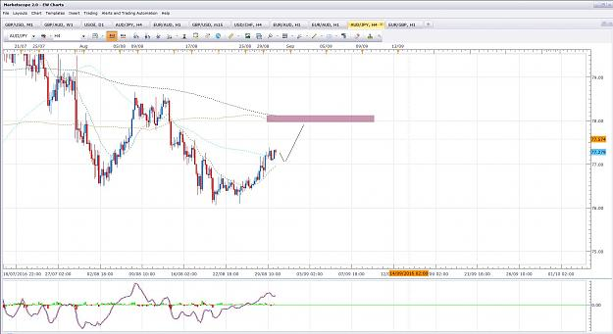

- Post 29,758
- Cleanup
- Quote
- Aug 30, 2016 8:40am
- JonnyPip
- Joined Nov 2012 | Status: Member | 338 Posts
AudUsd Potential Opportunity
Break 21ema/200sma, move to round number
Attached Image (click to enlarge)
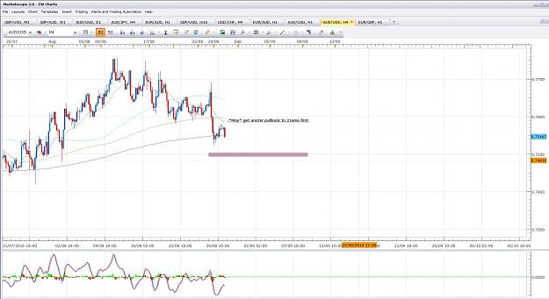

- Post 29,759
- Cleanup
- Quote
- Aug 30, 2016 8:43am
- JonnyPip
- Joined Nov 2012 | Status: Member | 338 Posts
EurGbp Potential Opportunity
Break 21ema/89 move to round number/200sma (Target 1)
Move to round number/365ema (Target 2)
Attached Image (click to enlarge)
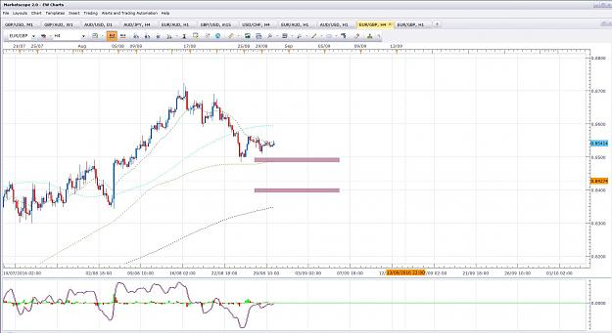

- Post 29,760
- Cleanup
- Quote
- Aug 30, 2016 8:47am
- JonnyPip
- Joined Nov 2012 | Status: Member | 338 Posts
GbpAud Potential Opportunity
Break 21ema/200sma move to round level
Attached Image (click to enlarge)
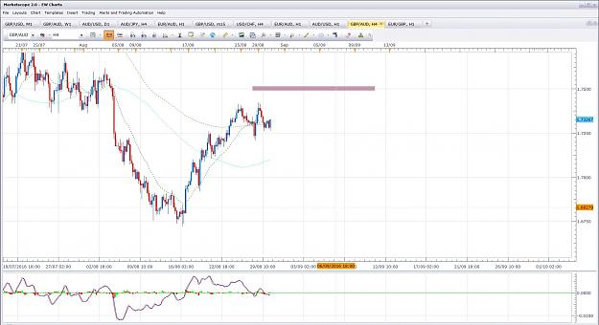
- Aug 31, 2016 9:55am
- JonnyPip
- Joined Nov 2012 | Status: Member | 338 Posts
OIL UPDATE
Here is an oil trade I took last night:
Total = +118 pips.
I wanted to also show for the new traders how it was executed so I added another chart explaining the trade to give a better understanding.
Remember these are the points as outlined in the thread and methodology. You CANNOT trade every chart the same there are different market conditions. These are KEY when looking at your charts for market rhythm.
When price is -
1) Trending - Look for pullbacks to the 21ema and move away (continuation)
2) Ranging (across the MA's) - *LOOK TO ESTABLISH YOUR SUPPORT AND RESISTANCE LINES*
Market rhythm happens within these two market conditions. They will help you know what the true market rhythm is. In the case of this oil trade it is as clear as day the market rhythm is a break 21ema, pullback, move to 89sma.
I have put number 2 in caps as it is very important and I am not sure from some messages I am sent this is fully understood yet by some of the newer people to the thread. If you are trying to trade moves from the 21ema and the market is ranging you are gong to get hit again and again.
Below this is outlined in the second chart.
Hope this helps
Attached Images (click to enlarge)
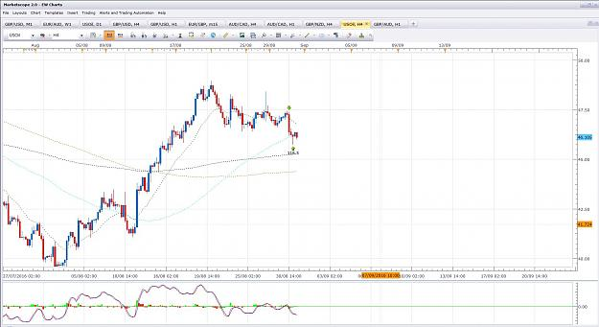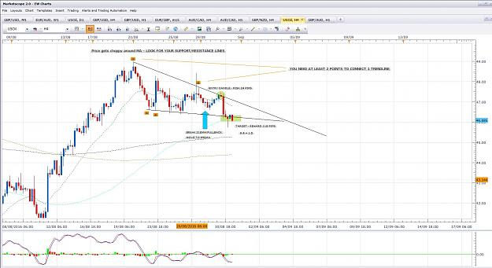

- Post 29,770
- Cleanup
- Quote
- Aug 31, 2016 11:52am
- JonnyPip
- Joined Nov 2012 | Status: Member | 338 Posts
GBPAUD UPDATE FROM YESTERDAYS POSTED OPPORTUNITY
Rhythm - break 21ema, pullback, move to round number.
Total = +161.8 pips
Attached Image (click to enlarge)
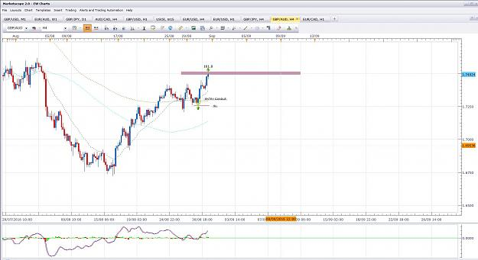

- Post 29,771
- Cleanup
- Quote
- Aug 31, 2016 2:19pm
- JonnyPip
- Joined Nov 2012 | Status: Member | 338 Posts
Potential Opportunity??
For those who read my earlier post, what do you see here?
Steps to the trade -
1) Price crossing ma's / messy MA's - Price is RANGING
2) Find SUPPORT and RESISTANCE lines
3) Check market rhythm - Price has broken below the 21ema and pulled back
4) Targets - Other side of support/resistance lines plus round number 1.2900
- 1.300 round number between here and ultimate target
This is the process you have to follow, you can't just look at a chart and say "right it's at the 89 sma and above it so I'm buying".
Hope this helps
Attached Image (click to enlarge)
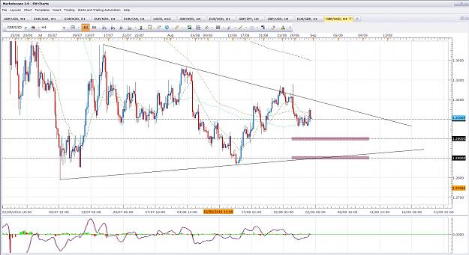
- Sep 1, 2016 1:47pm
- JonnyPip
- Joined Nov 2012 | Status: Member | 338 Posts
GBPUSD
This is how losses happen unfortunately....
You can do everything right and still take a loss. Once a new trader understands this concept they will never be emotional about taking a loss ever again.
I would be looking at now trading up to the 365ema but it has been a good week and with NFP tomorrow anything can happen. I'll see where this pair is sitting on Monday.
Attached Image (click to enlarge)
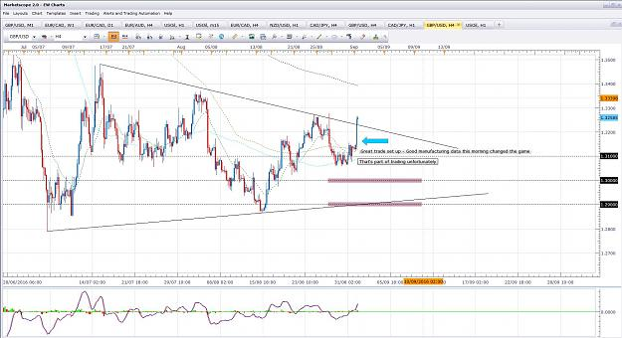
- Sep 1, 2016 2:37pm
- JonnyPip
- Joined Nov 2012 | Status: Member | 338 Posts
Quoting orangeRANGE
NZDusd {image}
I'm in this as well orange, a great 4h macd set up
Target - 200sma - R:R is 1:2
The only thing is NFP tomorrow so trade will have to be managed and reviewed before hand for me personally.
Attached Image (click to enlarge)
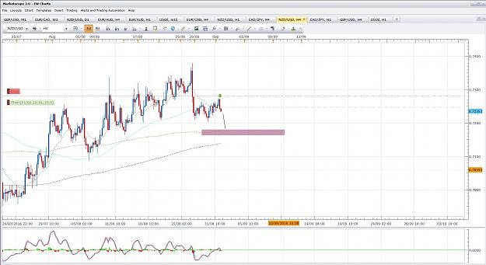
- Sep 6, 2016 9:20am
- JonnyPip
- Joined Nov 2012 | Status: Member | 338 Posts
EurUsd Potential Opportunity
Price is pulling back to the 21ema, looking for a potential turn and moves lower as price is below all the other moving averages
Attached Image (click to enlarge)
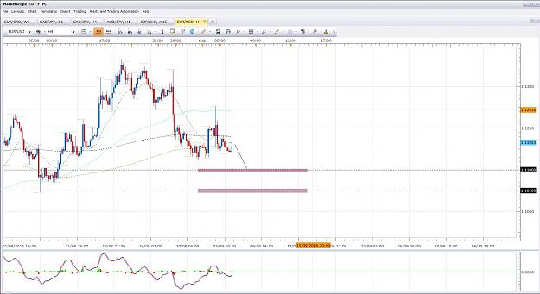

- Post 29,814
- Cleanup
- Quote
- Sep 6, 2016 9:25am
- JonnyPip
- Joined Nov 2012 | Status: Member | 338 Posts
EurJpy Potential Opportunity
Price has broken 21ema and pulled back suggesting potential moves down to around the 89/200sma's and the round level just below
Attached Image (click to enlarge)
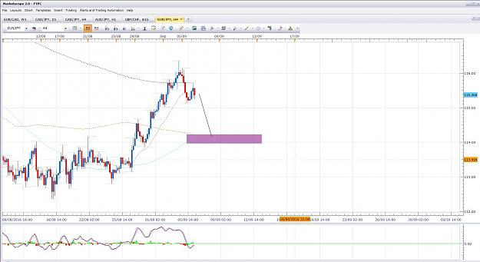

- Post 29,815
- Cleanup
- Quote
- Sep 6, 2016 9:33am
- JonnyPip
- Joined Nov 2012 | Status: Member | 338 Posts
GbpJpy Potential Opportunity
Price is pulling back to the 21ema and is suggesting higher moves, potentially to the 140.00 level
**NOTE** This may mean either the EurJpy move may not go to the 89/200sma or the GbpJpy move may not materialize. It is possible for both to go but they will need to be watched. The candles will tell us what their plan is.
Attached Image (click to enlarge)
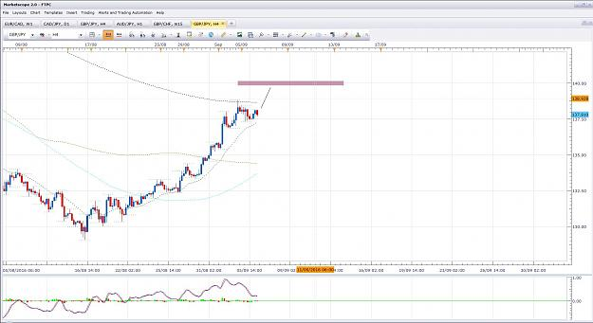

- Post 29,816
- Cleanup
- Quote
- Sep 6, 2016 11:22am
- JonnyPip
- Joined Nov 2012 | Status: Member | 338 Posts
Potential Opportunity AudCad
Could be setting up for a move lower - however due to the positive news which came out last night for the Aud it may not go straight away.
It is one I am watching though.
Attached Image (click to enlarge)
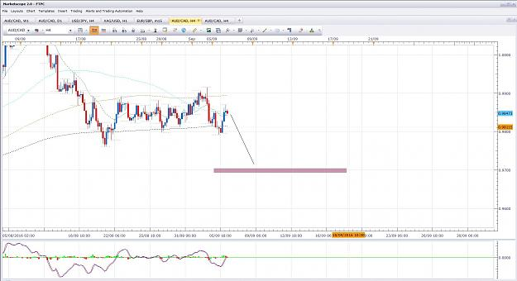

- Post 29,817
- Cleanup
- Quote
- Sep 6, 2016 11:46am
- JonnyPip
- Joined Nov 2012 | Status: Member | 338 Posts
USDCHF Potential Opportunity
NOTE - Jordan speaking later so could move the CHF
Attached Image (click to enlarge)
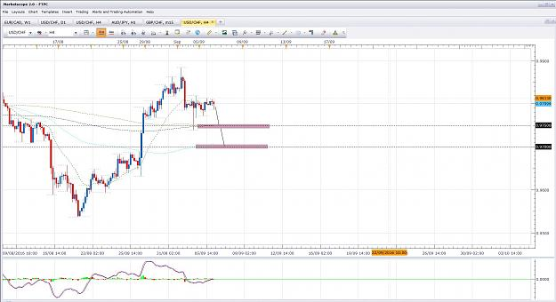

- Post 29,818
- Cleanup
- Quote
- Sep 6, 2016 12:38pm
- JonnyPip
- Joined Nov 2012 | Status: Member | 338 Posts
EurGbp Potential Opportunity
Attached Image (click to enlarge)

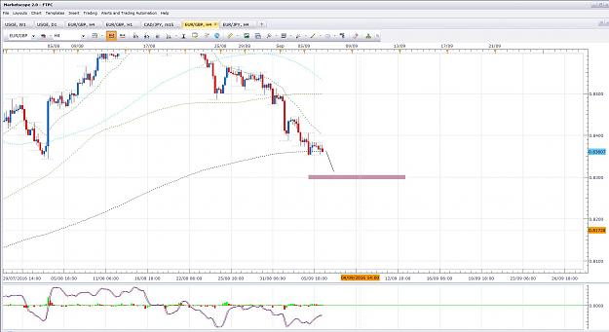
- Sep 19, 2016 8:21am
- JonnyPip
- Joined Nov 2012 | Status: Member | 338 Posts
Hey all,
I was very busy last week so didn't have much time to post, was a great trading week though hope everyone managed to get some nice pips out of last week 
I will put some opportunities up today for some moves that I am looking at this week
Rhythm - Pullback to 21ema, move to round level.
Here is one I see at the moment, I will put some more up shortly.
Happy Trading
Attached Image (click to enlarge)
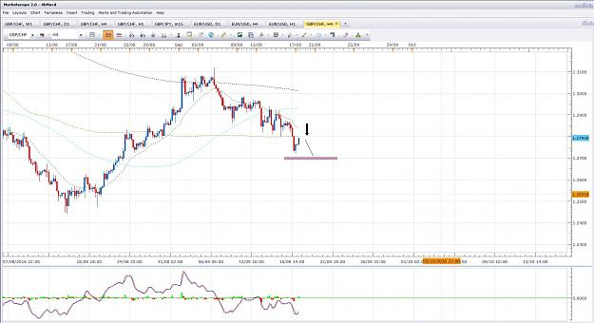

- Post 29,886
- Cleanup
- Quote
- Sep 19, 2016 10:18am
- JonnyPip
- Joined Nov 2012 | Status: Member | 338 Posts
EURUSD POTENTIAL OPPORTUNITY
Rhythm - pullback to 21ema, move to round level
Attached Image (click to enlarge)
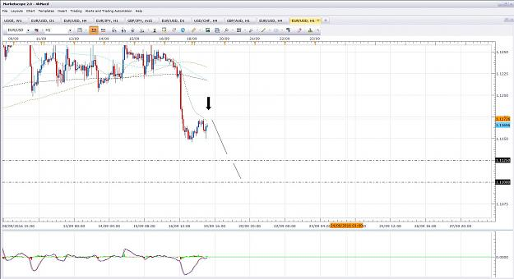

- Post 29,887
- Cleanup
- Quote
- Sep 19, 2016 10:46am
- JonnyPip
- Joined Nov 2012 | Status: Member | 338 Posts
GBPJPY POTENTIAL OPPORTUNITY
Rhythm - Pullback to 21ema, move to round level
Attached Image (click to enlarge)
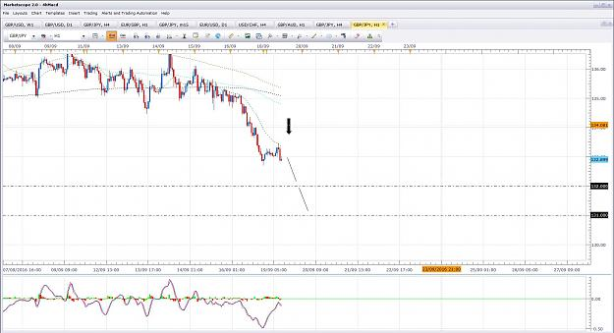
- Nov 15, 2016 2:46pm
- JonnyPip
- Joined Nov 2012 | Status: Member | 338 Posts
Quick chart of potential opportunity taking place AUZNZD 4h
Rhythm - Pullback to 21ema, move to round number
Happy Trading
Attached Image (click to enlarge)
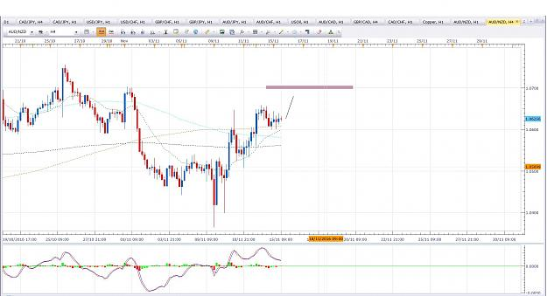

- Post 29,942
- Cleanup
- Quote
- Nov 15, 2016 3:56pm
- JonnyPip
- Joined Nov 2012 | Status: Member | 338 Posts
Potential Opportunity on Copper (for those who trade it).
Rhythm - Break 21ema, pullback move to round number/89 sma
Overall target is 89sma but be aware of round number in between
Happy Trading
Attached Image (click to enlarge)
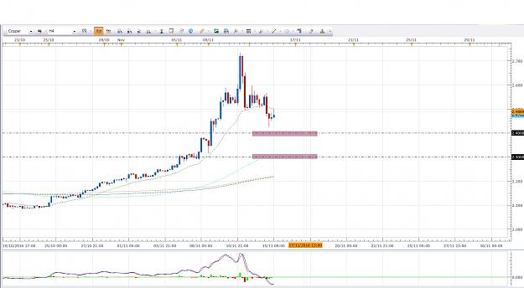

- Post 29,943
- Cleanup
- Quote
- Nov 15, 2016 4:31pm
- JonnyPip
- Joined Nov 2012 | Status: Member | 338 Posts
Audchf current position
Here is a trade I am in now, may still be a chance to get involved again on this pullback
Remember, there's no guarantees in forex, this is just a trade I personally have on which helps to show the rhythm
21ema - move to round number
Happy Trading
Attached Image (click to enlarge)
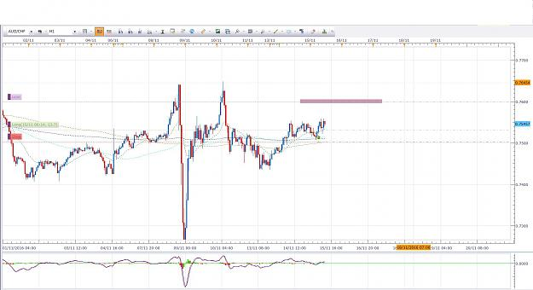
- Nov 16, 2016 8:38am
- JonnyPip
- Joined Nov 2012 | Status: Member | 338 Posts
Quoting naustingfx
{quote} It is nice you are here again to keep the forum warm...welcome back! I know that Phillip has given all here already...I do not really think that there is any new thing here...we are just doing the same thing in our own unique ways...and I think that uniqueness come with good screen time and experience...and it is not that easy to impact that to another trader...so as we share our unique abilities here, one has to really go home and work it out to see how it will work... Happy trading to everyone. Regards, naustingfx
I agree, doing the study and work is crucial. You can't just start speaking a different language you have to learn it. Unfortunately this is missed by many new traders, they want to immediately start speaking a different language and get frustrated when they can't. You have to do the study.
Potential Opportunity CadCHf 1h
Pullback 21ema, move to round number
Happy Trading
Attached Image (click to enlarge)
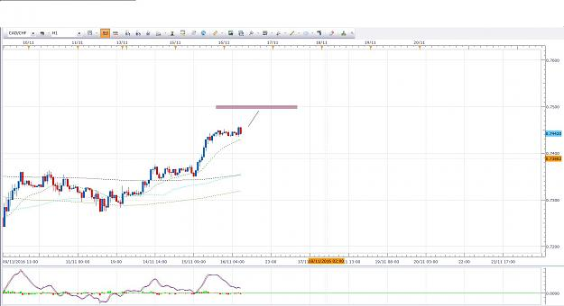

- Post 29,946
- Cleanup
- Quote
- Nov 16, 2016 11:34am | Edited at 12:18pm
- JonnyPip
- Joined Nov 2012 | Status: Member | 338 Posts
Update -
AudChf and AudNzd were both losses. I had three losses out of all open trades and unfortunately I put up two of the three losses and missed out the good ones.
But I wanted to use this opportunity of a loss to show some of the newer traders how to cut your losses when you understand the market rhythm. As Phil says "Hope is not a strategy".
Below is a chart of the audchf which shows expected market rhythm vs actual market rhythm. If you take the time to learn the market rhythm you will see it will tell you when you are wrong before your stop is even hit. You will see when the actual market rhythm changes and shows you are wrong, long before your stop is hit.
The second chart shows what rhythm is needed to consider a re-entry.
If you get into the market because you see and expect a certain rhythm and then the rhythm changes and gives an opposite signal, there is no reason to be in the trade still.
This is slightly more advanced and there is nothing wrong with having a stop hit. But once the basic concept is understood of the 4hmacd system this can be added to hugely reduce losses and increase overall R:R. When this method is applied an initial trade of risk:reward 1:3 can be transformed into a 1:8 or more.
For example, the initial trade I posted was (about)
26 pips risk vs 68 pips reward - RR - 1:2.6
But using and understanding the market rhythm, this trade was cut at around -8 pips which means the real RR of the trade was - 1:8.5
I.e if you were only right 20% of the time you would still make money. (most pro's will be at around 60-80, 90 is fairly exceptional)
Anyway I hope this helps and can be understood. It shows how to implement "Hope is not a strategy" by cutting your losses early BUT NOT because of emotion, but because the market rhythm is telling you to. If one can understand this principle and truly commits to learning the rhythm, this is one of the keys to being highly profitable compared to just slightly profitable
JP
Attached Images (click to enlarge)
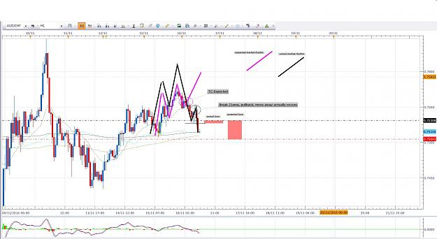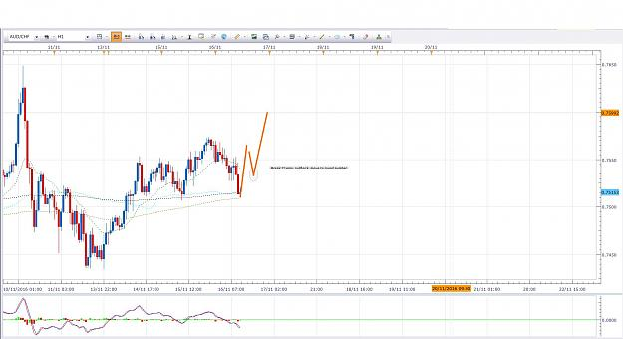

- Post 29,947
- Cleanup
- Quote
- Nov 16, 2016 11:53am
- JonnyPip
- Joined Nov 2012 | Status: Member | 338 Posts
Gold - Potential opportunity
Break 21ema, pullback, move to round number
Keep in mind USD news in about 1.5 hours
Attached Image (click to enlarge)
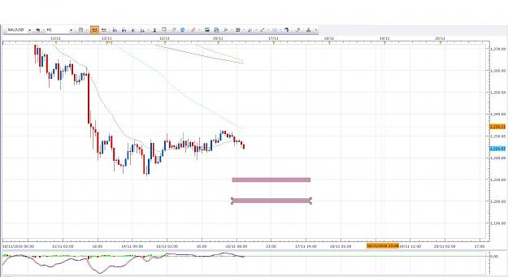

1

- Post 29,948
- Cleanup
- Quote
- Nov 16, 2016 2:00pm
- JonnyPip
- Joined Nov 2012 | Status: Member | 338 Posts
GbpChf - Potential Opportunity
Pullback 21ema, move to round number
Happy Trading
Attached Image (click to enlarge)
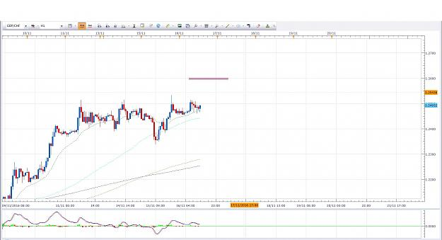
- Nov 21, 2016 7:56am
- JonnyPip
- Joined Nov 2012 | Status: Member | 338 Posts
GbpNzd - Potential Opportunity
Break 21ema, pullback, move to round level/89sma
Attached Image (click to enlarge)
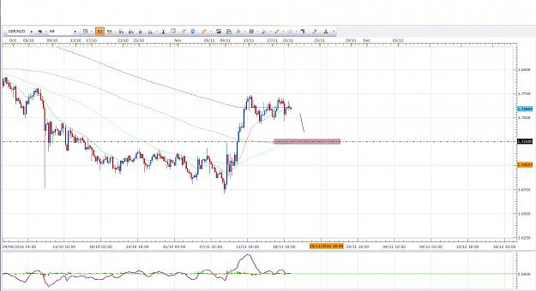

- Post 29,957
- Cleanup
- Quote
- Nov 21, 2016 8:00am
- JonnyPip
- Joined Nov 2012 | Status: Member | 338 Posts
GbpChf - Potential Opportunity
Same type of set up as last one
Break 21ema, pullback, move to round level/89sma
Attached Image (click to enlarge)
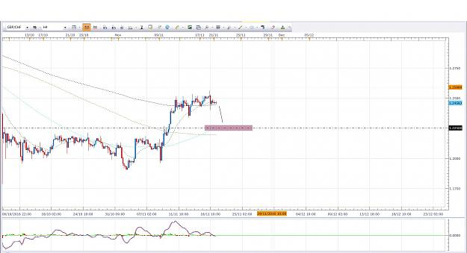

- Post 29,958
- Cleanup
- Quote
- Nov 21, 2016 8:21am
- JonnyPip
- Joined Nov 2012 | Status: Member | 338 Posts
NzdJpy Potential Opportunity
Pullback to 21ema, move to round number
Attached Image (click to enlarge)
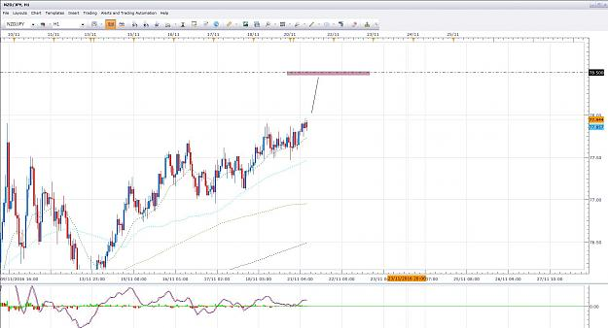

- Post 29,959
- Cleanup
- Quote
- Nov 21, 2016 9:56am
- JonnyPip
- Joined Nov 2012 | Status: Member | 338 Posts
AudJpy Potential Opportunity
Break 21ema, pullbakc, move to round number/200sma
Attached Image (click to enlarge)
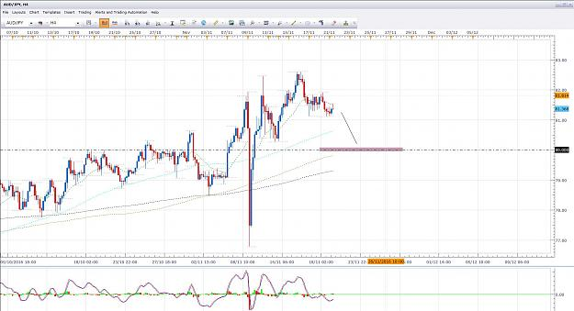
- Nov 22, 2016 7:36am
- JonnyPip
- Joined Nov 2012 | Status: Member | 338 Posts
Potential Opportunity EurGbp
Rhythm changed on the GBP pairs yesterday so only had the NzdJpy pair to get involved in with out of all set ups posted.
Had to be patient, but now we are seeing some nice rhythm the opposite way with the GBP (strength)
Here's one on the EurGbp
Rhythm - TC from 21ema to round level
Attached Image (click to enlarge)
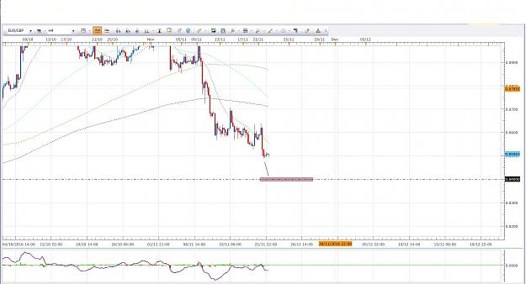

- Post 29,963
- Cleanup
- Quote
- Nov 22, 2016 9:12am
- JonnyPip
- Joined Nov 2012 | Status: Member | 338 Posts
Potential Opportunity GbpUsd
Break 21ema/89sma, pullback, move to round number
Attached Image (click to enlarge)
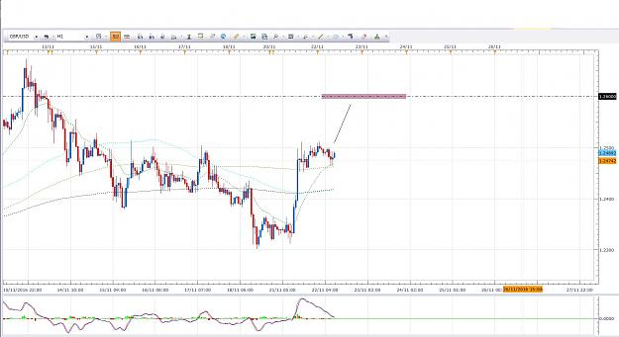
- Nov 30, 2016 8:03am
- JonnyPip
- Joined Nov 2012 | Status: Member | 338 Posts
EurJpy Potential Opportunity
Break above 21ema, pullback, move to round levels
Draghi speaking at 12pm so may want to wait for after
Attached Image (click to enlarge)
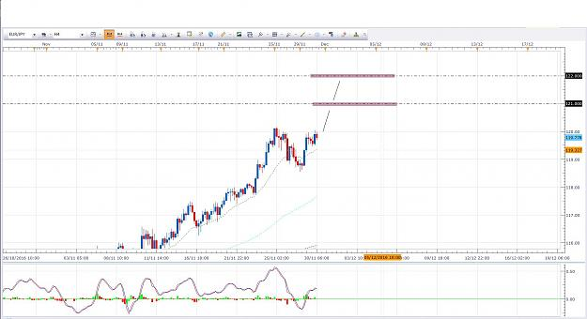

- Post 29,966
- Cleanup
- Quote
- Dec 11, 2016 8:21pm
- JonnyPip
- Joined Nov 2012 | Status: Member | 338 Posts
Hey all,
Hope everyone is well.
Lots of potential opportunities this week, here some that I see. I have attached both 1h and 4h charts to show the technique of combining multiple time frames, especially the 1h/4h.
EurJpy -
4h - Break 21ema, pullback, move to 89
1h - Break 89sma, pullback, move to 365ema (black box shows we may pullback further to 89sma before move lower)
Target - 89sma in 4h is initial target, but a break and pull back could see moves down to 200sma
Happy trading
Attached Images (click to enlarge)
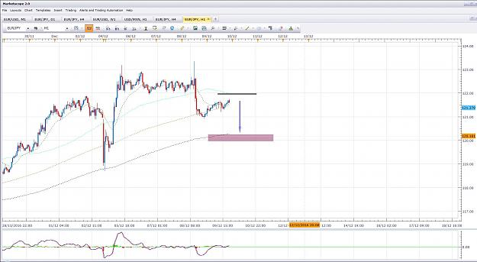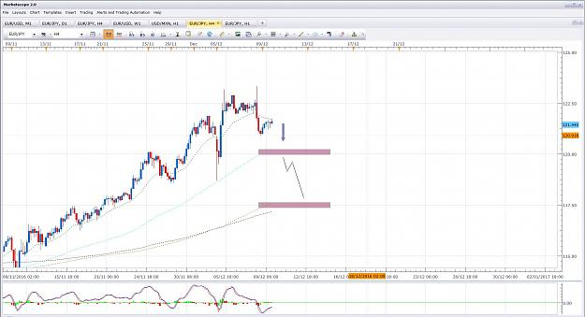

- Post 29,967
- Cleanup
- Quote
- Dec 11, 2016 8:37pm
- JonnyPip
- Joined Nov 2012 | Status: Member | 338 Posts
ChfJpy - Potential Opportunity
Price broke below the 21ema in the 4h and broke back above it.
I am looking for a pullback to the 4h 21ema and potential moves higher to the round levels.
Rhythm -
4h - Break above 21ema, pulback, move to round number
1h - Break above 21ema and 89sma, pullback, move to round number
Target - 114.00 / 114.50 levels
In the 1h chart you can see price has broken above the 21ema and the 89sma which suggests higher moves from here.
Attached Images (click to enlarge)
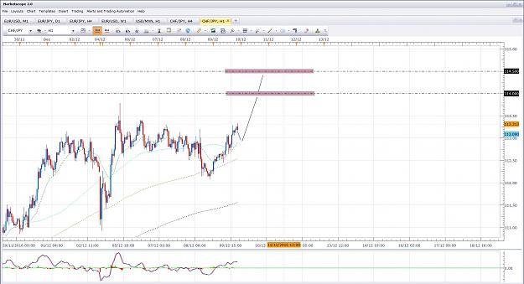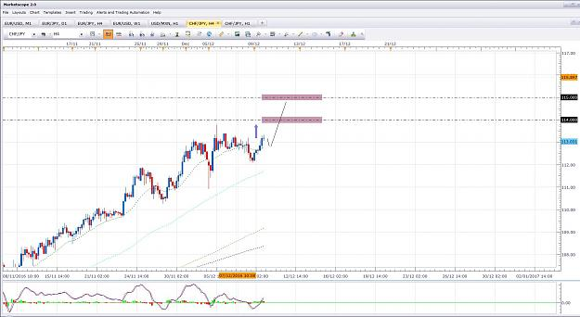

- Post 29,968
- Cleanup
- Quote
- Dec 11, 2016 9:02pm
- JonnyPip
- Joined Nov 2012 | Status: Member | 338 Posts
GBPNZD Potential opportunity
The GBPNZD has broken below the 21ema and the 89sma in the 4h and sits between the 200/365 ma's
Price has pulled back to the 21ema suggestion the higher probability is a move down towards the 200ma and the round level it sits at.
It the 1h price has broken below all moving averages and is completing a break 21ema, pullback move to 89 sma set up. I expect this to complete at the 89sma and head further south towards the 240 target.
More cautious approach would be to look for a break below the 21ema in the 1h, pullback and move away. However the trend line can give confidence to take the trade from a "turn away" of the 89sma (which is what I will be looking for)
Rhythm -
4h - Break 21/89/365 ma's, move to 200ma/round level
1h - Completion of break 21ema move to 89sma (expecting the 89sma to "turn price away")
Target
200ma in 4h + 1.7400 round level
These are just a couple of potential opportunities this week that I am looking out for.
IMPORTANT - This week is a week of 3 rate decisions in the USD, CHF and GBP which start from Wednesday night onward. These can cause a lot of volatility so you must consider these. Any trade set ups can be blown away by these so it is something to keep in mind. Please also remember these are based on probability, nothing is 100% in forex.
Happy Trading
Attached Images (click to enlarge)
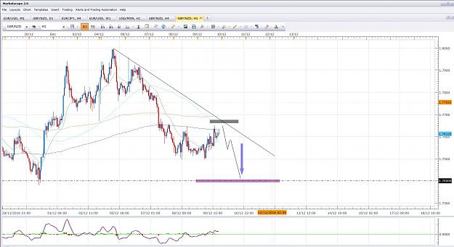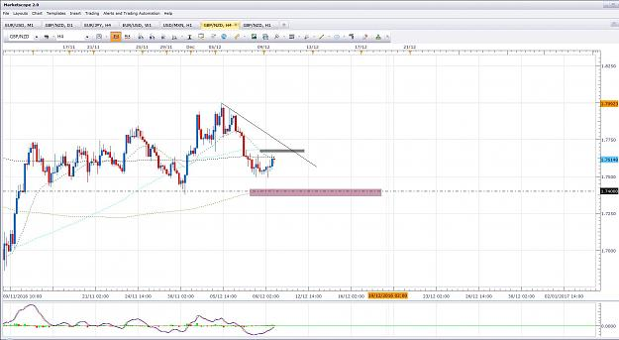

- Post 29,969
- Cleanup
- Quote
- Dec 12, 2016 8:51am
- JonnyPip
- Joined Nov 2012 | Status: Member | 338 Posts
GBPCHF Potential Opportunity
Price has broken the 21ema in the 4h and pulled back (it is currently above it) - Rules suggest higher probability is for a further move down to the 89sma
Rhythm -
4h - Break 21ema, pullback, move to 89sma
1h - Bounce on trend line or break below 21/89/200 ma's, pullback, move to 365 and round level (or both entries can be taken)
Target - 1.26500 level
Thursday has CHF and GBP rate decisions, best outcome would be a completion of move before Thursday as this pair will likely be very volatile on Thursday
Happy Trading
Attached Images (click to enlarge)
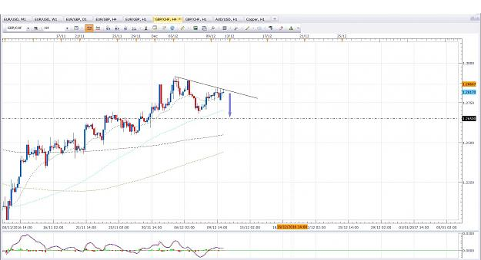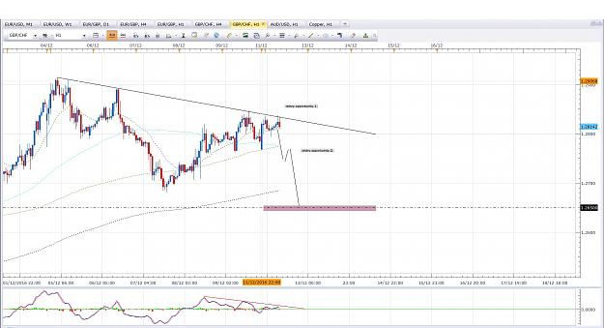

- Post 29,970
- Cleanup
- Quote
- Dec 12, 2016 10:00am
- JonnyPip
- Joined Nov 2012 | Status: Member | 338 Posts
ChfJpy Update
First target has been reached, this could give a pullback to the 21ema which would set up for potential moves higher to the 115.000 level (as mentioned in previous post).
Looking out for a TC from the 21ema.
I expect it to also possibly reach the 115.500 level if it gets into that area however I will see how price reacts at the 115.000 and keep in mind CHF rate decision on Thursday.
Attached Images (click to enlarge)
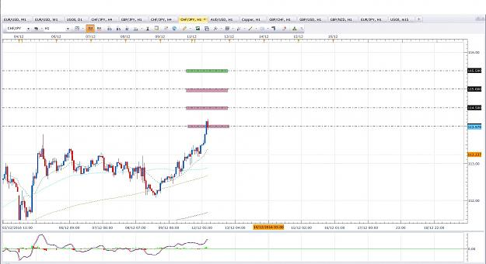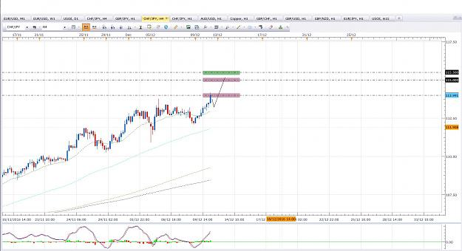

- Post 29,971
- Cleanup
- Quote
- Dec 13, 2016 11:30am
- JonnyPip
- Joined Nov 2012 | Status: Member | 338 Posts
GBPCHF Update
Price gave a nice signal candle from the trend line but failed to break below the candle. For those who read my posts normally you know I will look for the candle high/low to be broken as a way of filtering out bad trades.
Price broke above the trend line instead and has now given a nice TC from the 21ema.
I am looking for the 1.3000 level
It is good to have a plan and anticipate the market, but always be prepared to react to what the market does.
Hope this helps (patience is important)
Happy Trading
Attached Image (click to enlarge)
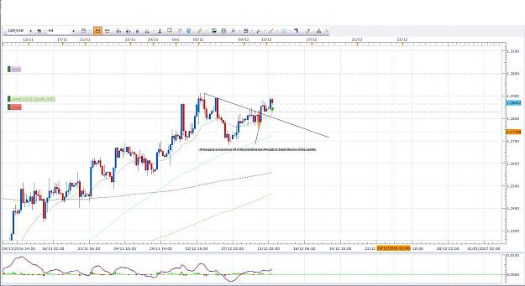

- Post 29,972
- Cleanup
- Quote
- Dec 13, 2016 11:54am
- JonnyPip
- Joined Nov 2012 | Status: Member | 338 Posts
USDJPY Potential opportunity
Price has given a nice break and pullback of the 21ema in the 1h.
This is a counter trend trade in the 4h so one must keep that in mind.
If a good entry appears I will be looking for a move down to the 200sma, keeping an eye on the 89sma on the way down.
Attached Image (click to enlarge)


