- Sep 3, 2015 1:56pm
-  JonnyPip
- Joined Nov 2012 | Status: Member | 338 Posts
Quoting nic73
NZDUSD, please comment on this pair. Is it going to move or is it going to stall? Should I wait for it to breach the bottom (dashed) TL to enter? And please see analysis within chart attached. Thanks for your time. {image}
Hi Nic,
This is my view on this pair at the moment.
I am currently sitting it out as it is in a tight range, going long here would be fighting the trend and going short could be risky as it is near a resistance area.
We have non farm payrolls tomorrow as well so I am not expecting any real moves before then.
My view is biased to the non-farm tomorrow pushing this further down, but for me I am just going to wait for the market to show its hand first. If it breaks higher, the overall bias is still down so I will view it as an opportunity to sell at a better price. We may also get a nice 4hmacd set up to capture some pips on the way up IF the NZDUSD pair break higher.
I have marked the three circles where I anticipate possible scenarios and their entries which are ringed with black. The highest one is a stop and reverse as the long term bias is down. I have also put in what macd signals we could expect and also what the market rhythm would be.
Now it is just a case of waiting to see if the set ups occur

Attached Image (click to enlarge)
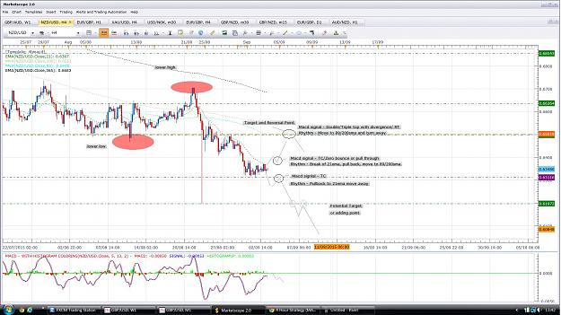

- Sep 7, 2015 1:40pm
- JonnyPip
- Joined Nov 2012 | Status: Member | 338 Posts
Potential set up on GbpUsd
Price has broken the 21ema (just), but the large candle suggests big buying/offloading of profits which means most likely rhythm is break of 21ema, pullback, move to 89.
I will be looking to enter on a pullback as the higher probability in my opinion is as mentioned, rather than another leg down from the 21ema
A sell off in the USD index also adds some confirmation to this.
Lets see how it plays out, could be nice
Attached Image (click to enlarge)
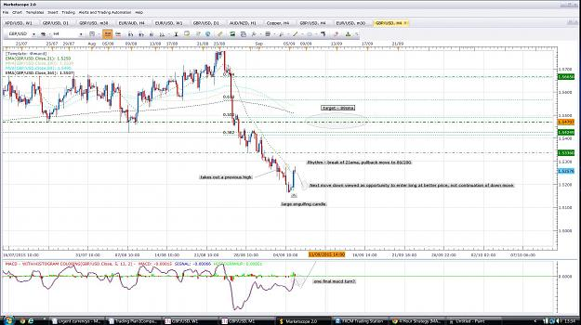

- Post 29,097
- Cleanup
- Quote
- Sep 7, 2015 4:54pm
- JonnyPip
- Joined Nov 2012 | Status: Member | 338 Posts
GBPCAD
Possible 21ema, pullback, move to 89 sma set up
I am already long, so will be looking to add to position, could be a good chance to establish new short term longs to 89 SMA
Looks like it could time itself with the pullback trade mention earlier in GBPUSD
Attached Image (click to enlarge)
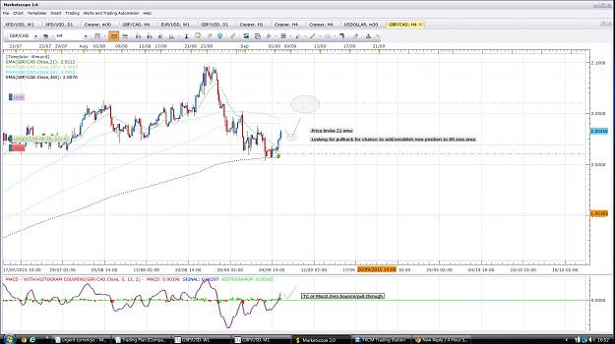
- Sep 8, 2015 7:07am
- JonnyPip
- Joined Nov 2012 | Status: Member | 338 Posts
AusNzd
Price has reached a resistance point where it has bounced a few times in the past
Price gave double top but with higher high, now waiting for a lower high to take the trade
Attached Image (click to enlarge)
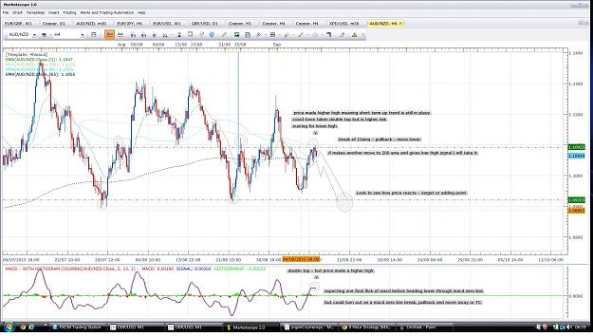

- Post 29,100
- Cleanup
- Quote
- Sep 8, 2015 7:40am
- JonnyPip
- Joined Nov 2012 | Status: Member | 338 Posts
Quoting nic73
EURJPY How would you trade this pair. Looks like it has the potential to move down (south). Price is pulling back to 21ema, and the pull back is not complete yet. But tend to reject the 21ema many times now. If you look at the history of this pair (where the 2 arrows and areas 1 and 2 are), price stalled and when it started to move downwards, it did so very quickly, forming a large candle and there is no chance to take the trade. Is there a possible way to take such trade? {image}
Hi Nic,
Looking at the EurJpy - the buying we have seen coming in seems very strong, too strong I suspect for this to just be a normal retracement. Counter trend moves are usually slow and choppy as they are fighting the trend. If you see a move like this (which is more or less as straight a line of price movement as you could get on my chart) you have to thinking that this is the start of a move up, even if it is just the start or a bigger correction on a higher chart.
So with that in mind, I will be looking for a pullback and move higher.
The trade set up would be:
Rhtyhm - break of 21ema, pullback, move to 89/200sma
Macd - Break of Macd higher with Zero Bounce or TC
P.s Regards to the EurJpy, it is possible to take those trades - I did in fact take it myself down to the 133.42 level which was a very nice trade. I also took the EurGbp before the same move in that pair which I am still in and holding/monitoring. The drop in Eur was down to "bad news" or rather negative statements from Eurozone officials.
I will put up a new chart to show you how I took it
- Sep 8, 2015 10:08am
- JonnyPip
- Joined Nov 2012 | Status: Member | 338 Posts
Quoting nic73
{quote} Hi Jonny, Quoting from your reply "If you see a move like this (which is more or less as straight a line of price movement as you could get on my chart) you have to thinking that this is the start of a move up.... " I'm afraid I don't understand this bit here. Can you please explain? Thanks. Yes please send me you chart pn the ove down to 133.42 Thank you.
Hi Nic,
Hopefully the charts below as a bit of a step by step will give you a better idea of how I view it.
Chart 1 - Analyzing your support and resistance.
Chart 2 - Entry
Chart 3 - Profit
Chart 4 - Post trade expectations
Hope this helps
Attached Images (click to enlarge)
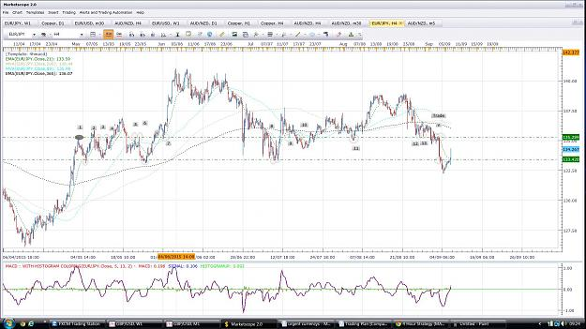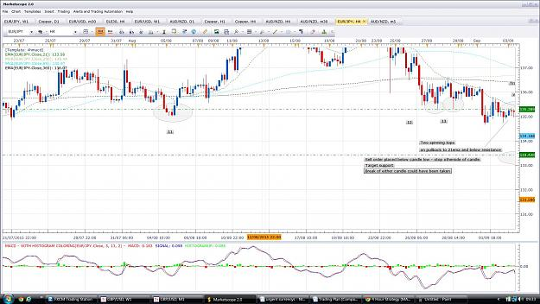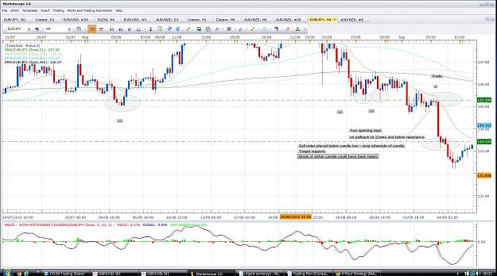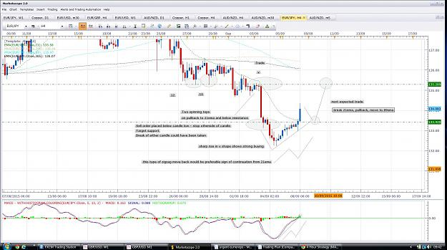

- Post 29,103
- Cleanup
- Quote
- Sep 8, 2015 10:21am
- JonnyPip
- Joined Nov 2012 | Status: Member | 338 Posts
Quoting nic73
{quote} Hi Jonny, Quoting from your reply "If you see a move like this (which is more or less as straight a line of price movement as you could get on my chart) you have to thinking that this is the start of a move up.... " I'm afraid I don't understand this bit here. Can you please explain? Thanks. Yes please send me you chart pn the ove down to 133.42 Thank you.
EurGbp trade
Please note it did break the rules slightly as rules state profit at 21ema. This would have still been a good trade to 21ema but with large analysis it was worth holding
Holding past the 21ema can be risky though if it is not in line with macro moves.
Price is now reaching a point to consider taking profit or adding to position
Attached Image (click to enlarge)
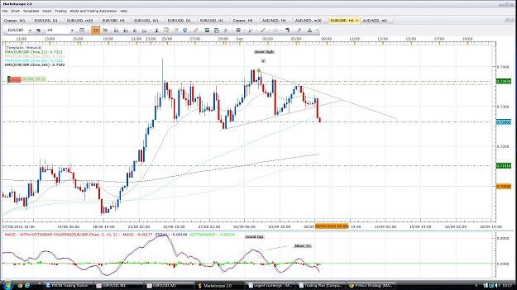
- Sep 10, 2015 4:04pm
- JonnyPip
- Joined Nov 2012 | Status: Member | 338 Posts
Quoting nic73
Hi can someone tell me what these candlestick patterns are? Thanks. {image}
Hi Nic,
This is how I see the UsdCad. It has been in this wedge shape range but it is coming towards the end of the pattern now, might not break out until Usd interest rate decision next week but who knows.
As it stands this thing should be heading higher to the 1.4 area in my opinion, so for me it is about positioning for the breakout.
When price is crossing the MA's like this is means it is ranging, so it is a good time to add your trend lines.
It has just made it's third touch of the longer trend line and a nice pin candle showing good buying coming into the market at that point. It has also broken 21ema, pulled back and moved away with a TC pattern. I have put the stop loss outside of the trend line however to give it room to work.
I see this as a good set up and have taken the trade anticipating the break out. I am not interested in taking short profits here, my target is 1.4 which is 740 pips to the upside with plenty of chances to add. If this position gets stopped out, so be it, I will look to re-establish a long position anywhere above that 1.2950/1.30 area.
Hope this helps
Attached Image (click to enlarge)
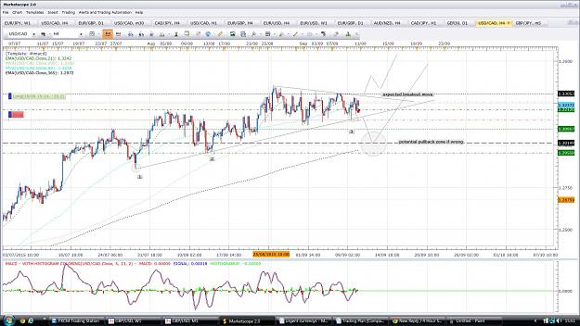

- Post 29,108
- Cleanup
- Quote
- Sep 11, 2015 10:24am
- JonnyPip
- Joined Nov 2012 | Status: Member | 338 Posts
EurCad
Closed long position (21 ema - 89sma) for almost 150 pips. Now entering short (89sma - 200/365/trendline *maybe further*)
Will be looking to see how it reacts to that trend line and the 1.4740 area.
It may push higher however before it comes lower but I think it is heading south for the next couple of weeks at least
Attached Image (click to enlarge)
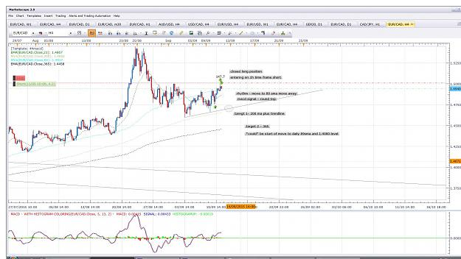
- Sep 14, 2015 8:57am
- JonnyPip
- Joined Nov 2012 | Status: Member | 338 Posts
GbpAud
Break of 89ma- pullback-move to 200
I am already in from 1h time frame so will have to watch closely how this candle closes in the 4h
Looks like a nice 4h macd set up though
Attached Image (click to enlarge)
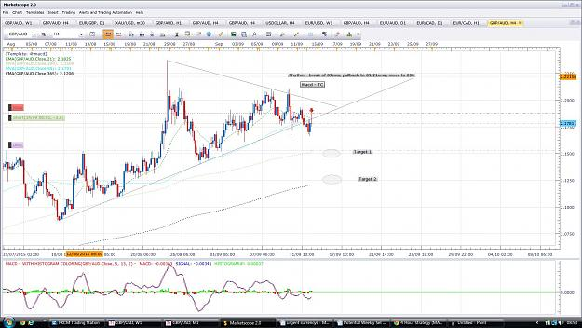
- Sep 14, 2015 10:52am
- JonnyPip
- Joined Nov 2012 | Status: Member | 338 Posts
Quoting nic73
{quote} I have a question about selling this pair - MACD is approaching 0.45 level on 4hr time frame. Have you considered that? And the last two candle before your entry, it seems that rice stop at about the same level and could not go further south. I have a trend line (s&r) at that level. Just my humble opinion.
Hi Nic,
I think you mean the daily one, certainly there is a chance this could hold price. There are 2 targets as per macd rules but if you have a look at the last picture I actually put a limit in order in at the first one to close the trade. This is because below there is strong support there so 365 might be a little ambitious. This pair is also still in an uptrend so I will be looking to buy around the 200 ma if possible.
There is some evidence here that it should move down at least a little further as it has made lower highs and lower lows so it is being pushed down by traders.
I will monitor it around that trend line but I think it will reach 200 ma. Ultimately this is a counter trend trade.
Regards the 0.45 level on the macd - it can be useful as a guide line but I don't get hung up on the macd levels to be honest because they are more just additional evidence rather than a *reason* to trade a trade in my opinion. As you can in the picture it smashed through the -0.45 levels a few times in the recent past anyway.
Attached Image (click to enlarge)
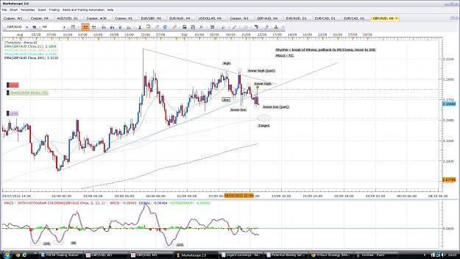
- Sep 22, 2015 9:42am
- JonnyPip
- Joined Nov 2012 | Status: Member | 338 Posts
AusNzd
Set up of break 21 ema, pullback move to 89sma seems to be setting up.
Already short but could still give good r:r after 4h candle
Attached Image (click to enlarge)
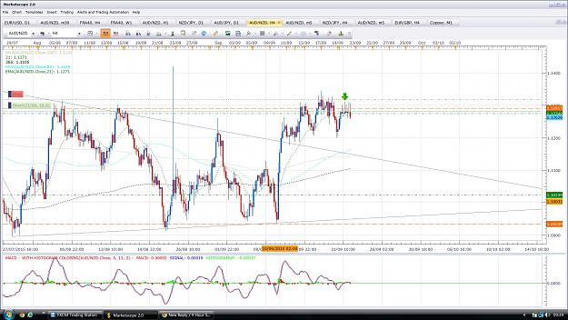
- Sep 24, 2015 9:38am
- JonnyPip
- Joined Nov 2012 | Status: Member | 338 Posts
Quoting nic73
AUDNZD taken on 22 September Moving from 21ema to 89sma, another counter trend trade. target profit almost reached. Hope you understand the chart. Quite a bit of info in there.{image}
Hi Nic,
It was a nice one huh?
H&S target has just been reached but looking at the larger time frames this might have some more legs in it.
Will have to keep an eye on it.
Attached Image (click to enlarge)
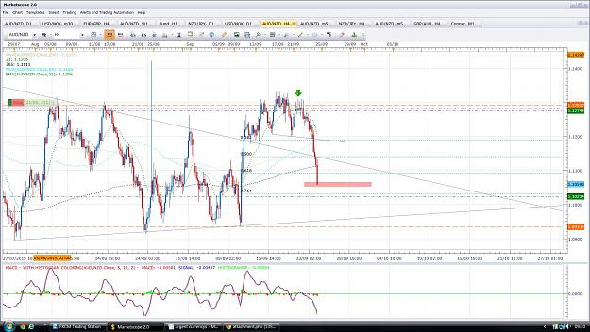
- Nov 6, 2015 12:00pm
- JonnyPip
- Joined Nov 2012 | Status: Member | 338 Posts
Hi Guys,
Hope all is well
Thought I would drop a chart in as haven't been on the forum in a while.
NzdUsd looks like a good set up here in 1h time frame.
Gives a nice 1-4 R:R
Overall trend is down so is a larger counter trend move - Break of 21ema, pullback, move to 200ma is the rhythm.
Only caveat is Non-farm pay rolls which could blow this further down and take out the stop but from what I can see the market seems set for poor USD data and even if I am wrong the 1:4 R:R makes it a worthwhile risk in my opinion
Attached Image (click to enlarge)
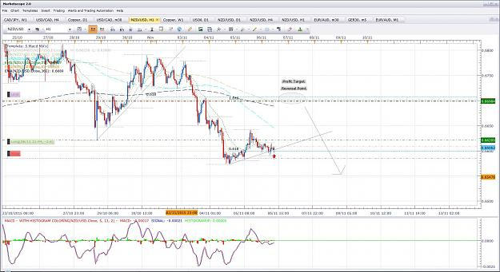

- Post 29,171
- Cleanup
- Quote
- Nov 6, 2015 1:59pm
- JonnyPip
- Joined Nov 2012 | Status: Member | 338 Posts
Yikes!
Was a great set up, everything was there, unfortunately non farms blew it out as highlighted was a risk.


- Nov 20, 2015 10:10am
- JonnyPip
- Joined Nov 2012 | Status: Member | 338 Posts
Hi Nausting,
Great charts very interesting to read and very detailed. It's great you put so much time into them. I haven't really had the time recently to put them up but I saw your USDJPY post and found it interesting and similar to my chart projections.
I personally didn't take the long trade due to the "railroad" candlestick pattern off the 21ema in the 1h which made for a strong selling signal, but I also thought it may go higher first before moving down, so I'm on the sidelines looking to short from higher.
There was also a bearish engulfing day yesterday in the JPY suggesting further declines.
Here's what I have and where I think this could be good to get short, just as you said in your post, I also have the 122 as roughly the target point.
Rhythm is break of 89, pullback move to 365 (or further).
Anyway lets see how it plays out and if we get a chance to jump on!
Happy Trading
Attached Image (click to enlarge)
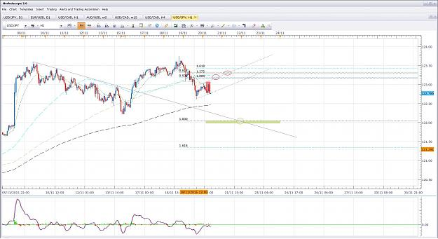

- Post 29,196
- Cleanup
- Quote
- Nov 20, 2015 11:01am
- JonnyPip
- Joined Nov 2012 | Status: Member | 338 Posts
Looks like this could be the 1h candle which gives the bounce, still to risky for me though
Attached Image (click to enlarge)
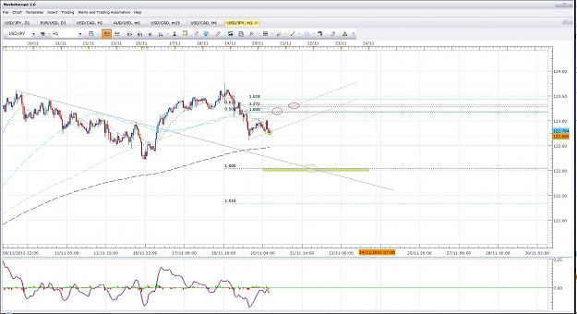
- Nov 25, 2015 4:44pm
- JonnyPip
- Joined Nov 2012 | Status: Member | 338 Posts
Hey Everyone,
Hope everyone one is well, hope you caught the USDJPY move as well as it played out nicely in the end
Nice set up looks to be forming on the USDCAD so I thought I would share.
I am already short on smaller time frame, but even with an entry in the 4h it should give a nice R:R.
One thing to watch out for however is how this 4h candle closes, if we get a lot of buying coming in and it closes up near the open it will be worth reviewing the position.
Hopefully we get a nice full bodied bear candle on the close.
Happy Trading
Attached Image (click to enlarge)
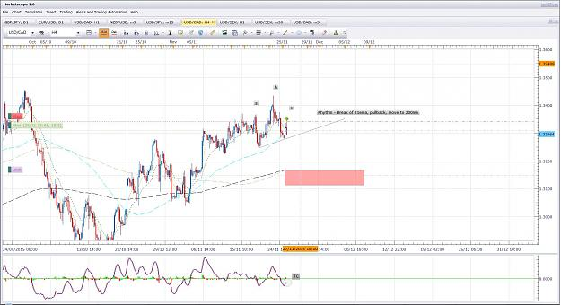
- Apr 17, 2016 8:52pm
- JonnyPip
- Joined Nov 2012 | Status: Member | 338 Posts
Hi Nausting,
Glad to see you still posting, doesn't look like anyone else is these days! Good work keeping the thread going.
As I trade full time and understand this system I will try and post some trade opportunities as I see them and perhaps we can get some more activity back on the thread! It's a great thread.
We can also bounce some ideas off of each other, I see some good potential opportunities this week, here's one of them on the USDCHF, I'd be glad to hear what anyone thinks of any opportunities coming up this week
Lets see how it plays out
Attached Image (click to enlarge)
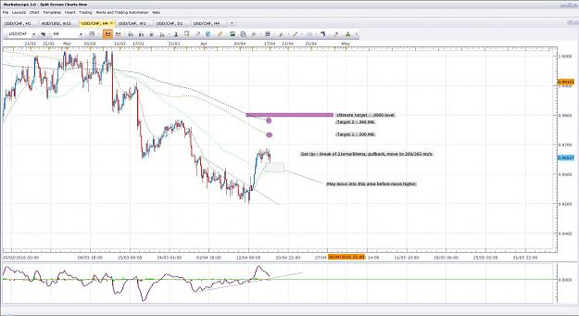
- Apr 18, 2016 9:31am
- JonnyPip
- Joined Nov 2012 | Status: Member | 338 Posts
Quoting naustingfx
{quote} Good morning brother! Wishing you a successful week. Thanks for you kind words. Thank you also for your great chart and analysis. That behavior of price you have exposed in your chart and anticipation with respect to profit targets are very good places to make pips...glad for your companionship. It is well! keep in touch. God bless.
Thanks Nausting,
I always have my trades anticipated in advance, I think many new traders unfortunately open the charts and look for a trade straight away just want to trade, trade and trade some more more. I know this because I did it my self once and then you learn to trade for money, not to trade for the sake of trading.
I'm hoping that by putting up some charts in advance it will give some new traders the opportunity to start anticipating trades as they should be, not just jumping in.
There is a lot of junk on forex factory and what many people don't realise is that this "system" is probably one of the best attempts to lay out how many professional traders actually trade (I don't think many people realise Philip Nel was clearly a pro stock trader before he started this thread!). They don't necessarily use the same indicators, most don't need indicators at all, but they would be trading in a similar way (not exactly as there are a lot of other techniques not included in this thread). It's designed to be easy for new traders to grasp and make money.
I have attached a UsdJpy chart of a trade I took this morning, I couldn't get it up beforehand but it is in its early stages. This trade has to be managed though as it is counter trend and may reverse without going to the final target. As Phil says, "hope is not a strategy", if a trade reverses, you should get out and reverse with it.
Attached Images (click to enlarge)
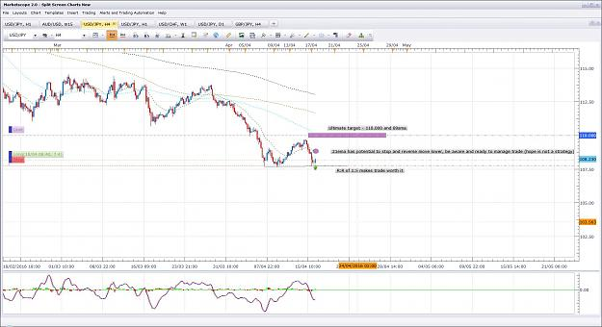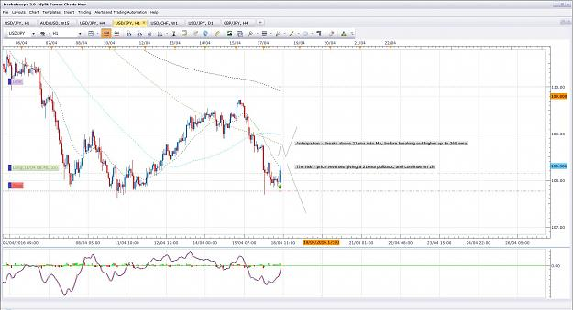

- Post 29,266
- Cleanup
- Quote
- Apr 18, 2016 10:34am
- JonnyPip
- Joined Nov 2012 | Status: Member | 338 Posts
Nice potential Set up on the EurUsd
Lets see how it plays out
Attached Image (click to enlarge)
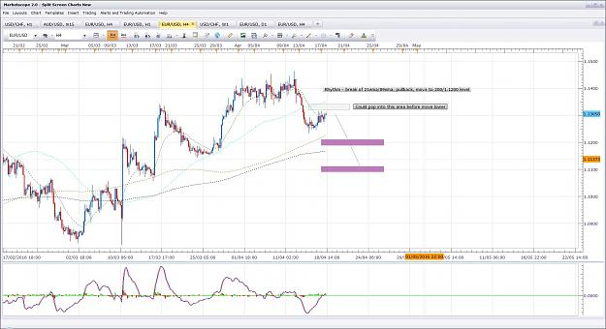

- Post 29,267
- Cleanup
- Quote
- Apr 18, 2016 4:44pm
- JonnyPip
- Joined Nov 2012 | Status: Member | 338 Posts
EurUsd and UsdChf trades didn't materialise today however quite a few others did, I am looking to add to this GbpJpy trade, looks like a nice opportunity could present itself for anyone not already involved.
4h - Break of 21ema, pullback, move to 89sma
1h - break of 89sma, pullback, move to 365ema
There is a target 2 higher up in the 4h (200sma) but be aware 89sma is all it could do if it pullsback/goes
Attached Images (click to enlarge)
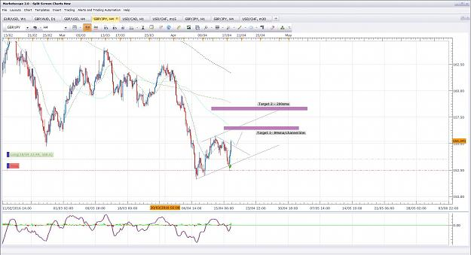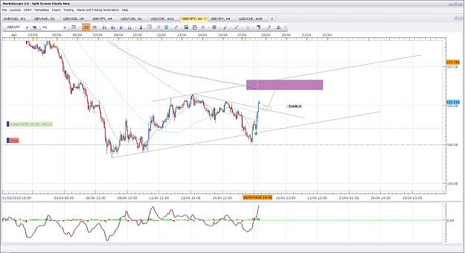

- Post 29,268
- Cleanup
- Quote
- Apr 19, 2016 8:35am
- JonnyPip
- Joined Nov 2012 | Status: Member | 338 Posts
GbpJpy - Update
Trade 2 went without me, closed for +229 at 89sma. Hopefully a few people might have caught it.
Price could be setting up for a counter trend trade back to 21ema in 4h, although it has the potential to break higher
Attached Images (click to enlarge)
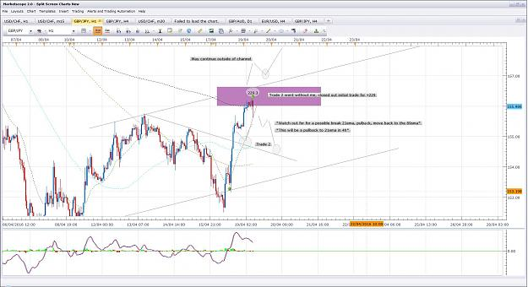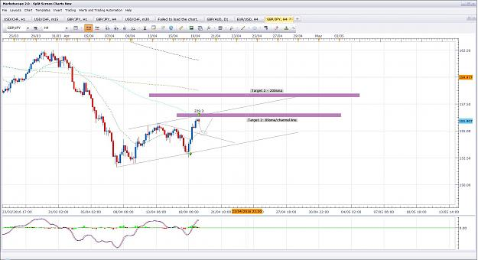

- Post 29,269
- Cleanup
- Quote
- Apr 19, 2016 8:46am
- JonnyPip
- Joined Nov 2012 | Status: Member | 338 Posts
Potential second entry opportunity on GbpChf
Rhythm, pullback to 21ema in 1h, move to target (200 sma in 4h)
Attached Images (click to enlarge)
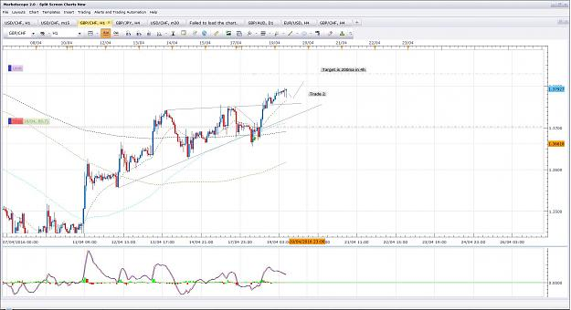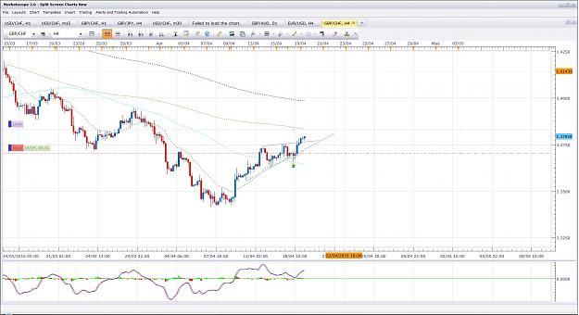
- Apr 19, 2016 10:43am
- JonnyPip
- Joined Nov 2012 | Status: Member | 338 Posts
Quoting naustingfx
{quote} Great! What you said is a reality! It is just the fact...I hope not only the new ones, but those who are as well still struggling with this business comes across your this post, read and digest it properly...thanks for the great insight. WOW! You have as well spotted great trading scenarios from all your many charts and analysis...and I think the way you are doing it is an excellent way to go. The problem or challenge I had from your post is that you tempted me to jump around multiple pairs...your charts and analysis were very interesting,...
Thanks for your kind words and detailed posts
It is a good potential opportunity on the AudUsd for a counter trend, I have added a 15 min chart to show what will get me in.
It is a bit late for me, if it goes without me, so be it
You are right, for newer traders there can be a benefit to studying and sticking with a few currencies. I have have done many studies across the various currencies so I have a good feeling of their "personalities". The only risk is when currencies are limited, there is a tendencies to jump into trades or search them out due to impatience. That is where discipline needs to be built with limited currencies in my opinion. But you are right, limiting currencies to begin with can be a sensible choice.
Attached Image (click to enlarge)
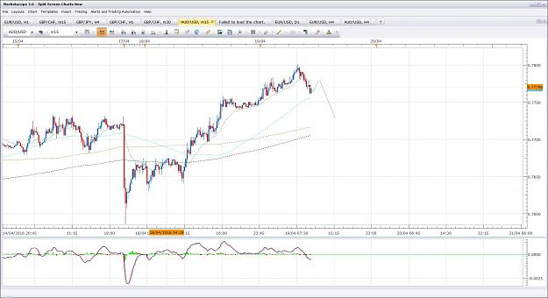

- Post 29,273
- Cleanup
- Quote
- Apr 19, 2016 11:18am
- JonnyPip
- Joined Nov 2012 | Status: Member | 338 Posts
GbpChf Update
Closed out for a total of +204 pips
I have added the 15m chart as well to show how if you know where you are going, enter a trade (trade 2) and the price moves against you, most time it is just giving you a chance to make more money! That is why I added a third position, even though trade 2 was in a loss.
Hope this is helpful
Attached Images (click to enlarge)
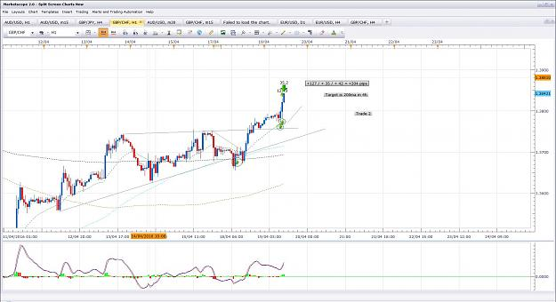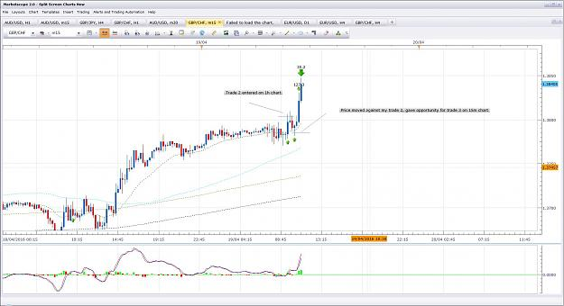
- Apr 19, 2016 3:51pm
- JonnyPip
- Joined Nov 2012 | Status: Member | 338 Posts
Quoting naustingfx
{quote} ...well said! You know I have been trading for years now, and my perspective of discipline is unique and based upon the many teachings Phillip had given in this thread. Initially I was having problem with my trading, then I decided to de-clutter (removing certain things that seem to make my trading complex). And reducing the currencies that I trade to just few pairs is part of it...VERY IMPORTANT TO NOTE IS THAT I HAVE A MONTHLY TARGET TO MAKE IN FOREX AND THE FEW CURRENCIES I AM FOCUSED ON GIVES ME THAT...AND THAT IS WHY LOGGING...
I admire your discipline, many people cannot help but to jump in and also cannot bear missing out on a trade. These two things alone are capable of destroying even technically good traders. Discipline is key but takes time and patience to acquire.
I don't know if you trade EurGbp, but I have attached a chart of a potential opportunity I see. The 4h rhythm is so simple if people will just keep it is as such and accept it is not an exact science. So if it doesn't fit as you see it once or twice, one can loose confidence because trading inexperience means the brain is desperate to have a system which never fails and tells you exactly what to do and when to do it. Once you realise that you can be right to take a trade and lose money, and wrong to take a trade and make money, you realise profit or loss on a trade IS NOT what determines whether it was right or wrong to execute, but whether or not you stuck to your rules and plan.
Hopefully also it will help anyone thinking "is this system still working?". Just the trades I posted which have closed out were +430 pips since yesterday and the ones that haven't closed are up nearly +200 pips. Plus I have other trades open which I haven't posted which are up a nice amount. If you do the work and have persistence you will learn and make $$$$
Target 1 reached on the EurGbp - may see a bounce here, hopefully will give an opportunity to enter again down to Target 2 at 365ema
Attached Image (click to enlarge)
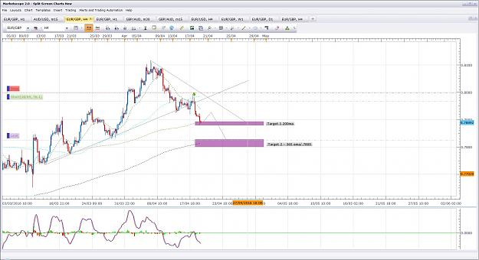

- Post 29,276
- Cleanup
- Quote
- Apr 19, 2016 4:48pm
- JonnyPip
- Joined Nov 2012 | Status: Member | 338 Posts
GbpAud Counter Trend Potential Opportunity
Counter trend trades (of major trend in this case) are the most risky as there is always the risk of a break out. If that happens I will go with the chart, but 1:3 R:R makes it well worth it for me
Attached Images (click to enlarge)
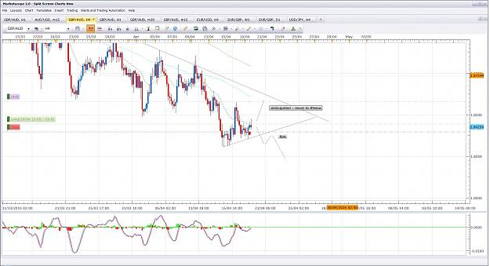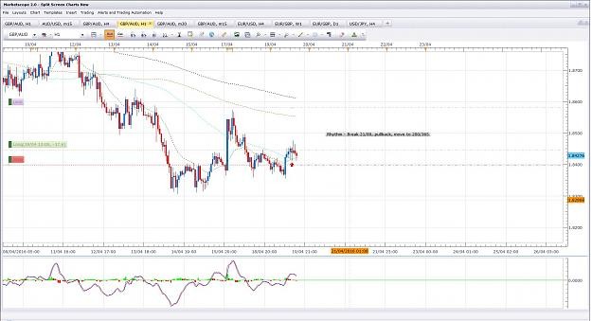

- Post 29,277
- Cleanup
- Quote
- Apr 19, 2016 5:15pm
- JonnyPip
- Joined Nov 2012 | Status: Member | 338 Posts
Quoting naustingfx
Late Entry I have taken the trade as indicated above...I was not on my computer on time, but for me the move is very nice and is still on. So I decided to take it on. {image}
Hey Nausting, my friend
Looks like your counter trade move could be ready, lets see if it goes this time
Attached Image (click to enlarge)
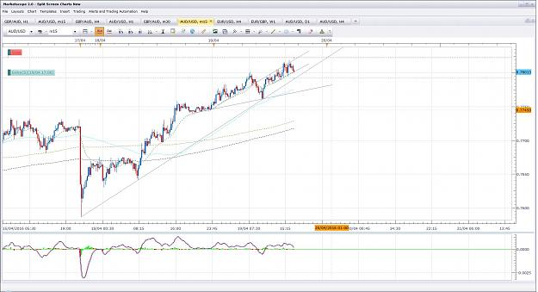
- Apr 20, 2016 10:53am
- JonnyPip
- Joined Nov 2012 | Status: Member | 338 Posts
Quoting naustingfx
{quote} Update on performance. {image}
Hey nice trade buddy,
I took a very similar position last night, I gave it a bit more room to breath and adjusted my stop slightly and this morning it was in profit. I was waiting to see if we would get a bigger retracement but I say this morning it was going to continue higher so closed out for around 6 pips (no issue) lost and took a long position, up around 20 pips currently. You have to be nimble with the counter trends, as Phil said "hope is not a strategy". This is so important to keeping your losses minimal.
It might only get to around the .7850 from here so it is something to watch.
Attached Image (click to enlarge)
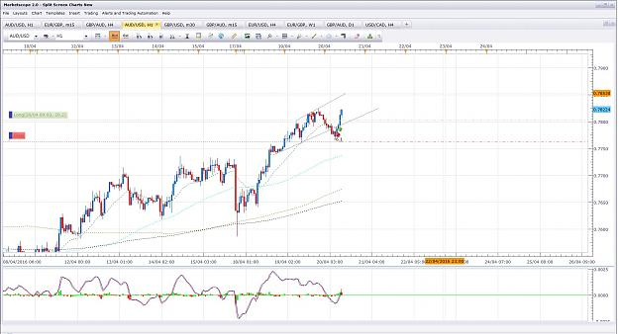

- Post 29,282
- Cleanup
- Quote
- Apr 20, 2016 11:04am
- JonnyPip
- Joined Nov 2012 | Status: Member | 338 Posts
Gbp Chf Potential Opportunity
Pullback 21ema, continue to round number
Attached Image (click to enlarge)
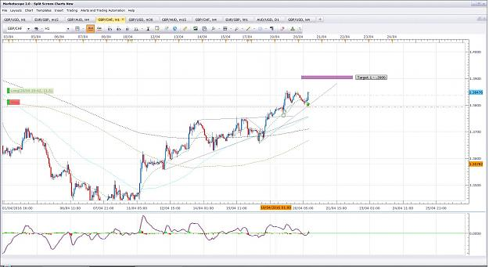

- Post 29,283
- Cleanup
- Quote
- Apr 20, 2016 11:09am
- JonnyPip
- Joined Nov 2012 | Status: Member | 338 Posts
Chart from earlier in the week, potential chance to add to UsdJpy
Break of 89sma, pullback, move to 365ema/110 round number
*note the labels on the chart are from earlier in the week not now, the risk of 21ema bounce has passed and the anticipated move has played out*
Attached Image (click to enlarge)
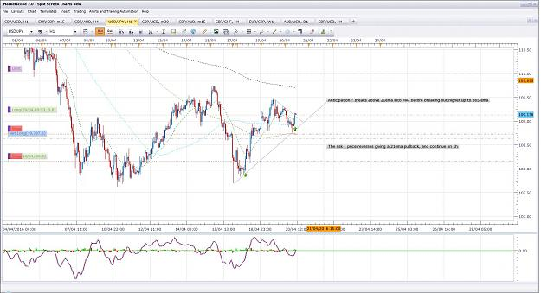

- Post 29,284
- Cleanup
- Quote
- Apr 20, 2016 11:15am
- JonnyPip
- Joined Nov 2012 | Status: Member | 338 Posts
GbpJpy potential chance to re-enter
This is another chart from the start of the week, I would have like to have still been in and adding but I was stopped out for +229 pips before it continued.
This could be another opportunity to ride it up to target 2 - the 200sma
Attached Image (click to enlarge)
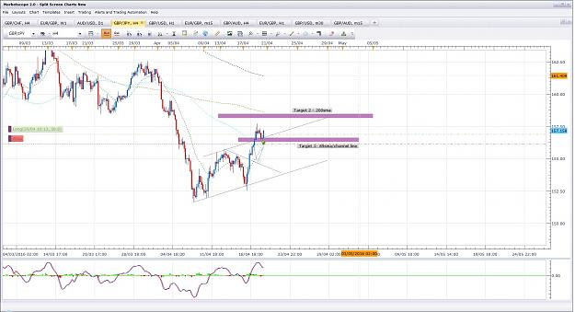

- Post 29,285
- Cleanup
- Quote
- Apr 20, 2016 11:20am
- JonnyPip
- Joined Nov 2012 | Status: Member | 338 Posts
Same with EurJpy, looks like a potential opportunity to the 125.00 level/200ma.
Rhythm, pullback to 21ema, continuation (TC)
Hope these are helping people to see the market rhythm and how it can be traded.
Attached Image (click to enlarge)
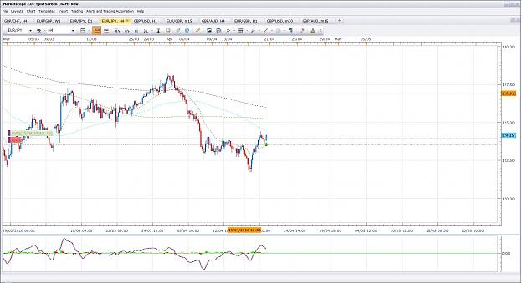

- Post 29,286
- Cleanup
- Quote
- Apr 20, 2016 11:28am
- JonnyPip
- Joined Nov 2012 | Status: Member | 338 Posts
UsdCad
Pullback to 21ema, continuation to 1.260 in 1h
*Note the oil inventories are today and Canadian governor Poloz is speaking later as well - has to be watched, I may prefer to tp at 1.2600 or before rather than ride the news*
Attached Image (click to enlarge)
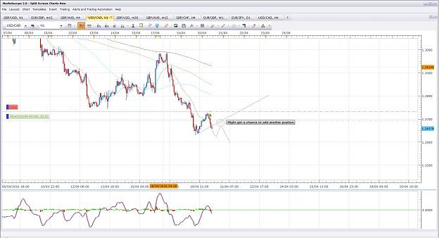

- Post 29,287
- Cleanup
- Quote
- Apr 20, 2016 11:48am
- JonnyPip
- Joined Nov 2012 | Status: Member | 338 Posts
Be aware
When you see this on the usdindex, it could be a sign trades like the USDCAD short, AudUsd long could fail and you could take small losses or decide to manage or cut trades accordingly. To avoid this process becoming emotion based see what the cnadles tell you on their close, not before hand just to save some pips.
This happens in trading and you have to accept and understand why.
Attached Image (click to enlarge)
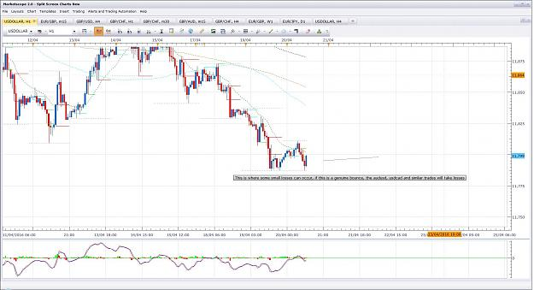

- Post 29,288
- Cleanup
- Quote
- Apr 20, 2016 1:58pm
- JonnyPip
- Joined Nov 2012 | Status: Member | 338 Posts
EurGbp looks like it could be set to continue mondays trade....
Attached Image (click to enlarge)
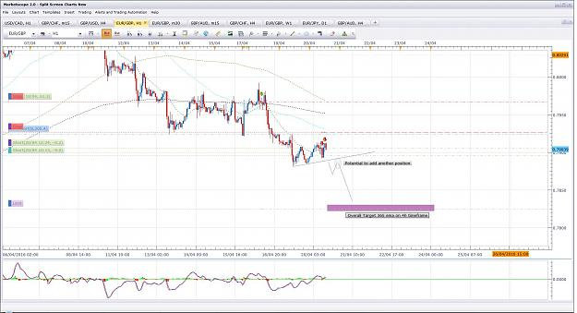

- Post 29,289
- Cleanup
- Quote
- Apr 20, 2016 2:08pm
- JonnyPip
- Joined Nov 2012 | Status: Member | 338 Posts
UsdCad Trade closed - Hope is not a strategy!
I might have reversed the trade were it not for the news the oil news afternoon
Attached Image (click to enlarge)
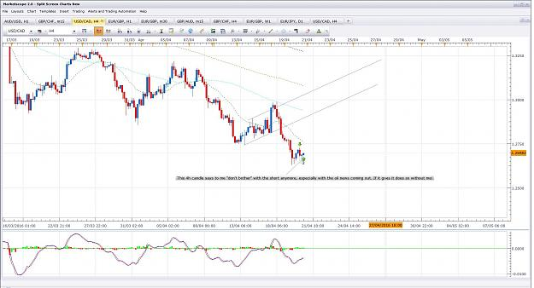

- Post 29,290
- Cleanup
- Quote
- Apr 20, 2016 3:17pm
- JonnyPip
- Joined Nov 2012 | Status: Member | 338 Posts
EurJpy Trade closed - Hope is not a strategy!
Hopefully these help with what it means. If a currency is showing weakness and you are involved, at the very least it will bounce around without going very far. Forget it and don't worry if it goes without you. Chances are it will go without you but not very far. If it rockets, who cares.
Attached Image (click to enlarge)
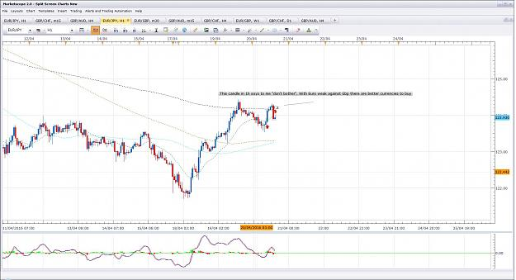

- Post 29,291
- Cleanup
- Quote
- Apr 20, 2016 3:26pm
- JonnyPip
- Joined Nov 2012 | Status: Member | 338 Posts
Closed AudUsd/GbpUsd (except initial one) as expecting retracement due to USD strength.
With the UsdCad/Eur/Jpy trades closed out it is a total of -4 pips. When you learn to do this, prepared to miss some trades if necessary, you will stop hoping and your losses will be minimal.
Attached Image (click to enlarge)
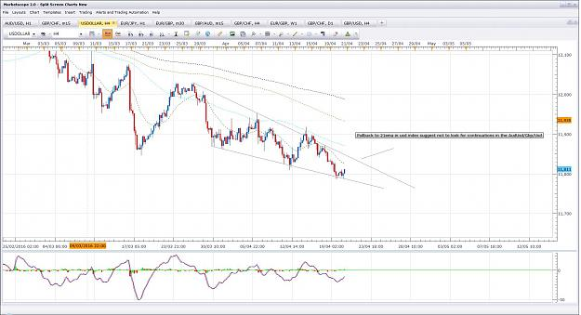

- Post 29,292
- Cleanup
- Quote
- Apr 20, 2016 4:15pm
- JonnyPip
- Joined Nov 2012 | Status: Member | 338 Posts
CadJpy - Break 21ema, pullback, TC to round number (87.00)
Attached Image (click to enlarge)
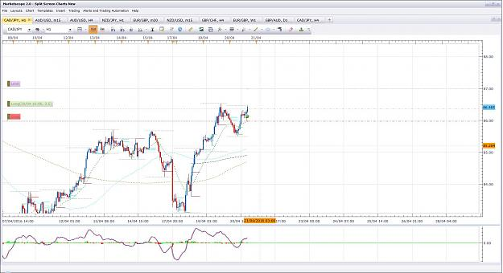

- Post 29,293
- Cleanup
- Quote
- Apr 20, 2016 4:46pm
- JonnyPip
- Joined Nov 2012 | Status: Member | 338 Posts
GbpUsd initial trade 1 closed
Usd is showing strength so a pullback is highly likely. I do expect another move higher but do not want to be with a 50% retrace and holding over weekend as retracement could take all of tomorrow and friday. I'd rather bank the pips and come back next week
That's +612 pips on the closed trades so far this week, -10 pips for cut trades is +602 pips so far with other profitable open trades. I hope the charts are making sense to people and showing the potential of the type of trading laid out in this thread
Attached Image (click to enlarge)
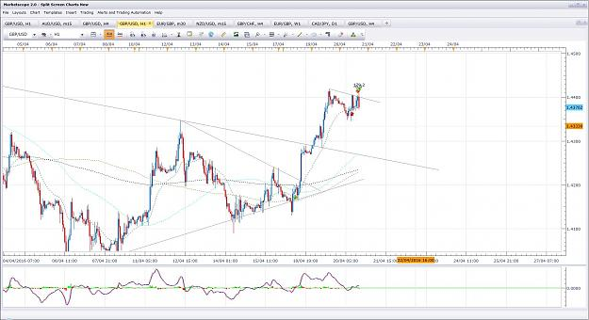

- Post 29,294
- Cleanup
- Quote
- Apr 20, 2016 5:00pm
- JonnyPip
- Joined Nov 2012 | Status: Member | 338 Posts
Closed CadJpy +37 pips, looking to take a potential short on NzdJpy suggesting possible Jpy strength (could be nzd weakness, probably is) and selling came in before the round number.
Will probably get to the round number but hoping for a chance to get a better price
Total closed = +639 for the week
Attached Image (click to enlarge)
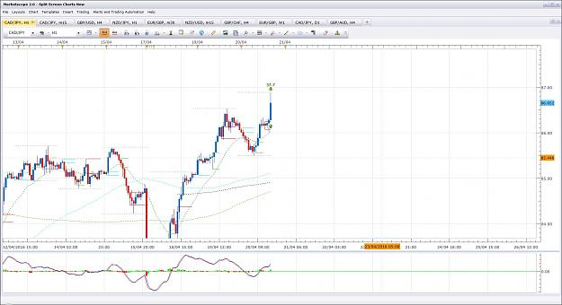

- Post 29,295
- Cleanup
- Quote
- Apr 20, 2016 5:10pm
- JonnyPip
- Joined Nov 2012 | Status: Member | 338 Posts
Potential Set up on NzdUsd
Pullback to 21ema, TC to 89sma
Attached Image (click to enlarge)
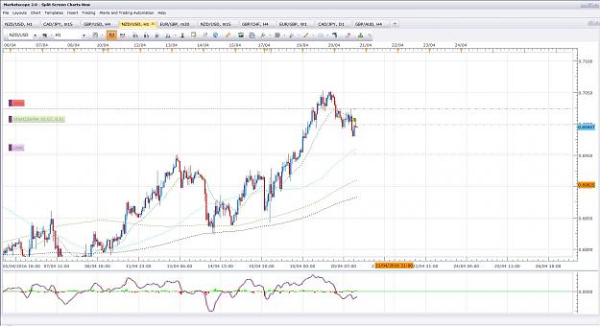
- Apr 20, 2016 11:18pm
- JonnyPip
- Joined Nov 2012 | Status: Member | 338 Posts
Quoting Mobber444
Hey JonnyPip, I've just stumbled across this thread in the last week. Read through a big part of the thread and it seems very interesting. Will try and paper backtest a bit this weekend. Do you still trade the method as explained in the 1st post (with all the references)? Reason I'm asking is it doesn't look like you rely on the MACD so much. Thanks
Hey Mobber,
I personally can trade with no macd, no moving averages, nothing. Just a blank chart. However I can see what Phillip has tried to lay out here in the "system", it is a guideline to how a lot of professionals would trade. I know that this is one of the few threads laid out which isn't written by a clueless person trying to persuade other clueless people they have found the holy grail.
This "system" is like having stabilizers on a bike. If you put stabilizers on a bike you haven't discovered a new "system" of transport, you are aiding inexperienced riders to try and ride like experienced bike riders. That's why I say "system" as I think some people hear the word "system" and think they can apply it like a robot. Real trading requires a certain amount of decision making.
I do find the macd is helpful, mainly for divergence, but I don't get hung up on it (I did in the beginning) as you start looking for the macd to tell you what to do - that is a big mistake - one Philip has alluded to many times in his presentations. You need to be able to read the chart (understand market rhythm) and then look to the macd for confirmation of your own analysis/market rhythm.
You HAVE to paper trade and put the time in to study it or honestly it is just like expecting to be able to perform open heart surgery just by putting on a white coat and picking up a scalpel. Unfortunately most people can't be bothered to do the work, so they never reap the rewards.
Hope this helps anyway
It's good to hear from you as I would like to get a bit of activity back on this thread. It deserves it as someone (Phillip Nel) has genuinely taken the time to put it together with no other intention than to purely help others.

- Post 29,298
- Cleanup
- Quote
- Apr 20, 2016 11:24pm
- JonnyPip
- Joined Nov 2012 | Status: Member | 338 Posts
Closed out GbpChf positions, one for +92 the other for +106 (total +198)
Price missed the 365ema target on the 4h chart by pips and produced a pin candle (emotion).
We may get another move up to the 365/1.4000 level after a retrace.
Total pips closed out this week +837
Attached Image (click to enlarge)
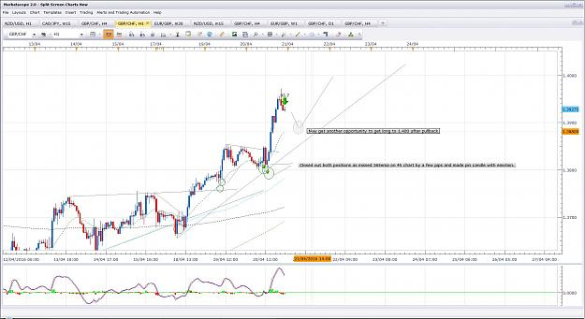

- Post 29,299
- Cleanup
- Quote
- Apr 20, 2016 11:29pm
- JonnyPip
- Joined Nov 2012 | Status: Member | 338 Posts
GbpUsd snapped back as anticipated.
Looking to hit target of 21ema before looking to establish new long position
Attached Image (click to enlarge)
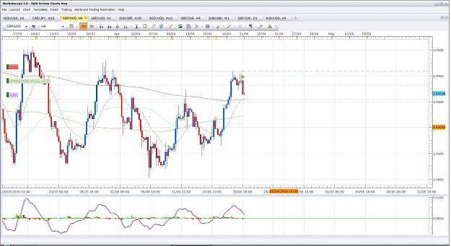
- Apr 21, 2016 7:35am
- JonnyPip
- Joined Nov 2012 | Status: Member | 338 Posts
GbpUsd - Potential Opportunity to add
Might get a chance to add, rhythm break 21ema, pllback, move to 89sma
I will only take it if it is minimum 1:1 R:R
Attached Image (click to enlarge)
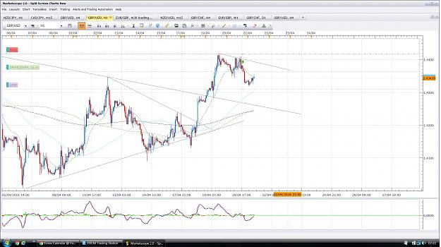

- Post 29,302
- Cleanup
- Quote
- Apr 21, 2016 7:44am
- JonnyPip
- Joined Nov 2012 | Status: Member | 338 Posts
NzdJpy short trade mentioned yesterday was triggered overnight
Does have potential for a breakout higher so it would be a bad idea to hold short if it does (hope is not a strategy)
Attached Image (click to enlarge)
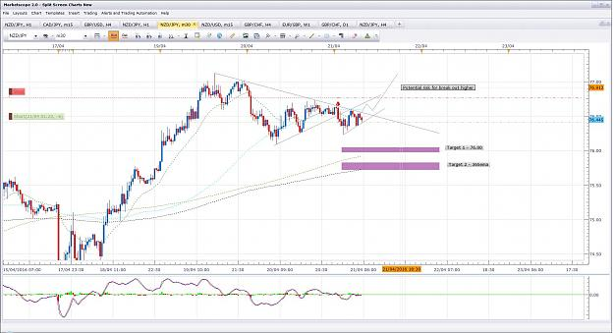

- Post 29,303
- Cleanup
- Quote
- Apr 21, 2016 7:57am
- JonnyPip
- Joined Nov 2012 | Status: Member | 338 Posts
EurGbp Trades Closed - Total +135
We have a minimum bid rate today from the ECB meaning the Eur could be slammed either way. Personally I would rather not gamble the pips, if it flies down further then so be it, there's always next week
Total pips on trades closed this week +972
In fact I am still anticipating a pullback and move lower, but you never know what can happen with interest rate decisions.
Attached Image (click to enlarge)
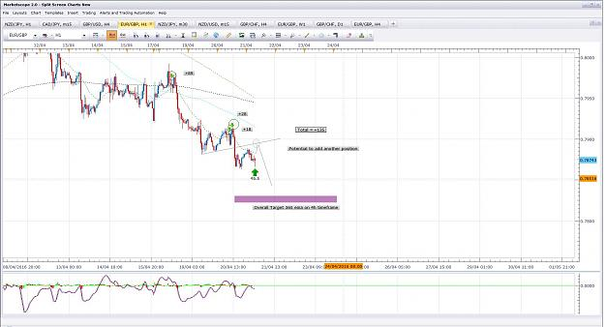
- Apr 21, 2016 8:51am
- JonnyPip
- Joined Nov 2012 | Status: Member | 338 Posts
GbpAud - First full losing trade this week
GbpAud trade is about to close for a loss. I posted it earlier in the week with a tight stop, I cut half the position for virtually break even and doubled the stop as we had news on Wednesday and it needed room. The news was negative and the price dropped so it was the correct thing to do. I then added another position as I had a much better price with trade 1 sill in tact.
I labelled the risk before hand as it was counter to the major trend, we just have to accept these as part of the reality of trading
Attached Image (click to enlarge)
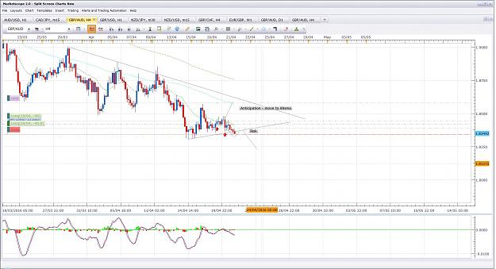
- Apr 21, 2016 9:44am
- JonnyPip
- Joined Nov 2012 | Status: Member | 338 Posts
GbpUsd Trades Closed - +54 pips and + 29 pips
Total +89 Pips
Attached Image (click to enlarge)
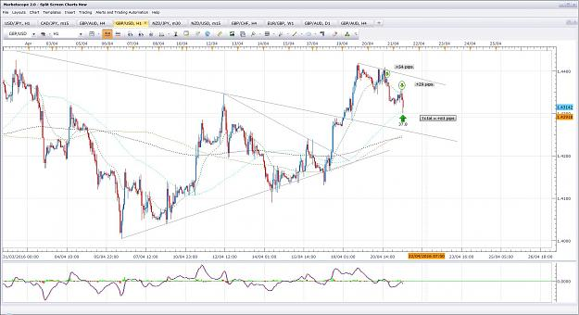

- Post 29,308
- Cleanup
- Quote
- Apr 21, 2016 9:49am
- JonnyPip
- Joined Nov 2012 | Status: Member | 338 Posts
GbpAud Closed out at loss
Total - -161
Total this week = 972 - 161 = +811
811 + 89 = +900
Attached Image (click to enlarge)
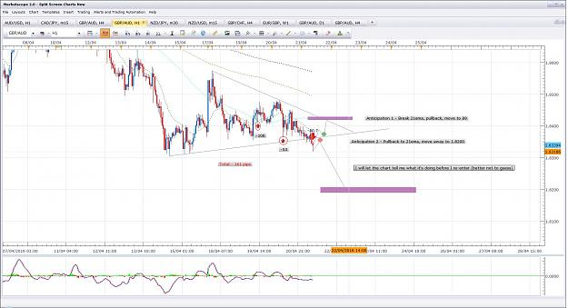

- Post 29,309
- Cleanup
- Quote
- Apr 21, 2016 10:15am
- JonnyPip
- Joined Nov 2012 | Status: Member | 338 Posts
NzdUsd Trades Closed - +44 pips and +33 pips
Total = +81 pips
Total for week = +981 Pips
Attached Image (click to enlarge)
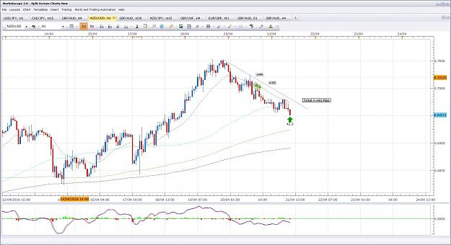

- Post 29,310
- Cleanup
- Quote
- Apr 21, 2016 10:36am
- JonnyPip
- Joined Nov 2012 | Status: Member | 338 Posts
Closed out NzdJpy for B/E, not worth it anymore
Nzd and Jpy are both weak so the NzdJpy is not doing as anticipated, it just looks a mess.
As a 1:1 R:R, counter trend trade, towards the end of the week (I like to wind down my trades so I hold few if any over the weekend), you have to ask yourself if it is worth the risk. Not for me.
If it goes without me, so be it.
Attached Image (click to enlarge)
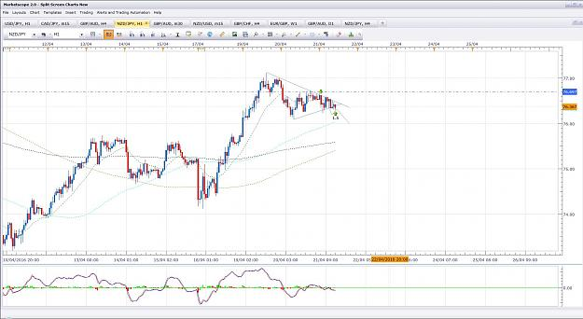

- Post 29,311
- Cleanup
- Quote
- Apr 21, 2016 11:05am
- JonnyPip
- Joined Nov 2012 | Status: Member | 338 Posts
GbpJpy - Closed Trade - +50 pips
UsdJpy - Closed Trades - +157 pips and + 60 pips (Total = +217 Pips)
Total for both trades = +267 pips
Total for week = +1,248 Pips
Closed the rest of my positions even though my expectation is for some higher moves. I cannot trade for the rest of today and there is some big news releases today which I would prefer to be able to manage the trades through. As I can't do that and it's Thursday I prefer to just wind them up and bank the pips.
It is unlikely I will make anymore trades this week.
I hope these charts helped some people this week understand how this method can be successfully applied and also to dispel any concerns like "does this method work".
I won't be posting as many next week as I missed quite a few trades whilst preparing the charts and uploading them, especially the huge UsdChf move which I highlighted on Monday 
But I will still put some up and am happy to help people who are trying to learn the methods laid out in this thread.
Happy Trading
Attached Images (click to enlarge)
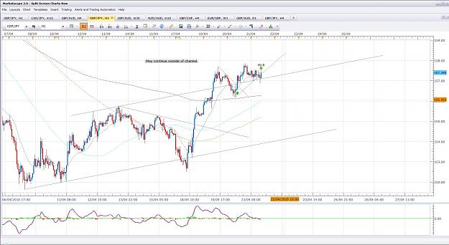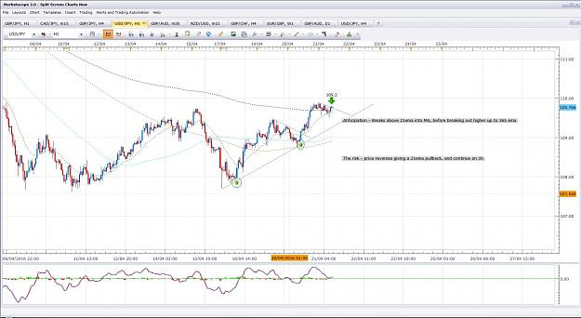
- Apr 22, 2016 8:39pm
- JonnyPip
- Joined Nov 2012 | Status: Member | 338 Posts
Quoting rare
{quote} Yes, i'm going to read it this weekend thank you. This is the trade I took to 1H 200 sma. {image}
Hi Rare,
This is what I am seeing if we are looking to the upside. I guess that trade is possible but I personally can't see enough evidence to be involved. The market rhythm isn't "clean" it's a bit messy (can be above or below 89sma from here just depending on how the candles close.)
Plus it is a counter trend move so it is naturally higher risk.
For these reasons I wouldn't trade this set up, I would wait for a better one.
Attached Image (click to enlarge)
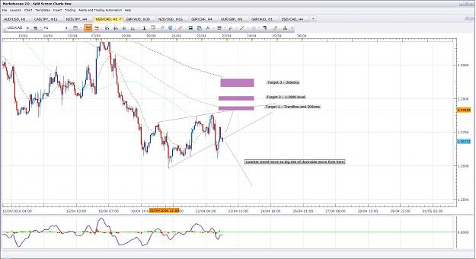

- Post 29,316
- Cleanup
- Quote
- Apr 22, 2016 8:43pm
- JonnyPip
- Joined Nov 2012 | Status: Member | 338 Posts
I forgot to say, if you look it is could also easily be a break of 89/21 lower, pullback and looking for another continuation lower. So you can see it is hard to gauge clear direction from here.

- Post 29,317
- Cleanup
- Quote
- Apr 24, 2016 7:47pm
- JonnyPip
- Joined Nov 2012 | Status: Member | 338 Posts
Quite a few good potential opportunities this week, I thought I would put a couple up for those interested.
Lets see how they play out, hopefully we get the chance to enter and make some pips
Attached Images (click to enlarge)
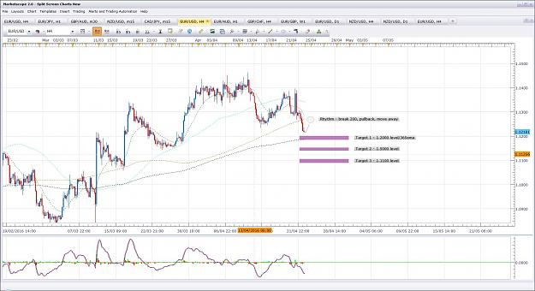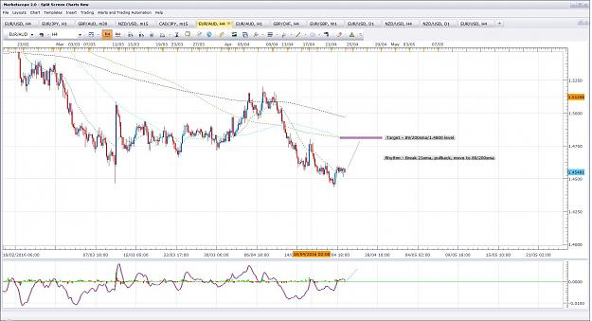

- Post 29,318
- Cleanup
- Quote
- Apr 24, 2016 7:58pm
- JonnyPip
- Joined Nov 2012 | Status: Member | 338 Posts
EurAud Potential Set Up in 1h Market Rhythm
Attached Image (click to enlarge)
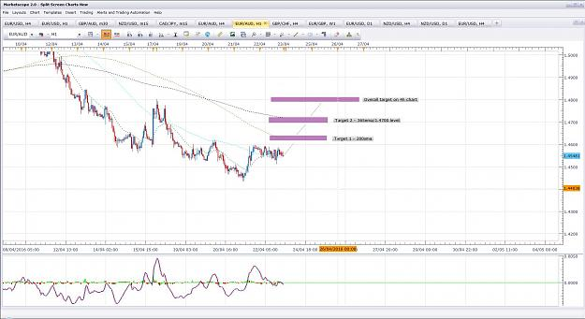

- Post 29,319
- Cleanup
- Quote
- Apr 27, 2016 8:50am
- JonnyPip
- Joined Nov 2012 | Status: Member | 338 Posts
EurAud Trade closed out last night.
Price went to target from a major news release which I couldn't watch, so I took a part of my position off at a small loss of -11 pips and gave myself a slightly wider stop to allow for volatility. I also had to put a TP as couldn't be in front of the computer to manage the trade.
Price crashed through all three targets from Modays post for + 139 pips, so +128 overall for me on EurAud.
Hope this helped
Attached Image (click to enlarge)
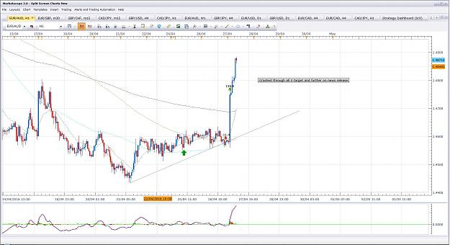
- May 3, 2016 7:22pm
- JonnyPip
- Joined Nov 2012 | Status: Member | 338 Posts
EurUsd counter trend trade
Rhythm -
4h pullback to 21ema
1h Break of 21ema, pullback, move to 89/200/365/price level.
Many traders don't realise this. A counter trend 4h trade IS an break 21ema, pullback, move to 89/200etc.
Just as a 4h break of 21ema, pullback, move to 89/200etc is a pullback to the 21ema on a daily time frame. So you see how the time frames work together?
Another important point to make about counter trend trades is this - they are higher risk as they are counter trend. Just because you have identified multiple targets such as round number level, 365 etc, it DOESN'T mean they will all get hit.
Once the trade is put on, new traders will often get caught up in targets they have set and then "hope" sets in. This means they leave the trade in the hope all targets get hit, completely forgetting they are trading counter trend. Therefore not only does the price eventually turn round and take them out, but they have completely missed a really good move in the direction of the trend.
As soon as a counter trend trade is open you MUST watch it and manage it with the thought process of "I'm just waiting to get a signal to go with the trend". When that happens you don't want to miss it because you are desperately waiting for your last target to get hit. Better to take the profit where it is and open the trade in the direction of the trend.
Hope this makes sense to people
Attached Images (click to enlarge)
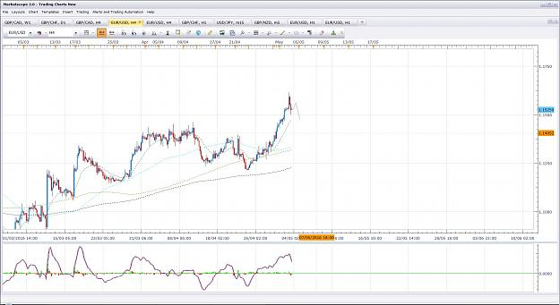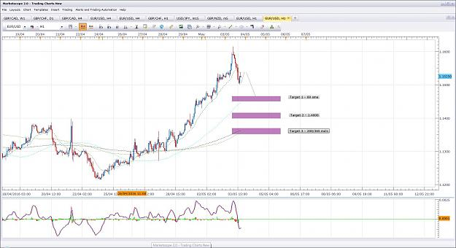
- May 5, 2016 3:49pm
- JonnyPip
- Joined Nov 2012 | Status: Member | 338 Posts
Quoting naustingfx
{quote} Great insight Jonny... This is the basics to my good trades. The time frames agree many times irrespective of whatsoever moving average or trend line they are interacting with at any given point...another insight is just how the move-away from the 21ema in the 4hr aligns with 3 little sister price set on the 1hr, and taking off from the 1hr 89sma...these are really great agreements....it can as well be worked or broken down to 5, and 15 minutes time frames...I am as well having some nice pips on smaller times...I just formatted my computer...
Thanks Nausting
Some really good set ups this week, plenty of chances to make good $$$$
The EurUsd trade I posted early in the week looks set to complete, was around a +100 pip trade.
Hope that helped someone make some $$$$
Attached Image (click to enlarge)
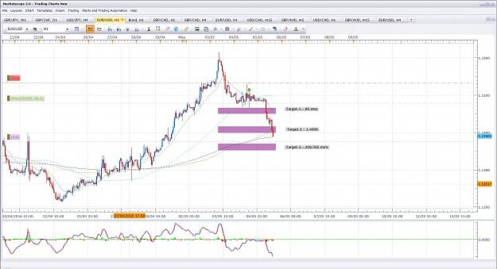

- Post 29,327
- Cleanup
- Quote
- May 6, 2016 9:41am
- JonnyPip
- Joined Nov 2012 | Status: Member | 338 Posts
Here is a nice trade from last night that could have been taken.
You can see the really nice market rhythm in this trade.
Price pulls back to the 21ema, smashes through the 1.9500 number so we keep with it, now it is approaching the 1.9750 level.
Due to non farms later today and the divergence, plus it being the end of the week, I have set my limits to just below the 1.9750 level.
Hopefully this gives some people and idea of some of the cleanest set ups that occur and how you can manage it as it progresses and set some potential targets (not just click out for small profits all the time, this will ruin a trader in the long run).
This trade from last night will be total +650 pips when it closes, so you can see for new traders that just by picking clean set ups WITH the trend can get you profitable fairly quickly. If you only took 1 or 3 of these a month as a new trader, you would make really nice $$$$.
Hopefully this helps
Attached Image (click to enlarge)
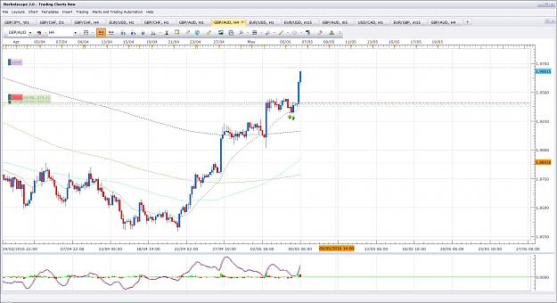
- May 9, 2016 1:20pm
- JonnyPip
- Joined Nov 2012 | Status: Member | 338 Posts
Quoting Gabryus
Hi Someone is going to be here this night at opening? I am new and would be great follow something with some "Senior guy"
Hi Gabryus,
Welcome my friend
There is a lot of information provided in this thread, I would strongly recommend any new traders studies it very carefully. All the information needed to be successful is right here. Very kindly put together by Phil Nel over a long period of time.
Here is a good opportunity I see for this week, one of the better ones in my opinion
Rhythm - break 21/89, pullback, move to 1.41 level/1.42 level.
Attached Image (click to enlarge)
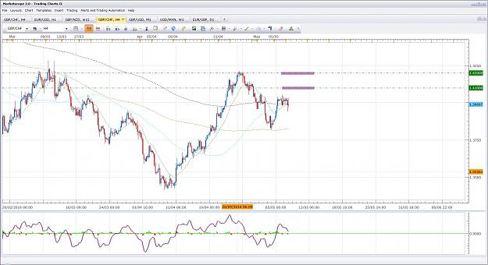

- Post 29,331
- Cleanup
- Quote
- May 9, 2016 1:39pm
- JonnyPip
- Joined Nov 2012 | Status: Member | 338 Posts
Another potential set up for this week.
Rhythm, pullback to 21ema, continue to 77.50 level.
There is divergence to notice in this pair as well which means it may continue to correct for a while longer before moving off. It is almost like resetting itself before the next move. Sometimes this can even mean a pullback to the 89 sma but not necessarily.
Attached Image (click to enlarge)
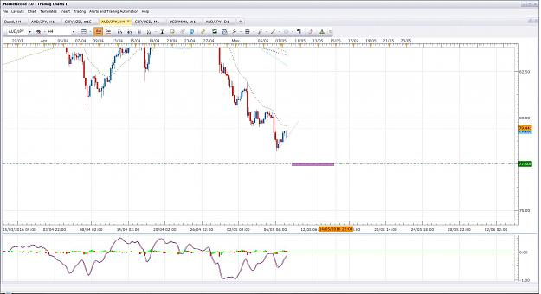

- Post 29,332
- Cleanup
- Quote
- May 9, 2016 1:54pm
- JonnyPip
- Joined Nov 2012 | Status: Member | 338 Posts
One to watch GBPAUD
If the two set ups posted above play out, we should also see some higher moves in the GbpAud this week. Here are some levels to watch out for if we get the anticipated moves in the other pairs.
Pullback to the 21ema, move away (to round number) is the market rhythm set up we are looking for.
Attached Image (click to enlarge)
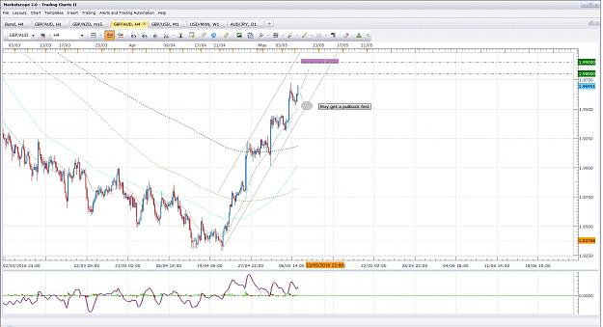
- May 9, 2016 2:14pm
- JonnyPip
- Joined Nov 2012 | Status: Member | 338 Posts
Hey Mobber
Just checked it out looks ok however you might find it is a slow burner because the Aud is weak across the board and so is the Cad. Its when you get an imbalance in the strength of the currencies you see nice moves, when they are equally weak or strong they tend to bounce around a lot. Plus you have the 0.9400 level in between to watch out for.
All it means is it usually requires a bit of patience
Here is one on the UsdCad I am in, there is a good chance it could pullback to give another chance of entry before any higher moves. If it does I will look to add another position.
It is showing divergence as well so it means we must be cautious and be prepared to accept the possibility the move is not going to happen. (keep an eye on it for signs of reversal in other words).
Attached Image (click to enlarge)
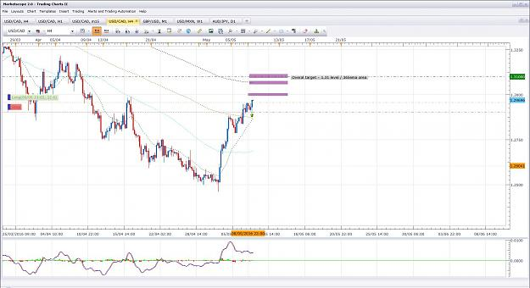
- May 9, 2016 4:25pm
- JonnyPip
- Joined Nov 2012 | Status: Member | 338 Posts
Potential counter trend on UsdChf
Remember counter trend trades are always more risky
I am looking to add a second position.
Attached Image (click to enlarge)
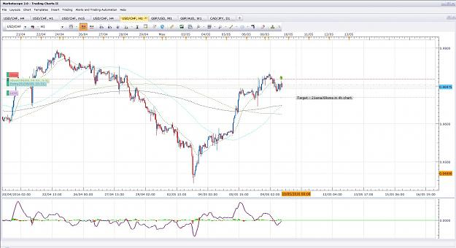
- May 10, 2016 8:06am
- JonnyPip
- Joined Nov 2012 | Status: Member | 338 Posts
Quoting Gabryus
{quote} Not clear how you determine 77.50 level, right now price on E21 (79.3) and 89 at around 82.948 how you can determine what should be move now? If breakking up then again to price and touching 89 (probably) if not? and especially when? PS I try to ask to you but, of course if too questions and too idiot easily let me know!
As you can see, price is now above the 21ema and has also closed above the 21ema in 4h telling us there is now strength in the Aud so looking for sell now could be risky. Even though we anticipated lower moves initially, the price is now telling us to think again.
Is this a surprise? Not really because we had divergence so it now makes sense for this to be happening.
Now we can be potentially anticipate a move higher to around the 89sma. However it doesn't necessarily mean we will get one. (Don't forget a move to 89sma is still counter trend on a higher time frame.)
Until it breaks below the 21ema and pulls back again, you can consider sells to now be more risky.
Hopefully this shows how the market and the MA's tell you what could be happening next and how you must be prepared to change your bias when the market changes. If you try and tell the market what to do, you will suffer.
Hope this helps Gabryus

- Post 29,351
- Cleanup
- Quote
- May 10, 2016 8:07am
- JonnyPip
- Joined Nov 2012 | Status: Member | 338 Posts
Chart for above post
Attached Image (click to enlarge)
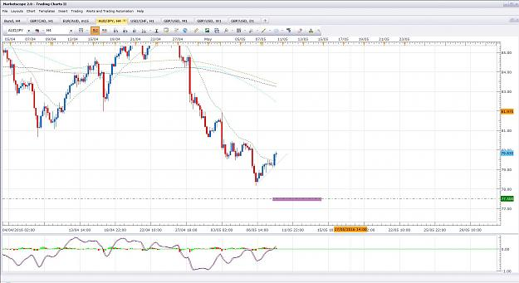
- May 10, 2016 11:05am
- JonnyPip
- Joined Nov 2012 | Status: Member | 338 Posts
For example:
Im my opinion why risk money trading against a strong AUD, when you can just simply wait for a currency such as this -
This is from the chart I posted yesterday, it moved this morning and this is what happens when you get a strong currency and a weak currency. See the difference in the move?
Catching these moves is what will let you hammer hundreds and even thousands of pips in a week. If you look at the week of trades I put up, you can see the final total was something over 1000 pips for the week and these trades I put up before/as they happened. The point of that was simply to answer the question of - "Does this methodology still work or not?" The answer is it works even better now than when the thread was created because the markets are more volatile.
You can see at the beginning of the thread Phillip says the markets have changed so now sometimes bigger stops are required. This is true, because bigger moves happen (more volatility). But equally this also means bigger profits when done correctly, the markets are always a double edged sword.
Hope this makes sense?
Attached Image (click to enlarge)
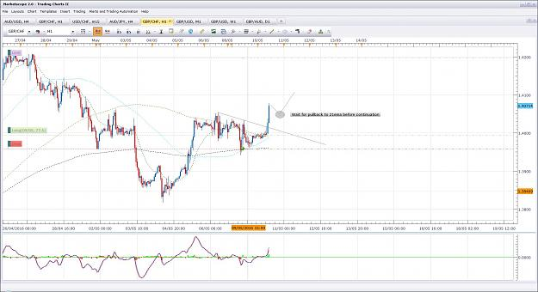
- May 10, 2016 11:46am
- JonnyPip
- Joined Nov 2012 | Status: Member | 338 Posts
No problem I am happy to help
Everyone starts as an absolute beginner remember.
Nice trade, I am also in the GbpJpy long, up currently around 120 pips. Entry was from a break 21ema, pullback, move to 89sma.
So you can see, even another method such as you mention is moving to the market rhythm. This is why I say there is only 2 ways of trading, the right way and the wrong way. People may misunderstand that as me saying "there is only one system that work and it is this one". What that means is, people spend a huge amount of time going through multiple systems and they are just being shown the wrong way of trading many different ways. Now yes, there will be other "systems" or "methods" and they will be successful. But ultimately when you look at it they will just be showing you a different way of looking at the market rhythm. This is why Philip even says, once you understand the market rhythm you can even use it with other "systems". If you truly understand the market rhythm it isn't necessary to add anything else, but you can if desired.
I will never take a trade just on divergence is the market rhythm/price doesn't back it up. Mainly I will use it to see if price could be correcting or slowing down. Trading divergence signals in a strong market will result in big losses, it is a bad idea in my opinion.
Attached Image (click to enlarge)
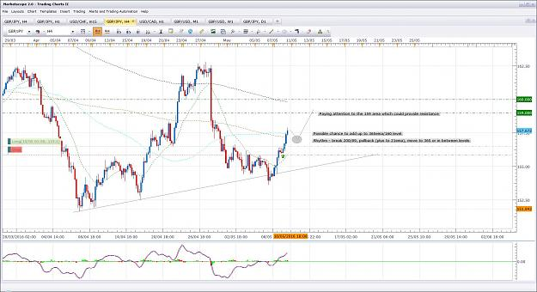
- May 13, 2016 5:19pm
- JonnyPip
- Joined Nov 2012 | Status: Member | 338 Posts
Quoting Gabryus
CADJPY going to touch 365? Have a look, how you read state there?
Hi Gabryus,
This is what I see on CadJpy.
The chart shows an important principle, when you see the MA's close together it means the price is RANGING not trending.
When this happens you need to find your support and resistance levels.
When they are drawn on you can see we have just bounced from the bottom trend line giving us support. We are below the 89 sma indicating we are looking for sell opportunities. However as you can see we are above the 21ema currently.
We need to break below the 21ema and pullback to have a sell opportunity, however if we do that we would be trading straight into the support trend line which is very risky.
So for this currency pair at the moment the safe trades would be, break above the 89sma, pullback to the 89 and 21 ma's before moving higher OR break the lower trend line, pullback to trend line/21 ema and head lower.
Hope this gives you an idea of how you can try and anticipate the market and then trade IF it plays out as you anticipate it.
Attached Image (click to enlarge)
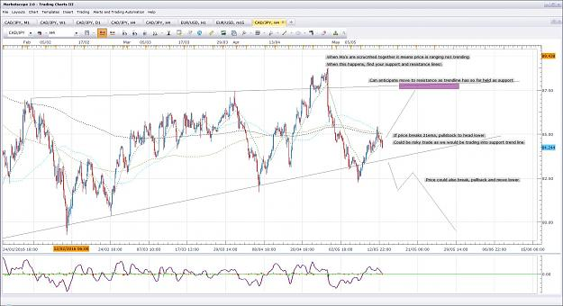
- May 19, 2016 9:04am
- JonnyPip
- Joined Nov 2012 | Status: Member | 338 Posts
Quoting naustingfx
{quote} Yeah! Don't really trade this pair; but just opened it now do do some analysis on it. No trade for me for now...price is squashed in between those trend lines... Hoping for some direction after some shaking off. {image}
Hey Nausting,
Yeah EurAud trade was stopped out unfortunately, these things happen
First loss this week I took it on the outside 4h candle but didn't get any follow through.
EurGbp is looking nice, possible chance to add on pullback to 21ema. Good potential opportunity for further moves down towards the .7600 level
Nice UsdJpy trade as well, I was waiting for that for over a week! Paying off nicely now though. Patience is key.
Same with GBPCHF, hammered through the target I posted previously, really nice move (I hope someone caught it with me!)
Attached Image (click to enlarge)
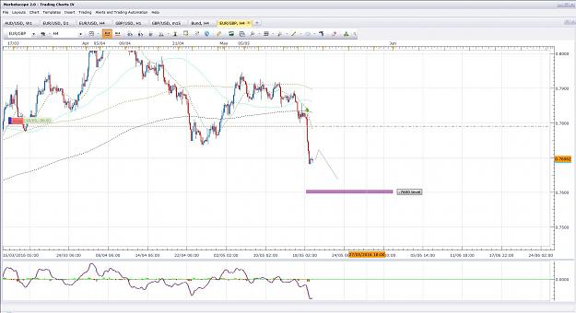
- Jul 29, 2016 10:27am
- JonnyPip
- Joined Nov 2012 | Status: Member | 338 Posts
Hey all,
Been away for a while, great to see the thread going strong and Trademin back and nausting still here as well
Thought I would put up a potential opportunity for today, it is a bit late now as had some problems uploading, but could get a pullback for an entry still for anyone interested.
Break of 21ema, pullback, move to 1.2800 level
Look forward to seeing some more posts from people
Happy Trading!
Attached Image (click to enlarge)
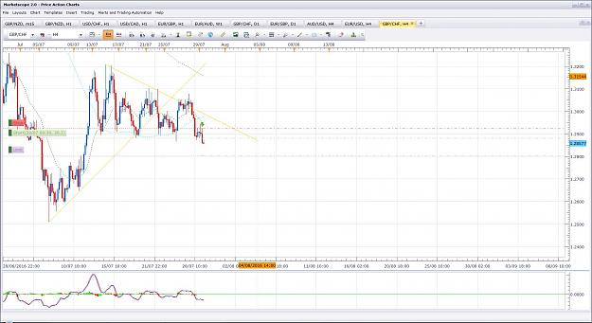
- Jul 29, 2016 10:43am | Edited at 12:44pm
- JonnyPip
- Joined Nov 2012 | Status: Member | 338 Posts
Quoting Kubiasty
You guys still trading using Market Rhythm  ?
Hey Kubiasty,
To show the method was still being used and working well I did a week of posting trades on the thread about 2 months ago (post around about 1470-1525? Not exactly sure but you can scroll though and find it). If you scroll back and find them you will see pictures of the exact trades.
The trades were posted live when they were taking (not retrospectively or pick and choose the best ones/winners), as you will it was over + 1000 pips for the week, including any losses.
Hope this helps
EDIT - post 29,311 - page 1466 was the final total for the week (+1,248 pips). Post leading up to that show all trades as taken including losers.
Hope this helps

- Post 29,482
- Cleanup
- Quote
- Jul 29, 2016 2:16pm
- JonnyPip
- Joined Nov 2012 | Status: Member | 338 Posts
UPDATE:
GBPCHF
Closed trade for around +53 pips (R:R - 1:1.25)
I still anticipate a possible move down to the 1.2800 level however, being a Friday afternoon I expected a retracement before reaching the 1.2800 level due to the divergence and the extended move from 1.2900. I would rather not hold it over the weekend.
If it weren't Friday I would have held out for 1.2800. R:R was still over 1:1 (1:1.25) making it an acceptable trade for me.
It may even make the 1.2800 today, but I would rather bank the pips then have a retrace which just sits there until Monday.
Anyway, hopefully someone got some pips out of it
Have a good weekend everyone
Attached Image (click to enlarge)
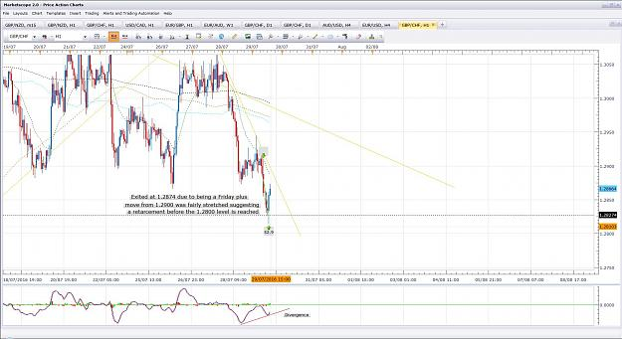
- Aug 1, 2016 8:43am
- JonnyPip
- Joined Nov 2012 | Status: Member | 338 Posts
A potential trade I am looking at for this week
Market rhythm - pullback to 21ema continue to round level
Looks like this week could give plenty of opportunities.
Happy Trading
Attached Image (click to enlarge)
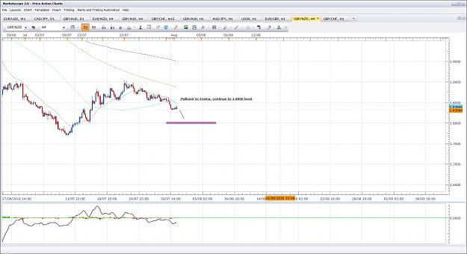
- Aug 1, 2016 12:23pm
- JonnyPip
- Joined Nov 2012 | Status: Member | 338 Posts
Hi Isin,
This is how I see it.
If you look at the 4h/1h it is suggesting higher moves. The problem I have with this pair is the Eur is weak and so is the Usd. This tells me that if we do get higher moves it could struggle or even fail to sustain higher moves.
Personally I may be interested in this but I will keep on eye on it as it approaches points of resistance. What this will likely come down to in my opinion is how weak the USD is.
My concern is it might just about make a new high before making a larger retracement. If it can sustain higher moves "Target 2" is where I would be looking at it going up to.
But hey, you can never be 100% sure with the forex market
Just my opinion anyway, hope this helps.
Attached Image (click to enlarge)
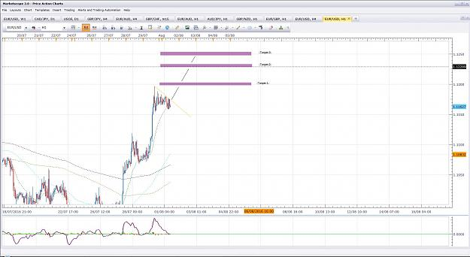

- Post 29,487
- Cleanup
- Quote
- Aug 1, 2016 12:54pm
- JonnyPip
- Joined Nov 2012 | Status: Member | 338 Posts
Potenital Opportunity EuzNzd
EurNzd could be setting up for an opportunity to the 1.5400 level
Rhythm - pullback to 21ema, continue to round level
Lets see how it plays out
Attached Image (click to enlarge)
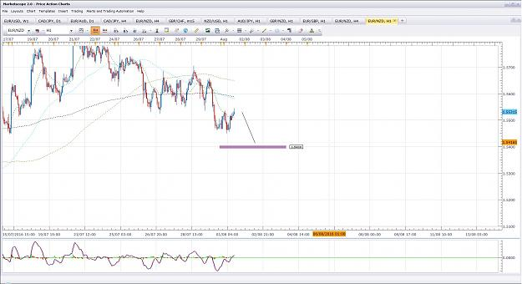
- Aug 2, 2016 8:55am
- JonnyPip
- Joined Nov 2012 | Status: Member | 338 Posts
GbpNzd Update:
Update from the opportunity I posted yesterday. Price is approaching a bounce point on the way to the 1.8000 level so I will be taking my profits and seeing how it reacts. If it breaks through I will look for a second trade down to the 1.8000 level as posted yesterday
Attached Image (click to enlarge)
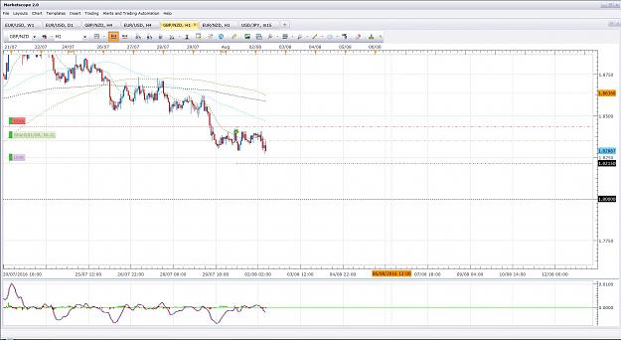
- Aug 2, 2016 3:59pm
- JonnyPip
- Joined Nov 2012 | Status: Member | 338 Posts
USDJPY
Closed at 101.00 level for + 84 pips
Rhythm - pullback to 21ema, continue to round level.
Attached Image (click to enlarge)
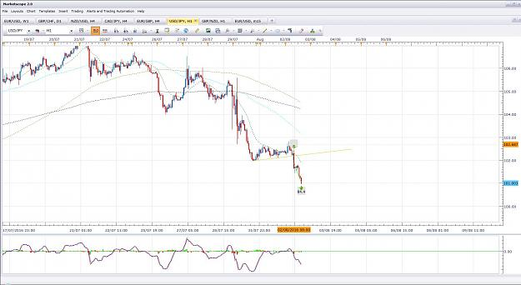

- Post 29,496
- Cleanup
- Quote
- Aug 2, 2016 4:22pm
- JonnyPip
- Joined Nov 2012 | Status: Member | 338 Posts
EurUsd Update
Closed trades at "Target 2" mentioned in yesterdays post.
Trade 1 = + 51 pips / Pullback to 21ema - move to 1.2250 level (Rhythm)
Trade 2 = + 44 pips / Pullback to 21ema - move to 1.2250 level (Rhythm)
Total = + 95 pips
Hope this helps
Attached Image (click to enlarge)
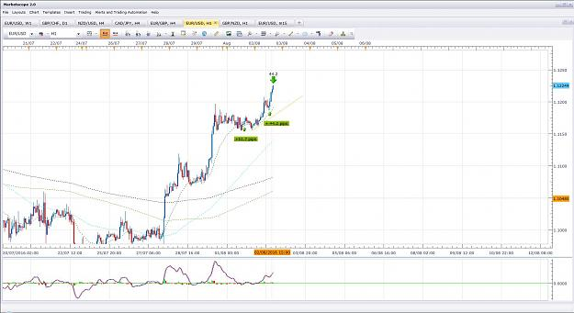

- Post 29,497
- Cleanup
- Quote
- Aug 2, 2016 5:35pm
- JonnyPip
- Joined Nov 2012 | Status: Member | 338 Posts
EurJpy
Rhythm - break 21ema, pullback, move to round number (113.00)
Total + 78 pips
Attached Image (click to enlarge)
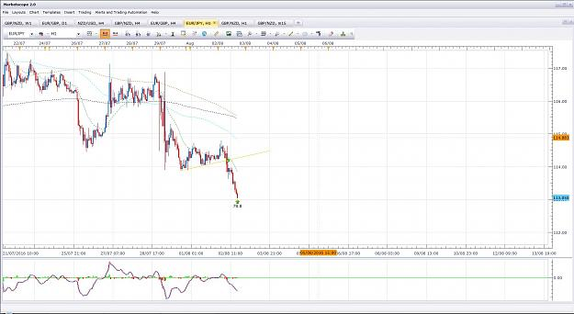
- Aug 3, 2016 7:57am
- JonnyPip
- Joined Nov 2012 | Status: Member | 338 Posts
GbpChf
Potential opportunity I see
Price is above the 21ema and the 89 sma, targets are the 200/365 ma's then the 1.3000 level
Lets see how it plays out
Attached Image (click to enlarge)
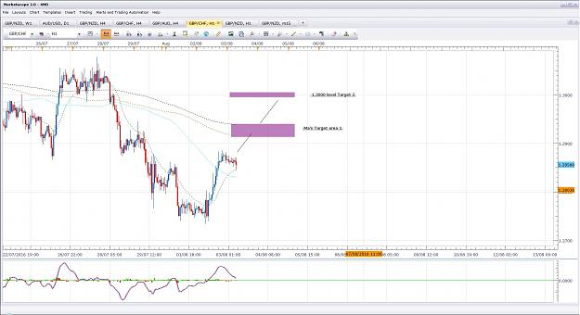
- Aug 3, 2016 8:05am
- JonnyPip
- Joined Nov 2012 | Status: Member | 338 Posts
Potential opportunity EurGbp
Price has broken below the 21ema and 89sma, potential target is 0.835 level.
Let's see if it plays out and if there is an opportunity to get involved.
Attached Image (click to enlarge)
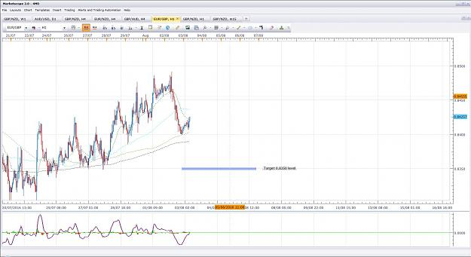
- Aug 3, 2016 9:13pm
- JonnyPip
- Joined Nov 2012 | Status: Member | 338 Posts
GbpChf Update
Decided to close the trades before the target as it is the end of the trading day and there is a GBP rate decision tomorrow. All sorts of games can be played by the big players leading up to major news, especially a rate decision. It may well to continue to target before tomorrow but I would rather play it conservatively.
Rhythm - Break 21ema and 89sma, pullback, move to round level (cut short due to major news)
Trade 1 - + 99.3 pips
Trade 2 - + 71.5 pips
Trade 3 - +31.4 pips
Trade 4 - + 4.6 pips (I would never trade for 4 pips normally, only exited for reason of rate decision tomorrow).
Total - + 206.8 pips
Also below are the graphs from before and after to give an idea for anticipating the trade
Hope someone else managed to get some as well
Attached Images (click to enlarge)
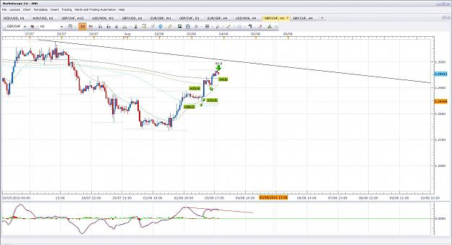

- Post 29,510
- Cleanup
- Quote
- Aug 3, 2016 9:21pm
- JonnyPip
- Joined Nov 2012 | Status: Member | 338 Posts
Eurgbp Update
Exited due to same reason as GbpChf, plus is it right at a trend line which could bounce it
Rhythm - Break 21ema, pullback, move to round level (cut short due to major news)
Trade 1 - + 47.5 pips
Trade 2 - +21.4 pips
Total = +68.9 pips
Again it might go to target before the rate decision, but I prefer to play this conservatively
Hope this helped
Attached Image (click to enlarge)
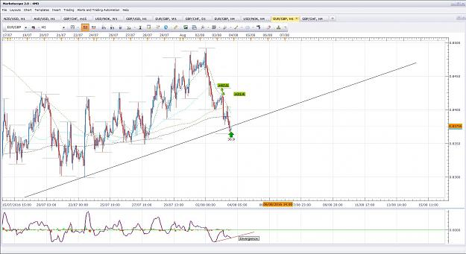
- Aug 4, 2016 8:43am
- JonnyPip
- Joined Nov 2012 | Status: Member | 338 Posts
EurAud 4h
Rhythm - break 21ema, pullback move to 89sma
It went through the 89sma so I kept with it and exited as buying started to come back in
Trade 1 - + 145.3 pips
Trade 2 - + 107.1 pips
Total - + 252.4 pips
Hope this helps
Attached Image (click to enlarge)
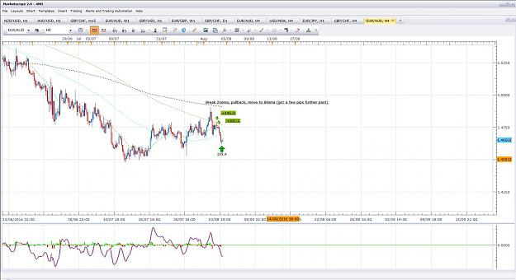
- Aug 4, 2016 4:39pm
- JonnyPip
- Joined Nov 2012 | Status: Member | 338 Posts
Quoting orangeRANGE
AUDcad Woohooo...we got evening doji (see ellipse) here.... {image}
Hey Orange,
AudCad is a funny one isn't it as Aud and Cad are both strong. But Cad has seen a huge push by an increase in the oil prices. I'm thinking AudCad will probably come down to around the last low/ 0.9900
I took the Oil trade instead actually (due to the Aud strength), I have posted it below
Market rhythm - Break 21ema/89sma in 1 h, pullback move to 200 / round number (my target is slightly more aggressive at the 42.00 level rather than the 200sma)
Market rhythm in 4h is break 21ema, pullback, move to round number
We'll see how it plays out anyway, oil moves fast but there may be a chance to jump in somewhere for anyone interested
Shows as well to anyone new to the thread that the market rhythm can be found on ANY chart as well as ANY currency pair.
Happy trading
Attached Image (click to enlarge)
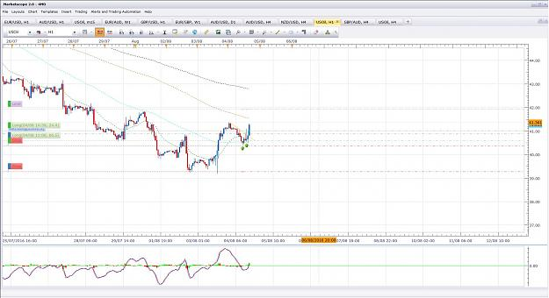
- Aug 4, 2016 5:05pm
- JonnyPip
- Joined Nov 2012 | Status: Member | 338 Posts
Oil trade explained
Just a post for those fairly new to the thread with a tip to spotting possible reversals and using the candles to confirm the rhythm.
Hope this helps
Attached Image (click to enlarge)
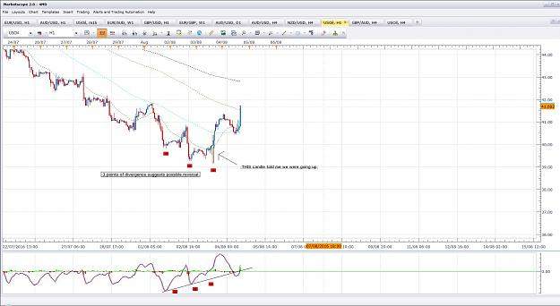
- Aug 4, 2016 5:21pm
- JonnyPip
- Joined Nov 2012 | Status: Member | 338 Posts
Oil Update
Wow this thing really flies when you get a chance to trade it. No chance to get additional entries on it.
Trade 1 - + 133 pips
Trade 2 - + + 90 pips
Total - + 223 pips
Attached Image (click to enlarge)
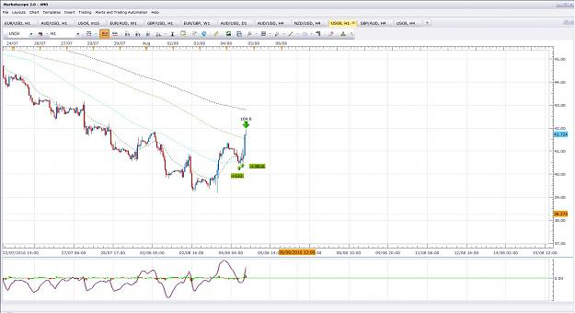

- Post 29,522
- Cleanup
- Quote
- Aug 4, 2016 6:48pm
- JonnyPip
- Joined Nov 2012 | Status: Member | 338 Posts
Weekly Summary:
That's probably me done for the week with NFP tomorrow, hopefully this has helped some of the new traders just starting on the thread and again has shown the power of the market rhythm. I know some people were messaging and asking for me to post the trades up so I really hope it helped as I know how it feels to be just starting out.
Total for the week =
+ 1,007 pips
I did get taken out for a loss of - 86 pips on the GBPNZD trade which means overall total including this loss =
+ 921 pips
15 trades - 14 wins / 1 loss - 93% win rate (including multiple entries)
Not quite as much as the other week of trades which was over + 1,200 pips including losses, but as I say, I hope this proves again to new traders that to be successful all they have to do is study and practice the information Phil has taken the time to put into this thread. There is no other place I am aware of which is free and has such a comprehensive list of trading information.
Anything I have seen with more advanced methods or treading techniques can't be accessed for free. I really urge people to take advantage of the info Phil has provided here freely.
Hope everyone has a good weekend

- Aug 5, 2016 9:45am | Edited at 10:10am
- JonnyPip
- Joined Nov 2012 | Status: Member | 338 Posts
Was planning to have today off because of NFP, but there may be a few which are too tempting to pass! (Mainly on the GBP pairs due to yesterdays cut).
We will have to see.
Below is one of them for anyone who trades oil.
Rhythm - Break 200sma, pullback to 21ema and 200 sma, move to 365/round level (42.500)
I may still leave any trading today, we will just have to see how they play out
Hope this helps
Attached Image (click to enlarge)
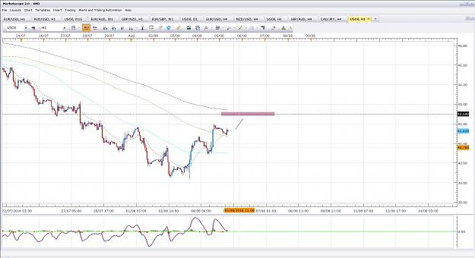

- Post 29,532
- Cleanup
- Quote
- Aug 5, 2016 9:50am
- JonnyPip
- Joined Nov 2012 | Status: Member | 338 Posts
GbpChf
Here is another potential opportunity
Break 21ema, pullback, move to round number
Lets see how they set up/play out
Attached Image (click to enlarge)
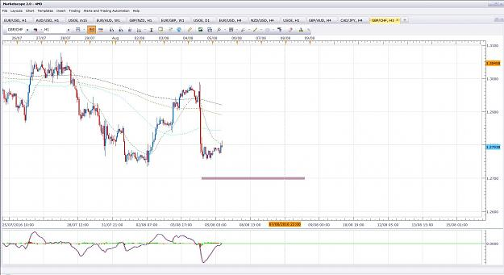

- Post 29,533
- Cleanup
- Quote
- Aug 5, 2016 11:29am
- JonnyPip
- Joined Nov 2012 | Status: Member | 338 Posts
GbpJpy
This is another one I am potentially looking at, but I am cautious as the JPY can easily get quite volatile with major USD news such as NFP in a couple of hours.
Nothing has set up to take a trade as of yet, I am certainly in no rush to trade today with the NFP.
Still, lets see what happens
Attached Image (click to enlarge)
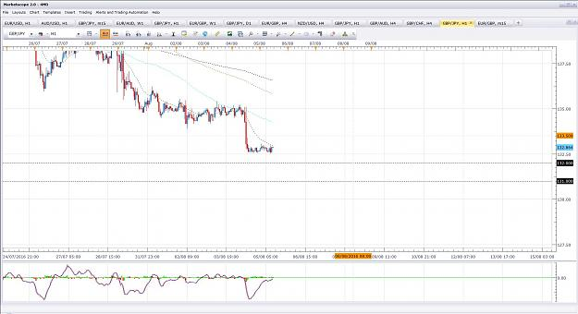
- Aug 8, 2016 8:40am
- JonnyPip
- Joined Nov 2012 | Status: Member | 338 Posts
Hey all,
Just a couple of things I see for this week
Still waiting for the same down moves for the GBP as posted last Friday. We may see a bit more GBP strength though before anything happens this week, we will just have to see.
Here is a potential opportunity I see for this week on the EurGbp
Market Rhythm - Break 21ema, pullback, move to round level.
Attached Image (click to enlarge)
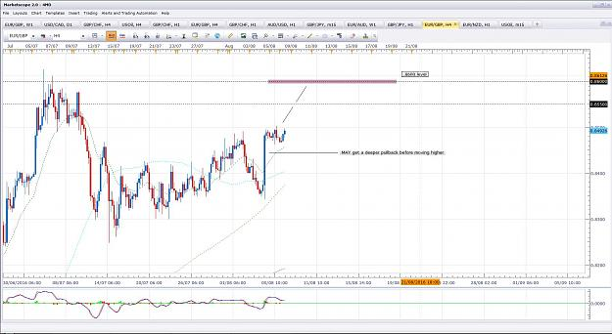
- Aug 8, 2016 8:46am
- JonnyPip
- Joined Nov 2012 | Status: Member | 338 Posts
Potential Opportunity USDCAD for this week
Rhythm - Break 21ema and 89sma, pullback, move to round level
Attached Image (click to enlarge)
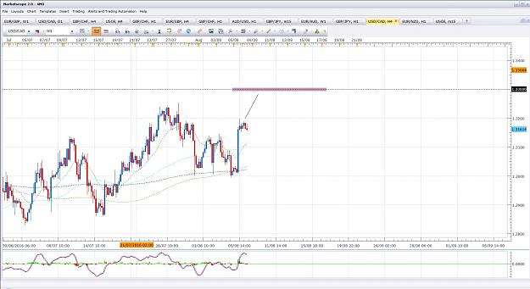
- Aug 8, 2016 9:25am
- JonnyPip
- Joined Nov 2012 | Status: Member | 338 Posts
Quoting Cheeseburger
AUDUSD Potential setup Break 21, pullback to 21 and move to round levels Again please advice me on these levels However, having gone through the thread, I've noticed that getting into a trade with the trendline so close is a potential risk. I'll wait for a break and pullback to the trend line before getting involved there {image}
Here's what I see CB,
On the 1h chart it is telling me it could be a "messy" break 21ema, move to 200sma.
The reason I say "messy" is because it is currently above the 21ema/89sma indicating a buy, but sometimes it can just be a "messy" break 21ema, pullback (above), move to 200sma.
I would either wait for it to break above the trend line looking higher, or see if we get another break of the 21ema downwards on the 1h chart, looking for the pullback, move to 200sma trade.
1.2800 in AudUsd in definitely on the cards in my opinion, barring any major news which reverses it.
That's how I see it.
Hope this help
Attached Image (click to enlarge)
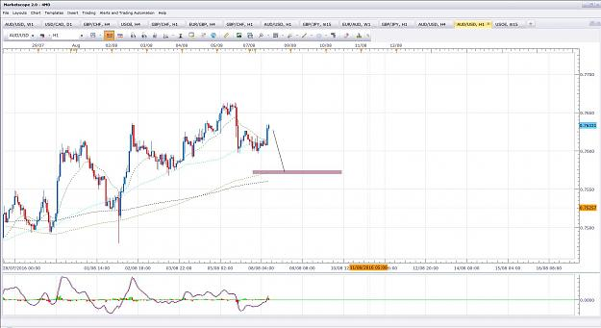
- Aug 8, 2016 6:11pm
- JonnyPip
- Joined Nov 2012 | Status: Member | 338 Posts
Quoting orangeRANGE
{quote} Need to wait macd to complete the pattern. I think the price might go into ranging zone (which is boring) again before continue / reverse trend. Weekly 200sma is the support now.
Hey Orange,
Yeah it's hard to say right now isn't it.
I am anticipating something like the chart below in 1h chart
We'll have to see how it plays out and trade accordingly anyway, otherwise we can only guess.
JP
Attached Image (click to enlarge)
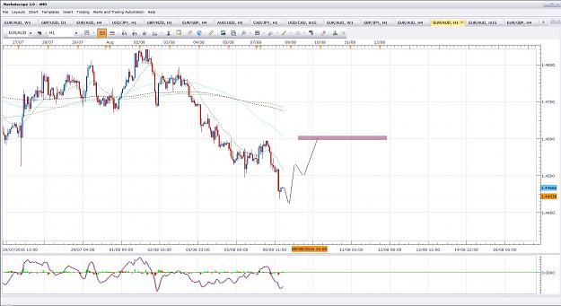
- Aug 8, 2016 6:38pm
- JonnyPip
- Joined Nov 2012 | Status: Member | 338 Posts
Quoting jcat
What do you guys think about this one. 4 hr chart. Crossed the EMA's Retraced to the 21. MACD went Red on last candle. {image}
Hi Jcat,
This is how I see the EurUsd.
Price is above the 89sma and below the 21ema so it is giving mixed signals from here.
Personally I would stay out of it until there is a break and pullback of the 21ema or the 89sma and I would aim for the round numbers highlighted.
Hope this helps
Attached Image (click to enlarge)
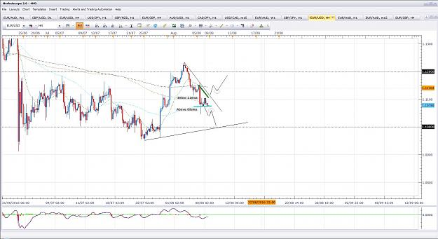
- Aug 9, 2016 8:10am
- JonnyPip
- Joined Nov 2012 | Status: Member | 338 Posts
EurAud Update
Here is the same chart I posted yesterday, EurAud seems to be doing roughly as anticipated, the question is whether we now get the final anticipated move higher or if if fails from here and turns down.
The overall 4h tend is down so any opportunity is technically a counter trend and therefore more risky in general. It could also turn at the 89sma.
Lets see how it plays out
Attached Image (click to enlarge)
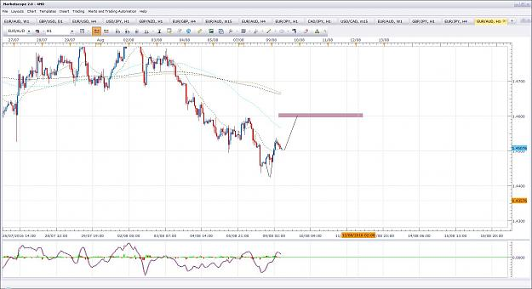

- Post 29,580
- Cleanup
- Quote
- Aug 9, 2016 8:45am
- JonnyPip
- Joined Nov 2012 | Status: Member | 338 Posts
Quoting jcat
{quote} Jonnypip, I was wondering if you would mind sharing some thoughts on entry. I've noticed you said you trade "naked." Do you use candlestick patterns for entry? Maybe you have shared and I have missed it.... I do see you use the lower time frames to time it better. thanks again.
Hey jcat,
No problem, always remember that "doing nothing" in trading is making a choice to do something. Doing nothing doesn't mean you are not trading, you can be waiting 3 days for a trade and during that time you ARE trading because you are making the choice not to enter as you have looked at the charts at the opportunity hasn't presented itself. Inversely, opening the chart and clicking buy or sell without knowing why is not trading, yet it feels like trading because trades are being put on. Understanding this is always a bit of a revelation for new traders.
I do have a chart which I always look at first which has nothing on it to give me the clearest idea of what the market is doing. Candlesticks are essential to understand, especially for beginners, however I don't just trade from candlestick formations I also go down to smaller time frames to see what pattern or market movement has caused that candle to form. Often this will show me which candles will work and which ones to avoid. (Every candle is caused/formed by certain movements in price).
This is a skill though which builds up over time and I would definitely say trying to learn that before learning candlestick patterns themselves would be putting the cart before the horse and generally unhelpful for you.
What you have to remember with candle stick patterns and general price movement is it will tell you when and where it runs into support or resistance by the candle that forms. So if you understand them well, it will show you a strong support/resistance area without it even being on your chart.
Again, this is still something that takes time to learn as a skill. It's like studying books on how to build a shed for years and then attempting to build your first shed. You might know exactly how to build one but you still haven't practiced the execution. So although you know which pieces to put where, your first couple of sheds will likely be pretty useless as you start to acquire the skill and craftsmanship needed.
What can happen often is a new trader can, for example, read everything Phil Nel has put in this thread. They now know how to build the shed. They attempt to build it and after a few panels think "this isn't going very well, I better go and ask someone else's opinion on how to build a shed". The same thing happens and they spend their entire trading career searching for different ways to build a shed, without ever actually taking the time to learn the craftsmanship side of it.
It's like the meetings they have for people with addictions, they always famously say step 1 is accepting you have a problem, otherwise you can't fix it. Most traders never become successful because they refuse to believe it is their own ability which is lacking and needs training (NOBODY is born a good/successful trader), as oppose to the theory/system (book) etc.
I know this slightly extends beyond your question by the way Jcat, but it's really as well for any new traders coming to the thread. I believe this is so important for new traders to understand.
So my advice is definitely learn candlesticks. You don't have to set out to become a master of candlesticks, just simply picking some of the best ones and learning to see them on the charts without thinking is the best way forward. Having the discipline to only stick to those entries as well, after you have chosen them, is also very important. You will start to see that the market rhythm gives you the direction and the candles will then tell you when to go. I.e your bias and your trigger.
Hope this help
- Aug 9, 2016 1:45pm
- JonnyPip
- Joined Nov 2012 | Status: Member | 338 Posts
EurGbp Update from yesterday (Exited at .8550 level)
Trade 1 = +44 pips
Trade 2 = + 57 pips
Total = +101 pips
Attached Image (click to enlarge)
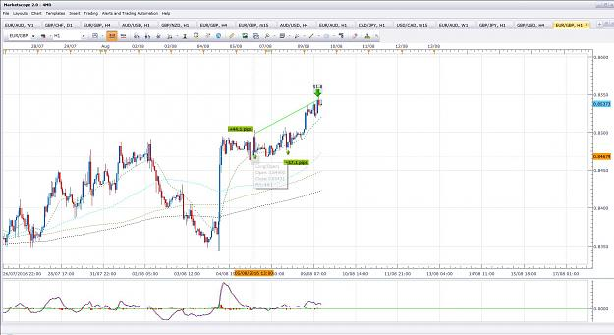
- Aug 10, 2016 2:14pm
- JonnyPip
- Joined Nov 2012 | Status: Member | 338 Posts
GbpNzd Update
Closed trade at 1.8000 level
Total = + 258 pips
Rhythm - Break 21ema, pullback, move to round level
Attached Image (click to enlarge)
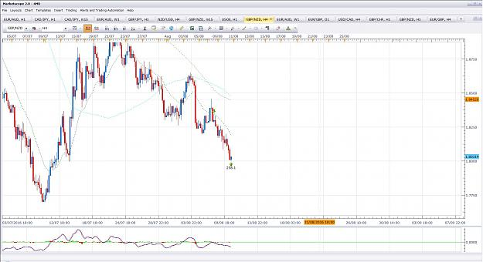
- Aug 10, 2016 3:01pm
- JonnyPip
- Joined Nov 2012 | Status: Member | 338 Posts
GbpJpy Update
Trade 1 = + 153 pips
Trade 2 = + 179 pips
Total = + 332 pips
Rhythm - Pullback to 21ema, move to round level (4h) / Move to 89sma, turn away, move to round level (1h) **Notice the diferent market rhythm set ups on both time frames showing 1 move/supporting each other**
Attached Image (click to enlarge)
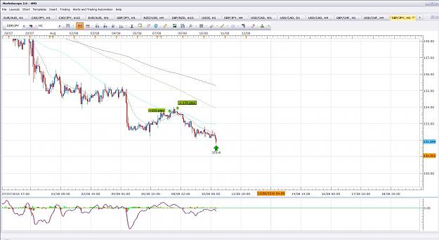
- Aug 15, 2016 9:01am
- JonnyPip
- Joined Nov 2012 | Status: Member | 338 Posts
Hope everyone had a good weekend!
Here is a potential move I am looking at for this week.
Market rhythm - Pullback to the 21ema, move to round level.
Attached Image (click to enlarge)
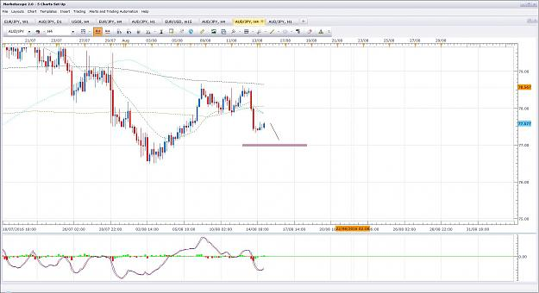

- Post 29,660
- Cleanup
- Quote
- Aug 15, 2016 9:09am
- JonnyPip
- Joined Nov 2012 | Status: Member | 338 Posts
Similar set up on EurJpy
Rhythm - Move from 21ema to round level (.50 level)

Attached Image (click to enlarge)
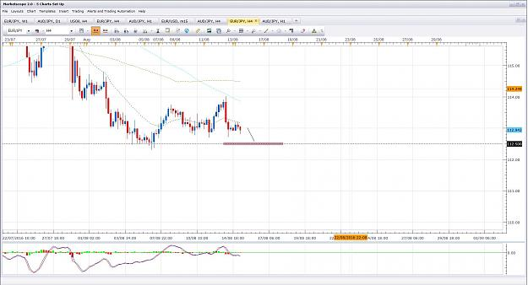
- Aug 15, 2016 9:14am
- JonnyPip
- Joined Nov 2012 | Status: Member | 338 Posts
UsdJpy
Rhythm - Pullback to 21ema, move to round levels
Lets see how they play out
Attached Image (click to enlarge)
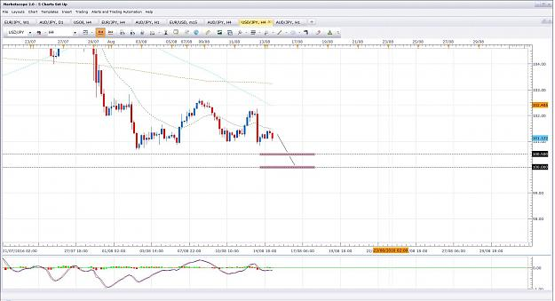

- Post 29,662
- Cleanup
- Quote
- Aug 15, 2016 10:40am
- JonnyPip
- Joined Nov 2012 | Status: Member | 338 Posts
Potential Move in the EurCad
Rhythm - pullback to 21ema 1h, move to round level
Attached Image (click to enlarge)
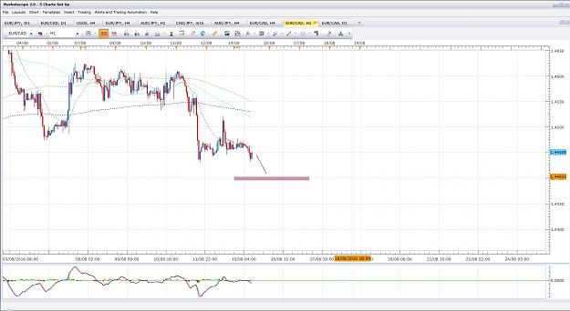
- Aug 16, 2016 7:32am
- JonnyPip
- Joined Nov 2012 | Status: Member | 338 Posts
EURJPY UPDATE
Rhythm - Break 21ema, pullback, move to round level (112.50)
Trade 1 = +82.2 pips
Trade 2 = +42.8 pips
Total = +125 pips
Attached Image (click to enlarge)
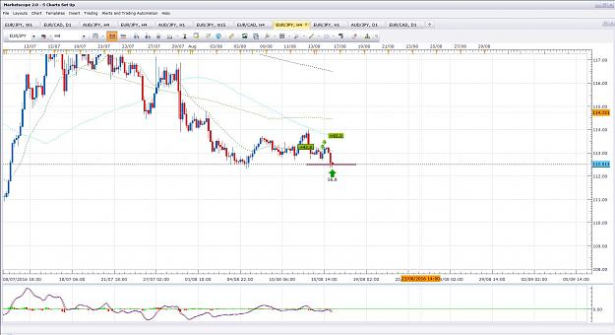

- Post 29,667
- Cleanup
- Quote
- Aug 16, 2016 7:41am
- JonnyPip
- Joined Nov 2012 | Status: Member | 338 Posts
USDJPY UPDATE
The good news with this trade is is worked out exactly as anticipated. It has breached the first target and it well on its way to target 2.
The bad news is, I missed the trade! Got sidetracked with something else and completely missed the entry 
Oh well, that's trading for you. There will always be more and I wont jump in late for the sake of it if it doesn't comply with the rules. So its no problem.
Hopefully someone else made some pips though
Attached Image (click to enlarge)
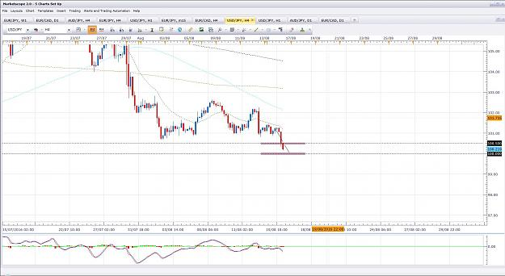

- Post 29,668
- Cleanup
- Quote
- Aug 16, 2016 7:54am
- JonnyPip
- Joined Nov 2012 | Status: Member | 338 Posts
EurAud Potential Opportunity
Rhythm - Pullback to 21ema, move to 200sma plus round level
** Heads up - This also leads me to be slightly cautious about the EurCad move posted before. The Eur is showing strength which could mean the EurCad set up never happens**
Attached Image (click to enlarge)
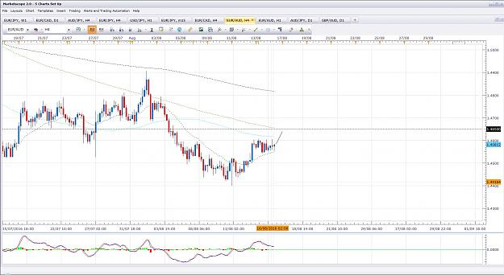
- Aug 16, 2016 1:47pm
- JonnyPip
- Joined Nov 2012 | Status: Member | 338 Posts
AudJpy Update
Only 1 entry on this as couldn't watch the charts while the trade was on. At least one more could have been added I would say. Still a nice trade
Trade 1 = +63 pips
Attached Image (click to enlarge)
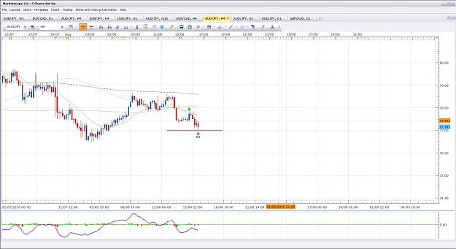

- Post 29,671
- Cleanup
- Quote
- Aug 16, 2016 2:38pm
- JonnyPip
- Joined Nov 2012 | Status: Member | 338 Posts
Quoting jcat
{quote} EUR/AUD, the MACD is showing divergence on the 4 hour, and a double top on the 1 hr. Both signs of weakness.
Hey Jcat,
Regarding the patterns, EurAud is actually showing what is known as an ascending triangle on the 1h, not a double top.
As you can see on the chart below this is a sign of strength, not weakness and suggests higher moves.
Ascending triangles have their own targets (where the purple box is) however round levels have the ability to turn the price and possibly reverse it. This is why it is better to set the limit order below that level as it has a higher chance of being hit. As you can see the R:R is around 3:1.
Patterns can be useful but if you are unsure of the correct pattern,simply following the rules of the market rhythm will keep you on the right track (i.e price is above 21ema).
Same with the divergence, divergence does not mean the price is going to reverse is means there is weakness. Sometimes price can keep going and going whilst there is divergence so if you are trading it you will get slammed.
There is a tendency when you learn to trade (I know as I did it myself) to try and use the indicators as buy/sell signals and to trade from them. You should NEVER trade solely from indicators, only use them to give you guidance of what price may be doing. Of course if you see divergence the price is going to reverse at some point, but it doesn't help with the timing which is what you really need to execute trades successfully.
Plus you have to remember, what looks like divergence at first will often turn into convergence. If the EurAud goes up high/fast enough in price you will see what currently looks like a lower high turn into a higher high on the 4h chart.
Hope this helps
Attached Image (click to enlarge)
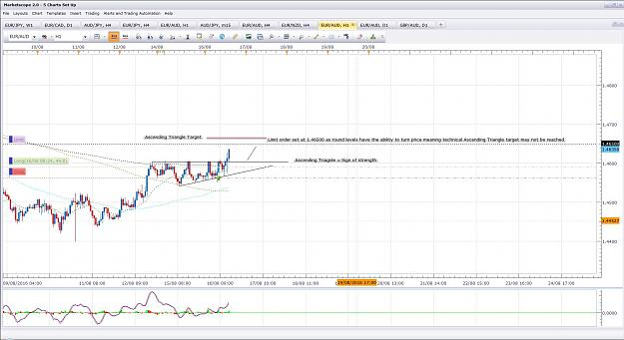

- Post 29,672
- Cleanup
- Quote
- Aug 16, 2016 2:46pm
- JonnyPip
- Joined Nov 2012 | Status: Member | 338 Posts
EurAud Update
+ 55 pips
(I accidentally put two positions on initially and had to remove one straight away, hence the - 3 pips as well)
Total = + 52 pips
Attached Image (click to enlarge)
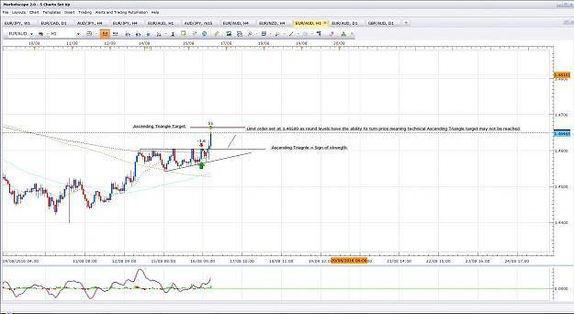
- Aug 17, 2016 8:05am
- JonnyPip
- Joined Nov 2012 | Status: Member | 338 Posts
Quoting orangeRANGE
{quote} AUDcad update Mindful the support @ 200sma & 365ema {image}
This move possibly looks done to me now.
I'm looking for this trade - waiting for the break above the 21ema and a pullback for a move to around the .9950/1.0000 round levels
Attached Image (click to enlarge)
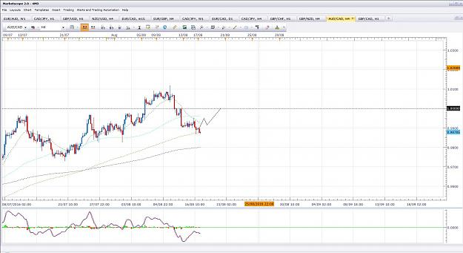

- Post 29,684
- Cleanup
- Quote
- Aug 17, 2016 8:19am
- JonnyPip
- Joined Nov 2012 | Status: Member | 338 Posts
EurGbp Potential Opportunity
Break 21ema, pullback, move to 200sma/round level
Attached Image (click to enlarge)
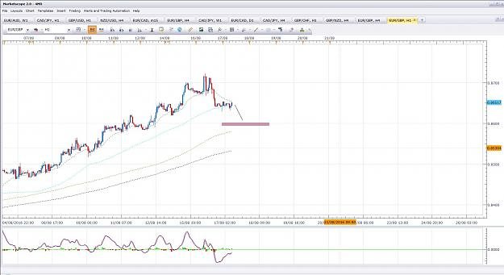

- Post 29,685
- Cleanup
- Quote
- Aug 17, 2016 8:32am
- JonnyPip
- Joined Nov 2012 | Status: Member | 338 Posts
GbpAud Potential Opportunity
Break 21ema, pullback, move to 89sma
Attached Image (click to enlarge)
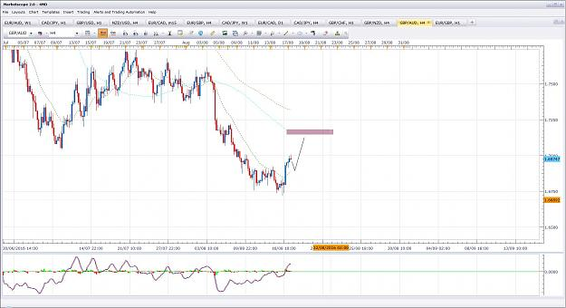

- Post 29,686
- Cleanup
- Quote
- Aug 17, 2016 9:07am
- JonnyPip
- Joined Nov 2012 | Status: Member | 338 Posts
Quoting jcat
{quote} Ok, so talk me through how you got the 40ish pips here. in the first pop. I entered there, I saw it, and entered. I set my profits for the nearest round number. I promptly got stopped out. I thought about setting my profit for the resistant line, that would have been 40ish pips, but looked back and saw it had been to the round number lately. {image}
Hey Jcat,
If you go down to the 1h chart you will see two opportunities to enter on pullbacks to the 21ema. These are the entries you are looking for, keeping it simple is the key.
As you can see the first one happened during the night time here so it wasn't a trade I would take. Second came during trading hours and was the move that took it all the way to the target.
You can see as well the reaction to the 112.50 level and why I set my limit there.
So entry rules as per guidelines of the 4h MACD rules is pullback to 21ema, move away in 1h time frame.
The trick is to find the trade say on the 4h or 1h chart, and once the trade is in progress you can use the 15m or 5m market rhythm to add entries. (Same market rhythm rules apply in all time frames). But adding entries in the 15/5min time frames is not advisable until you can consistently get the the 1h/4h trades correct as you don't want to add to losing or bad trades.
Hope this helps
Attached Image (click to enlarge)
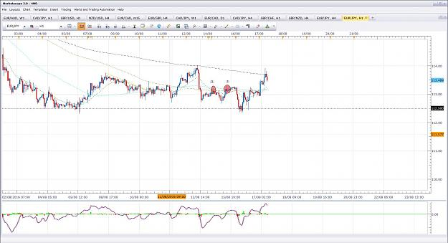
- Aug 17, 2016 3:02pm
- JonnyPip
- Joined Nov 2012 | Status: Member | 338 Posts
GBPJPY Potential Opportunity
Break 21ema, pullback, move to round level/89sma
Attached Image (click to enlarge)
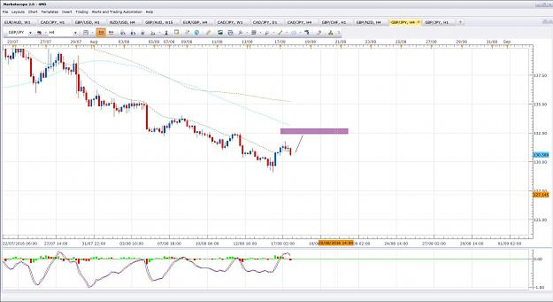
- Aug 18, 2016 7:26am
- JonnyPip
- Joined Nov 2012 | Status: Member | 338 Posts
Potential Opportunity EURNZD
Price has broken above the 21ema and 89sma leaving a potential move to the 1.5700 / 365ema area
Lets see how it plays out
Attached Image (click to enlarge)
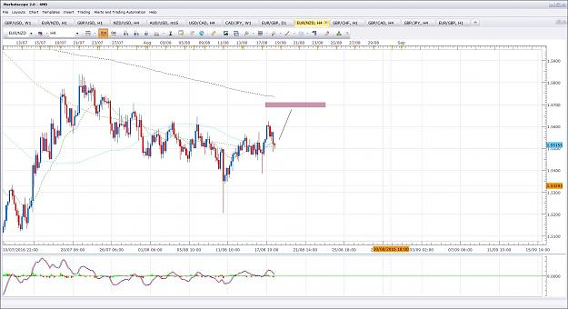

- Post 29,694
- Cleanup
- Quote
- Aug 18, 2016 9:37am
- JonnyPip
- Joined Nov 2012 | Status: Member | 338 Posts
GbpUsd Update
Pullabck to 21ema in 1h, move to round number
+ 87 Pips
Attached Image (click to enlarge)
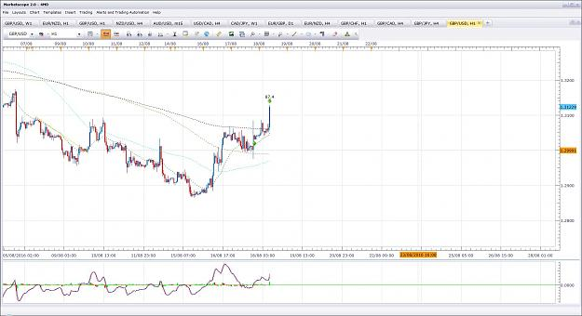

- Post 29,695
- Cleanup
- Quote
- Aug 18, 2016 9:42am
- JonnyPip
- Joined Nov 2012 | Status: Member | 338 Posts
GBPCHF Update
Break 21ema in 1h, pullback, move to round number.
Total = + 68 pips
P.s Anyone spot the ascending triangle as discussed previously in the EurJpy?
Attached Image (click to enlarge)
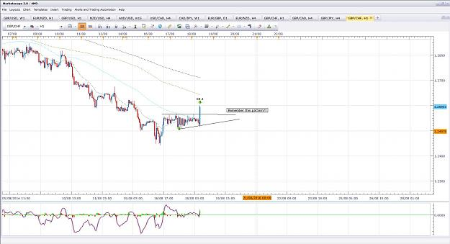

- Post 29,696
- Cleanup
- Quote
- Aug 18, 2016 9:59am
- JonnyPip
- Joined Nov 2012 | Status: Member | 338 Posts
EURGBP Udate
Break 21ema in 1h pullback, move to round level/200sma
Total = + 59 pips
Today looks like payday on the back of the GBP news this morning 
The only down side is it doesn't give a chance to add extra positions, but hey that's trading. You can only take what the market gives.
Attached Image (click to enlarge)
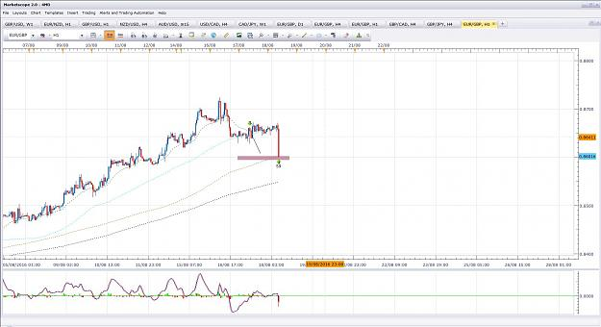
- Aug 19, 2016 7:39am
- JonnyPip
- Joined Nov 2012 | Status: Member | 338 Posts
Potential Opportunity EurGbp
EurGbp is setting up for a break 21ema, pullback, move to 89sma in the 4h chart.
Let's see if it goes today before the weekend
Attached Image (click to enlarge)
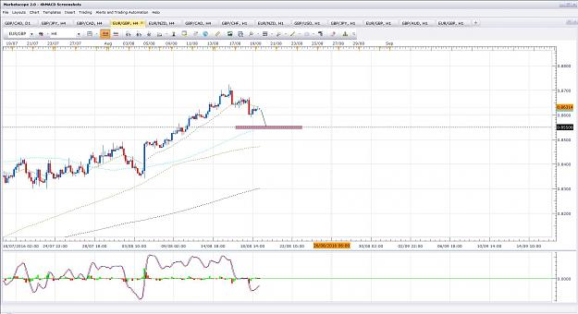
- Aug 19, 2016 12:10pm
- JonnyPip
- Joined Nov 2012 | Status: Member | 338 Posts
GBPCAD Update
Price hasn't yet reached round level target but as it is a Friday and big CAD news coming out in about 1.5 hours I'm out of this pair.
Trade 1 = + 77 pips
Trade 2 = - 4 pips
Total = + 73 pips
Attached Image (click to enlarge)
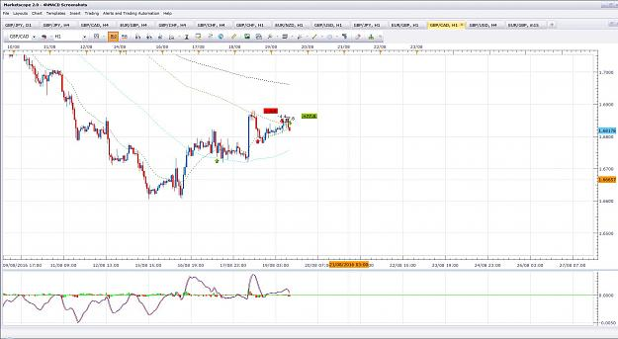

- Post 29,702
- Cleanup
- Quote
- Aug 19, 2016 1:07pm
- JonnyPip
- Joined Nov 2012 | Status: Member | 338 Posts
EurGbp Update
Took the 4h candle earlier, price has turned around and stopped it out.
First loss this week, no big deal. This happens sometimes unfortunately
Trade 1 = -33 pips
Attached Image (click to enlarge)
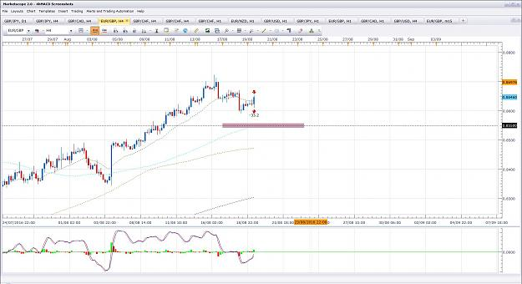

- Post 29,703
- Cleanup
- Quote
- Aug 19, 2016 1:56pm
- JonnyPip
- Joined Nov 2012 | Status: Member | 338 Posts
EurNzd Update
Closed trade due to being a Friday.
Price came within pips of the 1.5650 level and is now struggling at the 1.5600 level.
I'm done with this pair for this week
Total = + 49 pips
Attached Image (click to enlarge)
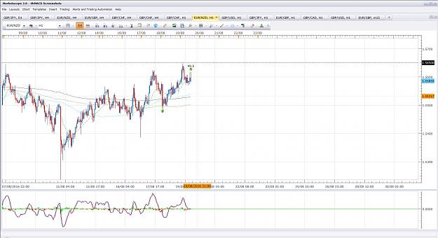

- Post 29,704
- Cleanup
- Quote
- Aug 19, 2016 2:21pm
- JonnyPip
- Joined Nov 2012 | Status: Member | 338 Posts
Well I'm probably done for this week now.
Total for the week =
+ 580 pips
Take away the 2 losing positions of 33 pips and 4 pips =
+ 543 pips
11 trades - 9 wins / 2 losses 82% win rate
Not as good as some of the previous weeks as many trades were just 1 position and I missed the USDJPY trade at the start of the week. But still a good week.
Hope this helped some of the newer traders.
Have a great weekend
- Aug 21, 2016 9:00pm
- JonnyPip
- Joined Nov 2012 | Status: Member | 338 Posts
Potential Opportunity for tomorrow - USDCAD
Price has broken above the 21ema and is above the 89sma, if we get a pullback to the 21ema tomorrow I will potentially be looking for a move to the 200sma.
This is one I am looking at - Lets see how it plays out
Attached Image (click to enlarge)
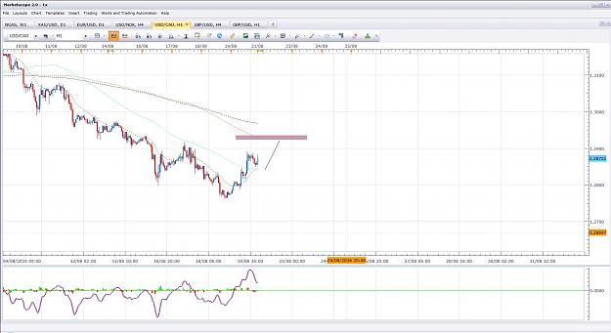
- Aug 22, 2016 8:29am
- JonnyPip
- Joined Nov 2012 | Status: Member | 338 Posts
Quoting timster
{quote} Hi JP, you are doing a great job with this thread. As someone new to this thread, do you have a recommendation as to certain posts or pages to read, to get going as quickly as possible. Obviously lots to read to a point in the right direction to get up and going so quickly would be great!
Thanks Timster
Unfortunately, and I have to be honest with you, there is no shortcut to trading. There isn't 1 or 2 pages you can read which will get you trading successfully straight away. Unfortunately that is the reality of it because trading is a skill and one of the highest earning professions in the world.
Think of it in the context of another profession, say engineering. It is like sitting down to your first lecture at university and saying to the teacher, are there any paragraphs in this book I can skip to so I can start building skyscrapers as soon as possible? Of course you would realise that such a skill takes time to learn and also must be honed, even after the knowledge to carry out such a skill has been learnt.
BUT it is not a stupid thing to ask because EVERYONE wants to do the same thing when they start to trade. I was exactly the same in the beginning and of course, ironically, we are instantly trying to bypass one of the most important disciplines in trading, which is patience.
You can however start to practice without reading every single piece of the thread first, I will tell you how.
Go to the first page and watch the video, it is about 1 hour long and explains the basic market rhythm. There are also a couple of lessons on the first page explaining the market rhythm rules. When you have done this and understand the simple market rhythm rules (around the moving averages) then I would advise you learn about the "entries" and what candlesticks to look for.
Once you have these two things you can start making trades aiming for round levels as target or moving averages (as explained in the 4hmacd rules). R:R is always 1:1 minimum.
My advice is practice taking trades according to the rules, but understand you are learning. If you start taking trades expecting to have a 90% success rate and awesome profits margins you will inevitably get frustrated and annoyed. That is when traders "move on" to find another "system". But of course they just do the same thing because they do not realise they are learning, they just think they are constantly failing. It's a downward spiral most new traders never break out of.
I would also advise taking the h/l break of the candle you choose as your entry to filter out bad trades (That is my tip to you which is not in this strategy). Plus keep a note of the trades you make, if you don't review them you will keep making the same mistakes over and over again. As you do It I would suggest reading all the lessons Phil has laid out and then re-reading them again. You will find you start to adjust the trades you make as you learn more. That is the "quickest" way to get started.
Hope this helps

- Post 29,716
- Cleanup
- Quote
- Aug 22, 2016 9:00am
- JonnyPip
- Joined Nov 2012 | Status: Member | 338 Posts
UsdCad Update
Price has just reached the target, unfortunately it went overnight here so no chance for me to get in. Hopefully someone else got some pips though
Attached Image (click to enlarge)
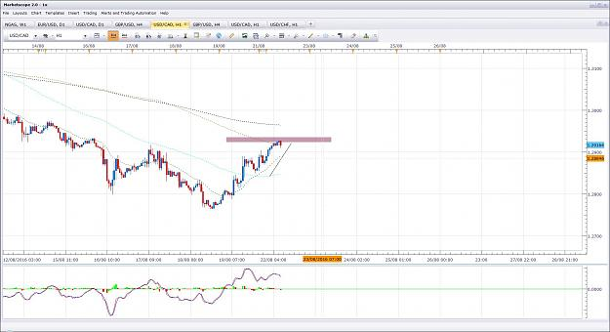
- Aug 22, 2016 9:12am
- JonnyPip
- Joined Nov 2012 | Status: Member | 338 Posts
GBPUSD Potential Opportunity
Can't say there is anything really great on this morning. Few bits and pieces but we might get a chance to squeeze some pips here.
Price has broken the 21ema, pulled back, now we have the 200sma and the 1.3000 level sitting below.
Lets see if it gives us anything (it is a Monday after all).
Attached Image (click to enlarge)
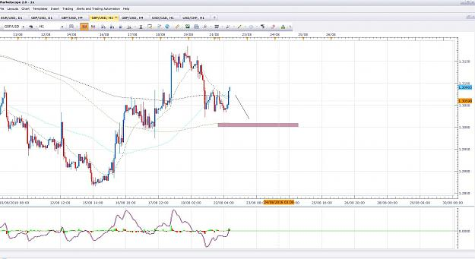

- Post 29,719
- Cleanup
- Quote
- Aug 22, 2016 9:42am
- JonnyPip
- Joined Nov 2012 | Status: Member | 338 Posts
UsdChf Potential Opportunity for this week
Price has broken above the 21ema, if it pulls back to the 21ema as per the rules we should be looking for a push higher into the .9700 / 89sma area
Lets see how it plays out
Attached Image (click to enlarge)


