- Jul 22, 2014 10:43pm
-  JonnyPip
- Joined Nov 2012 | Status: Member | 338 Posts
Hi Yvon,
Very interesting to read through your analysis. Especially as the Eur/Usd has broken to the downside today which usually jives with a Gbp/Usd bear run.
Here's what I have, sorry it looks a bit messy but had to add annotations into it to try and explain.
With the tag of the 1.272 extension/2009 high and it now seeming to form a higher low, it could prove to be a H & S and the turning point in this corrective wave, especially if Carney talks up the GBP tomorrow. There's a lot of air between here the next structural point up so it could be the start of quite a strong move.
If it breaks the 1.70352 level I think there could be a pretty strong down move as I am guessing there are going to be a hell of a lot of stops that get taken out under that point. Once it gets to the 1.618 extension (fitting expanded flat profile) it also hits the may high and the 1.7000 handle. This could prove another turning point back to the upside.
If that doesn't hold I think it is likely to then head down to the 1.6100 / 1.6000 level.
Either way it goes it looks like there could be some good opportunities to get in on pullbacks to the 21ema.
I could be totally wrong, but this is what I have got at the moment. I welcome any feedback as like I say I am still new to this so there is a good chance I am missing something!
Thanks
Attached Image (click to enlarge)
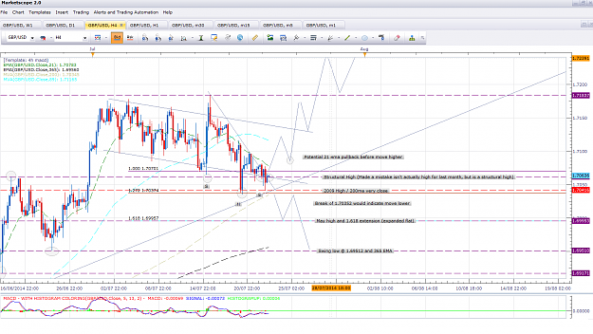

- Jul 23, 2014 12:03pm
- JonnyPip
- Joined Nov 2012 | Status: Member | 338 Posts
Also just taken this trade with the price moving above the 21ema then pulling back to it, small candles giving it a good r:r ratio of about 1:5. Overall trend is up and is third bounce on the support line.
Looks good as per rules 
Attached Image (click to enlarge)
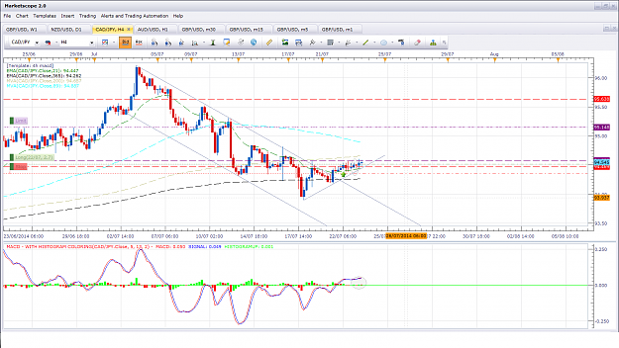
- Jul 24, 2014 12:01pm
- JonnyPip
- Joined Nov 2012 | Status: Member | 338 Posts
Hi Binnie,
Isn't it enjoyable watching yvon trade the system??
For what it's worth, I have this for the NZD/USD, maybe some kind of pullback to the 50/61% before heading up to the neckline/100% extension and around the 21ema. There could be a good entry set up to get back in on the way down, but if it's too strong a move it might not get back up that high, who knows. I wonder what yvons take on it is?
I also caught the gbp/usd move, I'l be looking to get out around the 1.6995 mark.
Got my fingers burnt on the eur/usd as it did tag the 1.618 extension before heading up, jumped in too soon 
Attached Images (click to enlarge)
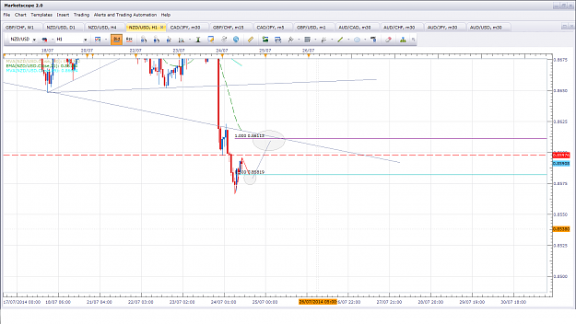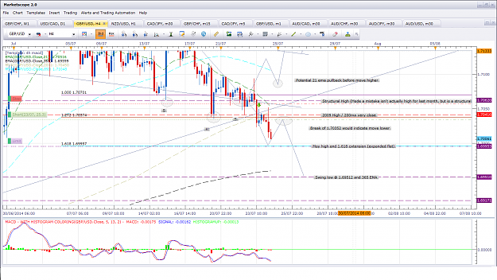
- Jul 24, 2014 2:54pm
- JonnyPip
- Joined Nov 2012 | Status: Member | 338 Posts
Aus/Jpy looks set for a good counter trend trade back to the 4h 21 ema, early entry on the 1 h @ top of the right shoulder could be a possibility? Down to 89 sma on 1 hour chart. Price has broken 1h 21 ema, pulled back, now looks set to head down. Also downwards sloping h&s set up so could be a stronger move, guess we will have to wait and see
Attached Image (click to enlarge)
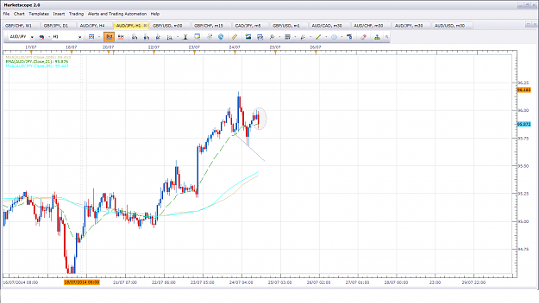
- Jul 24, 2014 4:34pm
- JonnyPip
- Joined Nov 2012 | Status: Member | 338 Posts
No problem 
I agree on the GBP/USD. I'm looking for some kind of pullback to the 1.6995 level before a move down again, at least to the 1.6951 level. if it breaks through there then I think the next stop seems to be the 89 sma on the daily and the 1.69204 level
Attached Image (click to enlarge)
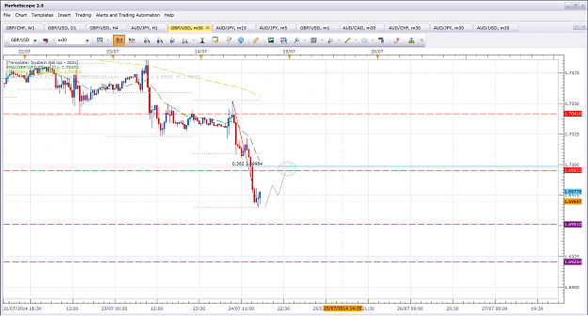
- Aug 4, 2014 8:13pm
- JonnyPip
- Joined Nov 2012 | Status: Member | 338 Posts
Anyone else looking at the set up in the USD/CHF?
In the 4h chart there is a nice break through the 21ema and a pullback, looks like next stop could be the 89SMA in the 4h.
I'm keeping an eye on the 1h chart as I think it will pullback to around the 0.9075 area before heading lower, so might look to get in at a turn around there or wait for the break of the 1h trend line and get in there, possibly on a pullback to the trend line.
Looks like a nice set up to me, guess we will have to see how it plays out
Attached Images (click to enlarge)
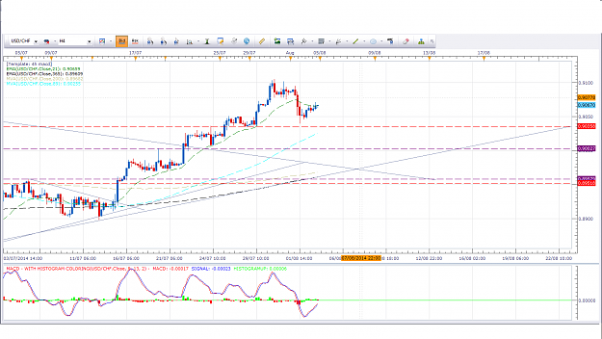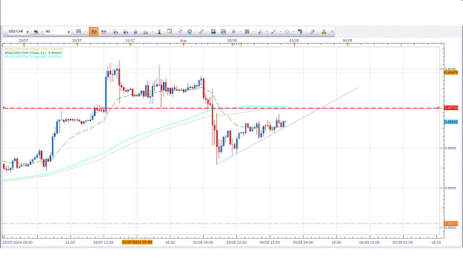
- Aug 5, 2014 12:51am
- JonnyPip
- Joined Nov 2012 | Status: Member | 338 Posts
Hi Binnie,
Absolutely you are right, I would say the 89sma on the 4h will be the support before it moves higher, so technically it will be entry on 4h or 1h but the trade itself would be a daily counter trend trade, trading the c wave of the pullback essentially. Therefore as per rules target will be 21ema (daily) - more or less the 89 sma 4h, which could be a good chance to get back in long. Any further short than the 89sma on 4h I would say is highly unlikely unless some serious news comes out. But who knows.
In regards the gbp/usd it looks a little risky to me to enter now as on the 1 hour chart there seems to be only one wave up so far, so personally i think it will do something like a pullback to 21ema in 1h, then up to 200sma 1h then it will head down. Making a 3 wave pullback with a kind of 50-60% retrace (21ema 1h) then 100% extension (200sma 1h). Which would complete a standard zig zag retracement.
I only say that because when practicing this system i made this exact trade many times only to get stopped out, then the price would head down. But I have also seen this set up where the price goes straight down so you could be right. I guess that's forex eh? Anything can happen.
Attached Image (click to enlarge)
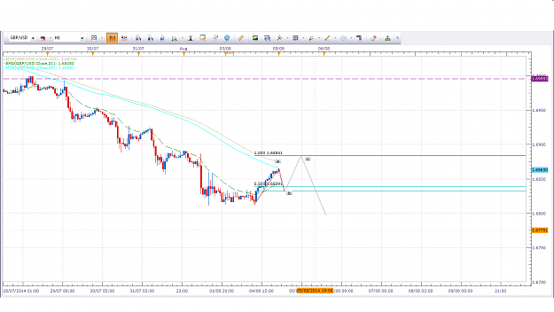

- Post 28,064
- Cleanup
- Quote
- Aug 5, 2014 1:15am
- JonnyPip
- Joined Nov 2012 | Status: Member | 338 Posts
Aus/Nzd seems like an interesting one but again seems risky at the moment to me as it certainly looks like it will be heading down to the 89 sma, but in the 1h chart it has just flagged so it would suggest it is still going to head up a bit further first. Below the c point of the 1h flag would violate the flag and suggest the move down has started so I guess now it seems to be in a bit of a no mans land. What are your thoughts on it Binnie?
Attached Image (click to enlarge)
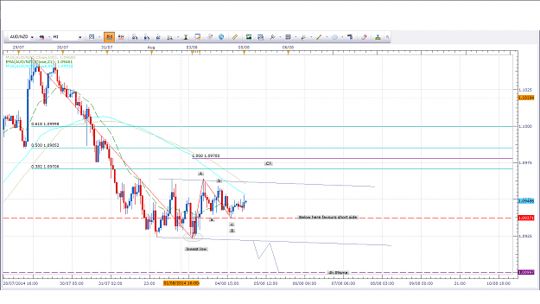

- Post 28,065
- Cleanup
- Quote
- Aug 5, 2014 1:44am
- JonnyPip
- Joined Nov 2012 | Status: Member | 338 Posts
Aud/Usd could be setting up for a move down too? Possible entry on break of 1h trend line and pullback?
Attached Image (click to enlarge)
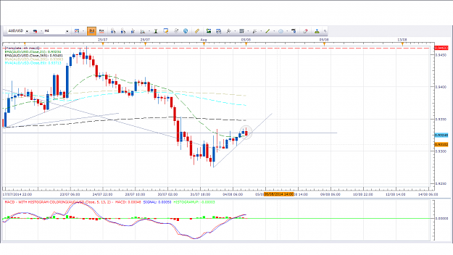
- Aug 5, 2014 11:03am
- JonnyPip
- Joined Nov 2012 | Status: Member | 338 Posts
Hi Binnie,
Burnt by that trade enough times to recognize it now! It helps me to always check the wave counts I find it keep me out of certain trades using this system and acts as a good filter.
Drilling down to the 15 mins it seems to be forming a bullish flag which would suggest another leg up, however if the flag fails then it could be the start of a bigger move down.
So I guess an aggressive trader would take it on the break below c if the flag fails or on the pullback for the more conservative trader (which is break below 21ema, pullback, move away set up). However like I say the 15min bias is still to the long side as flags are usually expected to continue in the given direction.
Either option could play out here and could be traded but any trade long may be short lived, maybe back to daily 21ema, as daily and 4h seem to be on the way down, although there is the added complication of the 1w being in an uptrend and having pulled back to the 21ema indicating a buy.
It's quite risky to predict the market at this point so I think it will be more of a case of watching to see where it goes and try and grab onto it's coattails on the way!
Attached Image (click to enlarge)
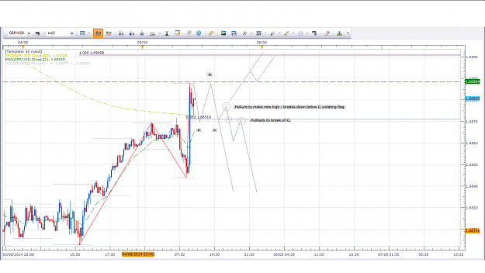
- Aug 6, 2014 12:31pm
- JonnyPip
- Joined Nov 2012 | Status: Member | 338 Posts
Hi Nic,
Essentially retracement waves, moves back towards the 21ema, should happen in three waves which make up the overall retracement. When I zoomed down into the 1h I could see that the had only been one wave which had gone up to the 21 ema therefore it suggested (but not guaranteed) there was going to be a retracement and another wave up to complete the three waves of the overall pullback. Which is why I though it would be risky.
Everyone has there own techniques and I am cautious not to turn this into a thread about wave counts or anything which starts to extend out from the 4h macd system as it is an awesome thread and should be respected. But I find using the principle of the three wave pullback helps me to time my trades better still in line with the 4h macd rhythm. I have posted two of the trades I have on in Gbp/Usd and Cad/jpy so you can see my entries on both. They are essentially the same set up entering on the end of the "third wave" if you like. I have also put up the 30 min chart as well so you can see the entry at the end of the c wave. Usually what can happen is wave A pulls back, people jump in, wave B goes down and people start to see a profit (or worse people fear they have missed the trade and jump in here), wave C goes up and shakes them all out of the trade, wave 1 of the new down move then starts but those who have lost money are too scared to re-enter and end up watching it ride all the way down. That's usually when the computer is sent spinning out of the nearest window.
I hope this helps Binnie as well as this is simply describing a basic flag formation
Attached Images (click to enlarge)
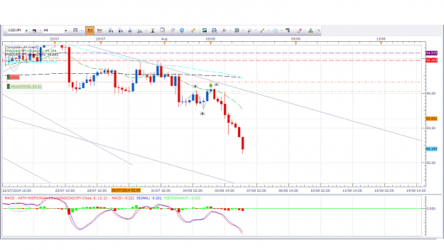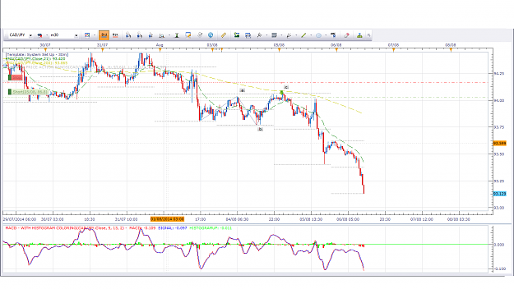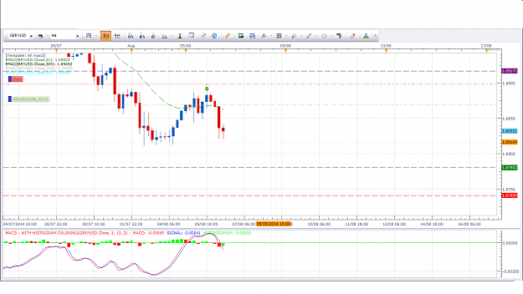

- Aug 6, 2014 11:59pm
- JonnyPip
- Joined Nov 2012 | Status: Member | 338 Posts
Hi Nic,
Wave is drawn from the initial turn around. You can see the pattern seems to be repeating here in the cad/jpy, in the 4h it looks like 1 wave but zoom to the 30 min and you can see it playing out in 3 waves.
I will be looking for it to now extend to the 100% mark and possibly making some kind of double top or something before adding to the short position. On the 4h chart this equates to a classic 4h macd set. So as you can see, this is still classic market rhythm. It just allows me to time my entry better I find, and therefore I usually have a smaller risk this way and so also a better r:r:r.
That's the plan anyway, whether it plays out or not is another question!
Attached Images (click to enlarge)
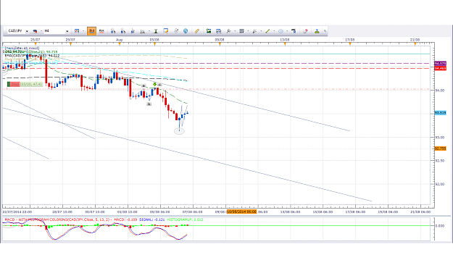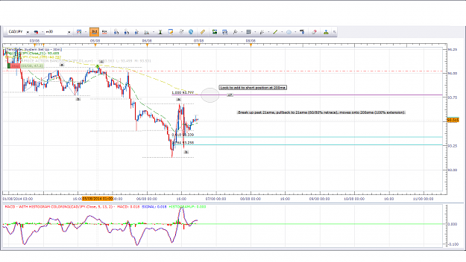

- Aug 6, 2014 11:59pm
- JonnyPip
- Joined Nov 2012 | Status: Member | 338 Posts
Hi Nic,
Wave is drawn from the initial turn around. You can see the pattern seems to be repeating here in the cad/jpy, in the 4h it looks like 1 wave but zoom to the 30 min and you can see it playing out in 3 waves.
I will be looking for it to now extend to the 100% mark and possibly making some kind of double top or something before adding to the short position. On the 4h chart this equates to a classic 4h macd set. So as you can see, this is still classic market rhythm. It just allows me to time my entry better I find, and therefore I usually have a smaller risk this way and so also a better r:r:r.
That's the plan anyway, whether it plays out or not is another question!
Attached Images (click to enlarge)
- Aug 7, 2014 11:21am
- JonnyPip
- Joined Nov 2012 | Status: Member | 338 Posts
Quoting nic73
Jonny, I have drawn it on NZDUSD chart, 1 Hour. Is this what it is suppose to look like? There might be a move down to south on the 3rd wave?{image}
Hi Nic,
Not quite, the A wave you have drawn is WITH the trend, the B wave you did is AGAINST the trend, that is the retracement wave and the one which you can zoom down onto a lower chart to see if it is breaking into 3 waves back towards the 21 ema. A move towards the 21ema in the 4h chart is usually a break of 21ema, pullback, move to 89/200 sma in a smaller chart. Look at the 4h and 1h chart of euro/usd atm. You can see where I am waiting to try and get into this in a short position with a break of the 21, pullback and move to 89sma in the 1h (possibly 60% retracement here instead of 100%). It might not get all the way there and we have the unemployment claims coming out later for usd.
My plan b will likely be a break below the 33638 low if I cant get entry higher up.
Did you catch the cad/jpy this morning? Turned around right in the circle I put up on the 30 min chart yesterday. If you zoom back out into the 4h chart you see it gives the entry really nicely on a pullback to the 21ema. Perfect market rhythm as per rules.
Attached Images (click to enlarge)
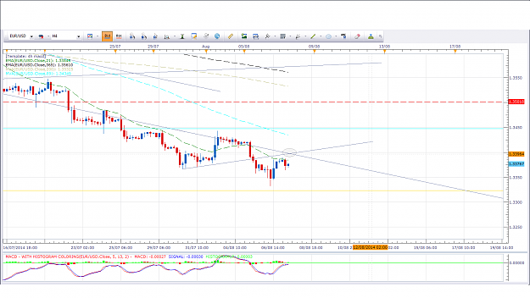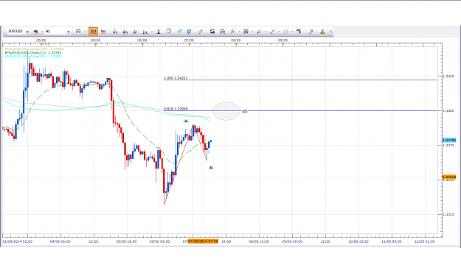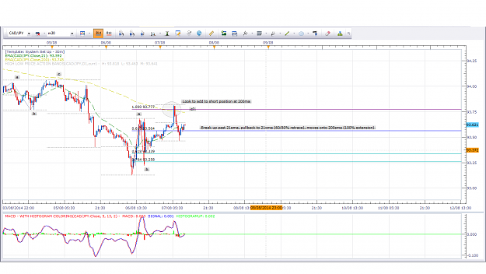
- Aug 7, 2014 12:15pm
- JonnyPip
- Joined Nov 2012 | Status: Member | 338 Posts
So I have kiwi 1h looking like this Nic, hopes this makes more sense.
Attached Image (click to enlarge)
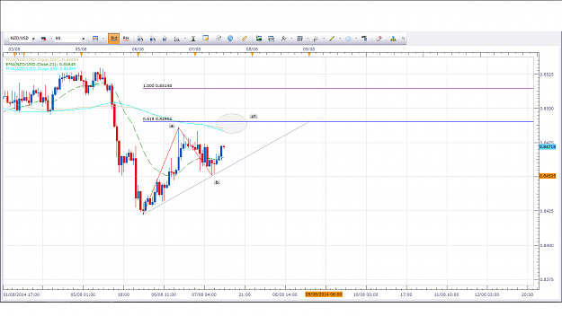
- Aug 8, 2014 12:07pm
- JonnyPip
- Joined Nov 2012 | Status: Member | 338 Posts
Quoting nic73
{quote} Hi Jonny, I am trying to understand this bit by bit. Is my understanding correct: i) A wave should be WITH the Trend e.g. moving away from 21ema ii) B wave should be AGAINST the Trend e.g. pulling back to 21ema iii) C wave is the one giving the signal is should be WITH the Trend i.e. moving away from 21ema. iv) It is when C wave is about to form that we enter. Am i right? Thanks so much Nicholas
Hi Nic,
Sorry I will try to explain a bit better
This is simply how I look for an entry when the price pulls back to the 21ema in the 4h chart. As per rules, price pulls back to 21ema in 4 hour chart and gives signal to either buy or sell as it turns away from 21 ema.
If you go down to a smaller time frame like the 1h chart, the pullback in the 4h chart often will break down into 3 waves in the lower chart and will look like a break above the 21ema, pullback, and move to 89/200 sma (in 1h chart).
So wave a b and c are all AGAINST the trend in the 4h chart. So the move back to the 21ema in the 4h chart can be broken down into three waves in say the 1h chart. (not every single time though as it isn't an exact science).
So below I have posted the chart from yesterday, and the same one again today and you can see it turned around exactly where I drew the circle yesterday. I have redrawn anything on the chart or moved the circle from yesterday. You can also see I have marked the three waves a b c. This whole a/b/c move is ONE move back to the 21ema in the 4h chart.
So looked to enter around .84807 (close of red candle in circle). Then target would be set 4h chart or maybe even daily. So trading in the 4h, entering in a smaller time frame.
For me, when trying to enter at the 21ema in 4h chart, this just helps me enter more accurately.
Attached Images (click to enlarge)
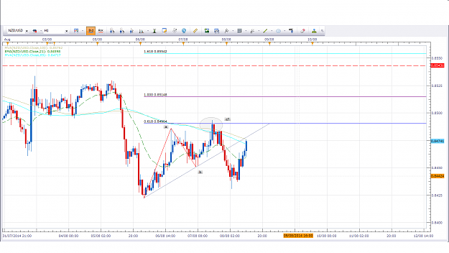
- Aug 8, 2014 12:56pm
- JonnyPip
- Joined Nov 2012 | Status: Member | 338 Posts
Could be another chance to enter the NZD/USD? Looks like right shoulder forming in 1h chart and it also has broken trend line and resistance. Don't think much will happen until monday so could mean holding over the weekend which isn't favoured by everyone.
If H&S does play out it would be downward sloping suggesting a strong down move is on the way.
Attached Image (click to enlarge)
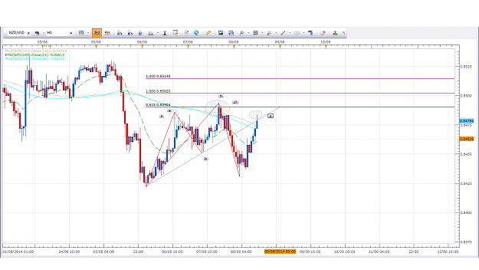
- Aug 13, 2014 1:14pm
- JonnyPip
- Joined Nov 2012 | Status: Member | 338 Posts
Hi Binnie,
I would say the Euro and Nzd are a gamble at the moment because they are set where there could pullback to the 89sma or head down from the 21 as they haven't crossed it yet. I would probably favour a long position here back to the 89 sma but we have the core retails sales coming out in about quarter of an hour which will likely determine which way the price will go. That's why I say it is currently a gamble.
I have a few trades on atm but not Euro/usd or kiwi. Chf/jpy has just broken out of a h&s which could provide a good entry on a pullback in the 30 mins. I am already in as per break of 21ema, pullback in 4h chart. Looking to target the 200sma on 4h chart for profit. Also looking to add to the position on the way there. Next entry in that pair could be break 89sma, pullback, move higher in 4 hour chart.
Aus/Cad and Usd/Jpy look strong as they have both broken out on the daily long so will be looking to hit these pairs as long as they stay bullish. Already long both pairs about 30 pips - set up was pullback and move away from 21ema and broken trend line in daily chart.
More than happy to answer any q's you have Binnie, I will answer them as best as I can. I am still learning and fine tuning things myself but I am happy to give my personal view on things
Attached Images (click to enlarge)
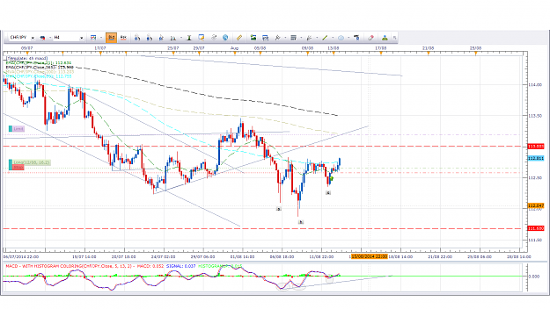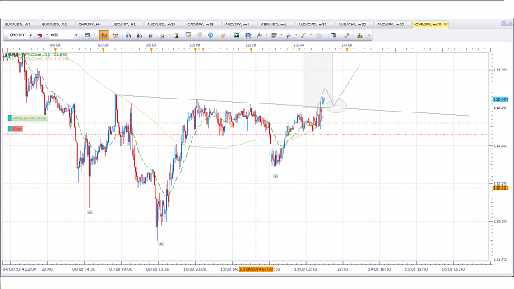
- Aug 13, 2014 3:01pm
- JonnyPip
- Joined Nov 2012 | Status: Member | 338 Posts
Hi Bmgsoares,
Nice to see you taking some money off the market - Those trades were far too risky for me to get involved with, until at least after the news, the USD/Chf does look set for a pullback as you said. That's where I will be looking to get in. H & S is setting up here too so could be all the way down to the 0.89500 mark. That's a long way down from here though many things can happen in between, especially if the H & S doesn't confirm itself.
Got into the euro/usd just after the news broke but looks set to give another entry in the 30 min chart. I agree with trademin usd looks bullish for the moment but as per rules will be looking to exit around the 21ema on eur/usd daily chart.
Attached Images (click to enlarge)
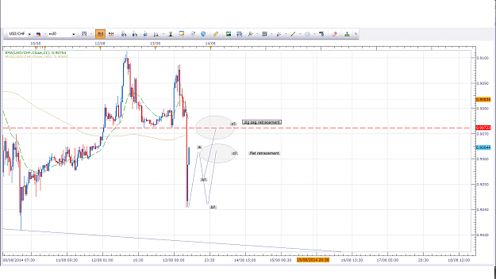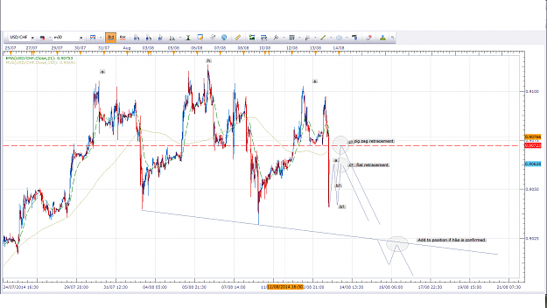
- Aug 15, 2014 10:47am
- JonnyPip
- Joined Nov 2012 | Status: Member | 338 Posts
Quoting binnie
Weekend Whisper - Aussie & Kiwi Hi guys. Only 1 trade this week ( short Euro) and had to close it just before US Red News the other nite. Took a 19pip hit but as it turned out , it saved me about 12 pips which was my stoploss and would have been taken out for sure with the poor US news. I find that the markets in these current times are really unsettled and it is hard to anticipate what may happen. Financial worries, wars everywhere , more & more News Events.... I guess what we got is what we got and I personally still struggle to find that signal...
Hi Binnie,
This is how I have the Aus/NZD pair. As you can see it would suggest any move down could be short lived. Possibly only to the 50% retrace of that small move up.
You can see a large candle on e (of a/b/c/d/e set up)which is where big boys have bought as this is set up for a long break out on the daily. (Unless it fails of course).
I may try and grab a quick short if i can find a good entry in the 30 mins otherwise I personally thinking shorting this pair could be a bit risky, especially anywhere past the 1.0950 level (which is around where I am hoping to go long somewhere)
Attached Image (click to enlarge)
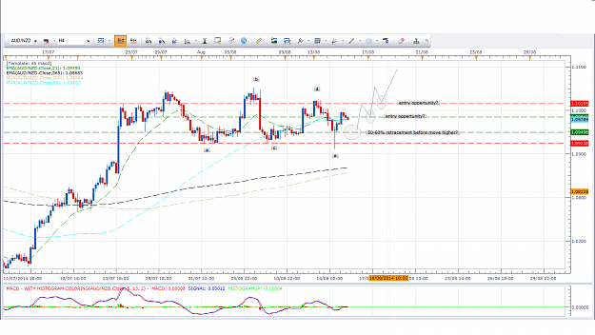
- Aug 18, 2014 7:18pm
- JonnyPip
- Joined Nov 2012 | Status: Member | 338 Posts
Quoting LaGrangeD
{image} EUR USD H4. Right, lets see. At A and B there is a tweezer bottom. There's a HH. The last two bars, prize bounce of MA21. Put Buy Stop at thin red line with SL just under and TP at green line above. Aggressively you can buy now. What can we chance about this outlook?
Hi LaGrange,
Don't forget it is important to always look at the longer term picture.
When the price is trading above the 21ema that simply suggests it is in an up trend. But the uptrend can be a minor correction on a bigger chart, so you think you are trading with the trend (and you are short term) but actually overall you are going counter trend and so you are either haveto make a quick profit assuming the R:R is there, or get stung. As you can see I took a short sell just before it broke out as looking at the daily you can see this recent long (up/buy) run was a minor correction in the bigger down move. So yes it was in an up move but it was the end of that correction. But also the end of that up trend can often by these rules be shown by a pullback to the 89sma, which is what happened here. So the "mood" was still short.
If I miss getting in before price breaks out I don't feel that I have missed out I just see it as a sign the price is now moving again and the markets ready to give you a chance to make some money.
Now price has broken down I will be looking to add to the position on a pullback to the 21ema at some point(s). So there should be a couple more chances yet to get involved (assuming it doesn't do a u-turn on some big news/event!)
That's my view anyway
Hope this helps
JP
Attached Image (click to enlarge)
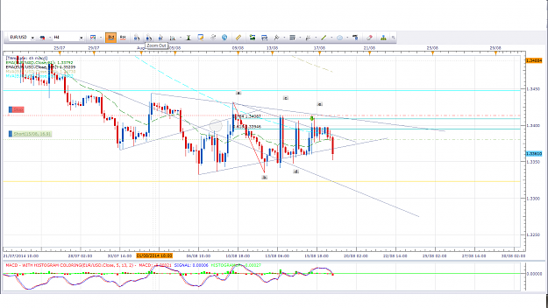

- Aug 18, 2014 9:53pm
- JonnyPip
- Joined Nov 2012 | Status: Member | 338 Posts
Quoting binnie
{quote} Hi JP - after Nic's homework on the weekend I think I am starting to see this also. I used the H1 even tho you sometimes show the M30. Can you let me know if this is close to what you are saying please? If the 89 ( 161extn ) is tagged on the H1 & price rolls down with a bearish close, is that sufficient to try a short if it appears before the TC on H4 macd? Or is there another trigger on the H1 macd still to come. Sometimes it seems as if the H4 trigger could happen before the H1 ( or M30) but by waiting for these shorter T/Frames...
Hi Binnie,
Nailed it as well bud 
I don't usually look at the Eur/Chf as they tend to trade together so it can get a bit choppy
I have broken down what I think will happen for you below on the 4h and 30 mins and got pretty much the same thing.
How cool is it to see that the market rhythm fits in perfectly with the way the market moves in waves? The clarity at times can be amazing, like reading a book.
The chart you have chosen seems to be a perfect example as now seems like the "perfect" time to sell (as per rules) as it has pulled back, but I believe it will move down from here by about 50-68% then head up again to the 21 more than likely taking out anyone who enters now or on the next macd signal/candle down. As you rightly say this should be a pullback to the 89 in the hour/30mins chart.
If you look closely it seems in the 30 min chart this pullback will break down into 5 waves not three, suggesting it is in fact likely to follow the path I have laid out.
You have to remember though that any news or event can send this shooting down/up and could blow all of this out of the water and nothing is guaranteed as I am sure you know.
I use a few different techniques for entry but generally speaking it should just give a standard macd double top/h&s as outlined with the rules. The rules apply no matter what time frame.
I guess we will see how this one pans out but it seems to be the perfect candidate. I will be keeping an eye on it. Thanks for the heads up
You will see entry in the lower time frame will reduce your s/l and risk as well. Which ultimately for me is the main basis for each trade
Attached Images (click to enlarge)
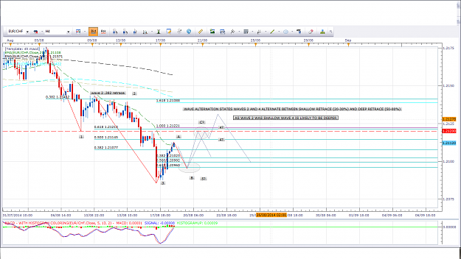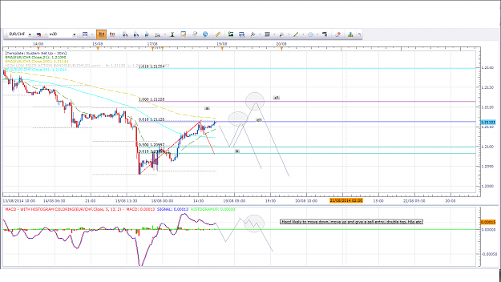
- Aug 19, 2014 11:31am
- JonnyPip
- Joined Nov 2012 | Status: Member | 338 Posts
Quoting nic73
Jonny / Binnie / Richard / anyone interested, Can I trouble you to enlighten me how you would trade GBPUSD implementing the 123wave with the 4h MACD system? Thanks {image}
No problem Nic I hope it helps you to time you entries better like it does with me. You should see it pop up more and more
The Gbp/Usd is a good one for why the market rhythm is important. If you look at the 30 min chart the break above the 89sma, break below 89sma and then move up to the 200sma is very messy. Take away the moving averages and it is going to be very difficult to workout the wave count. But put up the macd system and like magic it will show you!
We know from the rules price will tend to break above the 89sma (this must be wave a) pullback to the 89sma (wave b) move onto the 200sma (wave c)
So by the time it has reached the 200sma we know it has likely already made the abc retrace even if it looks so messy we can't pin point the exact waves.
As you can see in the 30 min once it has reached the 200ma it gives an abcd set up AND a macd 1 2 3 (trigger) signal. Entering shot at the end of the b wave is asking for trouble at any other time because it is completely against the trend. But we know in the 4h chart it has pulled back to the 21ema and so now, as per rules, is likely to head down from here. Meaning anyone buying at that point, even though the short term 30min trend is up (even at its peak), is actually going counter trend.
There should be more chances on the pullback to the 21ema in the 4h if you are not involved yet though
Attached Image (click to enlarge)
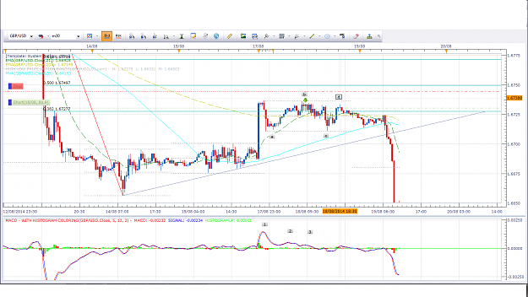
- Aug 19, 2014 3:50pm
- JonnyPip
- Joined Nov 2012 | Status: Member | 338 Posts
Quoting trademin
{quote} Hi Nic, "2. Please share how you entered GBPUSD . I thought it was going downwards, which it did but again I did not pull the trigger not knowing if this was for sure. Besides I have a 1.67026 as a temporary resistance close by the entry." A bit soon, but was expecting the pull back earlier than when it happened, sometime I am too quick on the trigger {image}
Hi Yvon,
If you check some of my earlier posts to Binnie and Nic I explained to them how I personally filter those trades to stop myself entering too early. That trade happened to me SO many times until I started looking closer at the pullback to the 21ema in 4hs in a lower time frame. Checking the pullback has made the right amount of waves back helped me a lot, it may be something you can find useful as well
I know Phil Nel doesn't enter using 4hs as he always says he uses smaller time frames.
If you see below in the 30 mins I got entry at the top by checking the waves. But make no mistake, it still follows the 4h mach rules. It's all the same thing.
It helped me out a lot anyway but everyone has their own way of doing things
Attached Image (click to enlarge)
- Aug 21, 2014 12:38pm
- JonnyPip
- Joined Nov 2012 | Status: Member | 338 Posts
Quoting nic73
Good Morning from Asia. Did this trade on GBPUSD at around midnight here. Noticed also on H1 chart, there was a formation of 123wave which gave me the confidence that the market is ready to move away from 21ema on H4 TF and for a early entry. Essentially, the BPM and the long spiked candle gave the hint for a high probability trade. Currently about 40pips gained. SL adjusted to BE TP about 96pips Please give me your comments. Jonny, value your advice. Thanks. ps. 4h MACD system remains the main one for my trading and 123 wave is used as a filter...
Hi Nic,
You traded it correctly although you labelled it wrong.
A good way to remember is wave a will be against the trend, wave b will be with the overall trend (which is why people jump in at this point), wave c against the trend (often stopping people out). Then the start of a so called wave d is the next leg down.
But as you can see you did actually nail the trade anyway!
Hope this helps
Attached Image (click to enlarge)
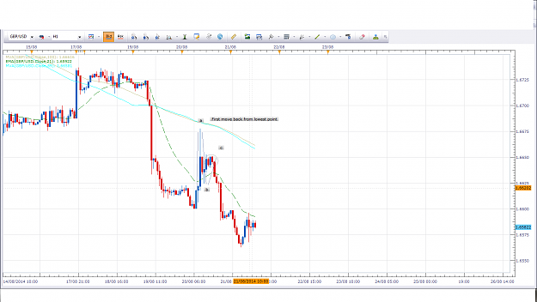
- Aug 21, 2014 1:00pm
- JonnyPip
- Joined Nov 2012 | Status: Member | 338 Posts
Quoting nic73
{quote} Good day Richard, At the moment I have not spotted another example to post to you. But I have here AUDNZD that I was watching this afternoon and anticipating a pull back on both H1 and H4. But that did not quite happen thus the wave cycle was not complete. I have posted the charts explaining why I did not take the trade. (I would have entered if without knowledge of the 'abc wave' system). I am very new to this and is testing out if I have fully understood it. I guess Jonny would be the best person to ask around here. If there is any inaccuracy...
With the Auz/Nzd I am looking at the same thing as you.
4h macd rules state, break of 21ema, pullback to 21ema, move to 89 sma.
Whilst this might seem set up in the 4h chart if you look at the 1h chart you will see you would be breaking the rules of market rhythm by buying here. Price has broken the 21ema in 1h, pulled back, so now we would assume it will move back to the 89sma before it will head higher.
Daily is set for long breakout so I am waiting for a pullback to the 89sma in the 1h before looking to buy in.
Attached Image (click to enlarge)
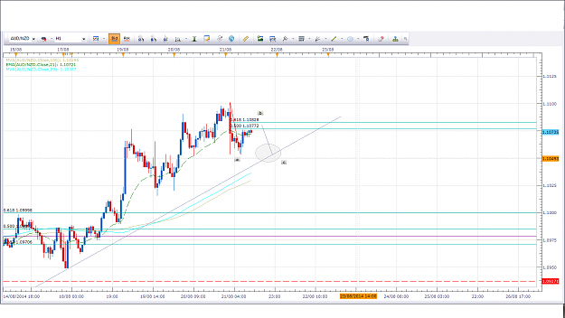
- Aug 21, 2014 1:40pm
- JonnyPip
- Joined Nov 2012 | Status: Member | 338 Posts
Quoting nic73
{quote} Thanks. And looks like I am not familiar with drawing the wave. A little unsure how it's at the moment. But will have to figure it out. Thanks Jonny and please keep posting feedback to me.
No problem Nic, I am happy to help in someway if I can
You will find it easier and easier the more you see it happen. I have spent a long, long time going through all this stuff so I see it easier now. But it can be confusing at first.
Just remember-
Wave a is the first "move" towards the 21 ema in the 4h chart. It starts at the lowest or highest point and as far as I know is impossible to trade as price can reverse at any point. This is usually 1 move through the 21ema on the lower charts.
Wave b pullsback to 21ema
wave c can extend to the 89 or 200
So if you always look for the lowest (in a down trend) or highest point (in an uptrend) that is where you start the first counter trend move of wave a from
You can see it looks to be playing out in the eur/usd at the moment
Attached Image (click to enlarge)
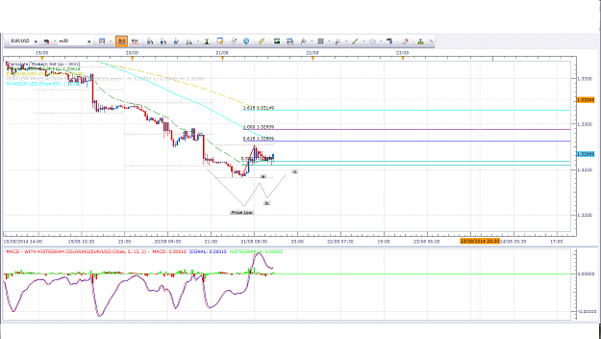
- Aug 22, 2014 12:04pm
- JonnyPip
- Joined Nov 2012 | Status: Member | 338 Posts
Quoting yaakruay
Pulled the trigger early on a sell on the Euro. Testing my new found little dangerous knowledge.... Looking for that a.b.c on the lower time frames to support the H4 move. H4 deep macd...retraced back to zero (boz) Price just under a BRN and a previous support level. Price tabbed the 21 Lets see a TC down to the previous low. H1/M30...both showing a.b.c pattern up...just waiting for the leg D...down down down.... {image}
Hi yak,
This is how I see it, slight change of plans for me.
It did play out similarly but there is a slight difference. If you look in the 30 min it pulled back to the 89sma/fib extension in 5 waves, not 3.
We know what we are looking to trade here is a pullback to the 4h 21ema
Without getting too complicated, the fact it pulled back in 5 waves not three suggests to me that it is wave a on the 4h chart which means we have probably still got another B and C wave on the 4h chart yet to come.
So essentially it now looks like this is going to be (in 30min chart) a break of 89sma, pullback, move onto 200sma trade. (rather then heading straight down from here)
Or on the 1h chart if you prefer, it seems to still be in the process of making the move - break of 21ema, pullback to 21ema (happening now), move to 89/200sma
So my bias at the moment is potentially looking to catch a quick long trade up to around the 200ma (in 30min chart) this afternoon. Possibly look at a short on monday.
Please remember though this is only my opinion of what I am personally thinking. I'm not making any recommendations to take or not take trades
Attached Image (click to enlarge)
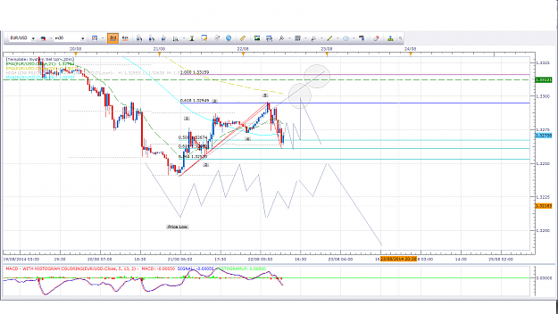
- Oct 15, 2014 8:33am
- JonnyPip
- Joined Nov 2012 | Status: Member | 338 Posts
Hi Yvon,
Nice posts agree with everything you have there. Pretty spot on as usual!
Nic for the Nzd/Usd I would say Yvon is right, bearish bias but for me there is a chance of a larger pullback.
The currency is in limbo at the moment. It is making higher highs and higher lows in the 4h chart which means it is in a (short term) uptrend currently so could be risky to trade short now.
For me I will wait for the market to show its hand above or below the marked lines. Wait for a pullback to 21ema and then go with the flow
Having said that if you can get in short with a technically good set up which gives you a small stop loss the odds are in your favour for more bearish momentum, so could be worth a shot. But I'm going to wait it out. 
Attached Image (click to enlarge)
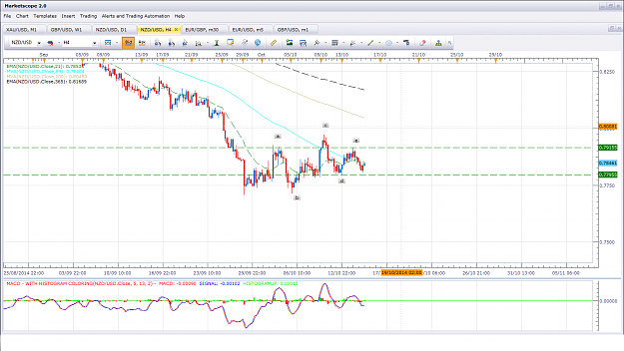
- Oct 16, 2014 9:57am
- JonnyPip
- Joined Nov 2012 | Status: Member | 338 Posts
SL to break even as this above this 100% mark red candle I think will be back to 89sma, if not this is where I will add!
Attached Image (click to enlarge)
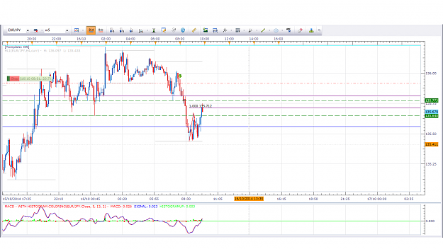

- Post 28,426
- Cleanup
- Quote
- Oct 16, 2014 10:13am
- JonnyPip
- Joined Nov 2012 | Status: Member | 338 Posts
Added another short with less units (slightly late as I was typing!)
Moved second stop to net BE point so either plain sailing down from here with extra units or will turn around and take me out for no loss.
Risk : 0 pips
Reward : 0-250 pips
Just how I like my trades!
Attached Image (click to enlarge)
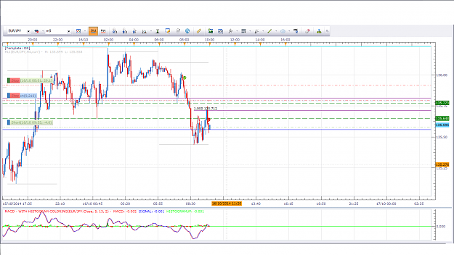

- Jan 29, 2015 3:09pm
- JonnyPip
- Joined Nov 2012 | Status: Member | 338 Posts
Quoting trademin
{quote} ... the pair was at around 1.1695, now something like 400 pips lower, at least the price is going the right way: 1.1274 already...
Great stuff Yvon (as usual!)
Im loaded up long on the EurUsd at the moment, looking at the Dollar Index it looks set for a move to the 89sma in the 4h having broken the 21ema and pulled back. Looks like the could be a bit of a snap back in the Eur/Usd up to the 1.15412 level perhaps
Looking for break of 30 min and pull back to confirm it. I will also look to add to it there as well.
What's your view of this the moment?
Thanks
Attached Image (click to enlarge)
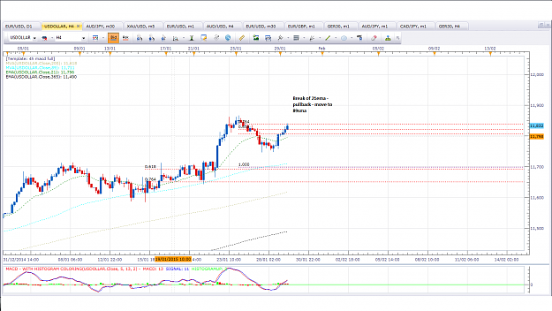
- Aug 14, 2015 7:20am
- JonnyPip
- Joined Nov 2012 | Status: Member | 338 Posts
Nice looking counter trend trade on Eurusd. It is a counter trend trade so more risky. I have removed some of the other moving averages to give a clearer picture, pullback to 21 ema which also is a support level. Turned at 61.8% as well.
It's possible this could go down to the 1.10256 area if it is a zigzag correction. I will play it safe though at take profit at the support level and 21ema. If it is going further down it will like give another break and 21ema pullback anyway
R:R over 3:1, so worth it for a counter move if you ask me
Attached Image (click to enlarge)
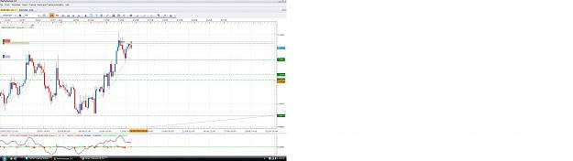
- Aug 14, 2015 8:29am
- JonnyPip
- Joined Nov 2012 | Status: Member | 338 Posts
Looks like a nice set up on GBPCAD forming
Price broke out of trend line, pulled back to trend line and 21ema+89 sma
Overall trend is bullish
Personally I will likely take the break of this 4h candle, if it is a bullish candle that is how I would trade it anyway, but a bearish type pin bar on the trendl ine, it COULD be quite an explosive move away meaning anyone waiting for a nice bullish candle will miss out.
Lets see how it plays out
P.s - The counter trend trades are still on by the looks of it
Attached Image (click to enlarge)
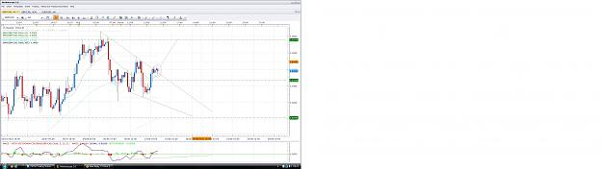
- Aug 14, 2015 4:35pm
- JonnyPip
- Joined Nov 2012 | Status: Member | 338 Posts
Update:
Closed out my EurJpy trade, made up for the EurGbp and EurUsd pairs I got stopped out on plus a bit extra.
There seems to be a broadening top pattern appearing in the 30min GbpCad pairs.
I have closed out my trade and will wait and see instead if this pulls back a bit further before getting in. There is clearly uncertainty here now and I don't want to gamble as people already long may start to take profits here and push the market down. If it does break higher I will see if I can get another long entry to the 2.05778 level.
If not it will be just one of those trades you watch whilst it goes in the direction you anticipate, but there will always be another one next week!
Hi Ross - It's impossible for anyone else to say if you are ready to be honest, really only you will know that by being consistent on a demo account. Even when you switch over it becomes a lot more emotional, even if you are 100% certain you will conquer your emotions.
If you keep at it, you will get there. How soon?- That is another question my friend
Attached Image (click to enlarge)
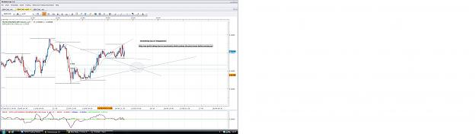
- Aug 17, 2015 10:43am
- JonnyPip
- Joined Nov 2012 | Status: Member | 338 Posts
Hi Nic,
I fully agree with the overall outlook of NzdUsd - It looks set to come down.
This just leaves it as an issue of timing, and in my opinion we have a slight problem at the moment.
In the 4h chart we made a new low, followed immediately by a new high in no less than 3 4h candles.
This strong buying which made a new high has signaled to many traders that this is likely to now make a new high or move up again.
This may or may not be what happens, but as a result of having a new low followed by a new high, technically traders are split as to whether this will be going up or down short term. This means, in my opinion, any buying or selling in between the new high and low will be right in the middle of no mans land where the bulls and bears are battling.
As a result I am currently on the sidelines with this pair, if the bears break lower there should be a good chance to get in on a pullback, if the bulls push this to new highs, there MAY be a chance to grab some pips to the upside, but with the overall trend down (as you correctly said), it might be better just to wait for a chance to short at a higher price.
That's how I view this pair at the moment
Attached Image (click to enlarge)
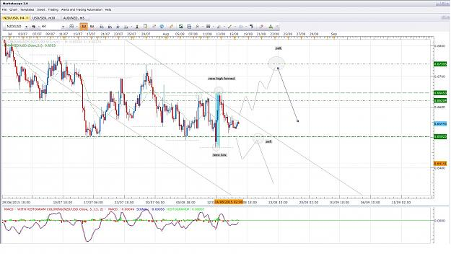

- Post 29,030
- Cleanup
- Quote
- Aug 17, 2015 11:50am
- JonnyPip
- Joined Nov 2012 | Status: Member | 338 Posts
Looks like a nice set up in EurJpy
Price has pulled back to the 21ema, now looks to be heading higher
There is a chance of a larger pullback to the lower trend line but the 1:4 RR plus other technicals make the trade worth it for me.
We may see 1 or 2 small red candles down first before it moves up however
I have removed moving averages not in use as to give a clearer view
Attached Image (click to enlarge)
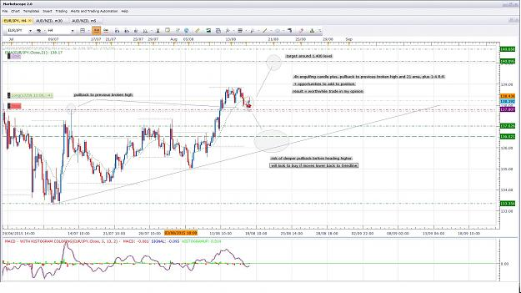

- Aug 17, 2015 12:33pm
- JonnyPip
- Joined Nov 2012 | Status: Member | 338 Posts
No problem nic
I have also taken two positions on Eur Aus
The first for reasons similar to the EurJpy - 21 ema pullback set up with macd signal
The second is because it also broke a trendline and pulled back in the 30min chart.
There is a higher chance of position 2 being stopped out as the stop is much tighter, so I use less risk money wise.
But because of the tight stop it gives a better R:R.
I am not convinced however this will make new highs yet, I may be wrong though
Attached Image (click to enlarge)
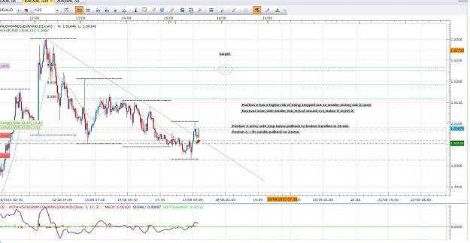
- Aug 21, 2015 2:36pm
- JonnyPip
- Joined Nov 2012 | Status: Member | 338 Posts
Make or break for the NZDUSD???
NzdUsd looks interesting going into next week.
It made a new high as I suggested was traders expectations in my last post. How high it goes from here, or if it goes higher past the trend line at all, who knows.
There should be a chance to make some pips on this pair regardless of whether it goes up or down!
I have attached a picture of chart below to show what I am looking for - I look forward to any feedback
Attached Image (click to enlarge)
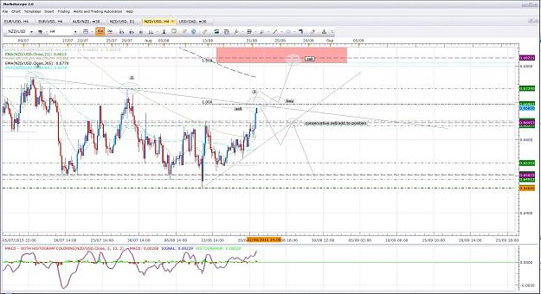
- Aug 24, 2015 7:25am
- JonnyPip
- Joined Nov 2012 | Status: Member | 338 Posts
NzdJpy
Broke out of consolidation zone, as long as this breakout holds we could se moves down to the .78-.75.50 area
I will try and hold onto this trade and add to it rather than take a short term profit
Attached Image (click to enlarge)
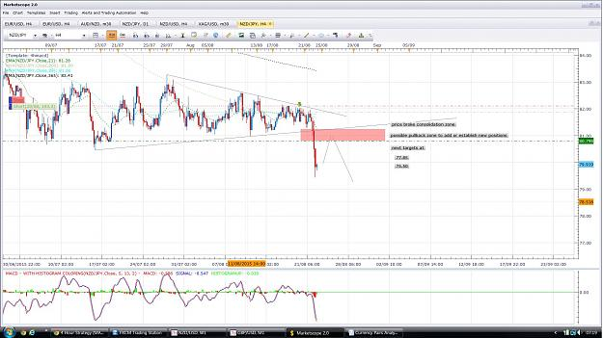

- Post 29,047
- Cleanup
- Quote
- Aug 24, 2015 7:41am
- JonnyPip
- Joined Nov 2012 | Status: Member | 338 Posts
AudUsd
Made new low after messy period over the ma's.
New low suggests a further a move lower, I anticipate down to around .70500 level and will be looking to add to position from here if given a good opportunity.
Attached Image (click to enlarge)
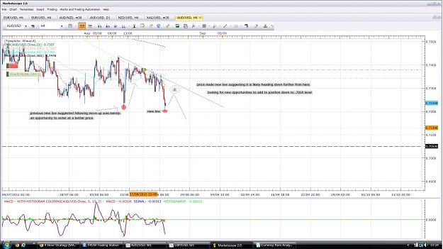

- Post 29,048
- Cleanup
- Quote
- Aug 24, 2015 8:05am
- JonnyPip
- Joined Nov 2012 | Status: Member | 338 Posts
GbpNzd
Price looks to have completed a large triangle pattern with wave 5 overshooting and coming back in
Price then moved above 21 ema and pulled back to it.
Of course, nothing is certain in forex but this looks like a great set up in my opinion and I will be taking it if we get a nice move from the 21ema
Attached Image (click to enlarge)
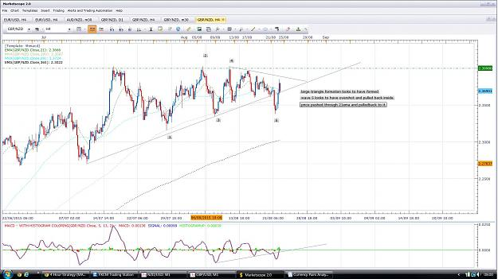
- Aug 24, 2015 10:04am
- JonnyPip
- Joined Nov 2012 | Status: Member | 338 Posts
Hi nausting,
I pretty much completely agree with your analysis on the NzdUsd, the only thing that concerns me is the new low made on the daily time frame.
It just looks too early for me to get involved here, as it stands I am anticipating a break of the supporting trend line and a pullback before a move lower.
If it makes a new high in the 4h and takes out that top trend line, I will consider longs.
Hope this one plays out for you though
Attached Images (click to enlarge)
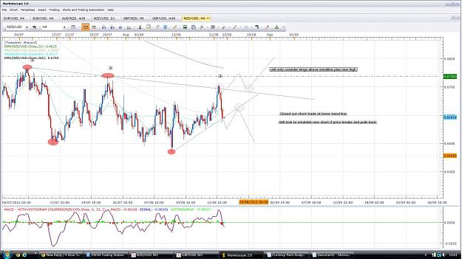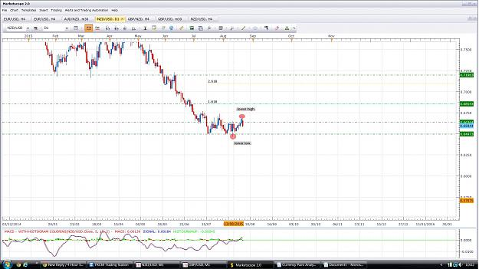

- Aug 28, 2015 7:42am
- JonnyPip
- Joined Nov 2012 | Status: Member | 338 Posts
Quoting nic73
This week, on Monday alone, managed to trade 3 counter trend trades on EURUSD, USDCAD and NZDUSD pocketing some 150pips in total. Thanks to the sudden surge of the market on the opening of US market on Monday. The move went towards my direction that I predicted. But after Monday, market momentum becomes kind of weak and I did not quite spot entry opportunity with the pair I am trading. But I am happy with my results and analysis of what I have already taken. Below is NZDUSD chart. Price pulled back to 21ema and looks like moving away. Momentum is...
Hi Nic,
Good work buddy
I agree with your analysis. I think this is a little early to get in at the moment but if we get a pullback to the macd zero line and then a good signal away from the 21ema and the .650 level it could the start of the next move down. If it breaks above that .650 level it could move as high as even the .6650 level though. As you say, there is also no harm in waiting for a move away then looking to get in on the pullback but then we have to accept it might not come as price moves strongly.
So to clarify, I will personally be looking for a zero line macd signal from the bottom of this range and the 21ema with a kind of double top in the candles. Or if it breaks above the 21ema I will look for a pullback and a TC signal. The 89sma and 200sma would be a little close for me and I don't see any reason the price couldn't make its way back to the top of that range anyway, sop that would be my target on a long TC pattern after a 21ema break.
Attached Image (click to enlarge)
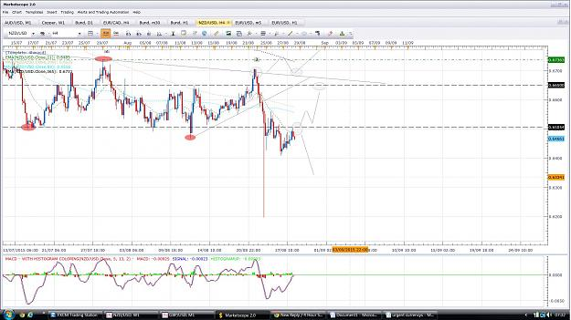

- Post 29,074
- Cleanup
- Quote
- Aug 28, 2015 8:00am
- JonnyPip
- Joined Nov 2012 | Status: Member | 338 Posts
The EurJpy trend line didn't hold as I expected it to. I anticipated greater EUR strength over JPY strength however there is no point denying what we see with our eyes right?
Price broke the trend line and has now pulled back to no less than FIVE resistance points, the 21ema, 200sma, 365ema, trend line, resistance level.
Does this mean price will definitely go down? We know the answer is no as anything can happen. But if we get a signal from the macd zero line it could be a very nice set up.
Personally if I can get in I will try and let it run to the 133.851 level if possible with an eye on the green line around the 135.27 level as somewhere it could bounce or maybe even give another opportunity to add to it.
It is also the right shoulder of a daily head and shoulders pattern on the chart (not the macd) so we could get an even bigger move down.
If price breaks above the 21ema here and pulls back, we could get a nice TC to the top of the previous highs. We will have to see whats on offer
Attached Image (click to enlarge)
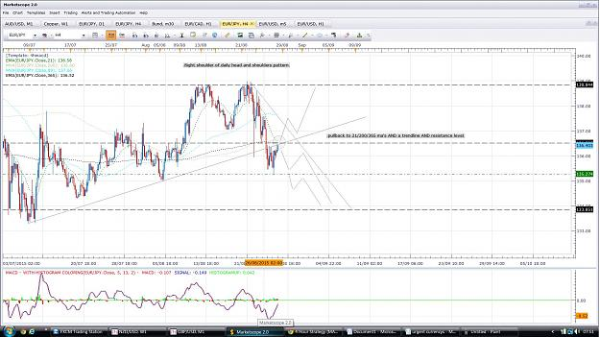

- Post 29,075
- Cleanup
- Quote
- Aug 28, 2015 8:24am
- JonnyPip
- Joined Nov 2012 | Status: Member | 338 Posts
Heads up:
A nice clear set up seems to be forming in the EurGbp
A look at the 4h charts gives us a pullback to the 21ema and a MACD zero line signal long
When moving down to the 1h chart we can see a nice triangle seems to be forming.
The entry could be a pullback to the 21ema in the 1h chart followed by a TC or more conservatively a break and pullback to the trend line.
The projected target for the triangle is around the .746 level giving a hefty R:R and possible chances to add to the position at intervening support/resistance levels.
This could be a nice move, we will have to wait and see
Attached Images (click to enlarge)
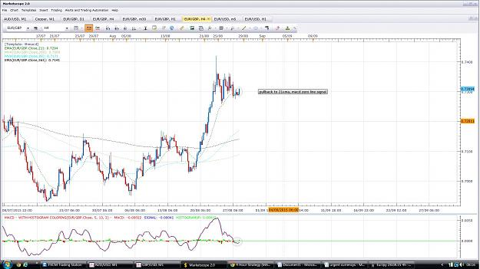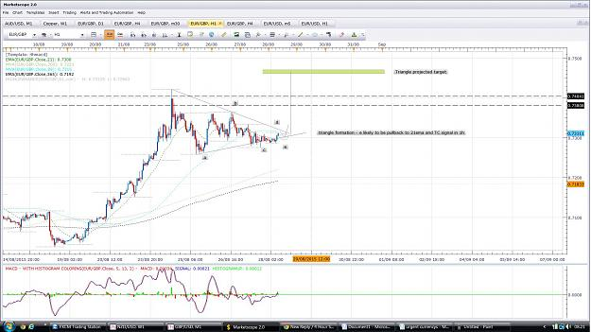
- Aug 31, 2015 7:03am
- JonnyPip
- Joined Nov 2012 | Status: Member | 338 Posts
AusUsd
Price is forming a kind of triangle pattern at the 21ema.
There is a lot to suggest to my mind that the high probability trade here is a temporary long on the AusUsd with the MACD zero line pull through being the set up and a move to the 89sma as the target. Break of 21ema, pullback and move to 89sma is the market rhythm.
R:R 1:2 makes this a worthwhile trade for me, I will also be looking at two other things with this trade as mentioned in the attached graph
1) Possibilty of adding to the position when I move the stop to BE
2) Exit and reversal short at or around the 89 SMA as this is a counter trend trade
It is a UK bank holiday today so price could be very slow and it can be better to just have a day off, but I think this is a good set up so I have taken it
Happy Trading
Attached Image (click to enlarge)
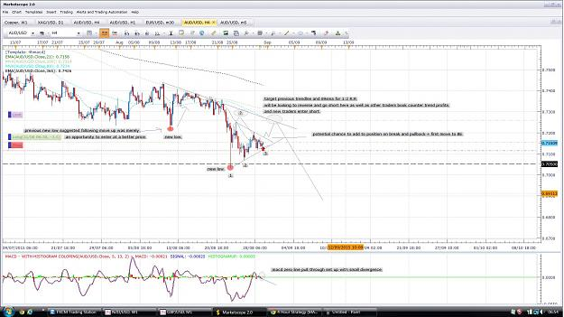

- Post 29,083
- Cleanup
- Quote
- Aug 31, 2015 7:23am
- JonnyPip
- Joined Nov 2012 | Status: Member | 338 Posts
Gold
Break of 21ema and pullback to 21ema and 89SMA
MACD gave a TC signal, with no MA's as target, the next level is previous broken support as shown in chart.
WARNING: This trade has the potential to make another pulback to fully reach the MACD zero line in which case I will be stopped out. I accept that risk. If this happens I will still be looking to re-establish this trade, possibly with a MACD zero line pull through set up, assuming I believe it is still valid - a R:R of over 1:2 makes it worth taking now in my opinion however I have lowered my % of risk as I see the risk as higher on this one.
Attached Image (click to enlarge)
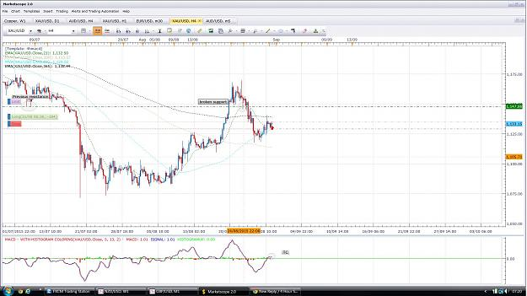
- Aug 31, 2015 3:22pm
- JonnyPip
- Joined Nov 2012 | Status: Member | 338 Posts
Quoting nic73
{quote} Hi, I look at this pair in a different angle. And I am replying two hours after your initial post. Right now, AUDUSD market has rejected the 21ema, 4-5 times. And is moving away from 21ema, about 26 pips down to the south. On the daily chart, it is very much on the down trend, rejecting 8ema on a few occasions. it is also testing the 23.6% fibonacci. MACD is a zero break. It could break the triangle (seen on 4hr) to either direction - up north or down south. I would wait for the close of this candle if it breaks downwards, then I might consider...
Hi Nic,
This is the issue I have at the moment, the USD index which is the USD paired against a basket of currencies is showing signs that it is losing momentum. I certainly agree the AUSUSD is in a downtrend and we don't necessarily want to be fighting it however looking at the daily and 4h charts below of the USD index I just can't help but see this having a small down move before it really gets going higher. This is all about timing in my mind, I still believe these pairs will show some short term strength against the USD (although it may be minimal) which is why I am sitting them out at the moment even though clearly they are edging downwards.
My Gold and AusUsd trades were stopped out for small losses, but I think I just got in too early as I even mentioned in the gold especially there was a risk of this - it can be a fine line though between getting your timing slightly wrong and getting back in, and getting your analysis wrong and banging your head against a wall, especially if it's counter trend! So I am prepared to reassess the possibility of a short term long position but I am in no rush, especially before the RBA rate decision tonight. If the USD index only pulls back to the zero macd line in the 4h chart the counter move probably wont be worth getting involved in, in which case I will just be waiting for the chance to get in short. This could only even play out as small pullback to the broken AusUsd trendline in 4h.
Plus if you look at the MACD for the USD pairs across the board, I.e GbpUsd, UsdJpy, EurUsd, NzdUsd etc they all suggest a last pullback maybe to the MACD zero line.
Considering the news, I was wondering whether the RBA rate announcement tonight will reflect the short term move higher I have been anticipating in the against the Usd before the USD non farm payrolls on Friday kick starts the move down..... Just a thought
Attached Images (click to enlarge)
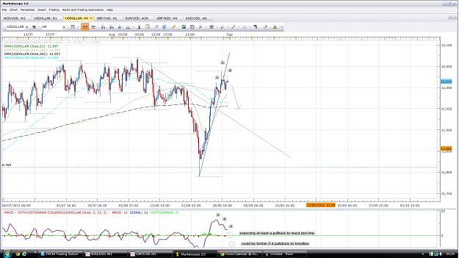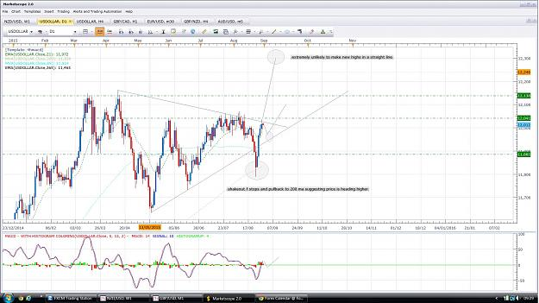
- Sep 2, 2015 7:48am
- JonnyPip
- Joined Nov 2012 | Status: Member | 338 Posts
GOLD
Pulled back to macd zero line and gave signal as warned it could in previous post, this was the signal to re-establish the long trade to target 1,147.86 resistance which was highlighted in previous post.
Price completed its move to the 1,147.86 level which means now a continuation of the down move could be on the cards.
A head and shoulders pattern on the macd looks to be forming at this point which I could be looking to take. It may not however pull all the way back to the resistance line it could give a lower high.
If this plays out I would expect a move at least down to the 200ma but I will be looking even further to the 1,085.00 level. Should be plenty of possibilities to add to position or even scalp short if holding longer term positions isn't preferable.
Attached Image (click to enlarge)


