JOWE Simple Trading System
Indicator:
SMA5, SMA20, SMA60, SMA100, SMA200
Time Frame: H1, H4
Buy Setup Requirement:
- SMA200 > SMA100 > SMA60 > SMA20 > SMA5
- SMA5 cross up SMA20 and during the cross the distance between SMA20 and SMA60 is not less than 40 pips (this is a must)
- Instant buy entry when requirements of number 1 and number 2 are fulfilled.
- TP1 is moving at dynamic following SMA60 line movement
- TP2 is moving at dynamically following SMA100 line movement
- TP3 is moving at dynamically following SMA200 line movement
- Put SL 10 pips below shadow of the lowest candle
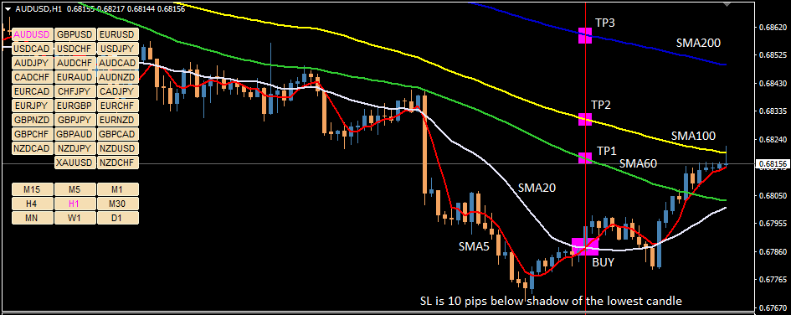
Picture 1. Buy Setup on JOWE Simple Trading System
Sell Setup Requirement:
- SMA200 < SMA100 < SMA60 < SMA20 < SMA5
- SMA5 cross down SMA20 and during the cross the distance between SMA20 and SMA60 is not less than 40 pips (this is a must)
- Instant sell entry when requirements of number 1 and number 2 are fulfilled.
- TP1 is moving at dynamic following SMA60 line movement
- TP2 is moving at dynamically following SMA100 line movement
- TP3 is moving at dynamically following SMA200 line movement
- Put SL 10 pips over shadow of the highest candle
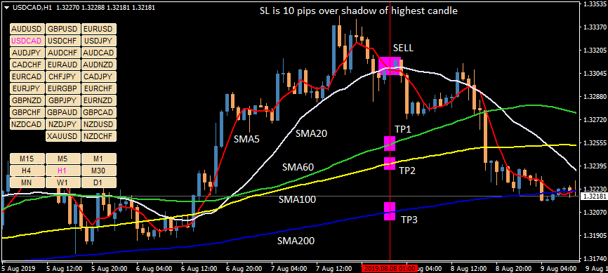
Picture 2. Sell Setup on JOWE Simple Trading System

Please help to create dashboard of all currency pair resume seluruh pair with below requirements:
Input Parameter:
- The minimum distance parameter between SMA20 and SMA60 when SMA5 cross up/cross down SMA20 (default 40 pip)
- List pairs to monitor in dashboard
- Entry trade signal duration will be displayed starting at the first time signal come and up to:
- 24 candles after entry trading signal come (for H1 signal)
- 30 candles after entry trading signal come (for H4 signal)
- Option that entry trading signal can be sent to mobile android and IOS
Dashboard display:
- Display is expected as Picture 3.
- all pair are in left side, analyzed in H1 and H4 time frame and will havte 3 possibilities of status:
- Neutral : does not meet any buy or sell requirement setup
- Wait to buy/sell : meet buy or sell requirement setup number 1:
Buy SMA200 > SMA100 > SMA60 > SMA20 > SMA5
Sell SMA200 < SMA100 < SMA60 < SMA20 < SMA5
- Buy/Sell : meet buy or sell requirement setup number 1 and:
Buy if SMA5 cross up SMA20 and during the cross the distance between SMA20 and SMA60 is not less than the minimum distance parameter
Sell if SMA5 cross down SMA20 and during the cross the distance between SMA20 and SMA60 is not less than the minimum distance parameter
- Entry Signal: when Buy/Sell requirement met, it will be displayed completely at right side of dashboard with entry price of sell/buy, SL, TP1, TP2, TP3
- Entry price : the cross of SMA5 and SMA20
- TP1 : where the price of SMA60 when entry signal come
- TP2 : where the price of SMA100 when entry signal come
- TP3 : where the price of SMA200 when entry signal come
- SL : on TF H1 and sell signal, SL is 10 pips over highest price within 24 candles before
on TF H4 and sell signal, SL is 20 pips over highest price within 30 candles before
on TF H1 and buy signal, SL is 10 pip2 over lowest price within 24 candles before
on TF H4 and buy signal, SL is 20 pips below lowest price within 30 candles before
- Entry trade signal duration will be displayed starting at the first time signal come and up to:
24 candles after entry trading signal come (for H1 signal)
30 candles after entry trading signal come (for H4 signal)

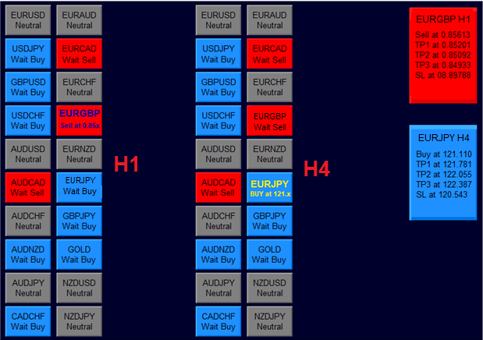
Picture 3. The dashboard display

