Simple Gold Trading Strategy – Gold Trading Secrets
by TradingStrategyGuides | Last updated Apr 17, 2019 | Published on Apr 24, 2018 | All Strategies, Chart Pattern Strategies | 0 comments


Simple Gold Trading Strategy – Gold Trading Secrets
The precious metal gold has been always perceived as a safe haven in times of troubled times. Our simple gold trading strategy will help you to buy gold and sell gold at the same time. Our proven gold trading approach uses a combination of Fibonacci retracements and seasonality trading.
Our team at Trading Strategy Guides will reveal how to trade gold. You'll also learn some valuable gold trading secrets that will help you bank fantastic profits.
The best strategy for trading gold, or other commodities, is to do precisely the same as the smart money trade commodity. Our simple gold trading strategy is based off what works in the financial markets.
So, it’s a strategy that tells you when to get into trades on virtually any time frame. Whether you’re looking at higher time frames for long-term investment or when you want to get in and out of short-term trades.
If you’re concerned about inflation, or the economy in general, investing in gold is an excellent way to protect your wealth. However, if you’re trying to make money from the trends in gold that require a method, and when we trade gold, use our simple gold trading strategy.
This guide will include every step to follow in order to understand how to trade gold the way big institutional traders do. We also have training for the best fractal trading strategy.
First, let’s unlock the secrets of trading gold!

Gold Trading Secrets
We’re going to reveal some gold trading secrets used by professional traders to invest in Gold.
There is a correlation between how gold moves and the gold seasonal pattern.
There are certain times in the year when gold is stronger. There are also other times of the year when gold is traditionally weaker. Wouldn’t it be great to know in advance when gold has a higher probability to rise or higher likelihood to fall?
The natural phenomena have the intriguing trait that they repeat themselves during the same parts of the year. Snow usually falls in winter while sunshine during the summer. On average these tendencies persist. And this is precisely what seasonality is.
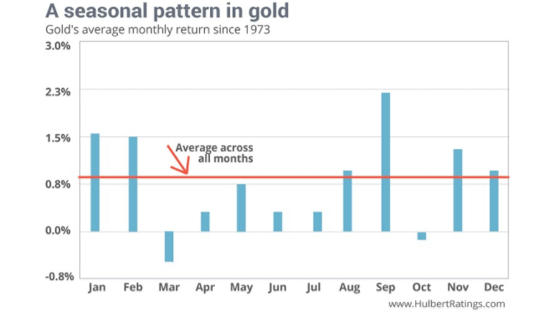
Gold price, according to its seasonal cycle, has the tendency to go up in the first quarter of the year. It also rises in the last months of the year as well. September would be one of the best trading months for the gold price if you bought it.
We have to keep in mind that these are just general indicators. The gold seasonal cycles will give you the tendency of Gold to bottom or top, or rally or fall, at a particular point in time.
The gold chart below puts into perspective the seasonal pattern:
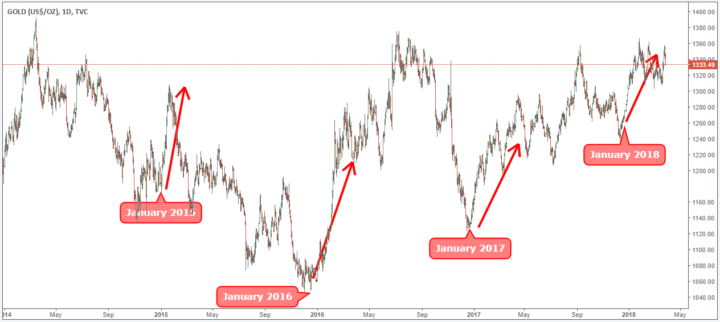
The Gold seasonal cycle is crucial because it’s one of the tools that highlight what smart money is doing.
Before outlining the Gold strategy rules let’s look at what indicators we need to trade successfully this method.
The only indicators you need are the following:
Fibonacci Retracements are very popular technical indicators. They are based on the key mathematical numbers identified by Leonardo Fibonacci many centuries ago. These mathematical numbers can offer us significant areas of support and resistance.
Now let’s see how to trade gold coins efficiently using these market trading secrets.

Simple Gold Trading Strategy
How to trade gold it ultimately comes down to your preferred time frame.
Do you want to daytrade Gold?
Or, do you want to swing trade Gold?
Even if you’re looking to simply invest in Gold, and buy and hold for the long run, you can take advantage of our simple gold trading strategy. Use it to time the market, no matter your trading style. Our trading strategy makes it simple for you to see the change in gold trends. You can easily spot those buying and selling opportunities. For the purpose of this article, we’re going to look at the buy side.

Step #1: Buy Gold in the trading months with above average return
The first step is to make sure that you’re buying the months that Gold price has the tendency to rally. According to the gold seasonal pattern, the best months to buy gold and the best way to buy gold is in January, February, August, September, November, and December.
The number one thing these months have in common is that the gold price return is above average during these trading months.
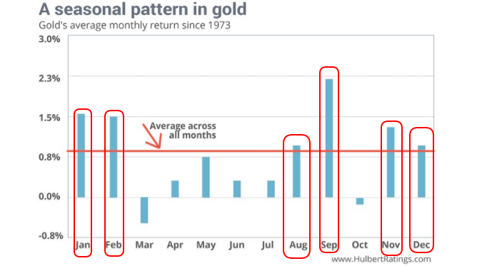
Note* We’re going to chose and trade January so we can walk you through an actual life trade example.
The seasonal price pattern for gold tends to repeat itself quite often because smart money tends to do the same thing over and over again.
Now that we’ve spotted the influence of seasonality on gold price is time to move to the second trading rule.

Step #2: Wait until Gold retrace to the 0.618 Fibonacci Retracement of the previous market swing
It’s not enough to identify the seasonal pattern and to focus just on that. We believe there should be at least one more element you should include in your trading strategy. here is another guide on how to make money trading.
When you combine both the seasonal pattern and the Fibonacci retracement indicator, this alerts you that a potential Gold buying opportunity lies ahead
This is a robust trading system, but you have to be flexible with the rules and try to fit it in the overall price action as well.
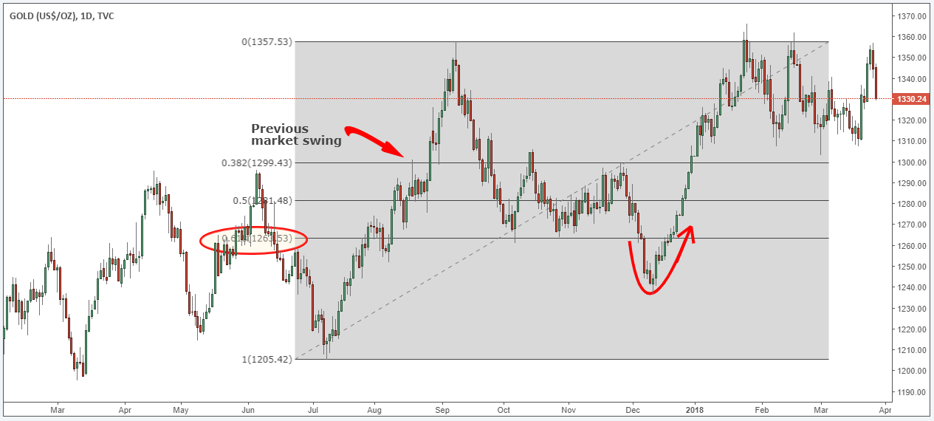
In our proposed gold trade example we can see that Gold has traded below the 0.618 Fibonacci retracement of the previous market swing. But this action happened during December and we can see that gold price started picking up right from the start of January 2018.
Next step will also outline our Gold buying strategy.

Step #3: Buy at support or on the way up as we break above resistance
Remember, when dealing with this type of trading principle it’s all about flexibility.
For our gold buying strategy, we’re proposing a very simple technique. If the price of Gold at the time of your analysis is trading at support you can go ahead and buy it.
However, if the market starts rallying before we enter into January, wait until we break above previous resistance to buy gold.
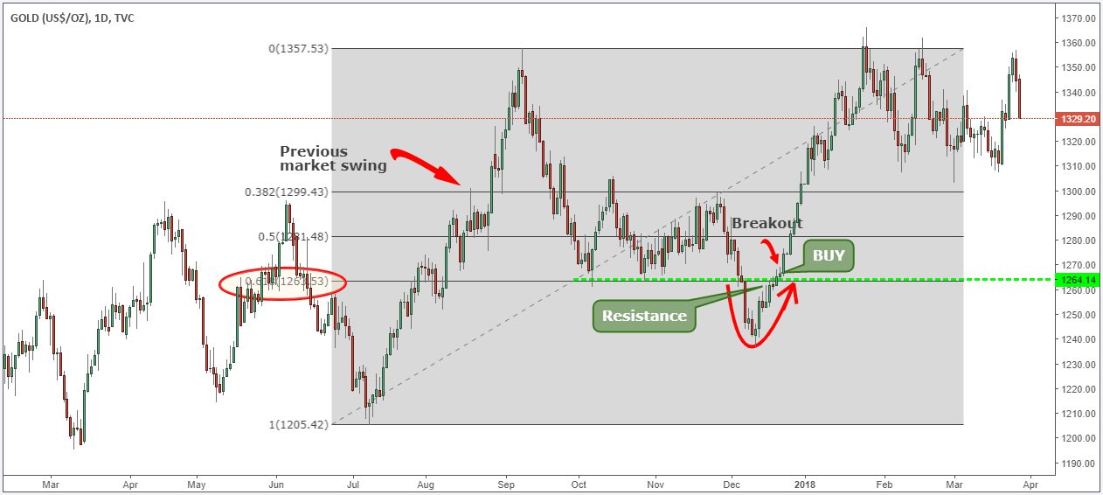
As you can see the actual gold price followed its seasonality cycle. This means that our seasonal analysis was correct
The next important thing we need to establish for our Gold strategy is where to place our protective stop loss.
See below …

Step #4: Place protective Stop Loss below last swing low
If gold is following its seasonal pattern than new highs should be seen not new lows.
If gold break to new low, this will invalidate our trade and we want to be out of this position.
In this regard, when we trade gold with this strategy, we place our protective stop loss below last swing low.
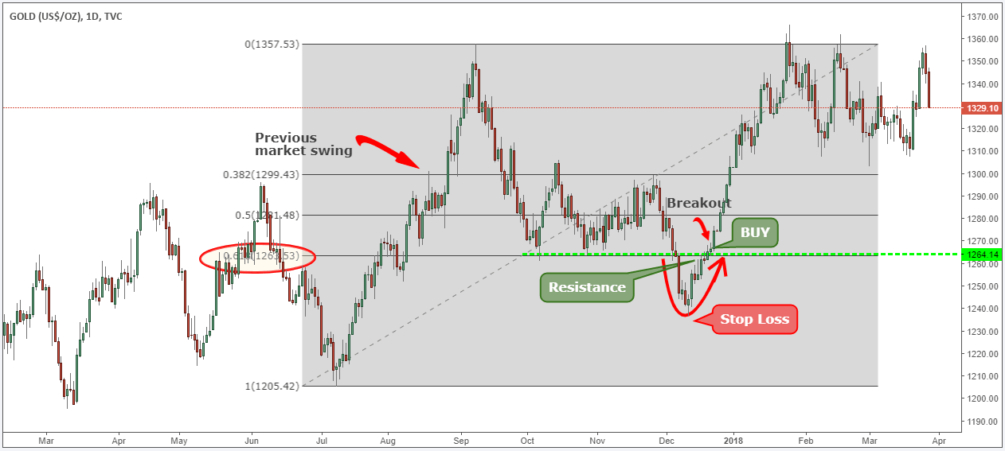
Now that you know where to hide your stop loss, let’s define our take profit strategy.
See below…

Step #5: Take Profits before the end of February and trail your SL below each swing low
If gold has followed its seasonal pattern in the first months, it’s wise to expect it to continue following the seasonal cycle moving forward. According to gold seasonal pattern, March is one of the worst trading months for gold, so it’s best to liquidate your gold position and enjoy your profits.
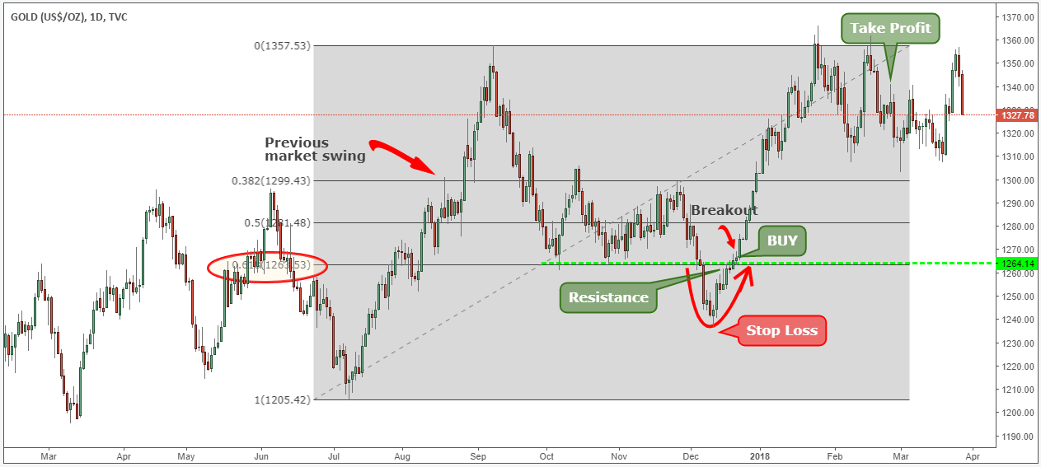
If you had used this simple gold trading strategy, you would have anticipated the new Gold trend and made some big profits from it.
In two months you’ve made a healthy profit as gold price went from $1265 to $1366.
You can also find sell signals using the exact opposite trading rules. The way it works for a SELL trade can be seen in the example below:
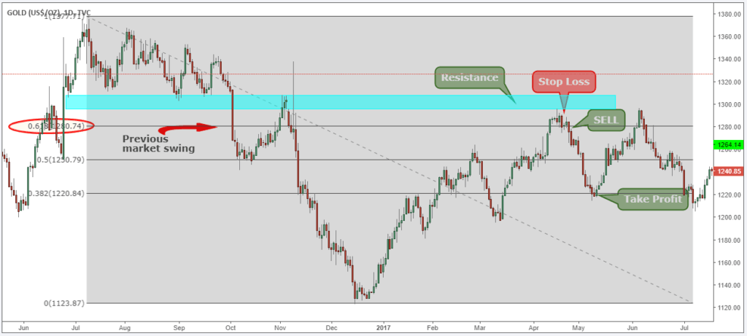
Note* We sold gold only in the months when it has the tendency to sell.
Subscribe to Trading Strategy Guides

Conclusion - How to Trade Gold
If you would like to develop your gold trading skills so that you can make similar profits, simply follow our simple gold trading strategy step-by-step guide. Gold has always been perceived as a store of value or a safe haven asset that can be stored for centuries without to decompose. Also, read our best winning news trading strategy.
The name of the game is all about trying to exploit the trends and you can use our gold trading secrets to help you identify when is gold most likely to rally or to sell. Buying gold as an investment can be very satisfying so make sure you diversify your portfolio by buying gold.
Thank you for reading!
Please leave a comment below if you have any questions about how to trade gold!
Also, please give this strategy a 5 star if you enjoyed it!
(6 votes, average: 4.00 out of 5)

