HI
OKAY, MY SYSTEM IS NOT ROCKET SCIENCE, IT’S TOO EASY.
Let’s begin : Setup 2 M15 charts with correlators, one with triple corrie and the other with session correlator, the triple corrie chart also has the breakout boxes and pair strength analyser and chart button v.2 so we can change to any currency and see what going on. We want the triple correlator to closely match with the session corrie .
Then 3 others charts, one for Asian, another for London then another for the USA session. In total only 5 charts.

Attached File
breakout_box_4_london_openingrange_indicator.ex4 20 KB | 11 downloads
Attached File
breakout_box_4_london_openingrange_indicator.mq4 15 KB | 14 downloads
Attached File
Pair Strength Analyzer.ex4 55 KB | 17 downloads
Attached File
Triple Corrie.ex4 35 KB | 14 downloads

Attached File
SESSION CORRELATOR FOR A FRIEND.tpl 44 KB | 12 downloads
Attached File
TRIPPLE CORRIE FOR A FRIEND.tpl 141 KB | 11 downloads

Session Correlator setup – Scan all the market to see what is moving.
Attached Image (click to enlarge)
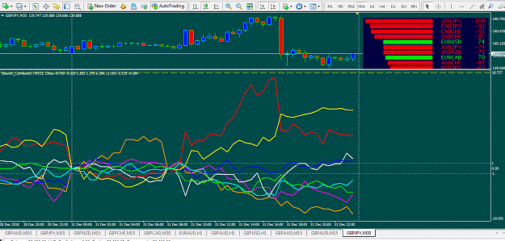

Triple Correlator setup – allows you to zoom to any chart.
Attached Image (click to enlarge)
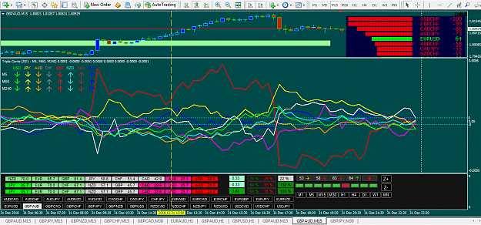

Attached File
Session_Correlator1.ex4 54 KB | 14 downloads

hi again now set up for trading 3 metal trader ASIA SESSION LONDON SESSION AND USA SESSION
Attached File
BreakOutBoxesV2.06.ex4 63 KB | 12 downloads

Attached File
BreakOutBoxesV2.06.mq4 58 KB | 16 downloads

Attached File
! GILBERT NEW BREAKOUT BOXES V 6 FOR LONDON ONLY.tpl 158 KB | 11 downloads

Attached File
! GILBERT NEW BREAKOUT BOXES V 6 FOR USA ONLY.tpl 153 KB | 11 downloads

Attached File
! GILBERT NEW BREAKOUT BOXES V 6 FOR ASIA ONLY.tpl 153 KB | 12 downloads

ASIAN Session Chart.
Attached Image (click to enlarge)
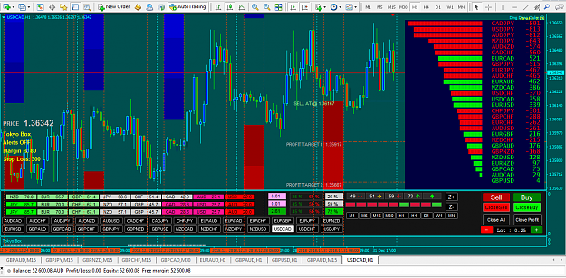

London Session Chart.
Attached Image (click to enlarge)
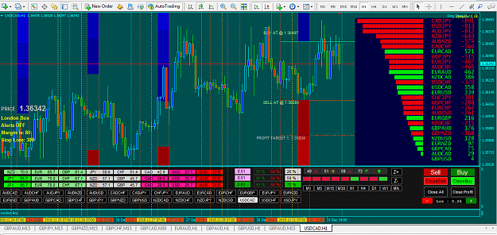

USA Session Chart
Attached Image (click to enlarge)
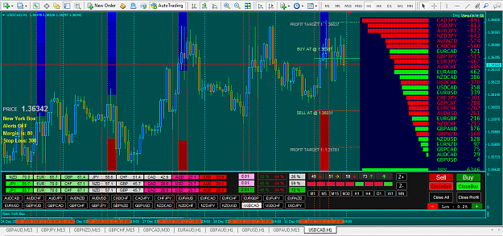
OK, so now I will show you how to set up the pair strength analyser because it may not upload as I use it.

Please change the values to same as the picture below .
Please be informed that English is not my first language so I do apologize for any mistakes.
Here is how I trade my system with the indicators shown.

So first I check the Session Correlator for any signal.

If I have, I will look to trade the strong currency against the weak one. Now on the corrie with the chart button v 2 you check the currency on the move then look for a candle breakout from the box. With the trend is a must, so we have a possible set up but not a trade yet,

Now go to whichever session charts, Asia, London or USA session in 1 hr time frame ,now if a candle is ready to enter the box you may enter the trade if you can see enough reward .
Practice - maybe you will like it, or not.
I don’t know you. Lol.
All the best.

Attached File
Ding Dong Order.ex4 22 KB | 11 downloads
that expert adviser for entering your trade

Correct set up for pair strength analyser

Attached Image (click to enlarge)
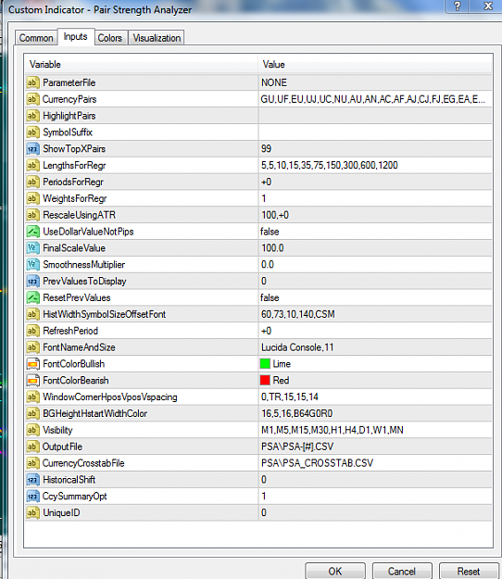

Footnote from Altostrader to any reader : Be advised Ellenbrooks tpl files will probably not work for you.

The charts above and in the forum should be enough for you to set it up for yourself. If difficult, consider it a learning process and persevere to come to an understanding of Meta Trader 4.

