780 pips step size
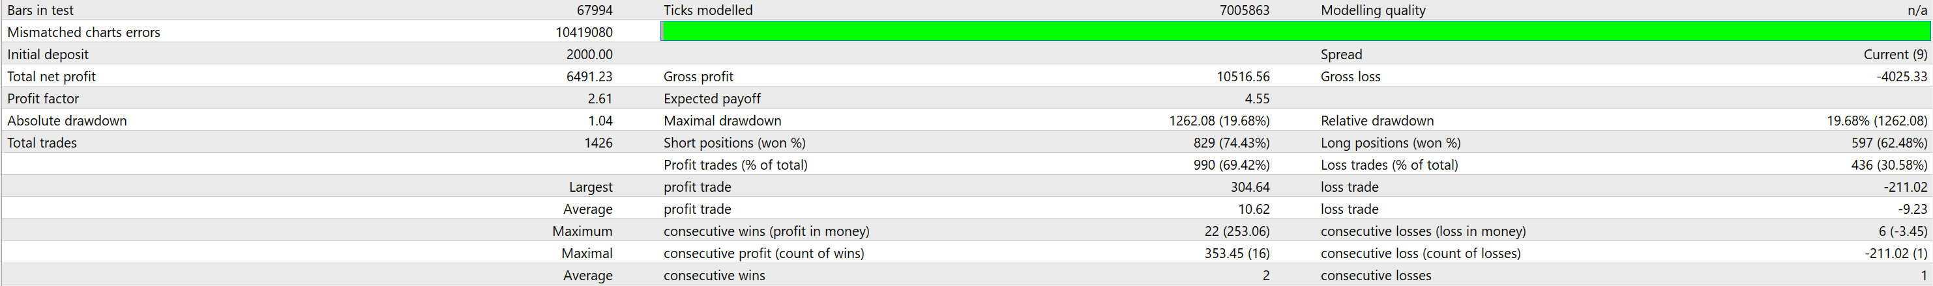

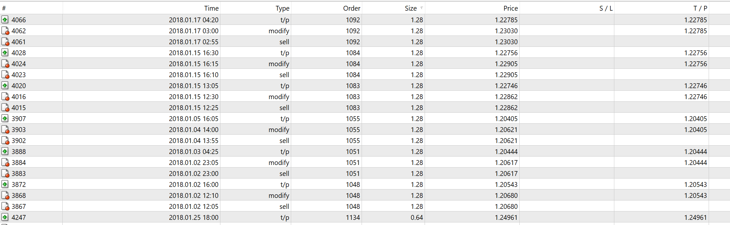

780pips step size & stop loss 780 pips.
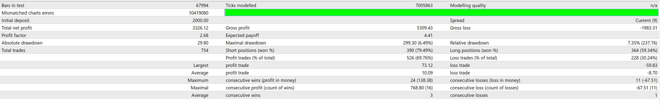
420 pip step size & 780 stoploss size pips
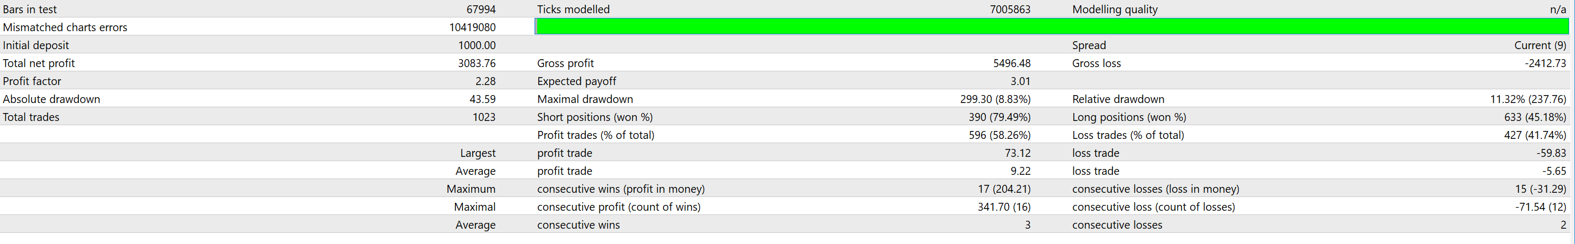
370 & 780
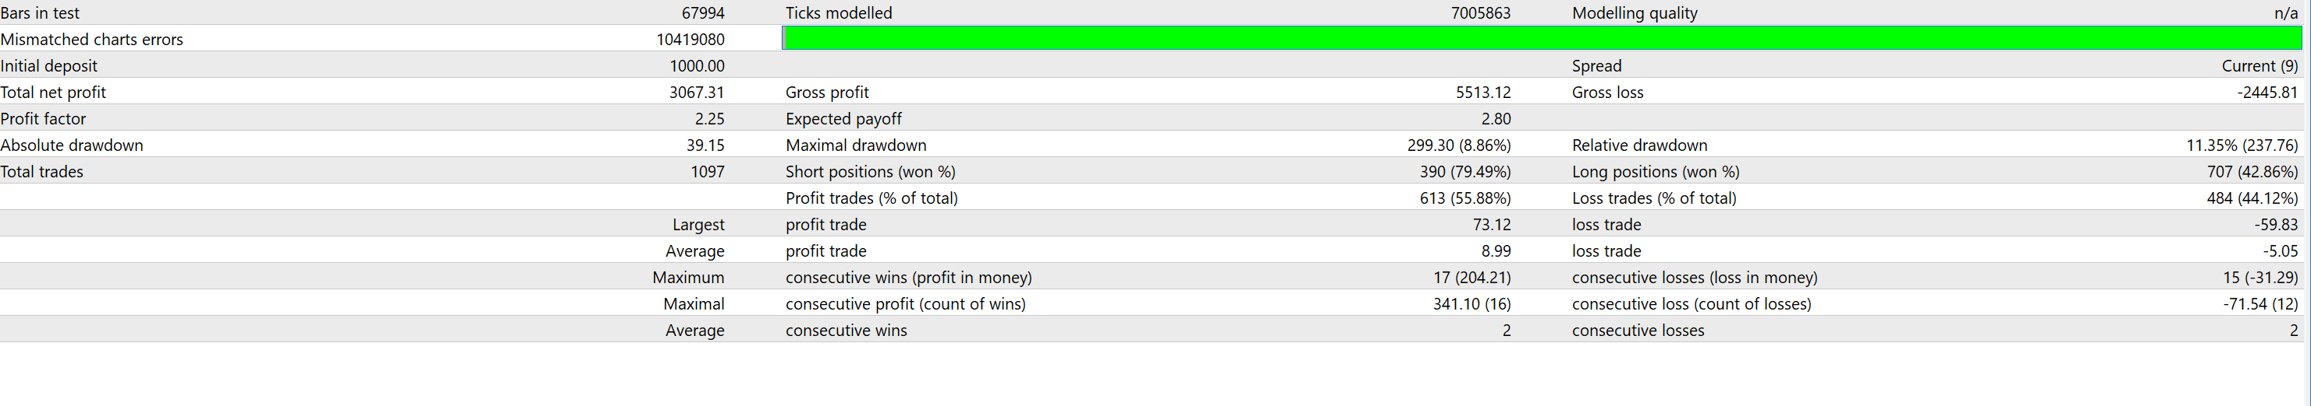

370 & 600
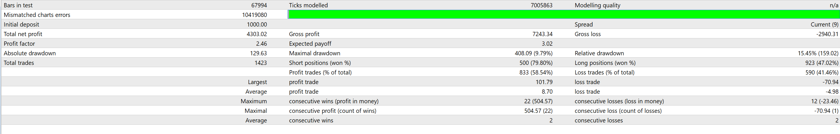

370 & 640
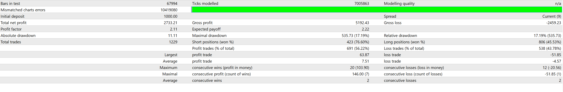
370 & 720

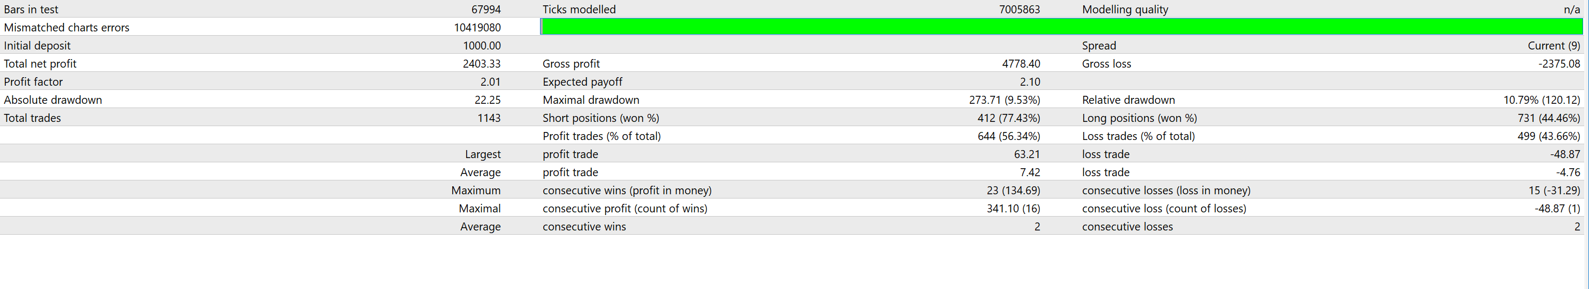
390 & 720 & 70 profit
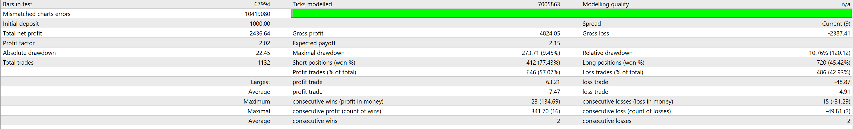
390& 720 & 30 profit
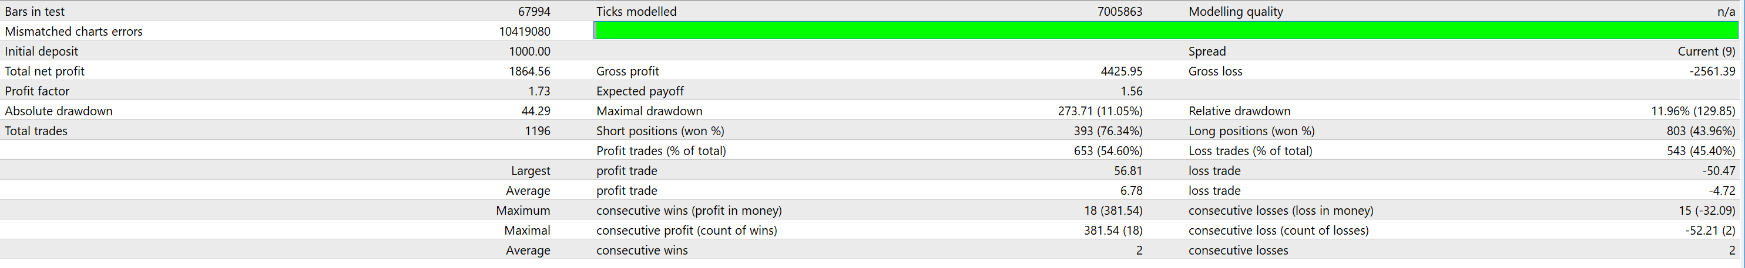
390 720 45 profit
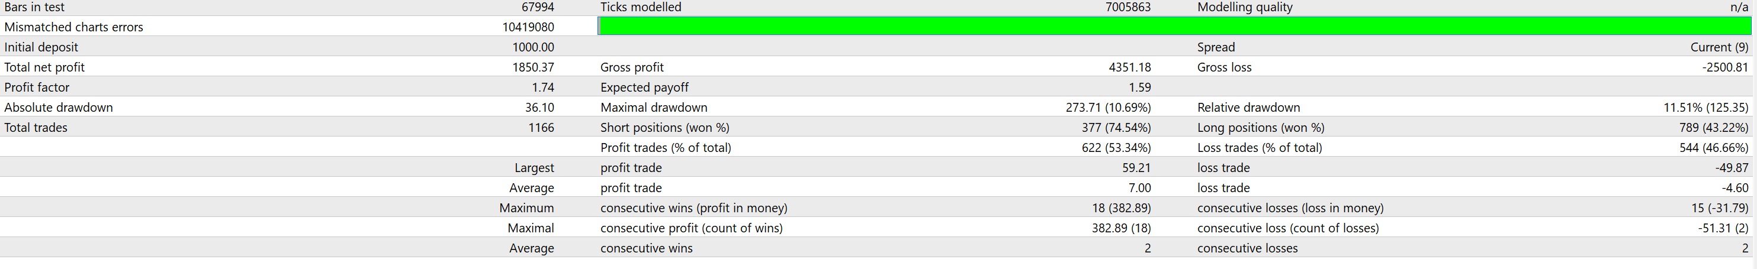

390/720/54
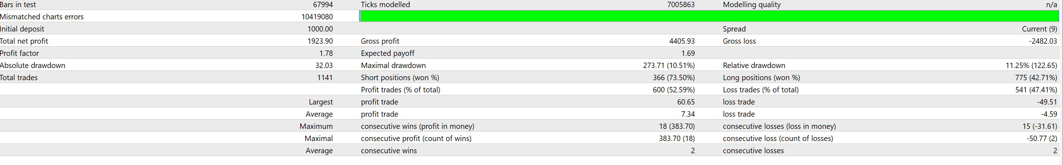

UJ- 390/620/70
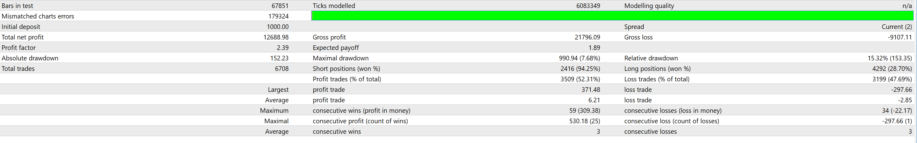
GU 390/390/70


