JayRai | Mar 1, 2017 12:19pm | Post# 1

Bank Currency Strength
5 Attachment(s)
BANK CURRENCY STRENGTH
Since some of you asked me to open a thread on how i use bank positions in my favour, welcome to my thread!
Here i will explain how i use bank positions to setup trades.
But first, i have to say that it is a challenge not mentioning any paid services. I was warned already. I do respect and understand that. This will keep the existing gap between retail traders and 'the rest' in stand, unfortunately. So, please keep in mind not mentioning any paid services in this thread. Sorry for this inconvenience.
Rules:
- Keep the thread positive. If you do not like my method or thread, just skip it. I am sure there are thousands of other strategies to look into that fit you more.
Let's get started!
About myself:
I am trading for about 12 years. I traded almost everything and used hundreds, probably like most of you, different strategies, indicators and expert advisors in my first years. Sometimes i actually made money. Not consistent and with too much risk though. All based on technical approaches. At some point i wanted a stable and consistent income. So i took some time off of trading. I used that time to think about how to do that. Actually, i was asking myself why i didn't want to study fundamental approaches. I already knew that fundamentals are the reason why markets move and in what direction. But it seemed all so complicated and so many different resources with different opinions. But i did it anyway. Started to learn how to read fundamentals and trade it. I studied it for a year. That was the time i gave myself to learn it. I did manage to trade successful. To me successful trading is simple; earn money with less risk than reward consistently. I opened an account at Citi and start trading with all my savings. I know, sounds risky but i calculated my risks though. After a year Citi approached me and proposed to join their fund managers program. So i did. 6 Months to prove that i am able to be profitable against low risks, awareness and understatement of fundamentals, correct money management and an iron psyche. I made it to become a fund manager and finally as an in-house fx trader. That changed everything. The things i saw, learned, heard... overwhelming. But time consuming. Never had time to do fun stuff. After a terrible accident on the road, i needed to rehabilitate. That gave me time to think about my future. I decided to make a plan to keep on trading but in less time. And i did. A simple one. Let the banks do what they are best in; leeching money. All i wanted is using their resources (positions) to easily see where their current focus are. Then i will make my own judgment what to do. Outcome; BCS, Bank Currency Strength ;-)
My trade-plan:
For every trader i have to say that it is important to operate like it is your business. Make a solid plan. Plan your trades and trade your plan.
to avoid any psychic influence, i study my interest of currencies every Sunday. I am not able to open or close trades. For me it is perfect. No active markets that distracts me. I open the chart or internet to see all summed bank positions. Than i will check if i see aligned interests of several banks for certain currencies. See below for an example.
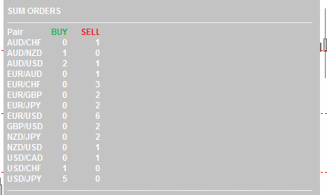
In that picture i see that several banks are in agreement that the EURO is weak, USD is strong, JPY and CHF gained in strength by grow in interest (over the last weeks), NZD getting weaker. I only use the most convincing and logic interpretation of the bank positions. for example: AUD was strong for a while but some banks closed their long positions and some even opened shorts. So i exclude AUD in my trades. Too many mixed signals. In the end, this is my conclusion;
strongest: USD
weakest: EUR
getting stronger: JPY, CHF
getting weaker: NZD
Therefor i seek opportunities (pullbacks) in the following trades;
short EUR/USD
short EUR/JPY
short NZD/USD
short EUR/CHF
short NZD/JPY
short NZD/CHF
I open the H4 charts to see if i detect a good s&r level in first sight. If so, i set an price alert at that level. I do not use any indicator to detect possible s&r levels.
Just a quick view. As if i have only a couple seconds to tell where the most strongest s&r level is nearby a possible entry.
Trades:
When an alert happened during the upcoming week, i open the chart. Whenever i see that the RSI (period 5, levels 75/25) is reaching OB/OS, i open a trade. It is not needed that the RSI must be over/under 75/25 at all times. No need to wait that a H4 candle closes. For the charts that i didn't see a good s&r level on Sunday, i am watching those charts every day. But only a quick view. let's say 30 seconds per chart per day to find a nice entry.
RSI:
Why am i using the RSI indicator and why those settings? It has to do with the technical aspect. The way it calculates price/time. Using the H4 chart to trade from, i am trading mid-term. However, i need a certain sensitivity to spot early pullbacks before a trend settled out already. Most retail traders are using higher timeframes for their lower timeframe based trades. I use lower timeframe indicator settings in my higher timeframe chart. I need faster confirmation (not too old data) because i already know where the currencies are heading (likely).
Money management:
Every Sunday i calculate how many possible trades there are for the opening week and how many trades are still active at that time. I do not want to risk more than 5% of my balance (not equity) in total, ever. And within the 5%, the combined trades must be able to handle -1.000 4-digit pips. However, i leave some room to open 2 or 3 extra trades during the week. So i do not use my full capacity every time. Lotsizes are calculated using the convincing strength/weakness per trade. The more convincing the trade is, the more lotsize it gets over others. In above case, EUR/USD gets the largest lotsize. NZD/JPY and NZD/CHF the smallest.
Actual trades:
As per my point of view, i opened a short EUR/USD again. Recently closed my short at 1.05. But banks increased their EURO short positions on multiple pairs. So entered a short on a nice s&r level and the RSI was even above 75 at the time i entered the market. See screenshot;
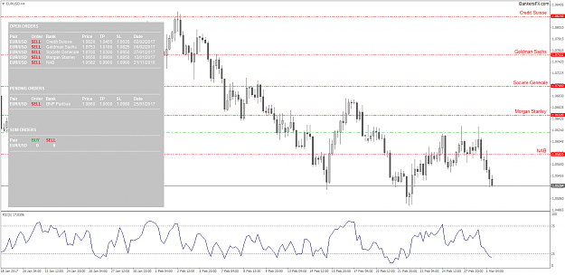
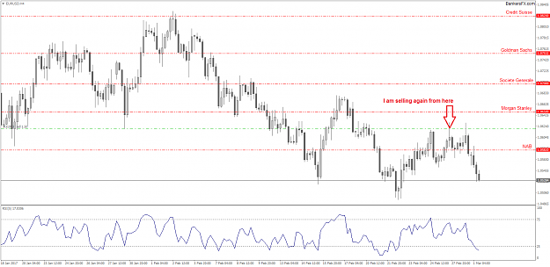
I opened a short position on EUR/JPY 2 weeks ago. EURO was very weak and the YEN got more buying interest from banks. I managed to enter at almost the same price as Citi which was a good moment.
It was in agreement with my own entry rules and BCS.
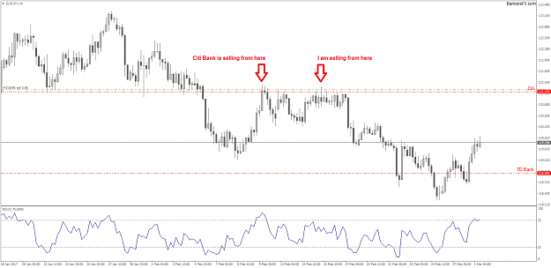
Shorting NZD/USD was my most recent trade. It hit the resistance and RSI was overbought.
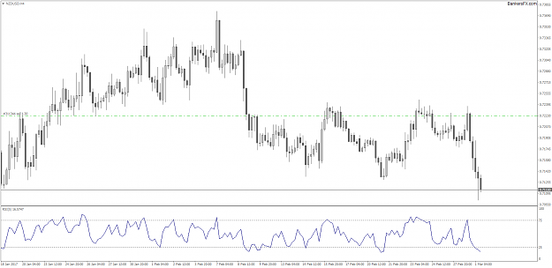
Exit:
As i use no SL or TP, i am always aware of the fact that it could be dangerous. But i do use an indicator that sends me an alert when i hit -1000 pips. Never happened though. As for profit taking, i close trades whenever banks are pulling out or tighten their trades (TP, SL). For me that is a signal that banks oversee fundamental changes that could affect their positions and view. Every Sunday i check open positions again and look if it is still in line with my previous foundings. When i lose my confidence about trades, i'll close them on Monday morning.
Final notes:
I do not convince you to trade the way i do, just explaining how i trade for those who are interested in a same concept of trading. This is my first attempt to explain my setups and hopefully it makes sense. Some asked me about some stats, track records and capital used. I'd like to keep some info private such as capital used. Further, my track record is recorded at Barclay in the time i traded as a fund manager, prop trader and in-house trader. Draw-down was as expected: <6% and yearly yield: 21%. Since i am a retail trader again, my yearly yield is >100% and my draw-down <5%. As a retail trader i have less rules to follow, so it is easier to gain fast. But also riskier. I do not use leverage at all to keep myself away from danger. There are others (family and friends) that depends on my skill as a trader as well. So there is no room for careless behavior. I know that my stats doesn't look that impressive among some retail traders but for me it is enough. In the end; you do not trade against banks, institutions, brokers, market etc... but you trade against yourself, your ego, your fear, year greed and so on. So plan your trades when you are in peace and neutral minded. Execute them when a trade comes into your plan.
Hope you guys got some valued info from me!

JayRai | Mar 1, 2017 3:56pm | Post# 20

Ok, here are some answers to all. I try to answer everyone but forgive me if i forgot anybody!
I do not know why some data suppliers are expensive and why some are cheap. But i have tried almost all of them. Ranging from 50,- to 2700,- a month. The cheap ones are good enough for as far i have tried. It depends how you are trading. The expensive ones give you access to API and other stuff that i don't need. In my time with Citi and Global Invest i had often contact with several data suppliers. They are reliable but the difference are mostly the number of banks they have access to.
@Aavon: Yes, the summed positions are based on different banks. And in case of big news events... i monitor the banks, not the market. I keep my positions open. But sometimes banks close them before announcements. If that happens, i close them as well. Also, sometimes banks close trades after a big announcement. Then i go along with them. Because the chance is big that the banks see the outcome of the announcement as a possibility to change the bias.
Furthermore, i really like to say, once again, that i am not affiliated to a bank or service. You can always send me a private message but please keep it positive. I really don't have a hidden agenda. My intention was to help retail traders with very interesting info that i gained during my time as a fund manager, prop trader and in-house fx trader. I started as a retail trader myself and experienced hard lessons myself. Just wanted to help others to skip all those years searching for something that i am willing to give you for free. Remember that please.

JayRai | Mar 2, 2017 2:47am | Post# 33

Quoting hibra68
Disliked
{quote} That's a good question which begs another question; Don't the banks have advisors following activity of other banks? why would a bank take an opposing position to 20 other banks? Say that 10 major banks are going long on Eur/usd. why would the remaining say 5 banks go the other way? It doesn't make sense. And I'm sure major banks like that have more accurate information about which positions the other banks are taking than just joe shmo the retail trader. I personally don't see any edge here for the retail guy.
@Aaven;
I do not put any specific number or percentage to the alignment. But if it is close to 50/50, is see my chances as 50/50.
When there is only 1 bank buying the NZD and there isn't a bank that sells the NZD, i keep track of NZD until there come 2 other banks that are buying the NZD. Regardless against which currency.
@Hibra68;
Banks have a whole board of advisors. But keep in mind that even banks are competitive against each other. It is a business. Every bank wants to be the best, beat any other bank and make the most money. However, banks are smart. I can't tell everything or every detail because my clausule but think about the following;
if every bank does the same thing at exactly the same time, what would happen? You need a, sort of, structured, well organized balance between supply and demand to keep making money all the time. Also, what i told earlier, banks are competitive. If the head fx thinks it is a smart move to buy the EURO against the USD, despite all other banks sells the EURO, it could be based on a short term sentimental move gaining the pullback. Or it could be that they are the first that detects a possible change of bias. That's why i said to keep the bankpositions in sight and study them every sunday. You can't see and understand the whole picture in a glance. It takes time and experience.
@Profitkeeper;
Correct, Goldman Sachs had a wider SL but they moved their SL lately. So that's why their position is still alive.
@Tmchrist;
I do check internal bank advisory with actual bank trades. But i know banks have to operate by certain policies. When they breach them, they will get fined big time.
Why am i checking the advisory reports then? Educational. There you can find why a bank made a move. But for most currencies i already know why. Just need to know when. And when do i exit a trade. When a bank closes a position without reaching the target. No matter what, no matter how many. It could be that the same bank opens the same trade again a week after. Recently happened on EUR/USD and USD/JPY. If a bank re-enters the market and other banks still having the same interest, i will seek opportunities as well to enter.
Here are some answers to some questions i got in private that i am able to answer here;
- If you trading HFT, i mean real HFT and not the M5 chart for instance, i wouldn't recommend to use these kind of services. Trading ticks is a whole different game.
- I spent about 1 hour every sunday and about 1 hour in total during the week.
- I didn't post anywhere else than here at forexfactory. This is the first and will be the last forum that i will join. Never joined a forum before.
- A while ago i had a brutal car accident. Since that moment i decided to make changes in my way of living. Start sharing and caring. Before i was a ruthless and selfish person. Not going to lie about that.
- I have some clients indeed. But most of them are family and friends that accept my way of tradingstyle.
- At this moment i find myself financially independent, but that is relative. Before my accident i do not think i would ever be satisfied about my bankstatement.
- 36 is my age. Studied nothing, worked everywhere before i became a fulltime trader.
- I lost a lot of money in my first years started as a retail trader. A lot!
- I did spent a lot of money and time on several trading courses etc. Some are interesting but none gave me solid ground.
- I prefer fundamentals over technicals. But when i started trading, i was all about technicals. The moment i understood fundamentals, i became consistent in profit making.
- There are banks that give retail traders an opportunity to become a fund manager or even an in-house trader. But mostly they want you to trade based on fundamentals. In the future you have to explain why you are making a move or made a move to investors and clients. They do not understand technicals and do not value that. Most of them are very smart as well and know what a market moves. They only trust a trader that understand that as well and is even better in anticipating.
Hopefully i gave some answers to the questions you asked!

JayRai | Mar 2, 2017 3:35am | Post# 36

Quoting kingdavid15
Disliked
Hello Jayrai, I'm eager to know what's the average duration of trades you take?
@Kingdavid;
Some trades a week and some several weeks (about a month). I do not set any specific goals regarding TP or equity curving. Just exit based on the views of banks. There are weeks that i only gained 100 pips but there are weeks that i gained several 100s of pips. Exiting the market is as hard as entering the market. Basically the same method; finding out what banks think and do. But i try to ride the bias as long banks do until i spot a change.
@Exofabulous;
Yes, the services provide realtime access to feeds and is therefore more important. Anticipating is key. But you need to know why and when. That is why realtime data is crucial. There are different kind of feeds (different tiers). It has to do with speed, number of banks and the way you can connect to the feed. For instance, the CoT reports overal and global values. Not precise enough. See the screenshot regarding EUR/USD for comparison. But exotic pairs are traded seldom with large liquidity by major banks. If it is traded with large liquidity, it is shown in the datafeed indeed. The only thing i suggest is to trade an exotic currency against a major. Research the fundamental status of the exotic currency; knowing what the central bank want to achieve based on inflation. Knowing what current inflation is and where ur needs to go to. What tools are used already by the central bank to hit the goal or what tools are they announce to use such as QE or interest rate cut/hike etc. So, the basic fundamental approach.
@Aaven;
Thanks for your compliment! Really appreciate it. My future goals and priorities... helping others, enjoy every moment that i have. It gives me joy to help others that appreciate my help. Their appreciation towards me helps me to enjoy life even more. That circle is my new world. I give but at the same time i receive even more ;-)

JayRai | Mar 2, 2017 3:57pm | Post# 65

Where to begin...
Yes, the markets moves loads amounts of money each day but banks aren't using their biggest investments in foreign exchange. In my experience, the smartest traders aren't the bankers but the HFT traders trading directly on the market floor. I had several opportunities to talk a bit with some of them in NY, Amsterdam, Frankfurt and London. Those are the real smart (read: highly intelligence) traders. Too intelligent (and complex) to trade for banks or to trade within a team.
In the meantime i received some nasty private messages, content is even moved to the commercial section and the thread is far away from a positive one.
I try to keep my live positive and thought that sharing some non-retail trader perspectives should generate a lot of positiveness.
At this moment i get the feeling that i need to defend myself against negativity. Also that i need to convince others about my approach or to convince people (and forexfactory) that i am not in any way are affiliated with any kind of services.
It all started in another thread where i posted a report about open bank positions to determine currency strength. It wasn't even my intention to start a thread but there came a lot of suggestions to start one. I thought about it and started this thread.
Please give me a moment to consider what to do next as i am, at this moment, not motivated to continue the thread. I will return shortly.
Sincere best wishes to all.

JayRai | Mar 11, 2018 8:18am | Post# 109

Hello guys,
I got tons of messages to please continuing the thread. After a while of silence due to 'troublemakers', i decided to re-ignite the thread.
It is not my intention or need to convince you. Just explaining my strategy and sharing my experiences. That's it.
If you are genuine interested, you are most welcome in this thread. If you are a 'troublemaker' or having some negativity to share, please go to a thread that allows that or fit your needs in a better way.
For the ones that are interested: yes, i trade still the same way i do for several years;
using bank positions to aim and using RSI for daytrade entries and exits.
When scalping, i use core volumes instead of RSI. (Volumes that are filtered by stock exchange data only)
If you have any questions, you can ask them here or send me a private message. Either way, when i have the time i will try to answer them.
Later on i will share my current trades and point of view for upcoming week.
Best wishes!

JayRai | Mar 11, 2018 5:30pm | Post# 110

3 Attachment(s)
Hereby 3 trades i am having. All 3 trades are based on the top currency that are bought by multiple banks: EUR and JPY against CHF.
USD/CHF: Also, i opened a long since the USD is strengthen up against CHF. But just to make sure, i moved my SL to lock profits.
I think i will collect my gains at 0.9545 area. I will keep that one in track.
EUR/CHF: Going long and hold it for a while. With this one i will keep following price with my SL. The reason why i opened this one was because of 3 banks. They openend at nice confluence levels in agreement with volumes. Perfect and easy trade.
CHF/JPY: Shortened the CHF with JPY. This is my second CHF/JPY short trade. The first hit my moved SL in profit. Re-opened the position but with larger lotsize due to previous gain. Inline with banks and also due to the fact that JPY acts as safehaven at the moment.
For coming week i will keep an eye on CAD and NZD/AUD. The currencies are moving in a trending manner. Just waiting what banks will do. I expect to see strengthening in those currencies. Possible trades: buying CAD/AUD/NZD against USD and/or CHF. But once again; waiting for bank movement and a nice pullback with RSI or volumes.
Screens open trades:
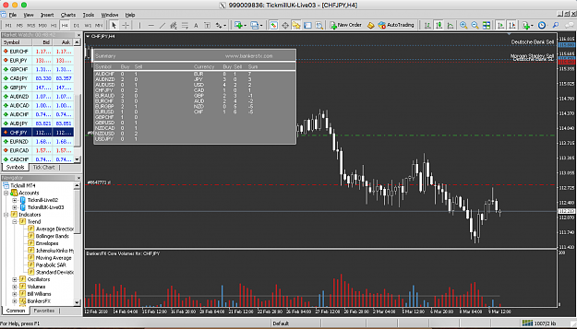
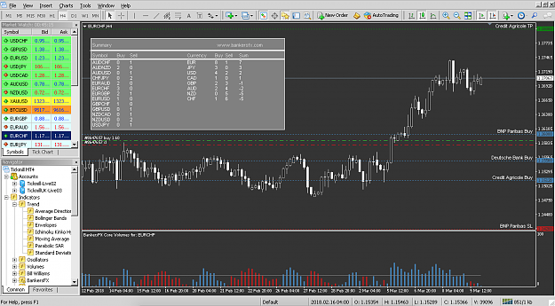
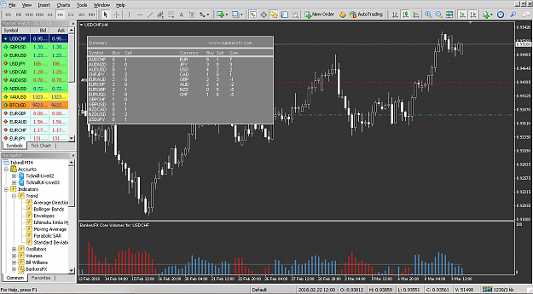

JayRai | Mar 12, 2018 11:08am | Post# 112

Quoting Angela1985
Disliked
Hi JayRai. Thank you for all your info. Really interesting! I am a volume trader and my eye got caught by the volumes indicator. Is it a bit like Quandl? Same data? Hope to hear from you. Love, Angela
Hello Angela,
it is similar to quandl indeed but quandl deliver the needed data from LSE alone and they do not have ready to use indicators. Most common is to integrate it with HRK terminals as i remember. I use this indicator because now i only need to have 1 subscription for the 5 major floors and i can use the free MT4 ;-)
Not as professional as HRK but for retail daytrading just fine!

JayRai | Mar 12, 2018 6:15pm | Post# 114

Quoting Koh Samet
Disliked
Hi JayRai Can you please explain further what the buy/sell numbers represent. In the eur/chf chart you have for EUR 8 buys and 1 sell (i know they are the sum of the detail box). Does it mean that 8 different banks have bought the euro or possibly one bank has taken 4 positions and another bank 2 positions and another bank 2 positions. Also what does the 8 buys represent in terms of volume ie. using above example: bank one 4 positions = 4*100,000 contracts, bank 2 = 2*50,000 contracts and bank 3 = 2*20,000 contracts. can we know the exact contract...
Hi Koh,
The number in the example mentioned represents the total bank positions for that currency. It often means that several banks have bought that currency instead of 1 bank. However, sometimes it can be the case that a bank buying that currency in 2 different orders/symbols like; Deutsche Bank buying EUR/CHF and EUR/USD.
The 8 buys represents the total positions, not a volume. Volumes from banks or floors are gathered separately by other indicators like the core volumes indicator or different data providers like quandl (professional package) earlier mentioned by Angela, Infolect (Level 2 and you must be licensed) or Intrinio (End of day prices only) for instance.
Hopefully you have something with this info.

JayRai | Mar 15, 2018 8:50am | Post# 116

1 Attachment(s)
Quoting Angela1985
Disliked
{quote} Thank you. Sounds even better!! Yeah i use Hark terminals since a while for specific volumes. But maybe switching back to mt4 and test that volume indicator would be much cheaper and 5 floors as you say. Is it live or post visualisation of volumes btw?? I read your posts and you mention that you use volumes only when you're scalping. However in your examples (pics) you opened day trade setups and no rsi? Did i missed something?
Hi Angela,
The indicator is updating live indeed. Regarding RSI, i use it when i am very certain about trades. I like volumes to be more certain in some situations because that reflects a better way how (with filtered volumes) the trade floors act and trade.
Trades.
USD/CHF hit my moved SL ending up with just +67 pips.
EUR/CHF stil stands and is hanging at a nice S&R with +100 pips open
CHF/JPY stil stands after i gave it more room to move (changed SL). Heading to a nice S&R so it could be that i will close the trade before the weekend. Currently +202 pips
The only trade i am looking at as suggested and expected earlier: AUD/USD. What i've expected to see was an interest of banks to look for opportunities in these currencies. It did and 2 banks opened a limit order. You can see that the USD is weakening against the AUD in the currency strength as well. I will wait what volumes are going to do. When the volumes kicks in positively with a certain amount, i will open a long position. See picture
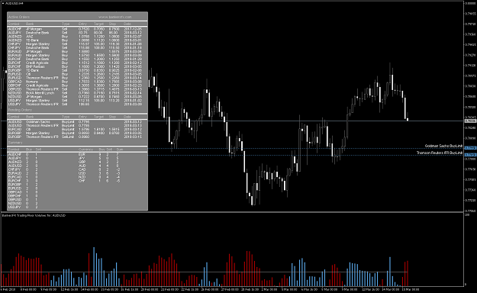

JayRai | Mar 19, 2018 4:28pm | Post# 119

Quoting Angela1985
Disliked
Hello JayRai, could you kindly assist? I used the whole weekend to study that volume indicator and today i did some small trades on majors. As you can see i had 5 trades and 4 where winners. Gained 97 pips today. Trade only on volumes and s & r. I am wondering what tips you can give me to enhance my trading? Should i use exits on low volumes instead of s & r to squeeze more out of it? And sorry if i polute your thread with volumes only questions! But i really want to know. Thank you so much!! {image}
Hi Angela,
Looking good. Personally, i would keep using the S&R as your guide. Because when volumes are getting low... it could be that the pro traders aren't interested to take action around that price level. So you are not able to judge if the money flow continues in the same direction or reversing. And as extra info, if you like to hear my point of view, i wouldn't go long on USD/JPY. Aside the bank positions, looking to correlations, 2 things to do with that trade: leave blank or seek short opportunities. Like your photo: the left 3 pairs are USD based and the right 3 pairs non-USD if you know what i mean. See it as joined agreement.
Maybe my point of view can assist you in your future tradings.

JayRai | Apr 7, 2018 5:31am | Post# 149

1 Attachment(s)
Quoting Angela1985
Disliked
Hi all! I was of for a couple of day (traveling) and i sent a message to the forexfactory staff regarding starting a new thread. I do not really know where to start it because i use paid services as jayray does. But it was sent a couple of days and didn't hear anything about it yet. Maybe just starting the thread then and find out what they will say or do?
Hi Agela,
Even if you aren't associated in anyway with a paid service, your thread will be moved to commercial and you will become a commercial member.
That happened to me so maybe you'd reconsider opening a thread knowing you will get a commercial label behind your name.
To other members reading my thread and posts i would like to say that i had an unexpected very busy schedule. Hopefully in the end of next week things getting a bit relax and would be able to share my pov.
Most of you ask me in private messages what service i use and why;
still using the 2 indicators from Bankersfx.
- Bank Positions to determine trend by strength in the indicator window
- Core Volumes to determine entries and exits
Regarding volumes... well, that can be used on so many different ways with success. But i wait for bargains in a trend. Mostly known as pull backs.
When is something cheap to buy? In the below example you can see clearly that banks are buying EUR against CHF. That is my trend right there.
Then i use volumes to see when it pulls back from the trend. Whenever there where large selling volumes (larger than the averaged line), i wait until it closes below. There is my entry. When do i close? Depends on several things like the actual bank targets, power in volumes or currency strength.
For now i give you examples the easy way: whenever buying volumes rises above the averaged line and starts to drop (getting less than previous candle).
See example below. This 'technique' is also used to scout possible peaks&dips.
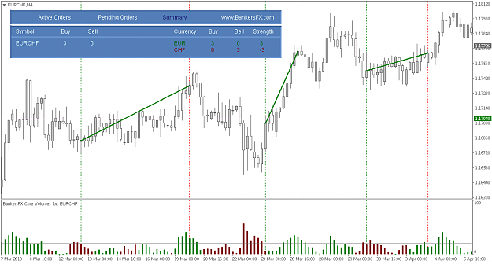
Whenever i have more time to share, i try to post more. But please understand that i may have a different mindset than some of you. And yes, maybe a bit more to spend. BUT, i started small as well. However, in the end, i see trading as a business and i treat it as one. I invest in quality data wether it is coming from Bloomberg, EXF, Quandl, AlphaVantage, Bankersfx etc etc, this is where everything relies on. Sorry guys but i had to say this because some of you ask me for alternative currency strength meters and volume indicators. I can't / will not / am not able to work with such tools. I find them too laggy or too technical (non-fundamental), i trade based on the point of view / positions from banks (what they expect and not what was) and volumes from decision makers from the trading floors. Yes, sometimes i use RSI but i prefer filtered volumes.
If you are not in the position to invest in certain data or tools, my way of trading isn't suited for you. Once again, this isn't a holy grail. Please read my first post again to understand it all what i am trying to say and share. Please do not feel offended, just wanted to answer some questions i got in private. I hope you all appreciate it

JayRai | Apr 8, 2018 7:09am | Post# 151

Quoting hanover
Disliked
@JayRai: nice thread, many thanks for sharing. 
Thanks Hanover, really appreciate your contribution.
I agree, a lot of retail traders have had bad experiences regarding paid services / products. I was once of them in my first few years before my professional trading career. Sadly there are scammers out there indeed. Mostly trying to attract potential victims with promising sales slogans like: "become a millionaire in a month" or "earn $2.000 a day". Whenever i read that kind of stuff... never mind. I do not believe in holy grails, i believe in smart, hard and consistent work. Even the highly paid analysts need to work hard, be smart and deliver consistent results. Otherwise they wouldn't be where they are now.
Ok, i had some questions in private how bankers predict markets. The answer to that is very hard to give. Most of them operate in teams like i did. There are fundamental analysts and/or technical analysts and/or risk managers that influence potential setups. Different strategies and techniques are used. But in the end, fundamental reasons are, in most cases, more appreciated by decision makers. To give an very easy example how a 'prediction' is created:
Bankers know that central banks have the ability and tools to influence a currency.
Central banks want to keep a currency in balance and use inflation figures to know what is and what to do.
(You can find current inflation figures, central banks target inflation figures freely yourself btw.)
If a currency is too overrated, central banks have the ability to use tools to depreciate a currency like quantitative easing.
Bankers already know that central banks will take action because of the large inflation difference between what is and what it should be.
So there is a solid fundamental based 'prediction' that a currency will getting weaker for instance.
Against which other currency could lead to best return on investment? The opposite situation.
The above example is based on position trading (longer term). But that one is an easy way to understand how most bankers operate / think.
Unfortunately i can not / may not share documents how a team operate but the documents Hanover shared is a good example how complex things can get.
In those documents your see trade recommendations and trade sims from analysts for board meetings. That doesn't mean that all those setups are actual trades.
They are potential ones. But, often, most of them are executed.
I just use their hard work.

JayRai | Apr 8, 2018 2:59pm | Post# 154

Quoting msap
Disliked
Hey JayRai, I appreciate your explanations so far and the work you put in here. Quick one, would you kindly explain what you meant by the highlighted quote " i wait until it closes below. There is my entry", would I be wrong to assume it means close of volume below the average line? Are you also using volume to indicate strength coming in on the bearish bars that have high volume but are reversed ( in line with the pullback into the trend)? lastly would the candle i have marked with an arrow in the attachment herein that had the highest volume in...
Hey msap,
That is indeed what i meant in the example. Waiting for a short bearish move rises above the averaged horizontal line and enter when bearish volumes get beneath the line again. But in your case or image, it is hard to say. Your volume indicator is based on and displaying other values than what i see and use.
I am not a coder at all but mostly volume indicators in MT4 are based on ticks from your broker. Very different. But when i mark the same candle in my chart, i would say that the bearish move is weakening instead of evolving. However, it is even harder to explain why. Could be many things that happened around those price levels. When you see a large bearish volume, it does not say that the trend will change btw. When, let's say, a bank opens a very big long order, you could see a large bearish candle at first due to complex order flow to offer a fair price to the bank. To say what exactly happened there, i must say i can't.
@Hanover:
Jarratt Davis is a solid fundamental trader indeed. As far as i know, he started as a retail trader himself and walked same paths as many others.
But he would be a good example to see what it takes to become consistent successful. It isn't easy at all.
A trader could make his/her own fundamental analysis but then again it would be wise to use great tools as well like Ransquawk for instance.
As you said; hard work is one of the requirements. I am aware that fundamentals isn't the most hot topic around here but i hope that traders try to put as many effort in understanding fundamentals as they put into technicals. I really think that could make a big difference in their trading.
Nice to see that you really know what you are talking about btw! Thanks for your time to read the thread and share thoughts, opinions and facts.
Appreciate it!

JayRai | Apr 9, 3:05am (41 hr ago) | Post# 159

Quoting rvenky
Disliked
{quote} Thanks for your advice. I will surely be careful. Learned a lot of new things from your and Angela. Thanks for exposing these things to the ff family
Hello rvenky,
You are most welcome. But i must say that it was already out there (certain data feeds) before i used it privately. I just use it on a certain way that makes things simpler. Glad to hear you appreciate it!
Quoting Zkk
Disliked
1) Will you do your own fundamental/technical analysis? How accurate are the info provided by bankersfx?
2) Are you trading only H4 charts?
3) How would you place SL?
Hello Zkk,
1. I do not anymore. For me, making fundamental analysis that are spot on to see potential setups asks very hard and focussed work.
I am not able to do that every day since my accident. I rely on the bank's analysts. The info coming from Bankersfx is, until now, accurate.
To make sure i check the positions from time to time with the sources i still got.
2. No. Some days i scalp as well using the 15 minutes chart. However, i do it on days when i feel like it. When i am 100% certain that i am focussed enough to do so.
3. When i open a position (H4) i do not start with SL or TP. Sounds a bit dangerous you might say. But i focus on entries at first. When positions are open, i keep track on bank positions. If banks adjust something, i will check the chart and then decide what to do. Until then, i give positions all the room.
It is all included in my trade plan / money management. When i scalp (M15) i use previous low / high to exit a loss. Not on the conventional way by exiting whenever the price exceeds the previous low / high but when a candle actually closes below / above it.

JayRai | Apr 9, 5:33pm (26 hr ago) | Post# 161

7 Attachment(s)
Quoting Zkk
Disliked
JaiRai, Will you apply core volume indi on M15 TF? How does it look on M15?
Hey Zkk,
Only when i am able to scalp (mentally). Due to my accident i am not always able to do so. But if, then i scalp only during volatile times.
See the charts for the majors. As you can see there are enough opportunities to get filled on an early-in early-out method or on confirmation trades:
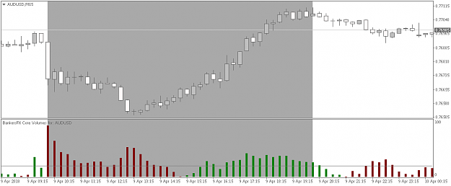
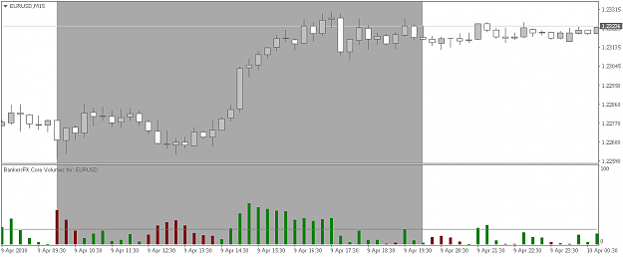
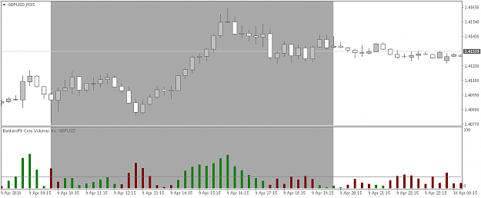
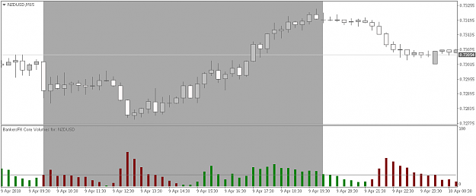
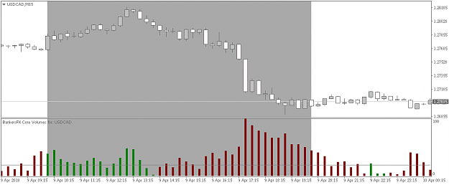
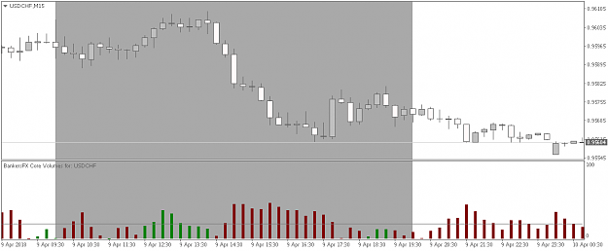
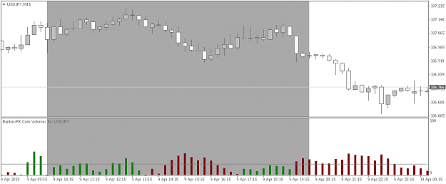

JayRai | Apr 10, 4:49pm (3 hr ago) | Post# 168

Quoting reo4ua
Disliked
Since I'm not 100% fluent on price action yet - is there any other way to determine if a trade at these levels is suggested or not?
Hello reo4ua,
Nice to see that it helps your trading! The answer to that question is somewhat difficult as there are many theories about that matter. I use prices from banks to determine S&R. Professionals (major banks, institutions, large investment companies etc) are able to see stop loss prices in volumes. So they are using that in their favour as well. Therefor the only thing i would use is the daily pivot beside bank positions. But the way Angela is trading looks interesting though. I must admit that. Maybe she can explain her way and it would fit more into your way of entering the markets?
Quoting rvenky
Disliked
I saw an indicator which more or less gives the same indications as the core volume indicator. Have not checked if it repaints. Will be nice if we check it out and report
Hello rvenky,
Sometimes it seems like there are indicators that are somewhat the same. But when we search for it, we can always find indicators that from what we think could be a bit the same. However, as long it isn't 100% the same, it is not. Even when it could be for almost 80% the same, it is not worth risking your capital since trading in global is a tricky business at its own. You need a tool where you can rely on and understand its logic. For me that is not a technical algorithm where i want to put my trust in (read as: risk my capital for). There are many, many indicators out there that looks pretty good but there are still many, many traders that are getting disappointed in the end and are on the edge to give up trading. My best advice would be focussing on actual trading with something you know very well, know its logic and try to become consistent. That task is already hard to crack and need all of your focus and available time. But it is possible! I am not the smartest person around here, believe me, but i managed to become a trader for a living.

