How To Get Forex Trading Alerts On Your Mobile – Metatrader 4 Push Notifications
JULY 11, 2013 BY HUGH KIMURA
When I first started trading Forex, there was only one way to get trading alerts on your phone. I used the Metatrader system for text message alerts, which involved setting up a website hosting account for access to SMTP email relay (luckily I already had one) and sending the alert via the text message email address of my mobile phone number. This is basically how it worked:
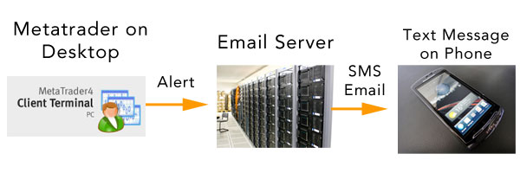
In this post, I will show you a better way to do it, explain when this will help you, and show you exactly how to get it up and running so you never miss another trading signal.

This Will Help You If…

Not every trader will need to have this capability. This will help you most if you want to execute trades when you are on the move and have a trading strategy that uses the 1 hour charts or higher.
Using these signals on a lower timeframe probably won’t work because the signals could get delayed as they make their way through the interwebs. Even if you get a signal immediately, it will take you some time to login to your trading platform on a desktop or on your mobile device, and by that time, the opportunity will probably have passed.
If you are trading a longer term day trading, swing trading or position trading strategy, then these alerts will probably help. Also, having an indicator that gives you alerts is ideal. Getting an alert when a pivot point is hit or two moving averages cross over is tough to do with ordinary price level alerts.
In addition, you cannot add custom indicators to the mobile version of MT4, so using the desktop version is the only way to get custom indicator signals. If you need alerts added to one of your indicators, I will show you how you can get that done towards the end of this post.

A Better Way To Get Forex Signal Alerts
Now that Metatrader 4 is equipped with a more direct solution, the text message version is obsolete. There may be instances where you want to still use the text message technique as a backup, but the direct method is much easier and you do not have to pay for text messages. If you do not have a smartphone with internet access, then this direct method will not work, you still need to use the text message method.
If you have a smartphone and want to get alerts when you are on the go, then read on! This is how the Metatrader 4 push notifications system works:
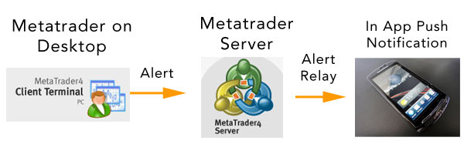
In order to get this running, you will need to have an iPhone or Android with the Metatrader 4 app installed. Then, you will need to have a desktop or laptop computer running Metatrader 4.

How To Set Up Metatrader 4 Push Notifications
First, I’m assuming that you already have Metatrader 4 installed on your desktop or laptop. In order for this to work, you will need to have your desktop Metatrader running so that it will fire the alert. The next thing that you need to do is install the Metatrader 4 app on your phone or tablet. Sign in to your broker account in the mobile app. You can use a demo or live account.
On your desktop, go to Tools –> Options. Then click on the Notifications tab.
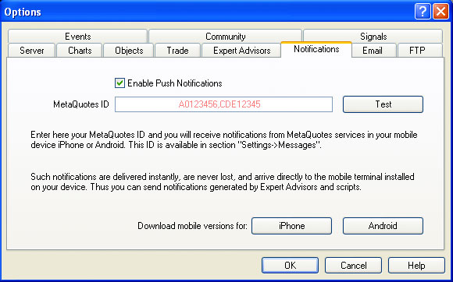
Metatrader 4 tools options
Check the box to Enable Metatrader 4 Push Notifications. Then enter your MetaQuotes ID in the box. To get your ID, go to your mobile device and open your Metatrader 4 app.
Tap on the Settings tab at the bottom and tap on Messages. You will get a list of your messages and your MetaQuotes ID will be at the bottom. Here is what it should look like:
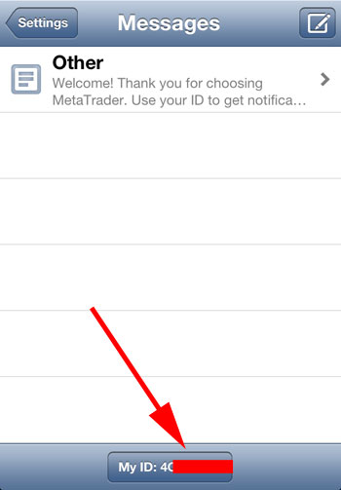
How to get your Metaquotes ID
Now take this ID and put it into your desktop Metatrader program. In your desktop MT4, you can add multiple IDs, separated by a comma. This is handy if you have a trading partner or multiple mobile devices. Click OK and you are all done. Be sure to click the Test button on your desktop to test it out before you start using it.
Whenever an alert goes off on your desktop computer, you will receive a push notification on your phone. Then you can check out the trade and see if you want to enter or not.

How To Create Custom Metatrader Alerts
There is the easy way and the hard way. The easy way is to just setup price level alerts. For example, if you are trading simple support and resistance and want to be alerted when the EUR/USD reaches 1.3000, you can set a simple alert that will fire off when when price hits that level.
You don’t even need the desktop version of Metatrader for this. Your broker app (likeOanda) can probably do this, or you can download the free TradeInterceptor app and set price level alerts there.
The hard way may not be that hard…depending on what you want to do. If you have an existing indicator that you would like to add an alert to, you can find a programmer to customize it for you. I have used these guys before and they did a great job, but there are others out there.
In order to do this, you will need to have the source code for the indicator. The source code file has a .mq4 ending on it and the executable file has a .ex4 ending to it. When you add the .mq4 file to Metatrader, a .ex4 version will automatically be generated by MT4 when it starts. However, if you only have the .ex4 version, you cannot work backwards and get the .mq4 version.
If you have any questions, be sure to ask a programmer. The cost to do this might be less than you think, so be sure to shop around. You can also find programmers on oDesk, orElance.

