TMMA Histo Idea
Buy
H4 and D1 both aligns White + Blue Candle .
Sell
H4 and D1 both aligns Red + Red Candle .

TP
Fibo skills /EMA logics/Auto Regression Channel .
Entry
SNR Price Action , Check TDI RT Clone on smaller timeframe to reconfirm the movement especially the Pivot points or SNR /SND . BN(Big number)
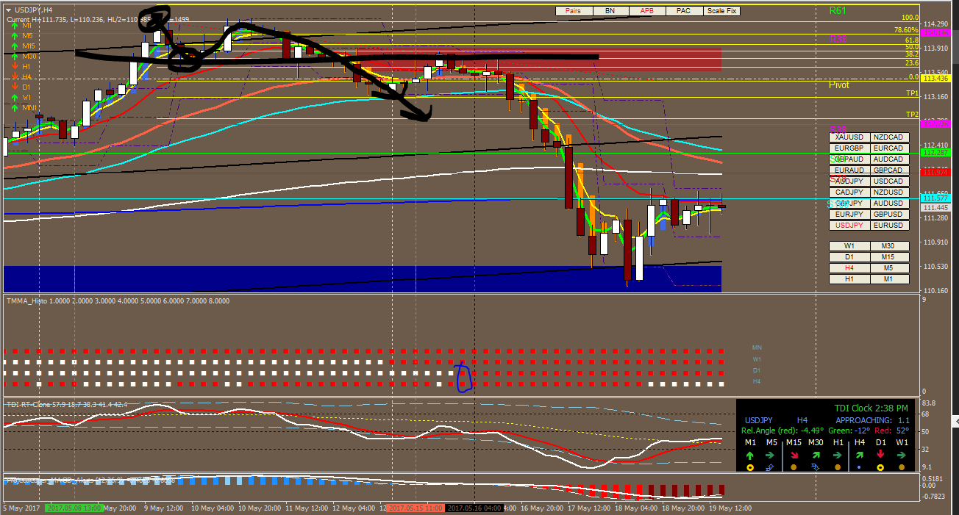Make sure the waves after 2 circles doesn’t break the high , so the TP1 n 2 is valid , but please place TP above them for safety purpose . Additional SnD for better confluence .
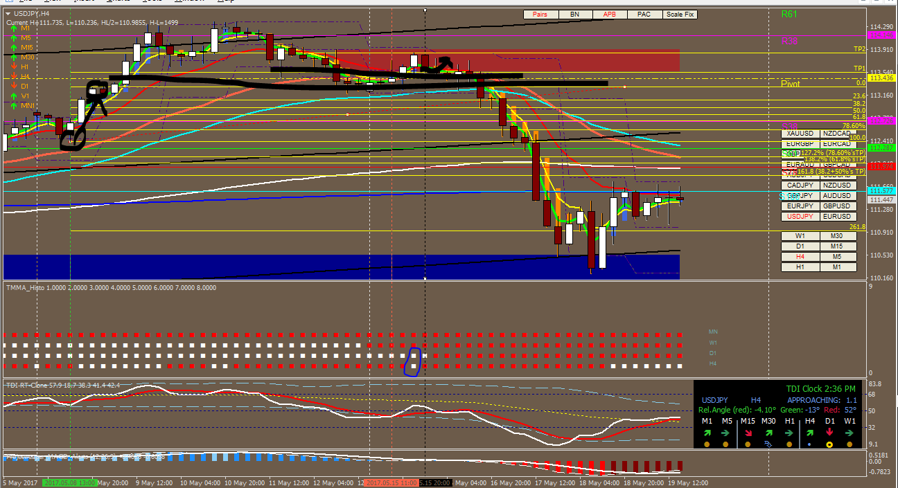
Like I said , Place your TP below TP1 for safety purpose .

