Saranga- method in its simplest form.
I would like to explain in this document that saranga method is simple and I will try to explain it so you can go ahead and study for yourself.
Chart visuals
Guppies Moving averages
TMA channel
200 EMA Exponential
No TDI : although if you want to see divergence and trade that then you need to pull that up every time you want to check for divergence.. (Don’t know what divergence is? PM ensale on Forex Factory and I will send you some info on divergence. )
Introduction
Saranga combines counter trend with the trend trading, his goal is to trade a combination of the two types of trades, I agree with this style of trading, now to understand the trend of the “Moment” he uses the guppies shown below.
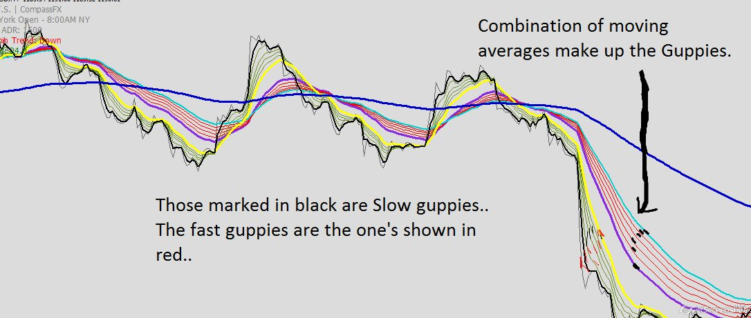

Pullback trade-saranga setup
A trader chasing the market when its going high or short is not a effective approach to trading, one we can trade moving markets when it has picked direction is to trade in the direction after a pullback, this setup with the guppies offer a successful way to enter the market in a trending market..

Here it is shown below.
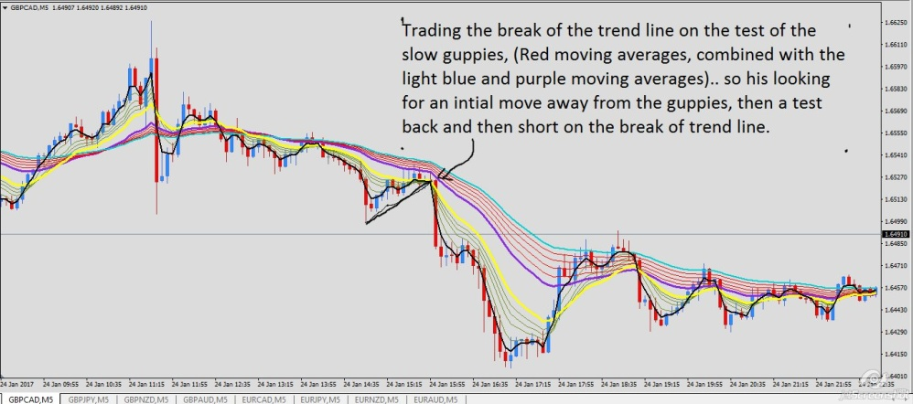
Stop loss a few pip above the light blue guppies after the cross for entry occurs.

More examples of this in the future. Now in the rest of the document I will cover other elements of his approach and how it all fits.

The counter trend approach
The TMA channel is used to trade counter trend trades, saranga aims to use them to read over-extended markets and counter them when they offer the correct setup. He does not use Japanese candles rather he uses Synergy average price bars.

He is looking for strong selling to come out of these outer channels. The candles and setups will be shown below. But the basic premise is normally a 3 candle formation.
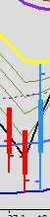

And a bigger view below

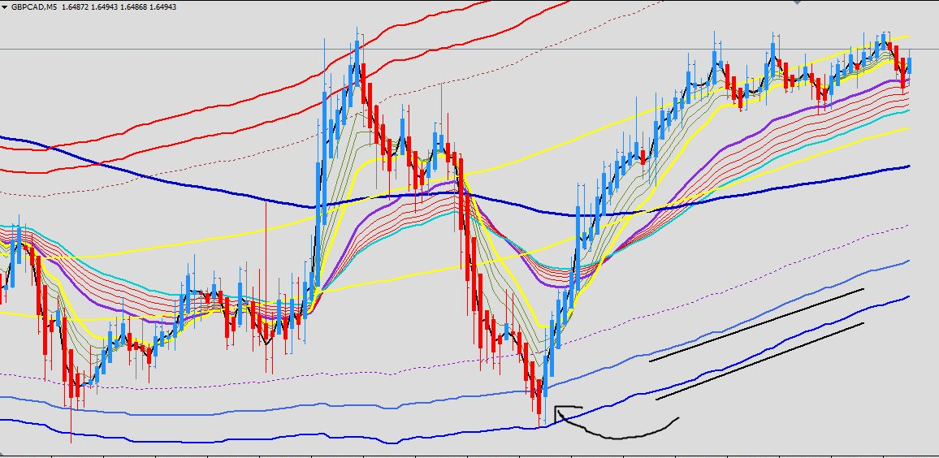
Notice how the channels come into play.
Second example points out the entry, stop loss placement and potential take profits. Trading back to the guppies has a good probability of working if you’re scalping. However consider going for bigger targets on pairs like GBPCAD,GBPYEN, GBPNZD and GBPAUD. 50 Pips is within ADR and normally a good target for the pairs mentioned. (Average daily range)

Another setup.
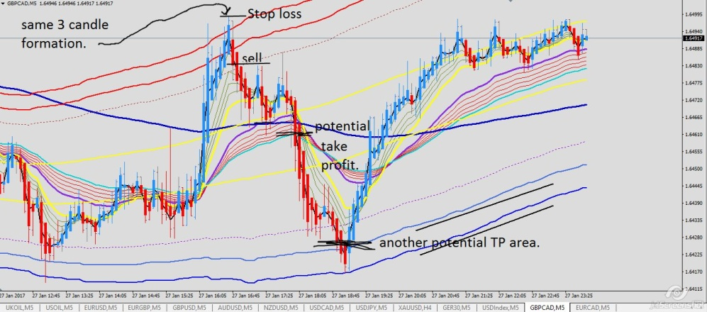
The above chart shows another setup, with Stop placement shown and where Take profit could be placed.

Moving on to how the 200 EMA is used. This is the last setup I will explain and this finishes of an interesting overall approach to the market.. There is obviously more to this that can help you, of course market experience is very important so it’s important to build this up. But this approach is one of the quickest and simplest you can learn.

“Let the market be your teacher”

200 EMA * tricks/tips
The 200 EMA can be a great area to take a trade on the 5 min chart if the guppies don’t act as the place continuation traders enter then we can look for the 200 EMA as the area we can enter the market, again an example will be shown below. I believe this will be eye opening for some traders, however for some they may need to see more examples.

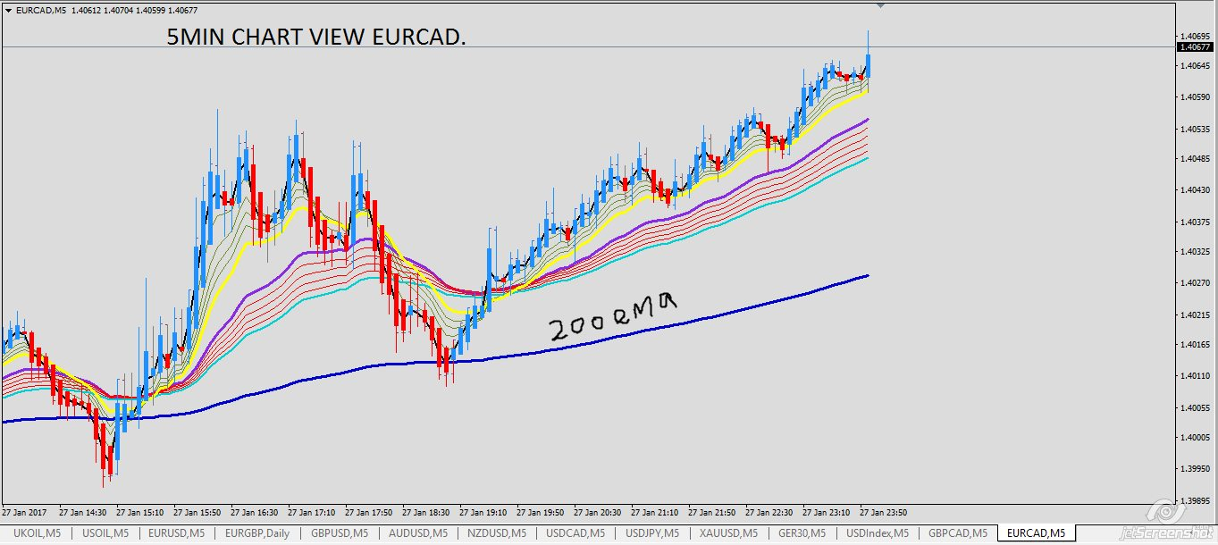

Above chart shows guppies pointing upward, they fail to hold however they give us a long indication, the 200 EMA is also pointing upward.
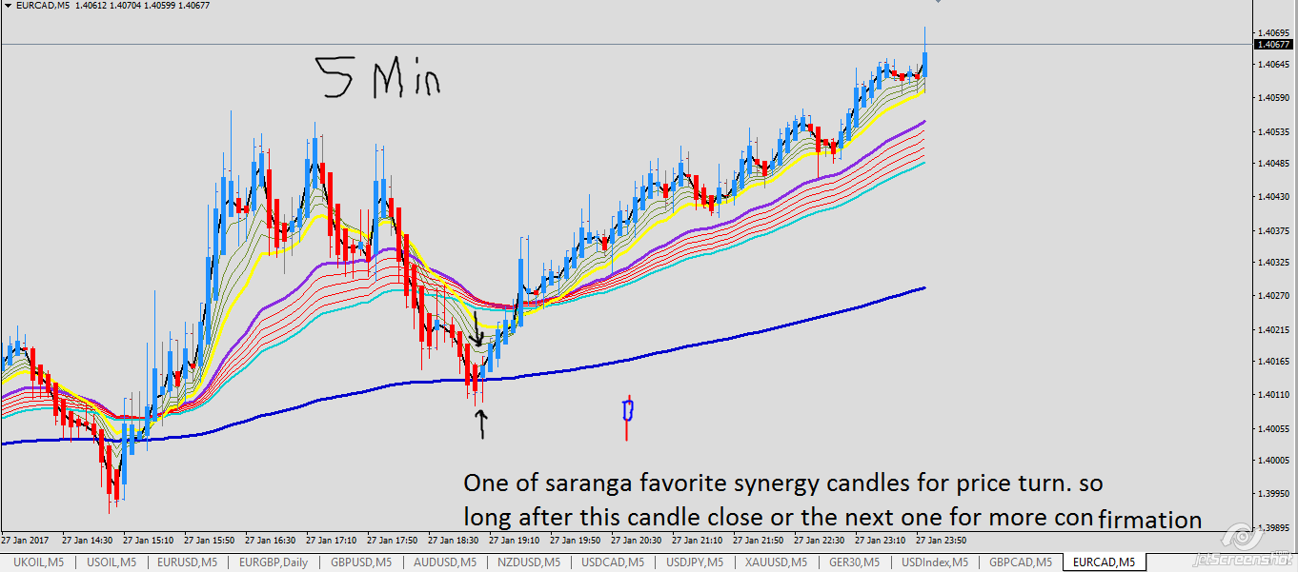

Ok now remember the two above charts we’re 5min view, below I will show you the 15 time frame view.

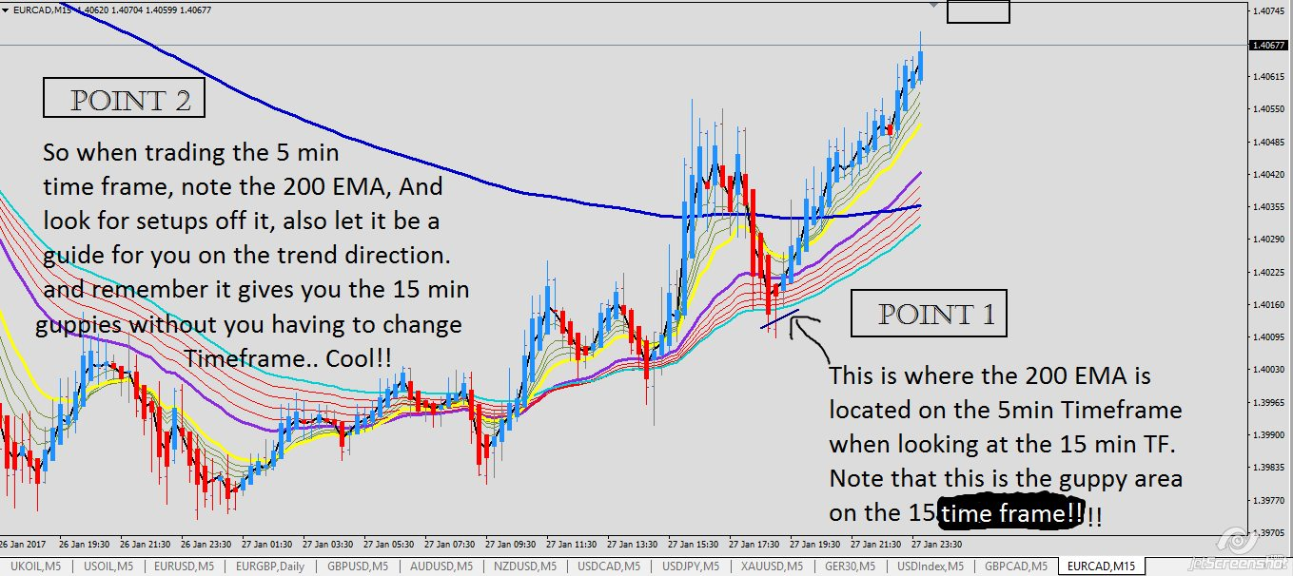

The above chart is the same as the two charts shown earlier, so we keep in focus on this chart, the 5min chart and become experts on 4-6 forex pairs. This method works well for crude oil, big mover and big pips!
Other traders
Other traders including me, have different variations but we all find value in the guppies and use them, tyross uses the Bollinger with the guppies, he also has a good understanding on ab-cd patterns which we can go through in more detail in future.

I trade with guppies and trade very similar to saranga, however I use the normal Japanese candles, and look for similar candle patterns with that format. I don’t use the TMA channels, I use the guppies reading to get the sense of the market over reaching itself. I also use a particular setup with this shown below.
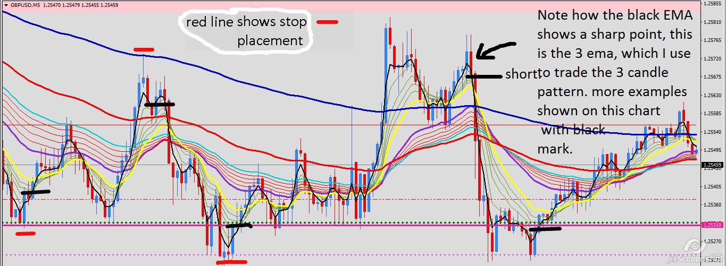
Setups I look for with Japanese candles. Other potential trades shown in black. For this you have to use a different colour for the 3 EMA.

Pundit is an excellent trader who uses the guppies and the TDI for divergence to pick his best setups. These are the traders in the saranga thread at the moment. One of them might have the approach you want to take.

