Forex Pulse Comodo Indicator

About The System
Forex Pulse Comodo Indicator is a manual trading strategy that you can use to generate profits from forex market every day.
You don’t have to be an experienced trader to be able to use it. In fact, even if you have no trading experience at all you would still make a lot of money from it just like pro traders.
There are many people that sign up to trade Forex that don’t understand or take the time to learn how and why to trade Forex. There are many risks involved in trading any kind of asset, whether it is stocks, bonds or currencies. If you are interested in trading, make sure you understand Forex risks.
One of the biggest Forex risks is a leveraged buy. Some Forex brokerages allow you to hold a certain amount of money in your account but leverage that amount to up to 100 times its worth. While this can be good if you are on the winning side of a trade, this can be devastating if you lose your entire accounts worth plus many times more. So please, before you start trading .. make sure that you understand and apply money management rules. No matter how powerful the trading system is, without money management .. it will become a time bomb! We recommend not to risk more than 2% of your initial capital per trade.

Back to system! It contains of one custom made indicator.
Each time direction change you will receive pop up alert.
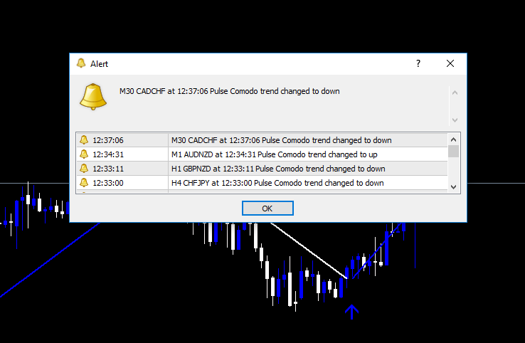
Indicator installation

MT4 900+ built installation guide
Open MT4 platform. Click: File/Open Data Folder. Inside click: MQL4/Indicators – and paste indicator.
Paste template to Templates folder.
After finished restart you MT4 platform for changes to apply.
Or Try to follow this video guide: https://www.youtube.com/watch?v=bATN4WRkfwk
Make sure to load template!

System Rules
Go Long:
The long signal occurs when Forex Pulse Comodo Indicator dot line turns blue and a blue arrow appears on main window.
Go Short:
The long signal occurs when Forex Pulse Comodo Indicator dot line turns white and a white arrow appears on main window.

Exit rules:
Exit trade when Forex Forex Pulse Comodo Indicator turns against your trade direction!

Example Nr.1
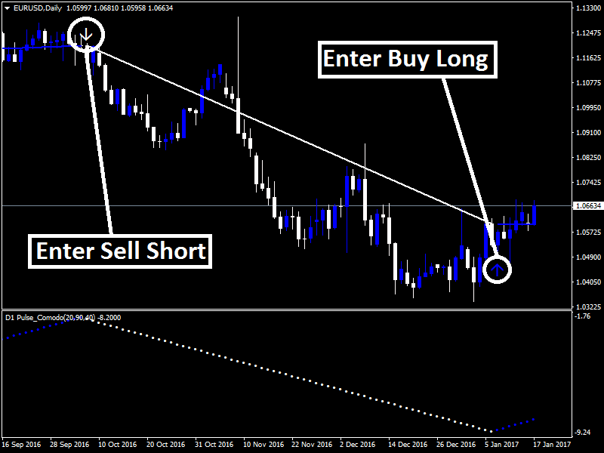

Example Nr.2
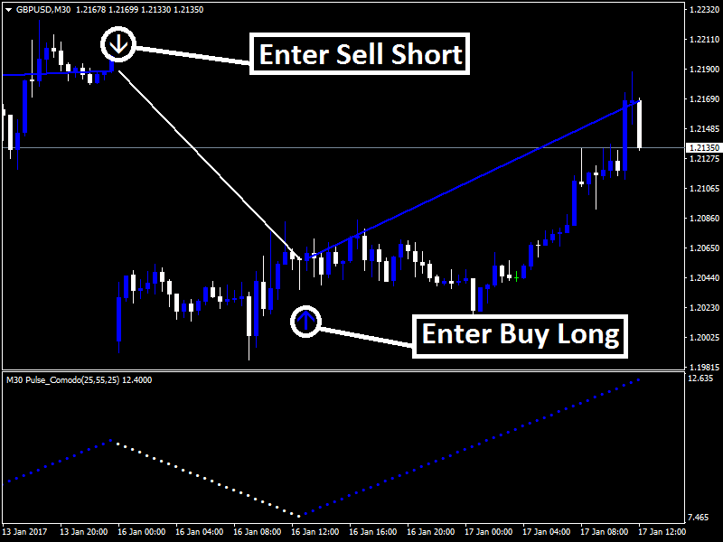

Example Nr.3
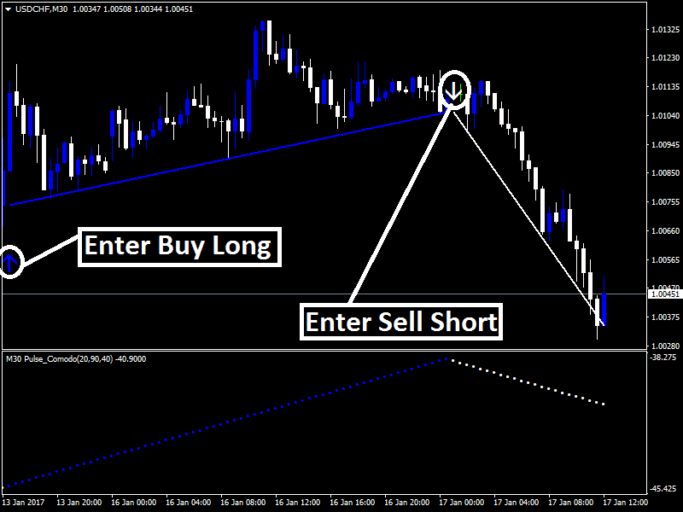

Example Nr.4
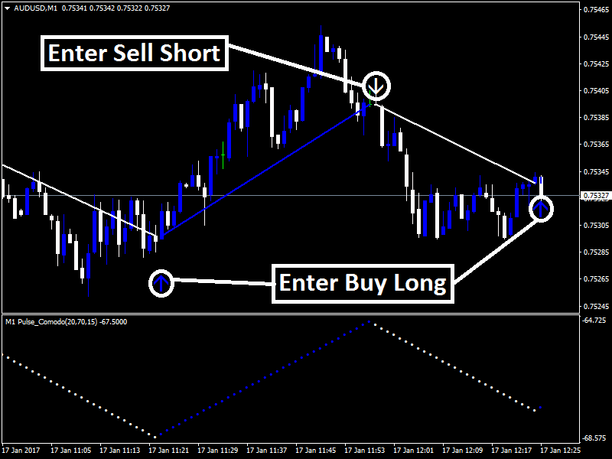

Example Nr.5
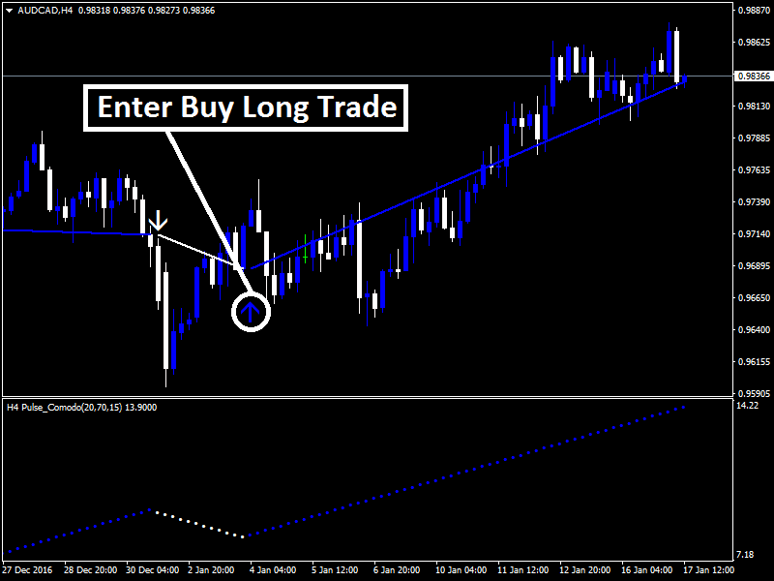

Example Nr.6
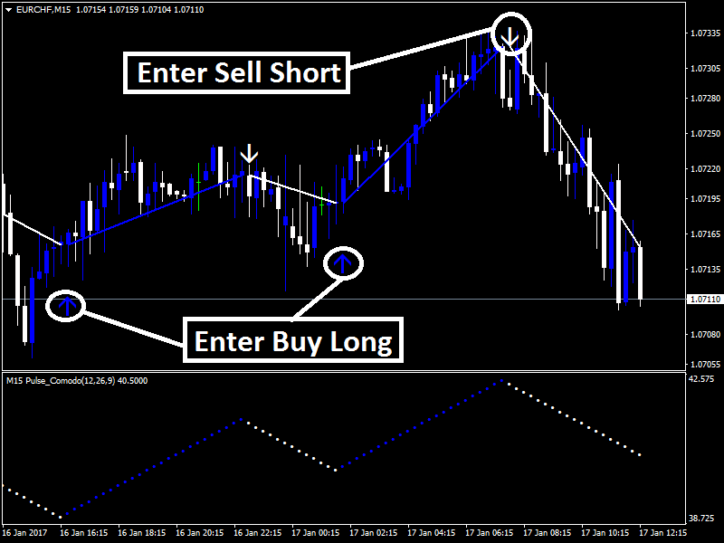

Example Nr.7
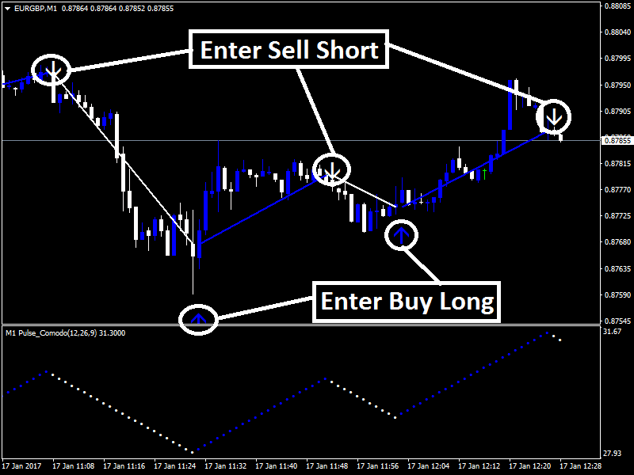

Best Regards,
Dominic Walsh
Forexobroker Team

