Astro based Turning Points known in Advance
By Abhay
First Post: Nov 13, 2015 14:00
Source : http://www.forexfactory.com/showthread.php?t=565863
-----------------------------------------------------------------------------------------//
Preface
I have finally discovered a natural law based on Astro factors that control the movement in market. Many people have been following my turning points on a daily basis, now I want to share with traders here as well..
=================================== ===================//
Indicators
I am attaching the Futuristic Looking Turning Point Indicator.
This the latest version indicators (everyone must install this), some fixes included and it will show Signal if generated on Live bar. If other files are already installed (from the previous version) then just copy TurningPoints.ex4
If you get account unauthorized message, then send an email to forexgeek @ gmail.com with mt4 account number and name on the account.
Attached File
TurningPoints(5).zip 863 KB
=====================================================//
Currency & Timeframe
Attach this to 1hr EURUSD or other Main Pair chart.
I mainly focus on EURUSD but other trader have used on other main pairs and most of the times they react at same times..
Using it on 5min timeframe, in my opinion may distort the perception of turning point, as it is designed for 1hr timeframe granularity, and we watch like from 1 bar before to 3 bars after, but with 5min you will not know when it is imminent...
So like in current move on EURUSD, the current candle started turning down and previous was exhaustion of move UP so I knew another turning happening. But on 5min how would I have used it *not sure*
No need for m1, you are most likely going to loose when you go so granular... I feel 1HR is sufficiently granular neither too small nor too large.. All movements are usually happening at 1HR timeframe from the perspective of Turning Points.

=====================================================//
How to install
(Wait for 45 sec to 1 min to allow it to complete calculations, if stuck for more than 2-3 min then kill and restart MT4)
Note:Combining with old lagging indicators will not be beneficial, need to re-train the mindset.
I am attaching the Turning Points indicator for people to watch and follow.. Some components of it are still evolving and some features will be added later on…
Copy files as follows:
Swedll32dll -->MQL\libraries
Swisseph.mqh --> MQL\include
Astro.csv --> MQL\files
TurningPoints.ex4 --> MQL\indicator
Macd_Colored_v103.ex4 --> MQL\indicator
Do not forget to enable DLL
gmtoffset in parameters is set automatically for your broker, but if you need then can be overwritten.
This has calendar built in until end of Jan-2016.
If color bars don’t appear at same points or if your account is not recognized in the chart then let me know..
================================================//
Regarding chart line colors
- Gold - high energy
- Red - low energy?
- Grey - what does means that zone?
Don't worry too much about other colors, it will take me long time to classify each, I have a lot of work to do.
But GOLD is high energy points, others are equally relevant so don't filter them out. Each turning point is important and the move size may correspond to the time of the day, news time
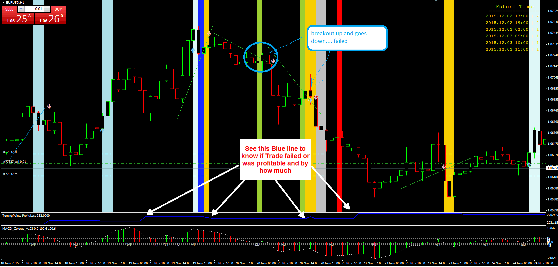
So all lines are turning points?
Yes, as my research continues if I find some events more likely then I will update but so far in auto strategy I have tested what works best from auto signals point of view.
If anyone switches to Manual strategy you may see some extra signals, Auto strategy ignores some turning points because it gives overall higher result but those turning points may still be helpful in manual. But for not good traders, Auto signal will be worth it.
=================================================//
Strategy
Indicator displays, Breakout Signals mixed with another strategy, on the chart and running potential Profit run for the number of bars selected.
This may help in understanding on how one can trade, another strategy will be reversal signals.
For those interested in using Turning Points to manually trade themselves, can set the parameter
Strategy= Manual
if using as standalone for manual trading decisions, tips to consider:
1) I watch the intensity and speed of the move into the turning point, likelihood of breakout vs reversal decision
2) for breakouts I watch preceding 2 bar high/lows and a little longer support/resistance levels, if I am taking reversal trade then these high/lows act as stop and potential breakout trades if near important news time.
3) If the price action going into Turning Point does not look good then it is not necessary to take every trade at every turning point, just few trades at only selected turning points can give you 40-50% returns in a month with good money management and moderate risk.
4) My average profit for each Turning Point trade is 40-60 pips, if price is extended and supported by trend forecast then I can go for over 100 pips and likewise if it is slow moving then I may go for just 20-30 pips profit.
5) If I get just 5-6 such good trades in a month then a lot money can be made and we are getting that in 1 week itself.
Tips for Trade:
1) Break of Trendline of 3-5 bars before or near the Turning Point is a good trade method
2) I also look for break of support & resistance of previous few 2-3 & 8-10 bars for a breakout trade and stops
3) If there is no likelyhood of a breakout then I look for confirmation from MACD for a reversal. When I incorporate the trendlines in autosignal then it may possibly be a good signal method as well..
4) I also look at the time of the day or if it is a slow day, then if price action of previous 3-5 bars is good going into the Turning Point then a reversal is most likely rather than a breakout... so I play for the profits depending on the move into the Turning Point. Always watching the momentum into the Turning Point or if a pending news time.
Manually chart watching, there will always be some signals that will appear as not the best place or should not be taken. But when you develop a strategy, then you implement a consistent method, which may give some wrong signals or may miss some trades that you would have taken otherwise, but on long term you usually do not make good money.
manually trading, I would be watching the trendline break as highlighted in GOLD color... because of the range of move. if range was not as much then maybe the way you have shown..
A little later, I will incorporate trendlines as well in AutoSignals...
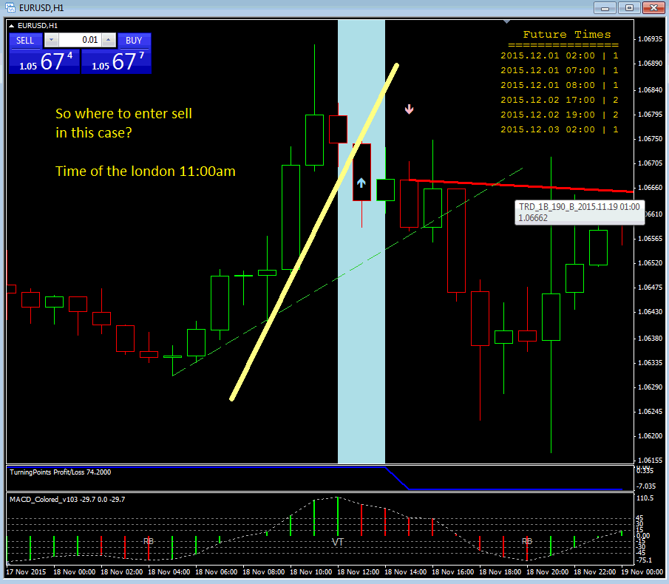
For those interested in using Turning Points to use AutoSignal Strategy
Strategy= AutoSignals
Note: One has to agree that automation can sometimes give loosing trades which may appeared like you should not have taken, but it is the longer term result that gives you net gain of that order.
In this version indicator does not give live signal on the current bar. But it will be included in later version.
Indicator will display all trades that would have been taken by this strategy and on last check, for last 5months starting Jul'15 to Nov'22nd, it generated 1700 pips ( You can see the running profit/loss in the indicator window at bottom. So if one starts with like $6000 or $7000 then you can expect to have got more than 200% ROI in this time period. (Results can be vary in different time periods depending on volatility and market conditions).
Looking at the the profit/loss curve one can see drawdowns or when losses occur.

The difference between Autosignal Modes and Manual is : AutoSignal mode will eliminate some signals that in Automated Strategy are not helpful but for a Manual trader an important trade could be there on those signals. But assumption is that good manual trader, will be able to filter out those signals at other times (only price watching and trendlines watching required for that skill)
But Autosignal method will always have some limitations because it uses consistent rules so net profit may drop if those signals are not eliminated.
The indicator currently does not place the trade, but shows the simulation of the AutoSignal strategy. I am working on Expert Advisor for placing trades automatically using this strategy...
--------------------------------------------------------------------------------------------------------------//
Is this a reversal indicator...?
No, it is not only reversal, but also the breakouts happen around these points...
It is this one filter that everyone has been searching, a filter to avoid unproductive periods, zones when most productive trades can be made...
Every single day since I started using this indicator I have made money...
When people advise have patience, then first question is how and till what time ? when should they jump in? Yes this gives you that reference in time till what time to wait and that helps you see the real move open up or be prepared to take action...
*********************************** ***********************************//
I request all traders to have patience and do not be greedy.
Don't immediately jump into trade unless price movement looks attractive.
You can make lot of money using this indicator in your trading decision but need to wait and divide your capital and start with low percentage of capital to trade.
First observe the past behavior of price movement around Turning Point Signals.
*********************************** ***********************************//
Examples Charts
See how 12th & 13th Nov reacted to the turning points and watch upcoming time also...
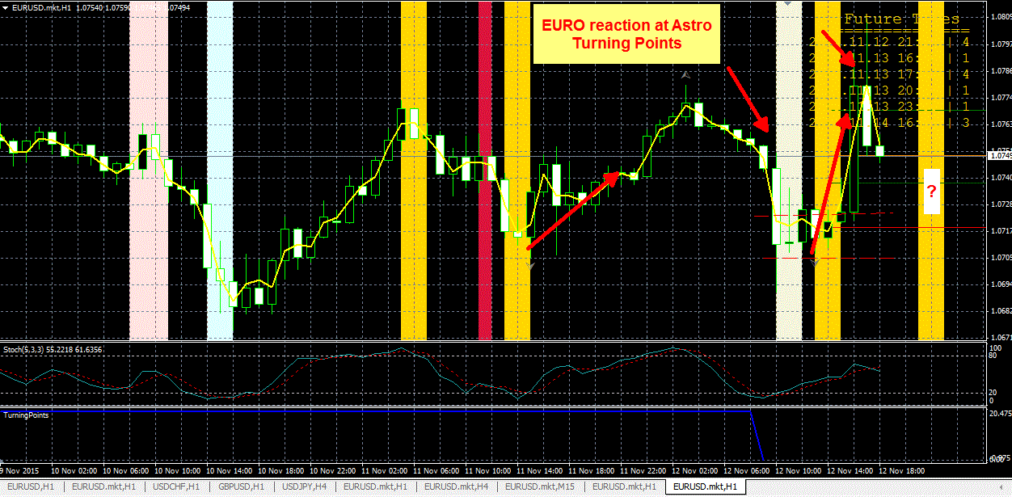
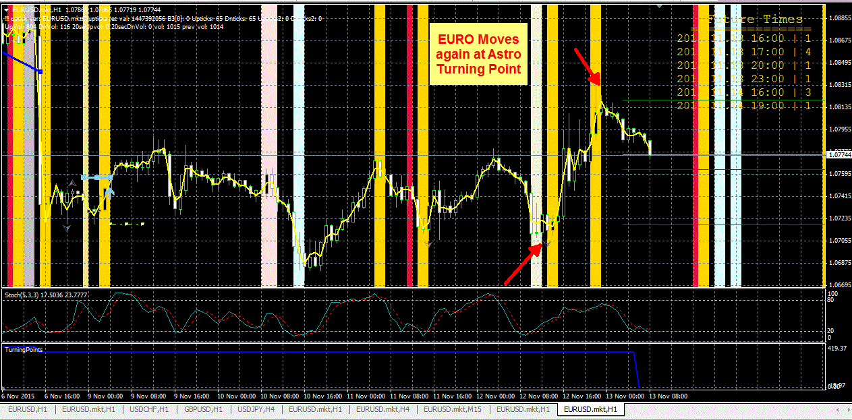
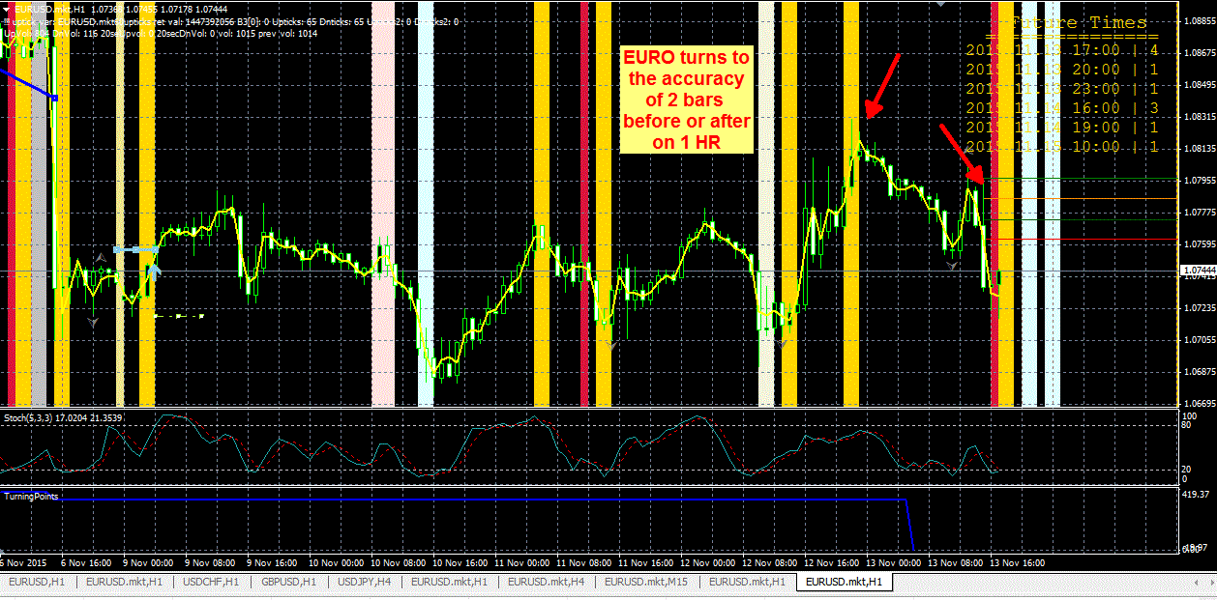

Note: The accuracy is within 1 or 2 bars before or after the Turning Point, most often it is almost accurate to within 1 bar. I look at Highs & Lows of preceeding 2 bars, if they are broken then I try to look for breakout/breakdown trade or if speed of movement is slow then I look for reversal trade.
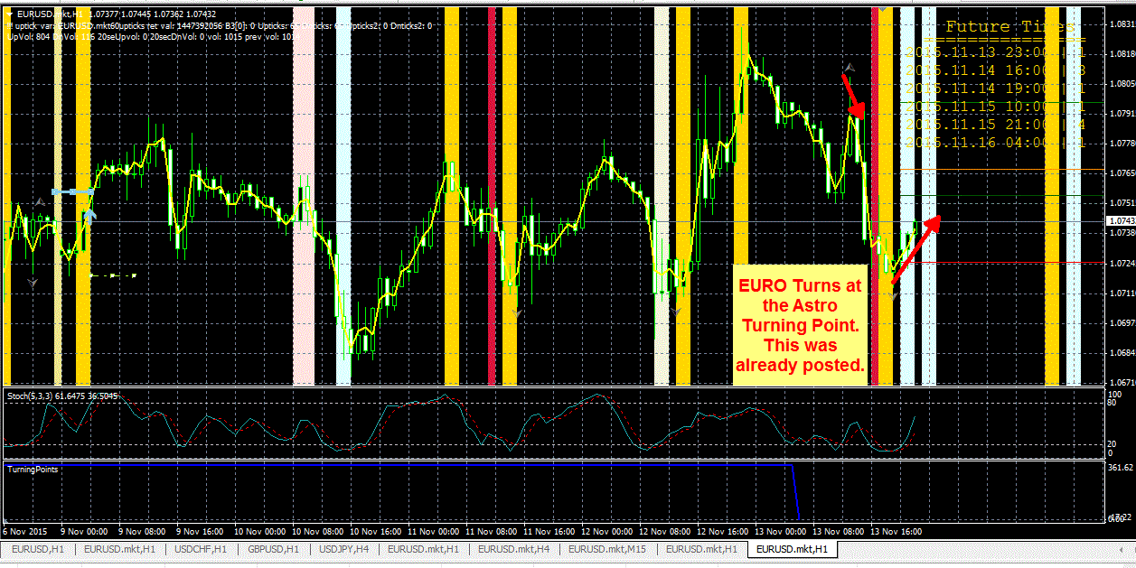
The morning turn in EURO was posted showing the future turning points clearly displayed and now you can see how the price has very nicely turned exactly on the TP. It will be short turn as Friday coming to close..
I closed my SELL trade at the beginning of the TP and added very small BUY which I will close soon..
abhay
------------------------//
Is this strategy profitable ?

Here are my live trades on Live account, taken based on the outlook from Turning Points and also Trend forecast that I do...
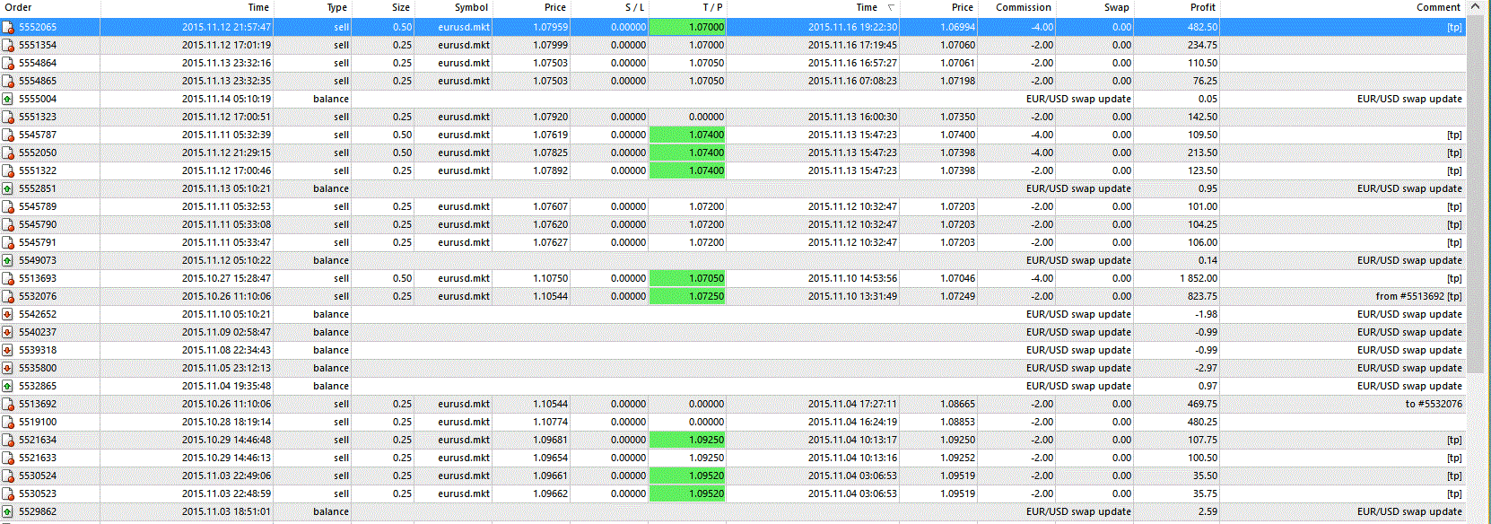
----------------------------------------------//
How much draw down ?
That will depend on the strategy you are using. Personally for me, I have been using this indicator for last 3-4 weeks and my equity has gone up about 60% since then and hopefully by another 1 or 2 weeks it should be 100% up and all trades have closed in profit. For me, I also have the trend forecast so I knew that the trend was overall down for these weeks and anytime I saw a nice move up into turning point then I would establish my positions in 2 or 3 portions to make sure the move is complete.
In one of the previous trade I started establishing short position (20% of capital) from 1.0725 (an hour before the turning point) and price move 35 pips against but once I was confirmed of move completion into the turning point the price was between 1.0750 - 1.0760, then I added rest as the speed had slowed down and it became stagnant so breakout did not look likely..
1) I watch the intensity and speed of the move into the turning point, likelihood of breakout vs reversal decision
2) for breakouts I watch preceding 2 bar high/lows and a little longer support/resistance levels, if I am taking reversal trade then these high/lows act as stop and potential breakout trades if near important news time.
3) If the price action going into Turning Point does not look good then it is not necessary to take every trade at every turning point, just few trades at only selected turning points can give you 40-50% returns in a month with good money management and moderate risk.
4) My average profit for each Turning Point trade is 40-60 pips, if price is extended and supported by trend forecast then I can go for over 100 pips and likewise if it is slow moving then I may go for just 20-30 pips profit.
5) If I get just 5-6 such good trades in a month then a lot money can be made and we are getting that in 1 week itself.
Anyone interested in my indicator should read these points many times to be really aware of when using it to trade..

----------------------------------------------//
More Charts Samples and Additional informations

another turning point is now almost on the horizon and EURUSD has made a nice move into it. So I am looking to short and add more with confirmation. My trend Forecast indicates that next week it will resume downward movement into sideways range... So it looks a very safe trade...
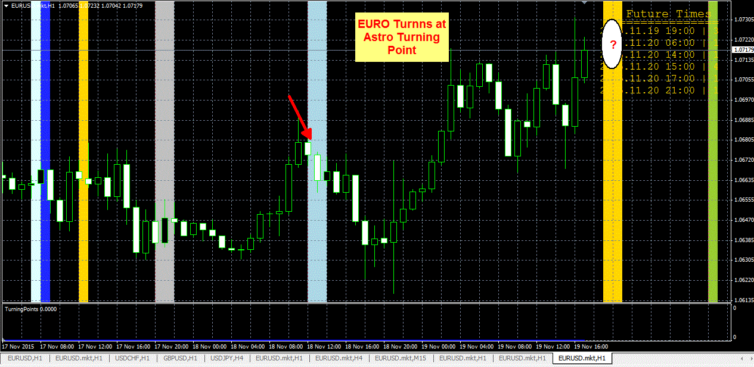

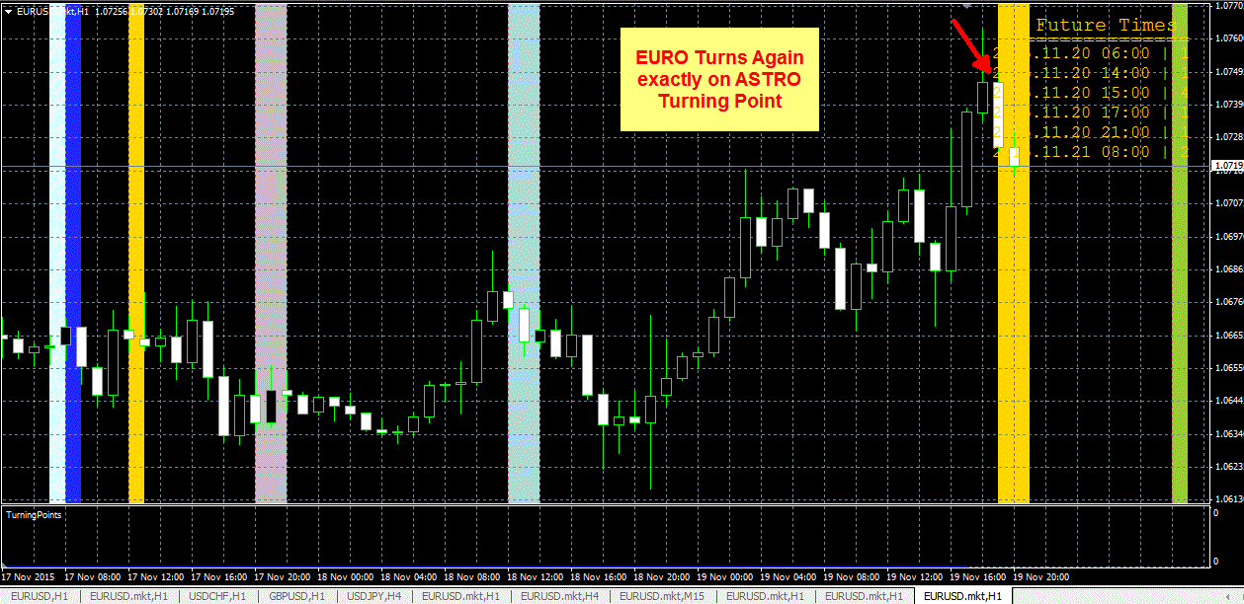
So the turning point was published well in advance and $EURUSD turns exactly on the time bar... giving nice profit of 30 pips already

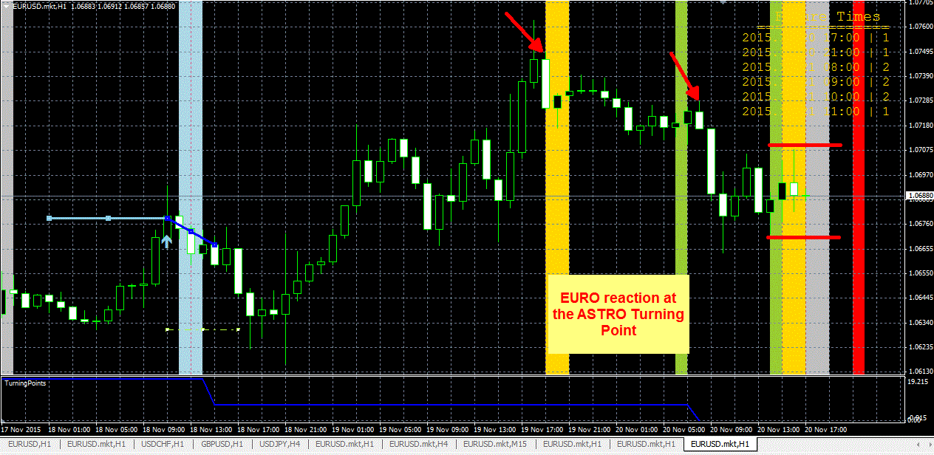
EURO again reacted to the Astro turning point and currently is running into a wall, so price does not seem to be going anywhere.. What is more important for people interested in it is to follow how price reacts around these points, often +/- 1 bar and other times +/- 2bar accuracy. Some members may want to get their hands on it ASAP but it will be more effective once you start getting comfortable with what kind of reactions happen and when you should enter the trade and what to do to protect the trade...
Compare with the previous chart and you will note Green Turning Point was already forecasted yesterday..

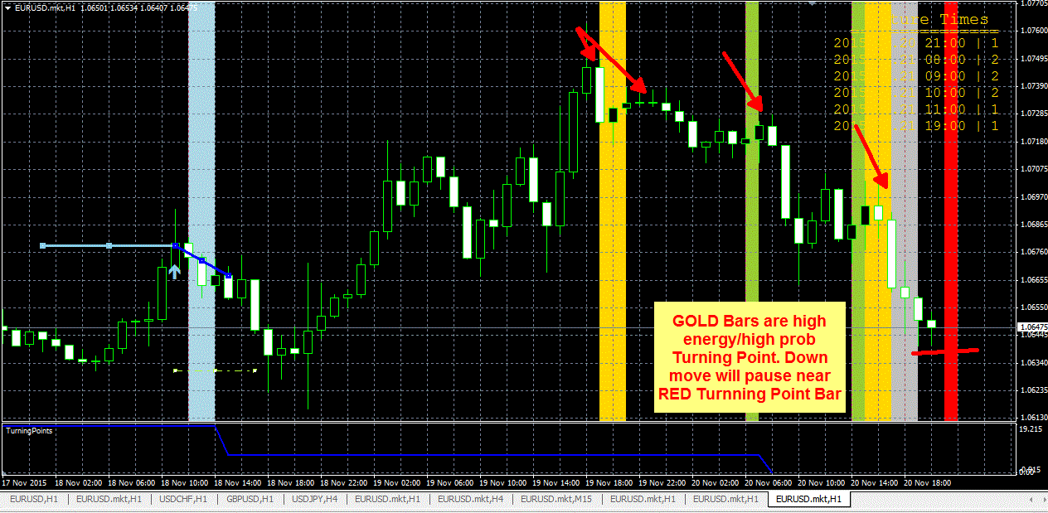
Yet again, last turning point is being hit... the down move nicely comes round to the Turning Point and will pause, if you were planning on doing something, it is a confidence factor.

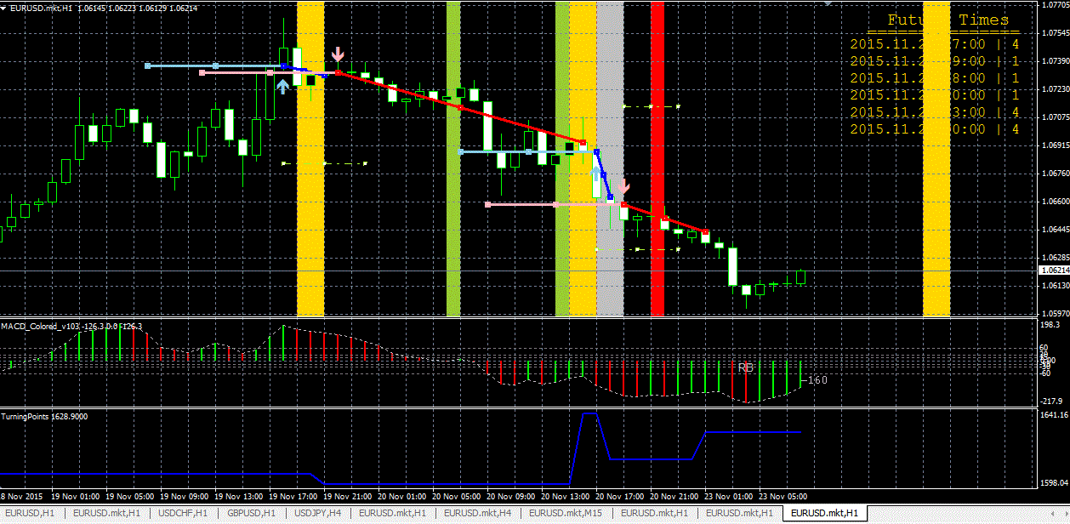

I posted the chart last night, I was watching the turning point, EURO did turn exactly on the bar, although the move does not look very interesting. But interesting to see how long slow grinding narrow move up turns on the turning point...
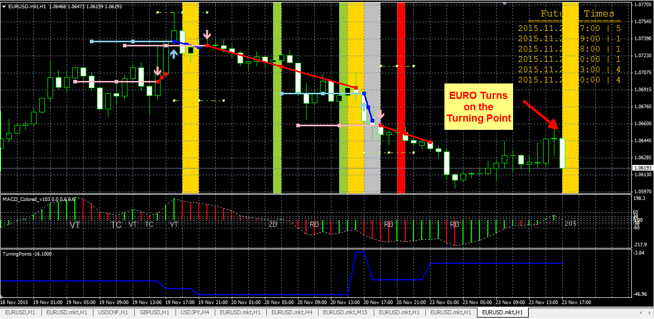

Sometimes price can turn on both sides of Turning Point... like it happened today..
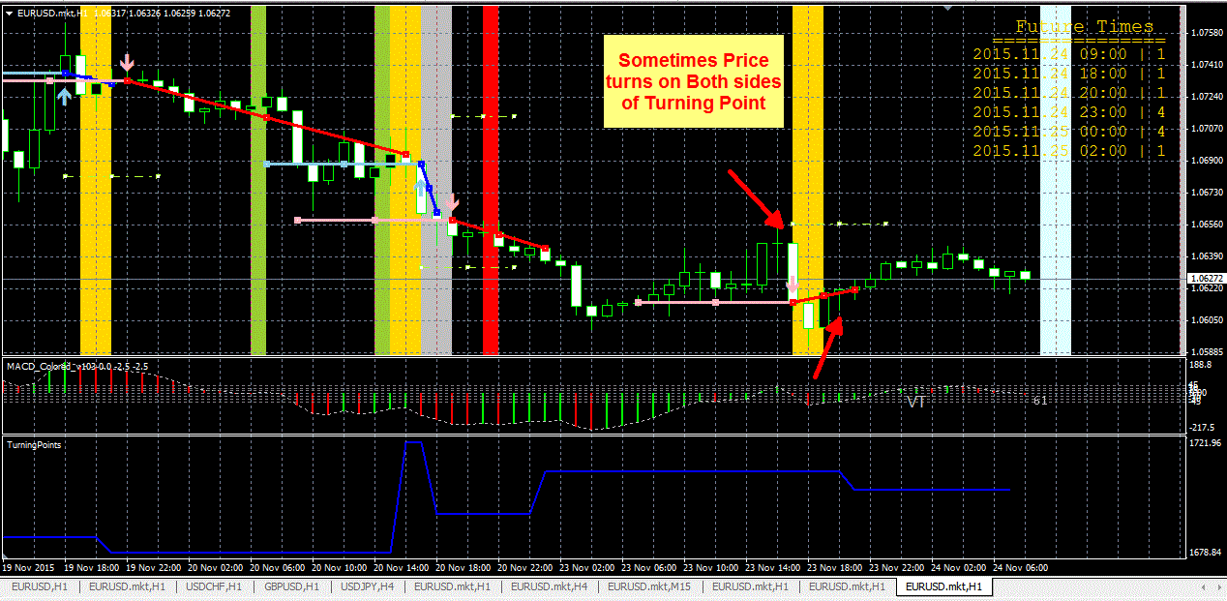
EURO has already reacted to the Turning Point and is heading up into the wall of events. GOLD colored lines are high energy points but seem to be late in the day that is slower in movement, so will have to be watchful
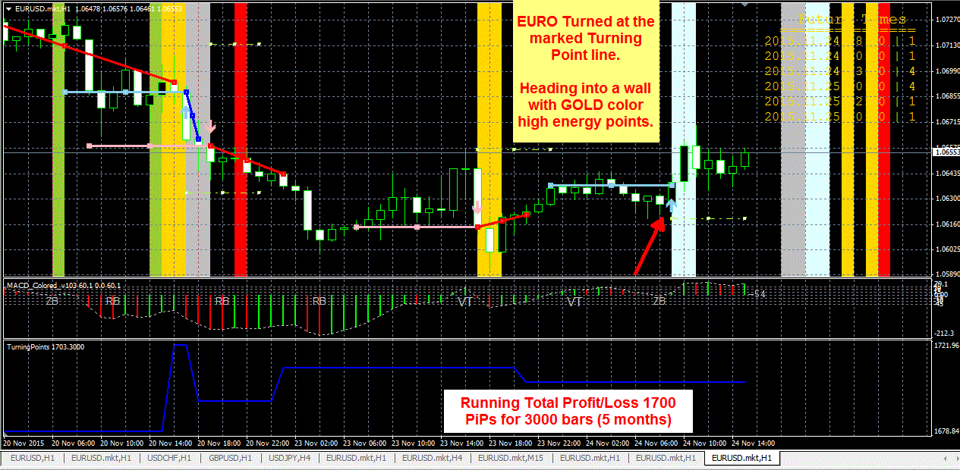

EURO drops before the turning point and then Turns again right on time... There is a heavy zone of events from here, so I will look to SELL if this short period move appears to be completing..
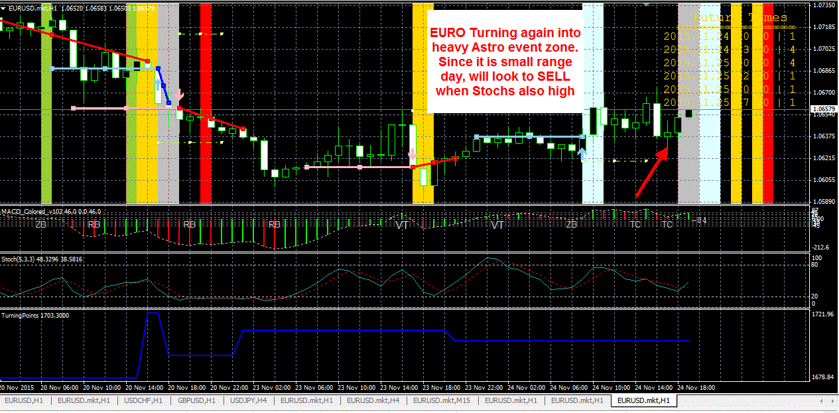
Since it is small range day zone, will look to sell..."

Because there are no news items and it is not moving much, so most likely will keep moving in a range. I was watching the trendline for reversal trade as it is in the Turning Point zone already and more turning points coming.. So a reversal trade which would have been a SELL would have materialized to profitable trade.
STOP would have been above the trendline.
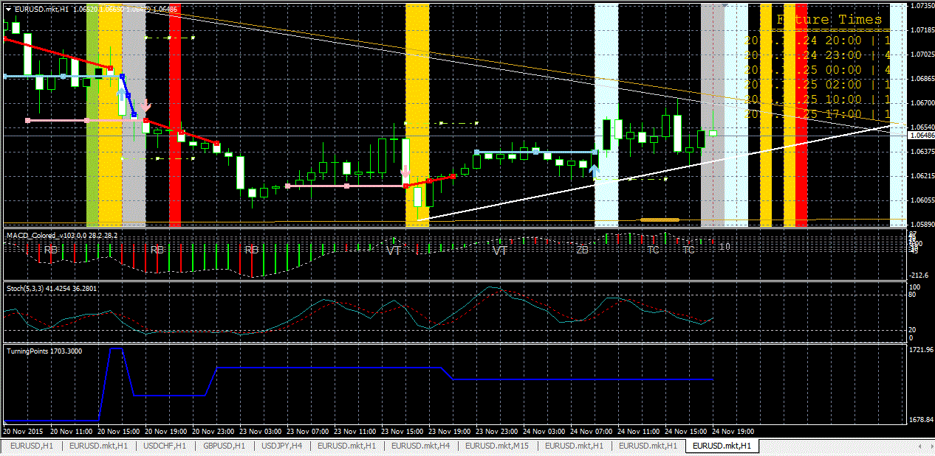

The GOLD colored bars and followed immediately by RED turning point gave the bounce to EURO (normally not an expected move at this time) but we have been watching this time.
I have a feeling 1 or 2 bars after RED timing point, it may turn down, watching if momentum fades then will SELL for some 20-25 pips move.
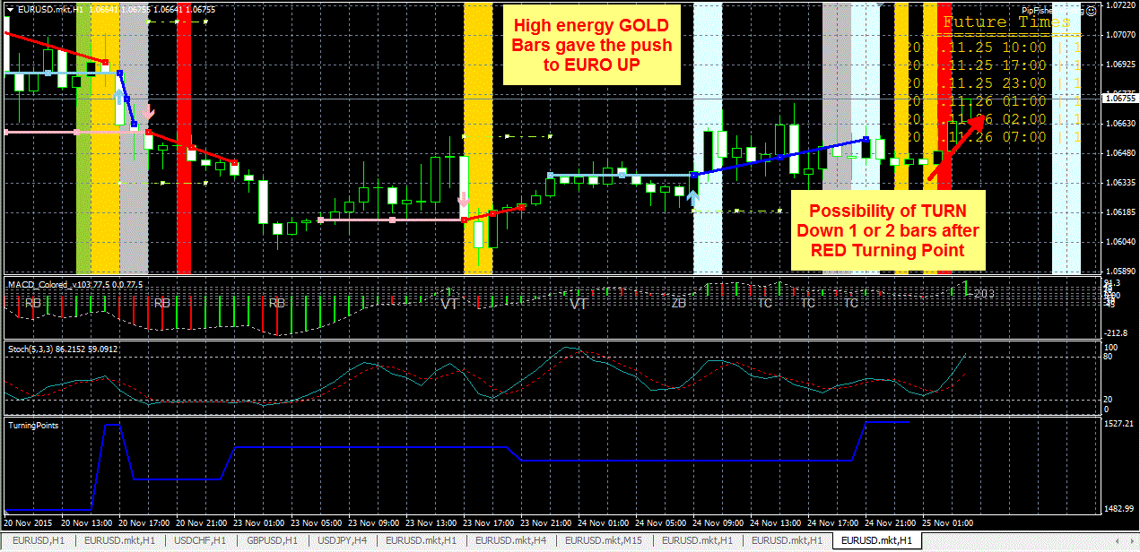

WoW !! It happened ! After 2 bars it goes down 20 pips !
Abhay can you explain more how did you predict that ?
So If there GOLD high energy and closer red energy give push in one side in non-important time, then it will be back soon ?
How to read it?

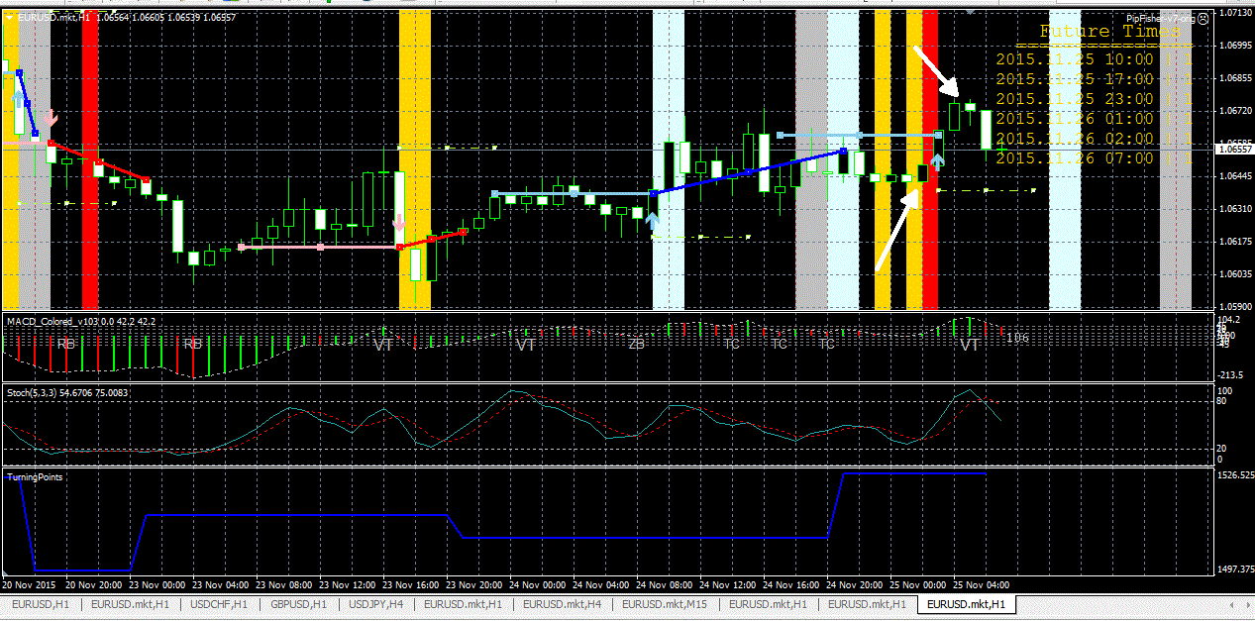
The reasoning is that if such strong Turning Points were present and price had sneaked UP from GOLD bar to 1 bar after RED
It was slow moving time period without any reason, then turning point looked almost 90% sure and should have happened within 1 or 2 bar accuracy, based on the move I noticed 1.0645-1.0655 was support price, so I expected from 1.0675 it should give a move down of 20-25 pips.

Question:
Why there wasn't reversal in this mark?
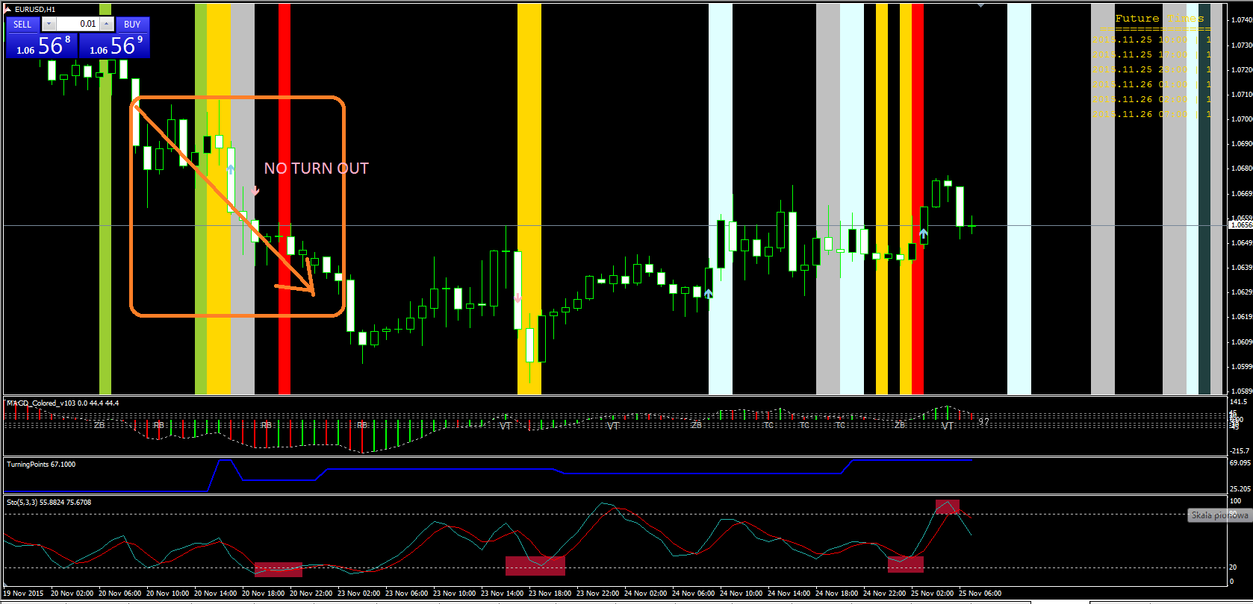
It won't always be reversal, sometimes depending on time and intensity of move there can be breakout right around the Turning Point. So I watch previous 2-3 bars high & Lows for breakout

Very nice move and nice to see EURO react at the turning point.
Now I am watching the next turning point, coming soon for a retrace bounce. *Remember sometimes in can be 1 bar before or even 2 bars after the turning point The price pattern forming will give you some idea.. And don't put all the capital in one trade....
My trend forecast indicates some kind of bottom will soon start forming form late this week into next week...
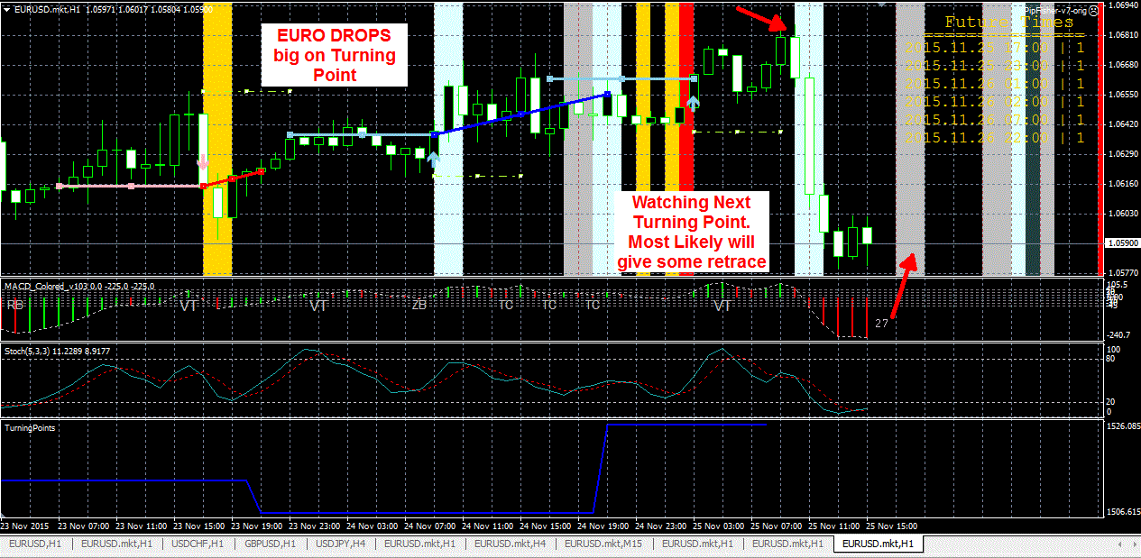
Now this move is looking good into the turning point....
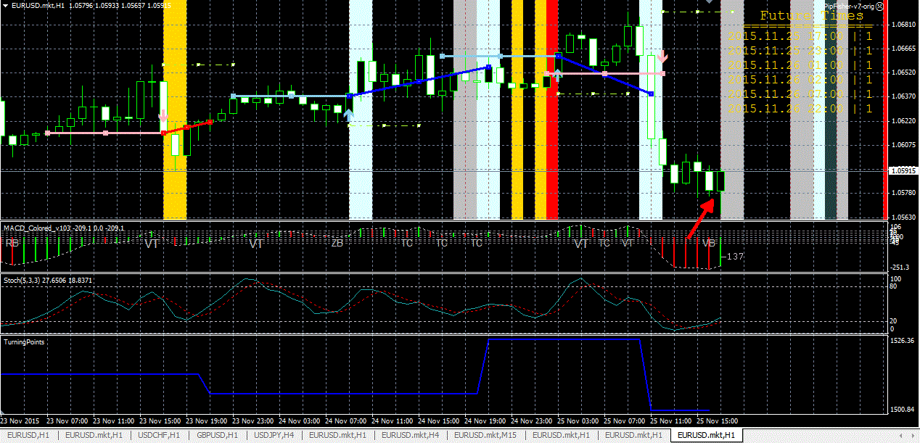

Watch this screenshot now and the Turning Point. Since we are already having a good move UP within the Turning Point at this time of the day, so it is likely it may turn down after the Turning Point. We call this turning on both sides...
Watch for loss of momentum when it moves with in 1 bar before and 1 or 2 bars after the Turning Point then you are likely to get turn on both sides...
So if you observe more and more you will start noting the patterns of price movement around Turning Points... Good profit very timely received...
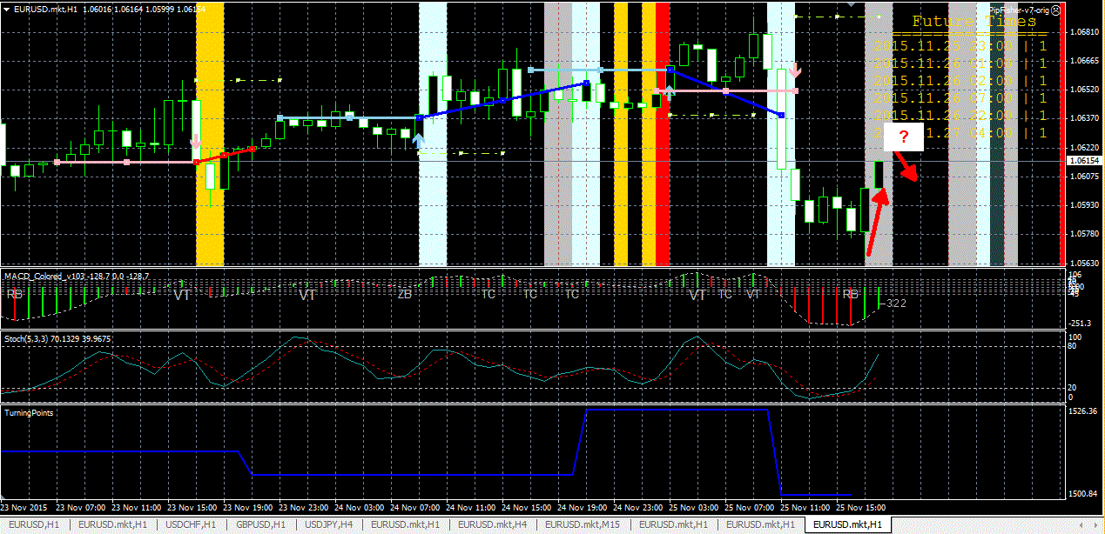

Today's turn in EUR, even though the market is almost dead.
As it is getting close to the next turning point, I may BUY some , although the market is dead and the time of day is also slow period, but this may give 10-15 pips, will watch price action...
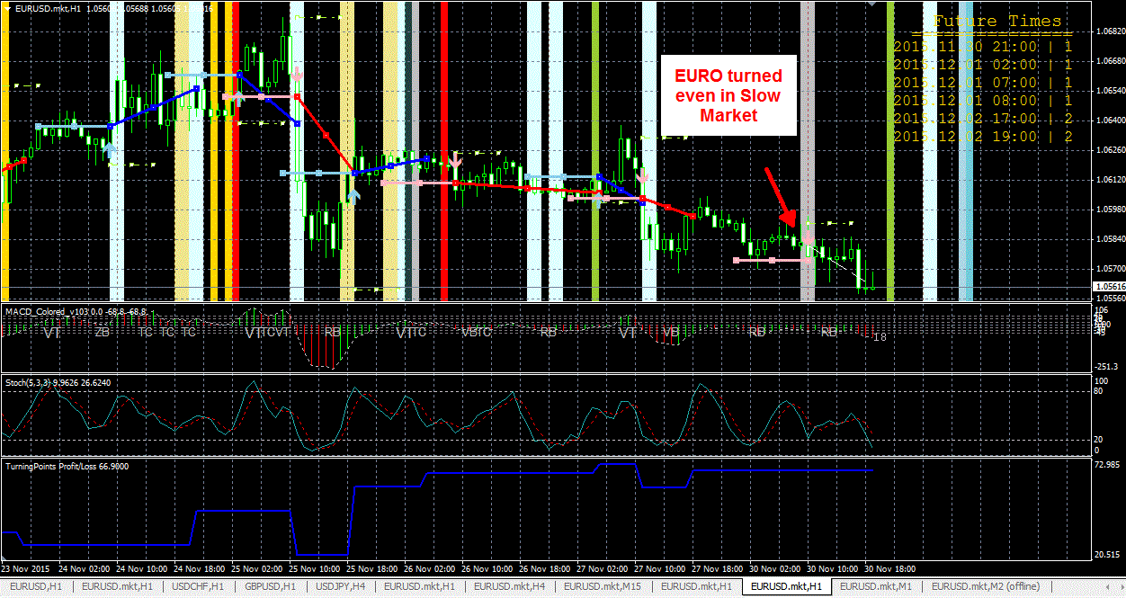

Signs of turning again at the Green Turning Point... although market is slow so will look for small profit accordingly.
If MACD closes in green (2 consecutive green), then SELL trade will be closed...
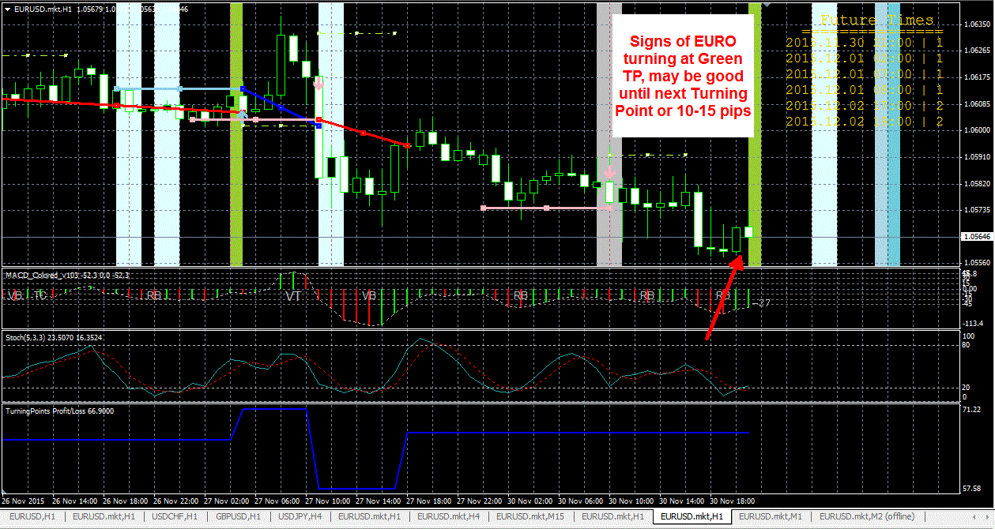

Turning Points are usually the best points to initiate a trade. breakouts or continuation trades are far less in %.
Watching Trendline break of previous 3-5 bars or even more if trendline is clear is very helpful but for autosignals I am using MACD as a detector and the breakout of support/resistance of previous bars.
So the Pink & Blue lines that you see on the charts are the levels that the autosignal strategy is watching and the dashed line you see shifted above or below to these solid lines are the stops. This is one part of strategy and other is using MACD.
Right now, my trend forecast shows we are putting in short term bottom and next few days to next week we may see bounces, sort of sideways bounce and selling. So with partial capital I am buying and holding until I get 30-50 pip profit and other part of capital I am keeping available if I get good turning point

What a nice sudden move in EUR, the BUY signal triggered still valid. This is a very good example of how rationality will go against the move but on a percentage scale and long term AutoSignals will keep adding profit, which is almost impossible for 95% traders...
To become profitable, it will need a change in mindset. Most people I see still keep doing what they have done all their trading lives and think of this just one more thing.... friends... think different... Trade the way this indicator works, something complimentary may be ok, but totally different style won't really help your purpose.
I am watching if the momentum stalls then it will probably go DOWN into next Turning Point..
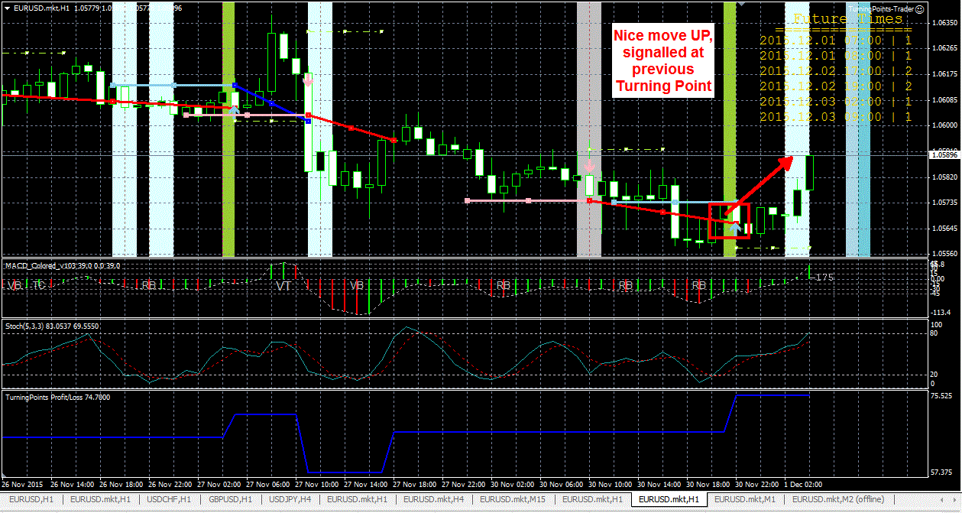

EURO turned again one bar after the Turning Point. I had mentioned that I was watching the loss of momentum after a good move UP without any real basis so it was likely to move DOWN. God 20 pips profit...
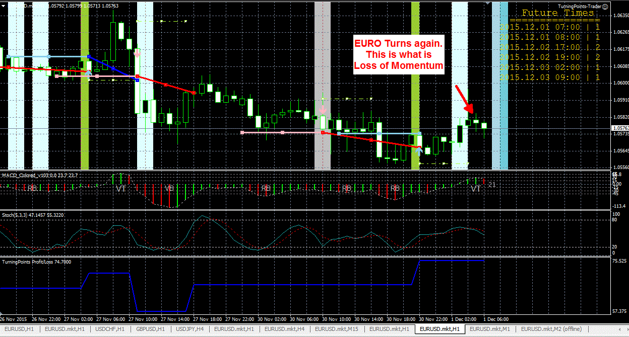

Summarized until page-20 by Gemini Man
================================//==========================================================

