Example 1

Baseline of original file with Nominated values.

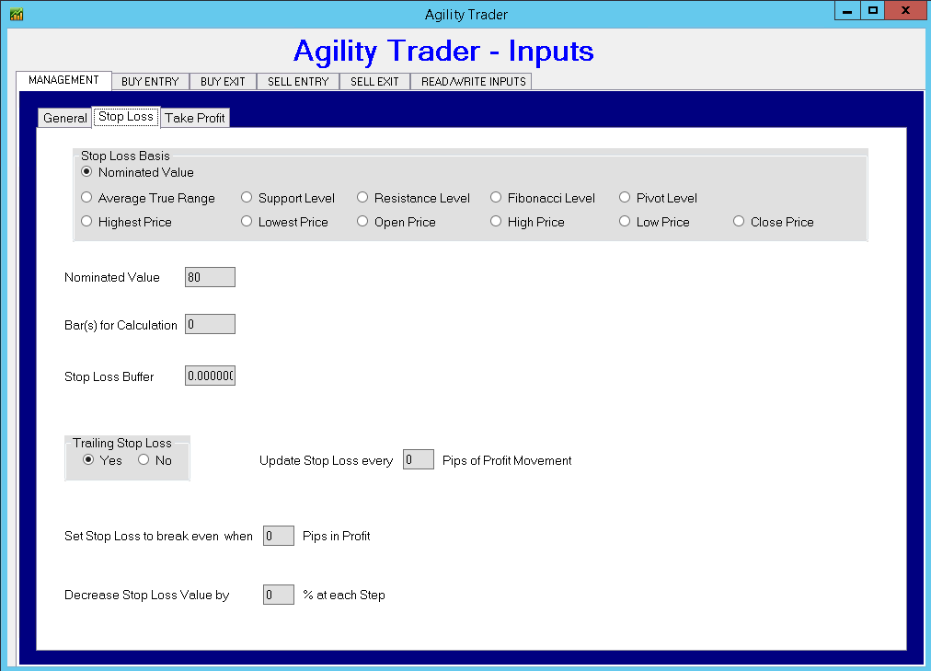

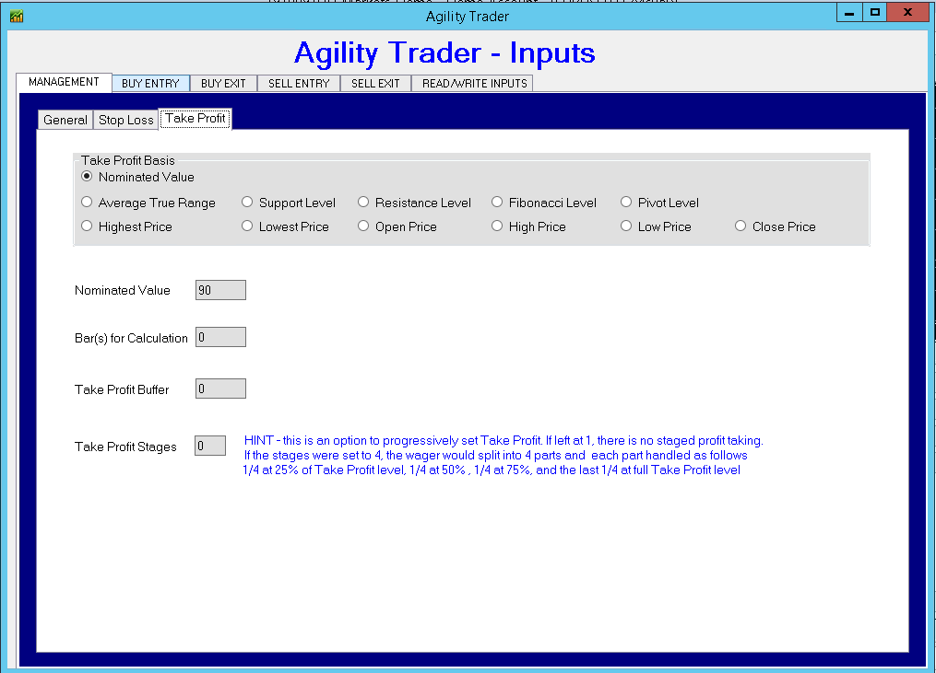

Example 2 with ATR

Using the following settings, take Profit IS being triggered but Stop Loss is NOT.

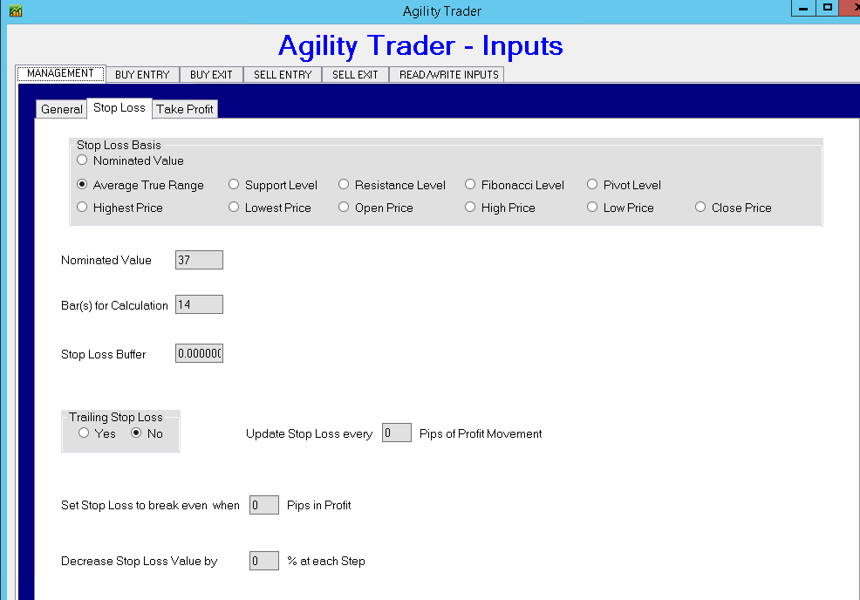

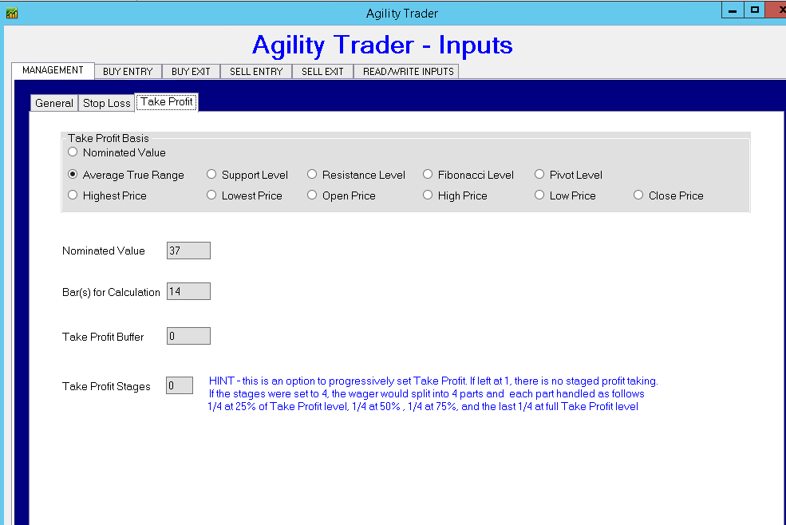

Screenshot of back tester running. This shows TP set but no SL



