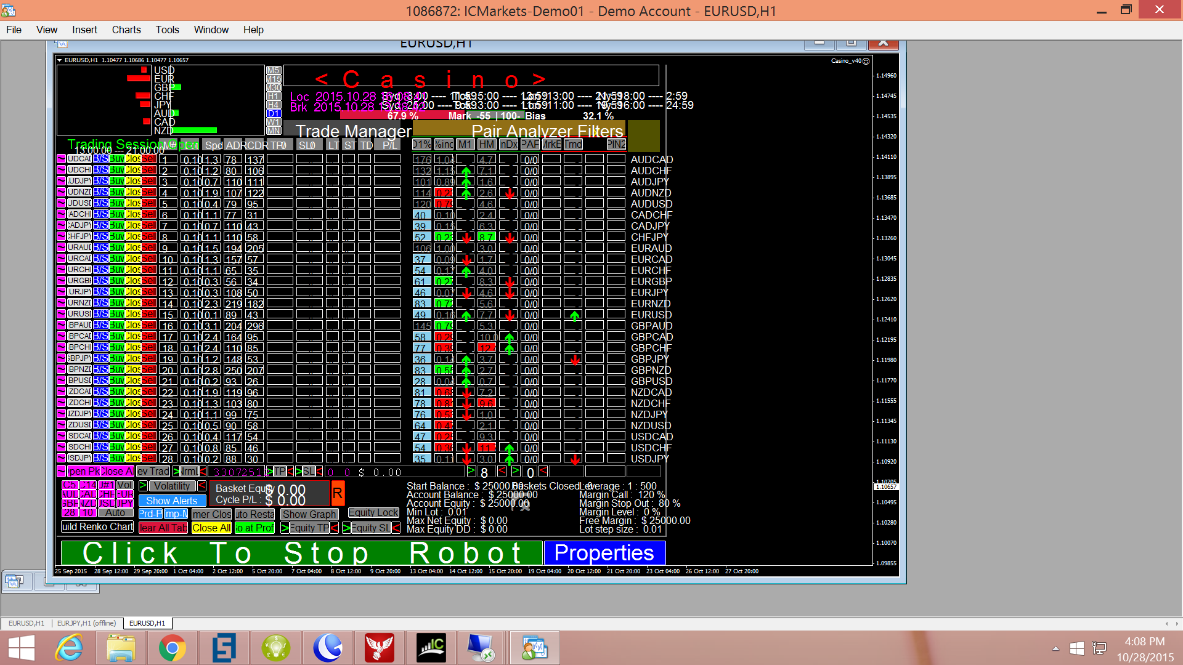

Settings input to the EA as follows:
=========================
FI1=- - Notes Max=30 each - -
Note1=
Note2=
Start_Balance=25000
Lot=0.1
Max_Spread=4.0
TradeComment=ddr1
Slippage=2
One_Trade_Per_Candle=true
FI4=- - Exit Settings - -
Broker_Take_Profit_Pips=0.0
Broker_Stop_Loss_Pips=0.0
Use_Plugin_TSL_Exit=false
Use_Plugin_TP_Exit=false
UsePIN1_Exit=true
UsePIN2_Exit=false
UsePIN1_Exit_No_Signal=false
UsePIN2_Exit_No_Signal=false
EL1=************************
EL2=- Equity Lock Settings -
EL3=************************
Use_Auto_Start_Equity_Lock_Time=false
Start_Equity_Lock_Time=00:00
End_Equity_Lock_Time=00:10
Trail_Last_Equity_Lock=true
Equity_Target_1=150.0
Equity_Lock_1=100.0
Equity_Target_2=0.0
Equity_Lock_2=0.0
Equity_Target_3=0.0
Equity_Lock_3=0.0
Equity_Target_4=0.0
Equity_Lock_4=0.0
Equity_Target_5=0.0
Equity_Lock_5=0.0
Equity_Target_6=0.0
Equity_Lock_6=0.0
Equity_Target_7=0.0
Equity_Lock_7=0.0
Equity_Target_8=0.0
Equity_Lock_8=0.0
EL4=************************
TT1=* * * * Trading hours * * * *
TT2=* Use 24 hour, Computer time *
TT3=* * * * * * * * * * * * * * *
Use_Trading_Session_1=true
Begin_Trading_Session_1=13:00:00
End_Trading_Session_1=21:00:00
TT4=* * * * * * * * * * * * * * *
Use_Trading_Session_2=true
Begin_Trading_Session_2=22:30:00
End_Trading_Session_2=03:30:00
TT5=* * * * * * * * * * * * * * *
Use_Trading_Session_3=false
Begin_Trading_Session_3=00:00:00
End_Trading_Session_3=23:59:59
TT6=* * * * * * * * * * * * * * *
Use_Trading_Session_4=false
Begin_Trading_Session_4=00:00:00
End_Trading_Session_4=23:59:59
TT7=* * * * * * * * * * * * * * *
Use_Trading_Session_5=false
Begin_Trading_Session_5=00:00:00
End_Trading_Session_5=23:59:59
TT8=* * * * * * * * * * * * * * *
Use_Trading_Session_6=false
Begin_Trading_Session_6=00:00:00
End_Trading_Session_6=23:59:59
TT9=* * * * * * * * * * * * * * *
FI5=- - Misc - -
SendEmail=false
AlarmSoundOn=false
Alert_Pop_Up=true
UsePushNotification=false
CurrencyType=$
LocalGMT=5
BrokerGMT=3
Magic_Add=0
AlarmScrnCapOn=false
ScreenH=1920
ScreenV=1080
FI6=-Data capture and Graph settings-
Save_Data_To_File=false
Minutes_Between_Data_Captures=5.0
BE1= D1% Settings
Min_D1_PerCent=5.0
Max_D1_PerCent=85.0
BE2= %inc Settings
Min_Inc_PerCent=0.2
Max_Inc_PerCent=0.85
BE3= Market Bias Settings
Min_Bias_PerCent=55.0
Max_Bias_PerCent=100.0
BE5= Magic 8 Settings
Use_Auto_8_Ball=true
Default_OpenLevel=0.0
BE6= TP/SL ATR Period Settings
TP_ATR_Period=0
SL_ATR_Period=0
FF7=- - User Pairs - -
FG7=- Add Suffix to Pair -
Pair1=AUDCAD
Pair2=AUDUSD
Pair3=EURUSD
Pair4=USDCAD
Pair5=USDCHF
Pair6=USDJPY
Pair7=EURGBP
Pair8=GBPAUD
Pair9=NZDUSD
Pair10=EURJPY
Pair11=GBPJPY
Pair12=GBPNZD
Pair13=AUDJPY
Pair14=AUDNZD
AT1=- - Auto Trading Setup - -
P1=- - - - - - - - - - - - - -
Auto_Trade_AUDCAD=true
Start_Time_AUDCAD=16:05
End_Time_AUDCAD=20:59
P2=- - - - - - - - - - - - - -
Auto_Trade_AUDCHF=true
Start_Time_AUDCHF=02:05
End_Time_AUDCHF=06:59
P3=- - - - - - - - - - - - - -
Auto_Trade_AUDJPY=true
Start_Time_AUDJPY=16:05
End_Time_AUDJPY=20:59
P4=- - - - - - - - - - - - - -
Auto_Trade_AUDNZD=true
Start_Time_AUDNZD=16:05
End_Time_AUDNZD=20:59
P5=- - - - - - - - - - - - - -
Auto_Trade_AUDUSD=true
Start_Time_AUDUSD=16:05
End_Time_AUDUSD=20:59
P6=- - - - - - - - - - - - - -
Auto_Trade_CADCHF=true
Start_Time_CADCHF=02:05
End_Time_CADCHF=06:59
P7=- - - - - - - - - - - - - -
Auto_Trade_CADJPY=true
Start_Time_CADJPY=16:05
End_Time_CADJPY=20:59
P8=- - - - - - - - - - - - - -
Auto_Trade_CHFJPY=true
Start_Time_CHFJPY=02:05
End_Time_CHFJPY=06:59
P9=- - - - - - - - - - - - - -
Auto_Trade_EURAUD=true
Start_Time_EURAUD=02:05
End_Time_EURAUD=06:59
P10=- - - - - - - - - - - - - -
Auto_Trade_EURCAD=true
Start_Time_EURCAD=02:05
End_Time_EURCAD=06:59
P11=- - - - - - - - - - - - - -
Auto_Trade_EURCHF=true
Start_Time_EURCHF=02:05
End_Time_EURCHF=06:59
P12=- - - - - - - - - - - - - -
Auto_Trade_EURGBP=true
Start_Time_EURGBP=02:05
End_Time_EURGBP=06:59
P13=- - - - - - - - - - - - - -
Auto_Trade_EURJPY=true
Start_Time_EURJPY=02:05
End_Time_EURJPY=06:59
P14=- - - - - - - - - - - - - -
Auto_Trade_EURNZD=true
Start_Time_EURNZD=02:05
End_Time_EURNZD=06:59
P15=- - - - - - - - - - - - - -
Auto_Trade_EURUSD=true
Start_Time_EURUSD=02:05
End_Time_EURUSD=06:59
P16=- - - - - - - - - - - - - -
Auto_Trade_GBPAUD=true
Start_Time_GBPAUD=02:05
End_Time_GBPAUD=06:59
P17=- - - - - - - - - - - - - -
Auto_Trade_GBPCAD=true
Start_Time_GBPCAD=02:05
End_Time_GBPCAD=06:59
P18=- - - - - - - - - - - - - -
Auto_Trade_GBPCHF=true
Start_Time_GBPCHF=02:05
End_Time_GBPCHF=06:59
P19=- - - - - - - - - - - - - -
Auto_Trade_GBPJPY=true
Start_Time_GBPJPY=02:05
End_Time_GBPJPY=06:59
P20=- - - - - - - - - - - - - -
Auto_Trade_GBPNZD=true
Start_Time_GBPNZD=02:05
End_Time_GBPNZD=06:59
P21=- - - - - - - - - - - - - -
Auto_Trade_GBPUSD=true
Start_Time_GBPUSD=02:05
End_Time_GBPUSD=06:59
P22=- - - - - - - - - - - - - -
Auto_Trade_NZDCAD=true
Start_Time_NZDCAD=02:05
End_Time_NZDCAD=06:59
P23=- - - - - - - - - - - - - -
Auto_Trade_NZDCHF=true
Start_Time_NZDCHF=02:05
End_Time_NZDCHF=06:59
P24=- - - - - - - - - - - - - -
Auto_Trade_NZDJPY=true
Start_Time_NZDJPY=02:05
End_Time_NZDJPY=06:59
P25=- - - - - - - - - - - - - -
Auto_Trade_NZDUSD=true
Start_Time_NZDUSD=02:05
End_Time_NZDUSD=06:59
P26=- - - - - - - - - - - - - -
Auto_Trade_USDCAD=true
Start_Time_USDCAD=02:05
End_Time_USDCAD=06:59
P27=- - - - - - - - - - - - - -
Auto_Trade_USDCHF=true
Start_Time_USDCHF=02:05
End_Time_USDCHF=06:59
P28=- - - - - - - - - - - - - -
Auto_Trade_USDJPY=true
Start_Time_USDJPY=02:05
End_Time_USDJPY=06:59
HAS0=============================
Use_HAS=false
HAS1=- !! Select only 1 of 6 !! -
Use_As_PIN1_D=false
Use_As_PIN1_X=true
Use_As_PIN2_D=false
Use_As_PIN2_X=false
Use_As_Trend_PIN1_D=false
Use_As_Trend_PIN2_D=false
HAS2=- !! Settings !! -
Chart_Period_HAS=15
MaMetod=2
MaPeriod=3
MaMetod2=2
MaPeriod2=4
HAS3=============================

