fundamental analysis bullet
1/ why monetary value increases ???
- exporters.
- stock market
- asset markets.

- Exporters: export partner wants to buy US goods, export partners to sell local currency to buy dollars
- Stock market: any company wants to make a profit by sales, market share as of: domestic and foreign.
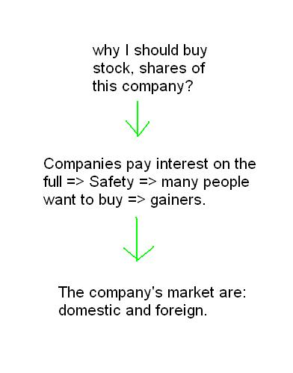
- Asset markets: demand for domestic goods increases, foreigners want to speculate on domestic goods.
wood, steel, iron, land, gold ..... (occur when high inflation)

2/ domestic and international.
- a number of questions you answer yourself:
- you look for the main export partners of Japanese and United States.
- Please note the economic data of: china, US, EU, JP, Canada. compare economic data this week from last week, it was: better, worse or remained silent.
- you can see the economic data better or worse than forecast.
- Your opinion is: the causes and factors that make the forecast figures?
- Think: why economic data better / worse than forecast positive impact or negative market?
- Here is a side question, if you wonder why using economic data so!

- Exporter: economic data of export partners.
- stock market and asset markets : National economic data and export partner.
- There are two kinds of companies is: the company exports and domestic sales.
- eg: I (you) is Canada, you want to buy US stocks. you will evaluate the US economy is: slow growth or development. Yes, the US market include: domestic consumption and export. If the domestic market is growing and worsening export partner, I (you) will realize that the US economy will slow.
- Eg: stock market attractive + export = forex
- examples attractive rate of shares (65% minimum safety and 75%)
example: Shares of US. The main export partners of the US are: EU and Canada.
US economic data = 50%
--------------------- Eu = 25%
--------------- Canada = 25%
2.1/ economic cycle.
growth - remained silent, declining slightly - retarded.
- before the economy from developed to underdeveloped transfer will be a stepping stone. you may consider economic data of any country in a few months, you see what state it is?
- note: the economic cycle is used to determine long-term trends from several months to several years.
- Short-term trends: a few days to two weeks.
- Medium-term trend: a few weeks to four or five months.
- comparative economic data this month on month.
3/ Economic data recording.
eg economic data from Canada.
- economic data week (December 2014)
Day | new |  | Actual | Forecast | Prior.
3 | Overnight Rate |  | 1.00% | 1.00% | 1.00%
5 | Changing jobs |  | -10.7K | 5.3K | 43.1K
 | Balance of trade |  | 0.1B | 0.4B | 0.3b
 | Unemployment rate |  | 6,6% | 6,6% | 6,5%
 | Labour Productivity q / q |  | 0,1% | -0.1% | 2,0%
8 | Housing Starts |  | 196K | 201K | 184K
 | Construction permits m / m |  | 0,7% | 2.1% | 12,5%
11 | Capacity Utilization Rate (production costs) |  | 83,4% | 82,9% | 82,8%
16 | Business Production m / m |  | -0.6% | -0.4% | 2.2%
 | Purchase of foreign securities |  | 9.53B | 5.21B | 4.64B
17 | Wholesale m / m |  | 0,1% | 0,9% | 1,8%
19 | Core CPI m / m |  | -0.2% | 0,1% | 0,3%
 | CPI m / m |  | -0.4% | -0.2% | 0,1%
 | Retail Sales m / m |  | 0.0% | -0.4% | 0,8%

- economic data monthly (December 2014)
Day | new |  | Actual | Forecast | Prior.
 | Changing jobs |  | -10.7K | 5.3K | 43.1K
 | Balance of trade |  | 0.1B | 0.4B | 0.3b
 | Unemployment rate |  | 6,6% | 6,6% | 6,5%
 | Labour Productivity q / q |  | 0,1% | -0.1% | 2,0%
 | Housing Starts |  | 196K | 201K | 184K
 | Business Production m / m |  | -0.6% | -0.4% | 2.2%
 | Wholesale m / m |  | 0,1% | 0,9% | 1,8%
 | Core CPI m / m |  | -0.2% | 0,1% | 0,3%
 | Core Retail Sales m / m |  | 0,2% | 0,2% | 0.0%
 | CPI m / m |  | -0.4% | -0.2% | 0,1%
 | Retail Sales m / m |  | 0.0% | -0.4% | 0,8%

https://drive.google.com/folderview?id=0B2x_ag89ufXmak5jNEVVNDhXd1E&usp=sharing
https://drive.google.com/folderview?id=0B2x_ag89ufXmRzJNakNSYjg5N3M&usp=sharing
Word file synthesis of my knowledge. it is the Vietnamese version, you can use google to translate.
I'm the short-term trading, I will take the example short-term trading.

- The main export partners of the US: Eu, Canada ( mexico )
- The main export partners of the Japanese: US, China.
- I had three weeks holiday trade, Christmas holidays, New Year's holiday and wait a week of economic data.
The first week of the new year is Jan 04 -10, 2015.
- of the week: EU economic data, Canada is worse than the last week in December 2014.
- US is better, JP and china is not available

eg economic data from Canada.
2014
2 good / 4 ugly
16 | Business Production m / m |  | -0.6% | -0.4% | 2.2%
 | Purchase of foreign securities |  | 9.53B | 5.21B | 4.64B
17 | Wholesale m / m |  | 0,1% | 0,9% | 1,8%
19 | Core CPI m / m |  | -0.2% | 0,1% | 0,3%
 | CPI m / m |  | -0.4% | -0.2% | 0,1%
 | Retail Sales m / m |  | 0.0% | -0.4% | 0,8%
2015
1 good / 5 ugly
06 | RMPI m / m |  | -5,8% | -4,6% | -4.3%
 | IPPI m / m |  | -0.4% | -0.5% | -0.5%
 | Balance of trade |  | -0.6B | -0.2B | -0.3B
09 | Housing Starts |  | 181K | 191K | 195K
 | Construction permits m / m |  | -13,8% | 0,8% | 2.1%
 | Changing jobs |  | -4.3K | 10.3km | -10.7K
 | Unemployment rate |  | 6,6% | 6,6% | 6,6%
economic data from Eu. ( 16 -19 fully ) ( 23 and 30 is too little and can not be analyzed. )
2014
3 good
16 | Italian Trade Balance |  | 5.40B | 1.97B | 2.02B
 | Balance of trade |  | 19.4B | 18.2B | 17.9B
17 | Official CPI y / y |  | 0,3% | 0,3% | 0,3%
 | Soul Core CPI y / y |  | 0,7% | 0,7% | 0,7%
19 | German PPI m / m |  | 0.0% | -0.2% | -0.2%
 | Current Account |  | 20.5B | 27.8B | 32.0B
23 | French Consumer Spending m / m |  | 0,4% | 0,2% | -0,8%
 | Italian Retail Sales m / m |  | 0.0% | 0,2% | 0.0%
30 | Spain Flash CPI y / y |  | -1.1% | -0.7% | -0.4%
 | M3 Money Supply y / y |  | 3.1% | 2,6% | 2,5%
 | The private loans y / y |  | -0.9% | -0.9% | -1.1%

2015
3 good / 9 ugly
05 | German preliminary CPI m / m |  | 0.0% | 0,1% | 0.0%
 | Spain Unemployment Change |  | -64.4K | -72.0K | -14.7K
07 | The monthly unemployment rate |  | 13,4% | 13,3% | 13,3%
 | CPI Flash Estimate y / y |  | -0.2% | 0.0% | 0,3%
 | Core CPI Flash Estimate y / y |  | 0,8% | 0,6% | 0,7%
 | Unemployment rate |  | 11,5% | 11,5% | 11,5%
 | Preliminary Italian CPI m / m |  | 0.0% | -0.2% | -0.2%
08 | German Factory Orders m / m |  | -2,4% | -0.6% | 2,9%
 | Retail Sales m / m |  | 0,6% | 0,3% | 0,6%
 | PPI m / m |  | -0.3% | -0.2% | -0.3%
09 | German Industrial Production m / m |  | -0.1% | 0,4% | 0,6%
 | German Trade Balance |  | 17.7B | 19.4B | 20.6B
 | French industrial production m / m |  | -0.3% | 0,4% | -0.7%
 | France's trade balance |  | -3.2B | -4.5B | -4.3B

economic data from United States
2014
4 good / 6 ugly
22 | Currently Home Sales |  | 4.93M | 5.21M | 5.25M
23 | Core Durable Goods Orders m / m |  | -0.4% | 1.1% | -1.1%
 | Waking GDP q / q |  | 5,0% | 4,3% | 3,9%
 | Durable Goods Orders m / m |  | -0.7% | 3,0% | 0,3%
 | HPI m / m |  | 0,6% | 0,3% | 0.0%
 | New Home Sales |  | 438K | 461K | 445K
 | Core PCE Price Index m / m |  | 0.0% | 0,1% | 0,2%
 | Personal Spending m / m |  | 0,6% | 0,5% | 0,3%
 | Personal Income m / m |  | 0,4% | 0,6% | 0,3%
24 | Dad unemployment |  | 280K | 291K | 289K
31 | Currently Home Sales |  | 298K | 287K | 281K
 | Core Durable Goods Orders m / m |  | 0,8% | 0,6% | -1.2%

2015
4 good / 4 ugly
06 | Total vehicle sales |  | 16.9M | 16.9M | 17.2M
 | Factory Orders m / m |  | -0.7% | -0.3% | -0.7%
07 | ADP Non-Farm Employment Change |  | 241K | 227K | 227K
 | Balance of trade |  | -39.0B | -42.3B | -42.2B
08 | Dad unemployment |  | 294K | 291K | 298K
09 | Consumer Credit m / m |  | 14.1B | 15.1B | 16.0B
 | Non-Farm Employment Change |  | 252K | 241km | 353K
 | Unemployment rate |  | 5,6% | 5,7% | 5,8%
 | Average Hourly Earnings m / m |  | -0.2% | 0,2% | 0,2%
 | Wholesale Inventories m / m |  | 0,8% | 0,4% | 0,6%

- Exporters:
- summary: Eu and Canada is worse than last week,
US is better than last week.
JP and china is no complete data...
- stock market attractive + export = forex ( ???? )
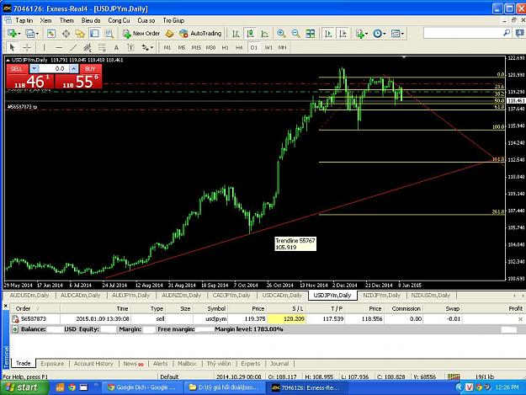
http://www.forexfactory.com/attachment.php?attachmentid=1586341&d=1420868465
January 9th.
US economic data released has a big impact are: unemployment and Non-Farm Employment Change is good.
after the publication of news, USDJPY rose 70 pips to 119.76
USDJPY then go down.
go up as: good for US.
go to: US is the main export partner of JP.
- this is a good time to sell because prices are pushed up. why it is a good time to sell?
http://www.forexfactory.com/showthread.php?t=216097 watch it and look for the article: big players move like? you will understand why!
- why I put TP in 0618 Fibonacci?
1 / If you see Jan 14, there are three major news can finish and change trend. I repeat: you must understand how the big players move and take advantage of important news.
2/ USDJPY has 3 days to go to the TP.

had two unexpected events do I have to stand commerce.

continued downward trend and a chance to be found. I predicted USDJPY will go to 23.6 Fibnacci but after the US announced CPI m / m and Core CPI m / m. I had to stop trading at 196.35 (trailing stop = 10pip)
now, I have not identified trends and USDJPY,next week with more news influential. I have an extra week to rest hahahaha. waiting and looking for opportunities.
commercial insurance:
1 / ratio R / R is 1/3.
2 / trailing stop is 1/2 or 1/3 of the way to move the rest.
Here is a method of hedging my, you can apply and draw lessons for themselves.
for example, your business has gone halfway, another 300 pips profit going to end.
- trailing stop: 100pip or 150 pips..


