Getting Started
BT_14_v2nb Basket EA

It is assumed that before you start here that you have placed all the files located in the zip folder into their respective folders.

This EA will run on any period offline chart.
You only need 2 charts open for it to work, a single pair M1 chart where you place your offline chart generator indy and the offline chart where you attach the EA.

You can create your own basket with other indicators found on different forums if you like, just make sure the pairs that are in the “Offline” basket chart are the same ones you are using in the EA, you can use from 2 to 14 pairs in the EA.

Quick Start for 14 pair Basket setup:
USDCHF,GBPCHF,EURJPY,GBPJPY,NZDUSD,EURGBP,GBPUSD,EURUSD,USDJPY,AUDUSD,NZDJPY,AUDJPY,CHFJPY,EURCHF

- Start up your MT4 platform
- Open a M1 chart of USDJPY
- Attach the Uj_h1_14P template to this chart.
- Go to the “File” tab of MT4 and pull it down and click on “Open Offline”

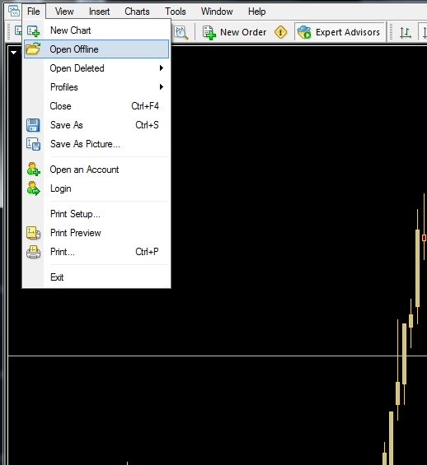

- From the window that then opens, double click the #BT#14,H1 chart.

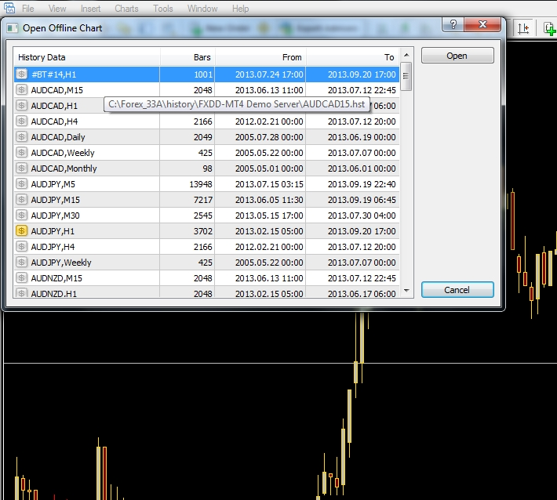

- A new “Offline Chart” should now open on your screen.
- Attach the BT_14_v2nb_14P template to this chart. Your offline chart should be similar to one of the following.

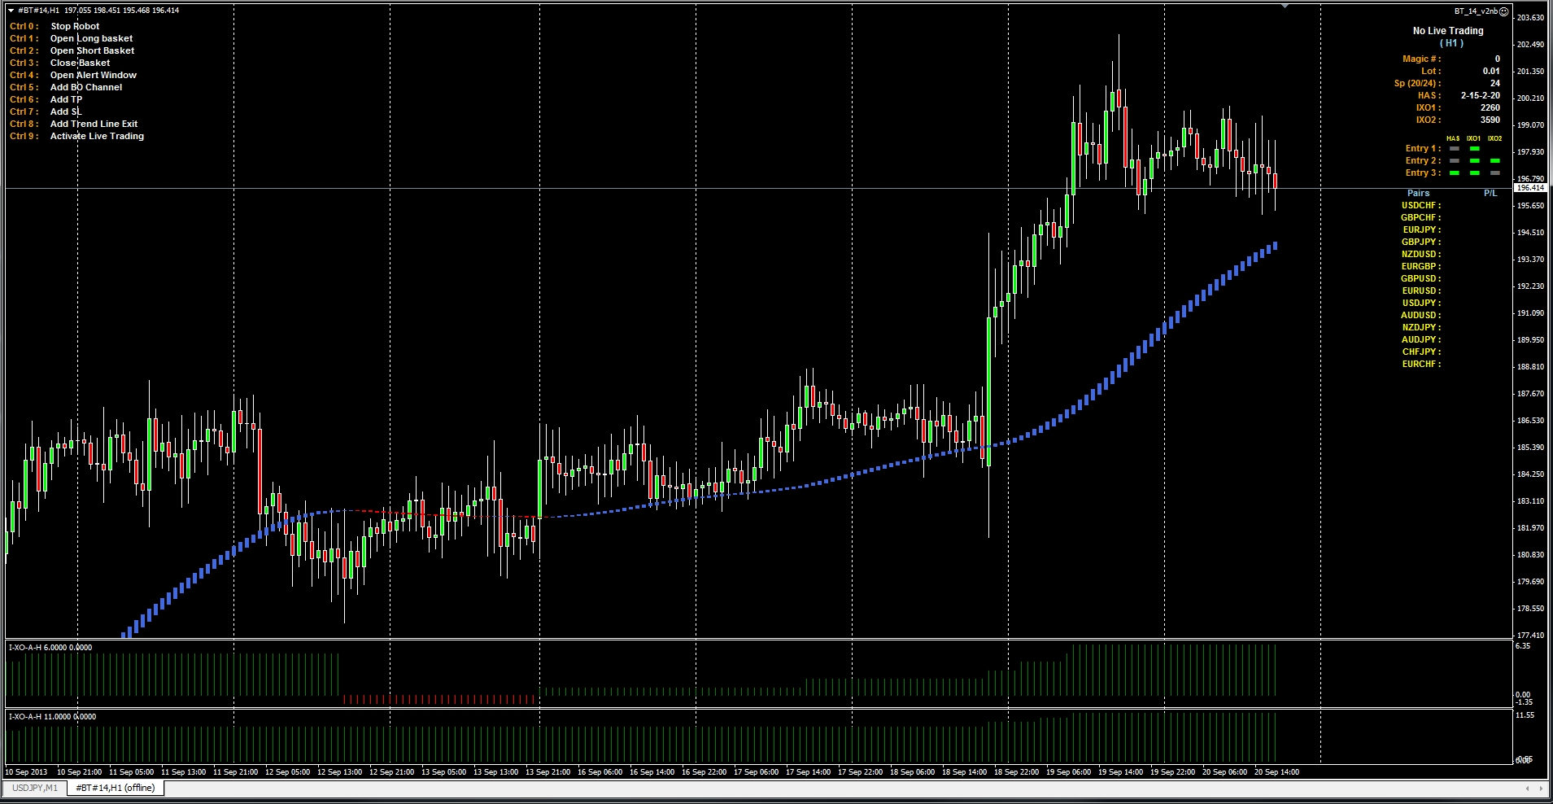

- Restart your MT4 software.
- To start trading live, use the Hot Key Ctrl+9 and click the YES button in the window that opens. If you want to stop trading live use the Hot Key Ctrl+9 and click the NO button in the window that opens.

Quick Start for 5 pair Basket setup:
EURJPY,GBPJPY,NZDUSD,GBPUSD,AUDJPY

- Start up your MT4 platform
- Open a M1 chart of USDJPY
- Attach the Uj_h1_5P template to this chart.
- Go to the “File” tab of MT4 and pull it down and click on “Open Offline”

- From the window that then opens, double click the #BT#05,H1 chart.

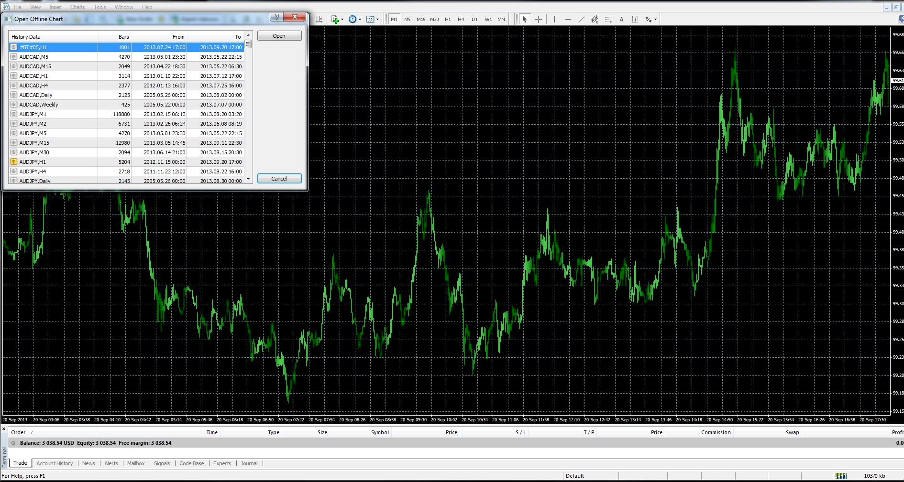

- A new “Offline Chart” should now open on your screen.
- Attach the BT_14_v2nb_5P template to this chart. Your offline chart should be similar to one of the following.

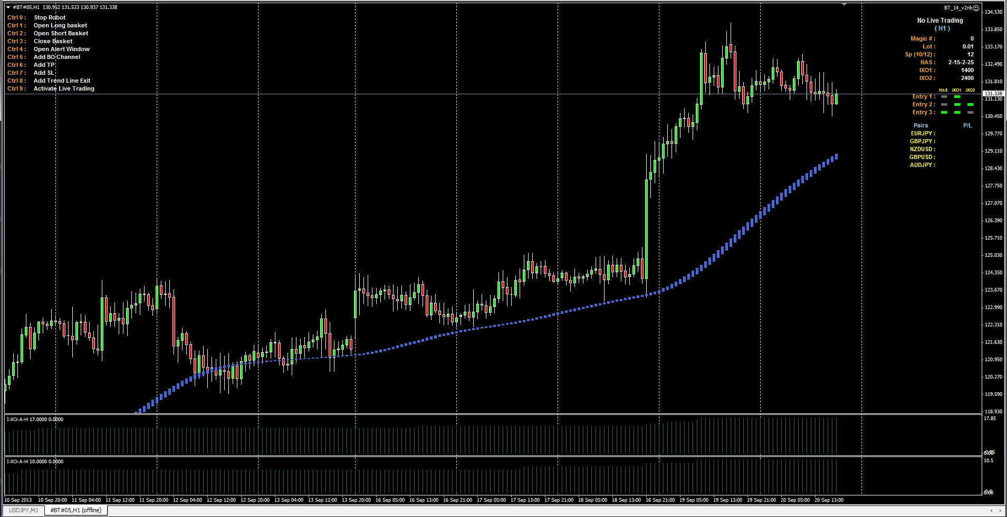

- Restart your MT4 software.
- To start trading live, use the Hot Key Ctrl+9 and click the YES button in the window that opens. If you want to stop trading live use the Hot Key Ctrl+9 and click the NO button in the window that opens.

Quick Start for different pairs Basket setups:

- Start up your MT4 platform
- Open a M1 chart of USDJPY
- Attach the Basket_Multi_indy_ET indicator to this chart to this chart.
- Set up this indicator for the pairs and time frame you want to use.
- Go to the “File” tab of MT4 and pull it down and click on “Open Offline”

- From the window that then opens, double click the #offline chart# you just created.
- A new “Offline Chart” should now open on your screen.
- Attach your indicators and the EA to this chart and set it up the way you want, be sure to set the pairs and time frame in the EA to the same ones used to create the offline chart it is on. You can also save a template of this setup if you want to.
- Restart your MT4 software.
- To start trading live, use the Hot Key Ctrl+9 and click the YES button in the window that opens. If you want to stop trading live use the Hot Key Ctrl+9 and click the NO button in the window that opens.

This EA uses Hot Keys rather than the Buttons, which makes it more cpu friendly and less troublesome. You will also notice that information has been added to the display on the right side of the chart to show you what the status of some of the EA functions are and also what some of the settings are, in case you have forgotten what you set them at in the EA properties window. There is also a help menu on the left side of the chart to remind you what the Hot Keys do, you can disable this in the EA properties if you don’t want to see it.

Here are the different types of entries that the EA can use:

Entry 1
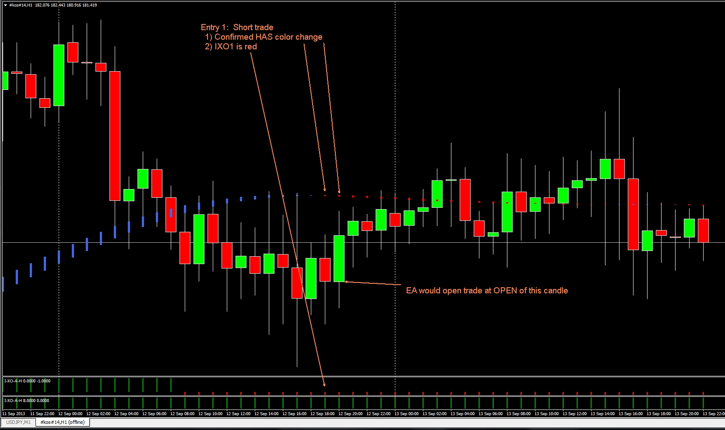

Entry 2
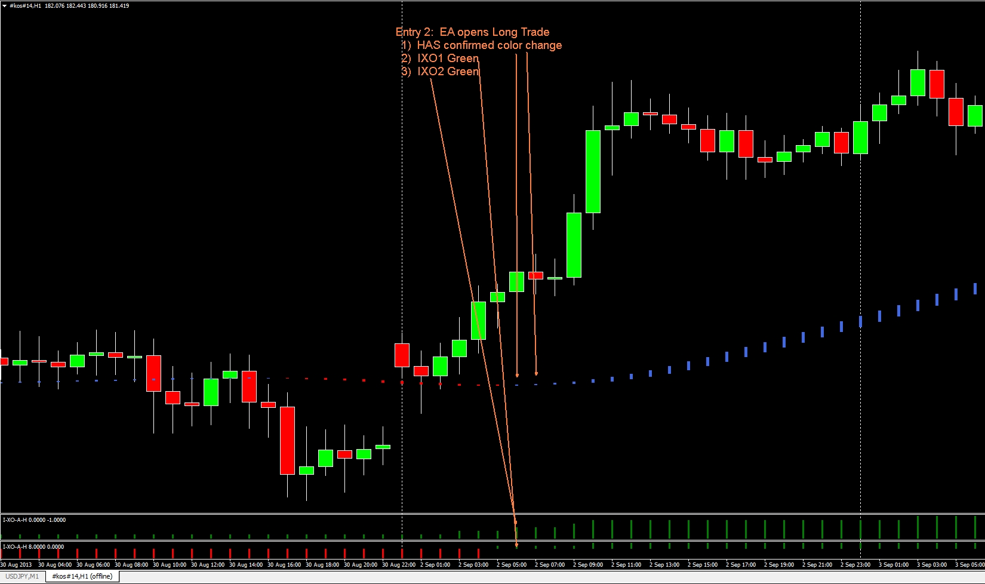

Entry 3
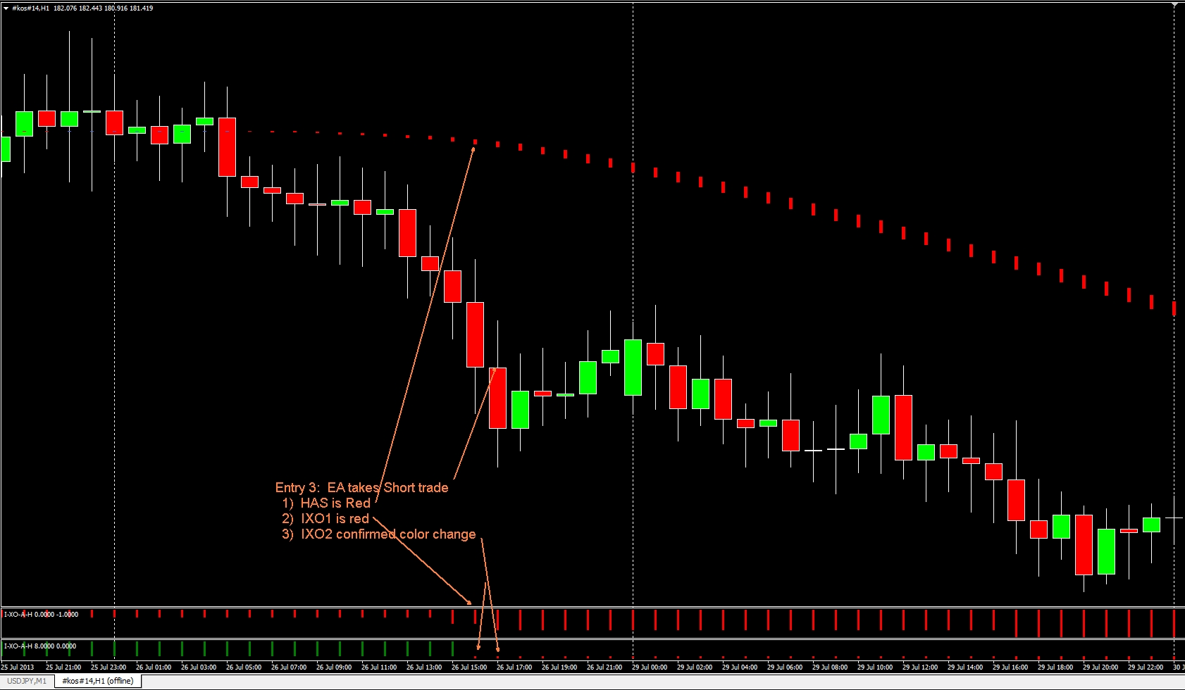

Range Break Out Entry
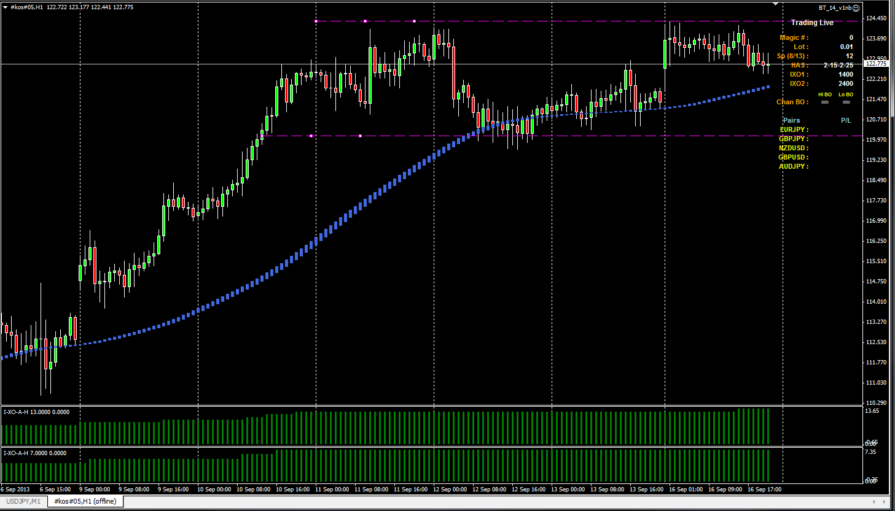

Trending Rage Breakout Entry
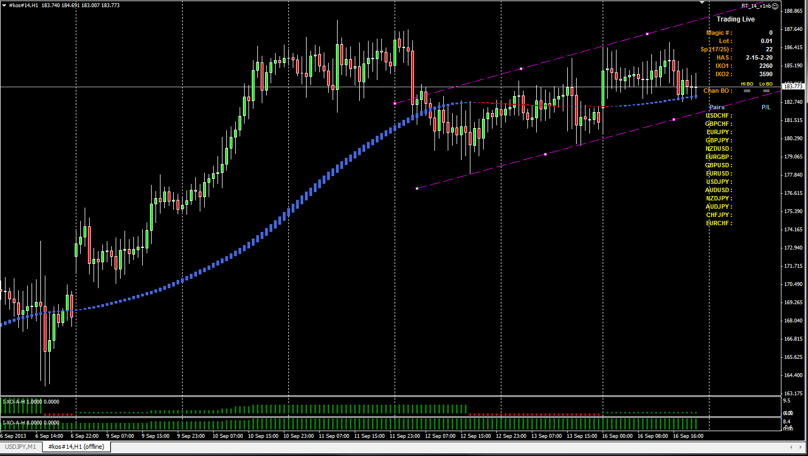

By looking at these charts you can see that the first 3 entries are shown in the display area and the signals that are required to trigger each one.

The EA looks for an entry following this sequence of Entry Rules:
Entry 2
Entry 1
Entry 3

The Entry name will change to either Green or Red if an entry has been made using that rule, and the corresponding signals will also be displayed. Remember the signal for a color change (cross) will only be there for one confirmed candle, then the signal will change back to gray.

You will also notice when using the Break Out Entry Lines that the display changes to show the two signals for the BO, the other signals, (HAS and IXO), are not used when in BO Mode so are not shown in the display area.
The BO lines can be either level or trending, you just double click them and move them around with your mouse to place them where ever you want them.

It is best when moving any lines on the chart to turn off live trading with the Hot Key so you don’t accidently trigger a trade.

Exit Rules:
- UseIXO1asExit = true; This is the default setting and will exit all trades when the IXO1 changes color. If you turn this off you will have no exit taken by the EA unless you set up the TP or SL in the properties settings.

- Trend Line Break: (Ctrl 8) This can be turned on by using the Hot Key during a live trade, this is used only as an exit, if the PA closes above(short trade)/below(long trade), the trade will be closed. Place this line where you want it on the chart by double clicking it and then moving it with your mouse, be careful when placing this on the chart not to trigger a trade accidently.

Trend Line Break Exit
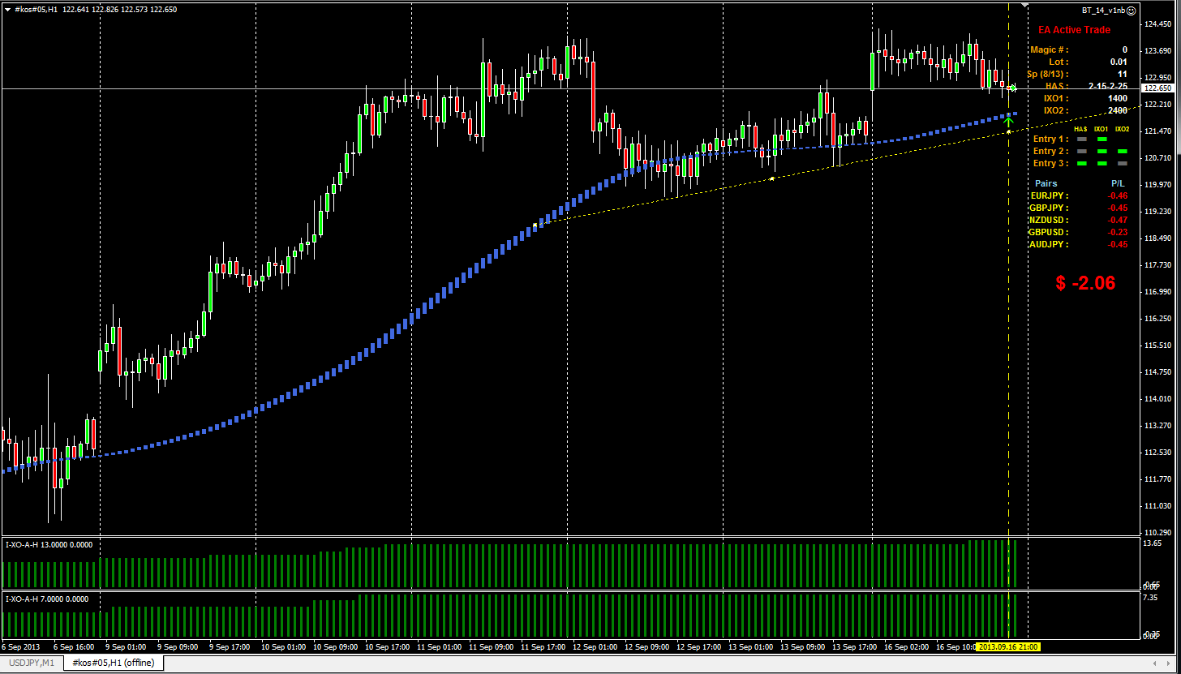

Hot Keys:
A Hot Keys Help Menu in the chart upper left corner can be turned on/off with “ShowCtrlHelp” in the EA properties or with the Hot Key “Ctrl+Alt+F10”.

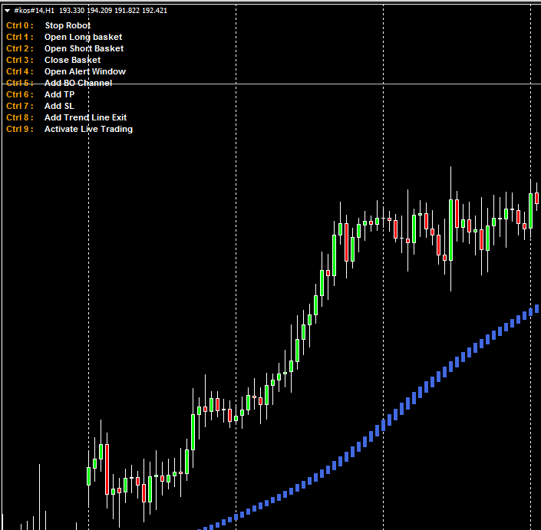
Ctrl+0 = "Stop Robot";
Ctrl+1 = "Open Long Basket";
Ctrl+2 = "Open Short Basket";
Ctrl+3 = "Close All Trades";
Ctrl+4 = "Open Alert Window";
Ctrl+5 = "Use Break Out Channel";
Ctrl+6 = "Add TP line to active trade chart";
Ctrl+7 = "Add SL line to active trade chart";
Ctrl+8 = "Use Trend Line Exit";
Ctrl+9 = "Live Trading On/Off";
Ctrl+Alt+F10 = “Show Hot Keys Help Menu”

Some of the EA Properties settings: (The default settings are for a 14 pair basket)

- - - - - - - - - - Trade Settings - - - - - - - - - -
MagicNumber=0;
Lot=0.01;
TradeComment="";
- - - - - - - - - - - Entry Rules - - - - - - - - - - -
TradeLive = true; (Ctrl_9)
TradePeriod = 60; This is the time frame the EA will be trading, you must have created an offline chart for this time period and attach the EA to it.
GoLong=true;
GoShort=true;
UseRobotForOpen = true;
UseRobotForClose = true;
FixedTakeProfitPips = 0;
FixedStopLossPips = 0;
ChannelBOTP = 400; When BO Mode trade is opened by the EA this will be used as a TP, set to zero if you don’t want the EA to have a TP in the BO Mode.
ChannelBOSL = 400; When BO Mode trade is opened by the EA this will be used as a SL, set to zero if you want no SL in the BO Mode. It may be a good idea to leave some value here and then you can always move the SL line on the chart as the trade moves along. The IXO1 Exit does not work in the BO Mode.
HASIXO1OnlyTPpips = 200; This is the pips of take profit that will be used for an Entry 1 trade.
UseEntry1 = true;
UseEntry2 = true;
UseEntry3 = true;

- - - - - - Entry Filter Settings - - - - -
MaxSpread = 70; This is the total spread of all pairs in your basket, if the total spread reached this number no trades can be taken.
IXO1val = 2260;
IXO2val = 3590;
HASMaMethodE = 2;
HASMaPeriodE = 15;
HASMaMethod2E = 2;
HASMaPeriod2E = 20;

- - - - - - - - Exit Filter Settings - - - - - - - -
UseIXO1asExit = true; If set to true the IXO1 will be used as an exit for all trades, Entry1, Entry2, and Entry3.
UseExitOnBE = true;
ExitOnBEpips = 400; Number of pips profit before BE is set.
BEprofit = 0.00; Dollar amount of profit you want when exit is set to BE, this is your BE dollar profit.

- - - - Restart Settings after shut down - - - -
UseAutoRestart = false
FixedTakeProfitPipsRES = 400
FixedStopLossPipsRES = 400

Restarting EA with live trade present:

Remember when a live trade is open the EA is handling the trade and the computer must be left up and running with the MT4 platform active, don’t expect the EA to remember everything you were doing when the computer was shut down and the EA restarted.

When restarting and there is a basket live trade already open that the EA has previously opened, a pop up window will ask you if you want to manage this open trade, this will only happen if the Magic Number set in the EA properties matches the open trade Magic Number and the “UseAutoRestart” is set to false. If they do you will get a series of questions asking you what you want to do, such as add TP/SL lines or use the IXO1 for an exit on the open trade.

If you answer NO, then you can still do manual adds of the TP/SL and Trend Line Exit lines if you wish with the Hot Keys.

If you set the “UseAutoRestart” to true it will use a fixed TP and SL when restarted.

Even if you use the Trend Line Exit option the IXO1 Exit will still be enabled unless you set it too false in the EA properties.

The EA does not resume where it left off when it was closed down, it will manage the trade with the presets you have set up if its Magic Number matches the Magic Number of the open trade.

*******************************************************************************************
Recording states and then restoring your states are not effective in my view.
Why? Because the time gap between recorded and restoration can vary and you may lose money...
That is why I prefer semi-auto trading; I believe human intervention is required and a must to make sure nothing goes wrong, like time gaps....
Imagine wanting to close all positions but no, only partial positions are closed. You lost connections and are stuck with open positions in the negatives....
Without that human element, you can lose money.
**********************************************************************************

Changes
BT_14_v3nb Basket EA

- The entry price, “Entry”, is now displayed in the display area.
- There has been added an option to the Entry 1 rule which is User selectable “ChangeToEntry2”, true or false. What this does is if you are in an Entry 1 trade and have not hit your Take Profit yet and IXO2 changes color going in the same direction as your Entry 1 trade the trade will be changed to an Entry 2 trade by the EA if this option is set to true. The trade will continue on then and use the same exit rules that Entry 2 trades use and will not exit with the Take profit setting of Entry 1.
- Another entry rule has also been added, “UseEntry4”, to help get you back into trades that you have gotten kicked out of when in a long trend because of the IXO1 changing color when using it for an exit. If HAS and IXO2 are the same color and IXO crosses to the same color a trade will be opened, an example is shown below.



