Trade No. 01/WK03/2014
Date: 13 Jan, 2014
Time: XX:XX PM
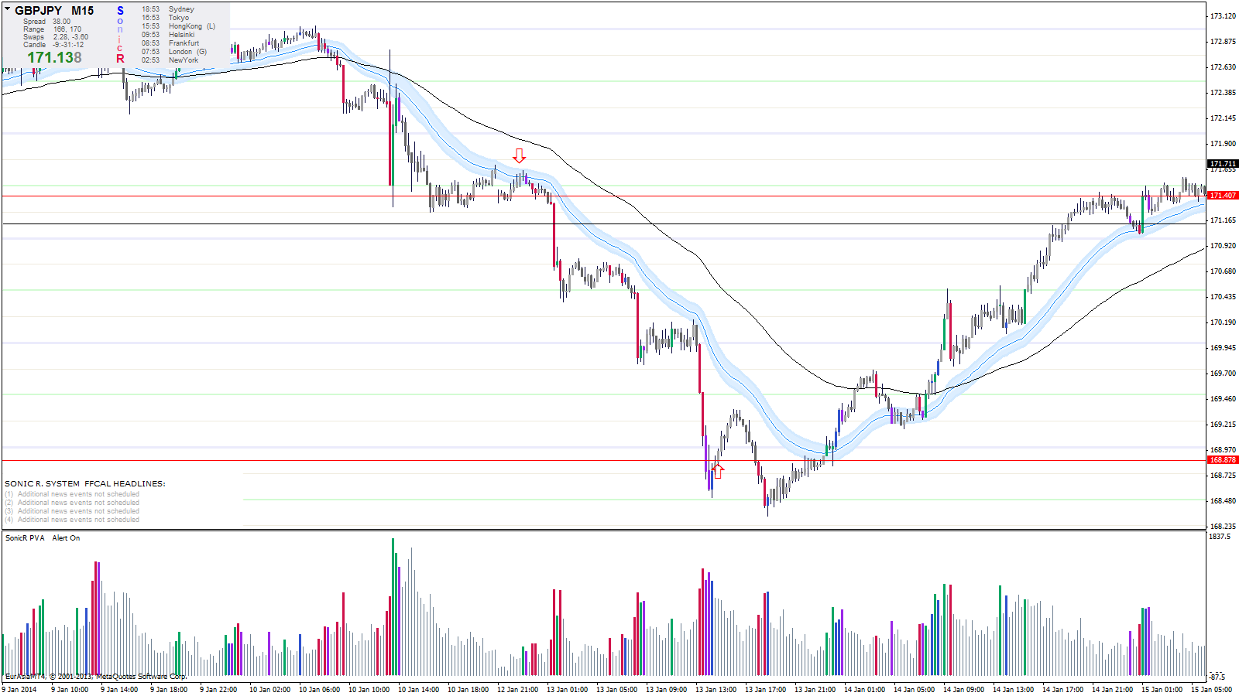

Paste your Chart Here

Trade Instrument: GLD (XAU/USD)
Monthly TF: Bearish Engulfing Candle
Weekly TF: Bearish Candle
Trade Type: Trend
EP Level: 171.40
SL Level: xxxx.xx (Below the previous nice swing Low)
TP Level: xxxx.xx (Overhead Resistance Level)
Lot size: 1
Remark:
In Line with weekly TF. Took a short below dragon .__________
__________________________________________________________________________________

Outcome: Win
Duration: X Hours

End Remark:
__________________________________________________________________________________Trade Closed with when the big volume coming in___________________________________________________________________
__________________________________________________________________________________

