DCASTFX ADVANCE PATTERNS RULES OF ENGAGEMENT (R.O.E)

Gartley Pattern:
- Tools
  - Fibonacci Retracements: Primary used (61.8% & 78.6%)
  - Fibonacci Extension: (127.2%)
- Timeframes
  - The Gartley Pattern was designed as a swing / position trading strategy. It was originally discovered by H.M Gartley in 1935. This pattern can be identified on virtually any timeframe.
- Tactics
  - The tactics for the Gartley Pattern are very similar to other well known advanced patterns like the Bat or Butterfly. With the Gartley Pattern we seek to identify 4 market moves and 3 major Fibonacci zones. The combination of these moves forms the points (X,A,B,C,D) that fulfill the pattern.

Rules of Engagement: Criteria 1
The Gartley Pattern begins with a market movement / impulse leg that establishes our X and A points.
Once the X and A points have been identified, we then look for our first criteria.
Criteria 1: The market forms the (B) completion point by fulfilling at least a 61.8% retracement of the XA leg.
Note: The AB move remains valid as long as there is at least a 61.8% retracement of XA and that it does not touch or come close to the 78.6% retracement of XA.
Note: The B completion point (candle wick) can extend and close beyond the 61.8% retracement of XA as long as the candle does not touch or close beyond the 78.6 retracement of XA. An example of this situation is presented below.
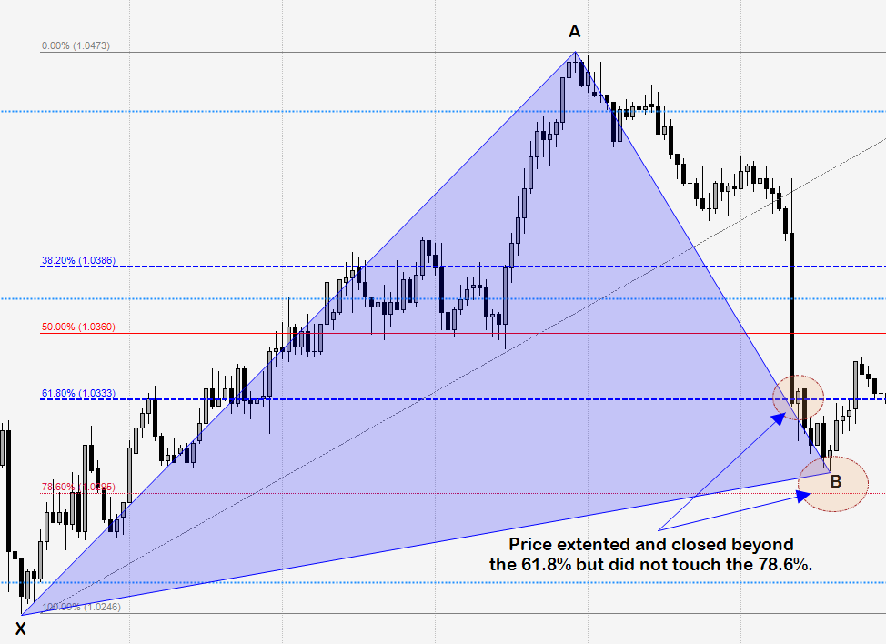
Rules of Engagement: Criteria 2
If criteria 1 has been meet, then look for criteria 2.
Criteria 2: The market forms the (C) completion point by fulfilling at least a 61.8% retracement of the AB leg.
Note: The C point remains valid as long as there is at least a 61.8% retracement of AB and there is not a candle close at or beyond the 88.6% retracement of AB.
Note: In a valid BC move, there must be a candle close beyond the 61.8% value. Failure to achieve a candle close beyond the 61.8% invalidates the move (this would be considered a Fibonacci failure which has no relevance to this pattern). An example of this is presented below.
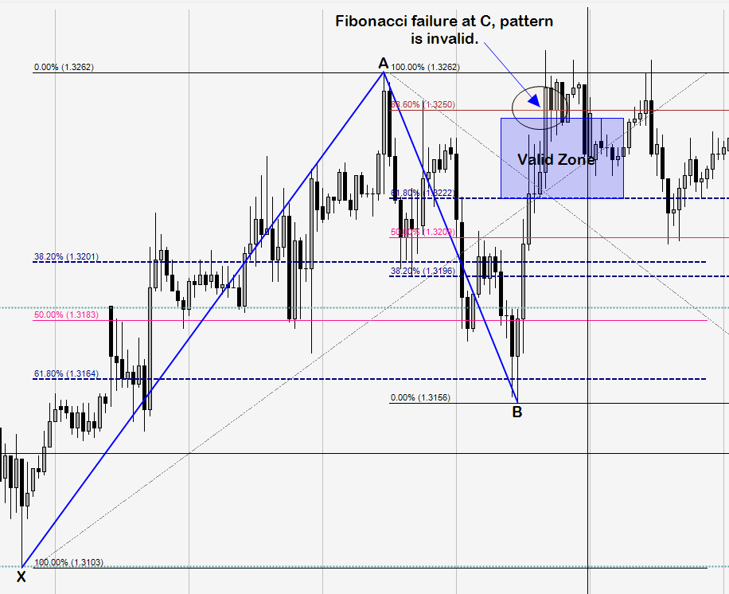
Rules of Engagement: Criteria 3
If criteria 1 and 2 have been met, then look for criteria 3.
Criteria 3: The market forms the (D) completion (entry point) by fulfilling a 127.2% extension of AB.
Note: In a valid CD move, the 78.6 retracement of XA (D completion point) shows ratio confluence with the 127.2% of AB. The D completion point cannot extend past X, this invalidates the pattern. An example of this is presented below.
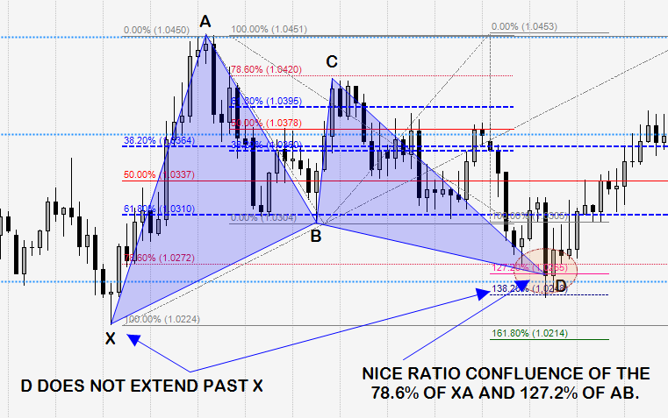
Trade Management: Entry, Stops, & Targets
Simple Rules
Entry: Limit order placed at D completion point (127.2% of AB).
Stop Placement: 10 pips +/- X.
If long entry, stop goes 10 pips below X.
If short entry, stop goes 10 pips above X.
Target 1: 38.2% retracement of AD leg. When attained, stop moves to breakeven.
Target 2: 61.8% retracement of AD leg.

Here is an example of a Gartley Pattern with entry, stops, & targets:


