10.2 TMA SLOPE INDICATOR 1.4

Unfortunately, you cannot use TMA, or any of its derivatives, without some poster yelling, “REPAINT, REPAINT, REPAINT!” It’s as if the minute you say “TMA”, someone will demand that you bury the indicator in FOREX purgatory forever and ever. Anytime I hear someone use “repaint” and TMA together, I’m going to refer them to this booklet, so they can read and understand our use of TMA. Hopefully, that will avoid filling our thread with pages of debate.

It’s far more important to understand the strengths and weaknesses of an indicator, than to categorically reject it because it’s not perfect. Just as in trading, there is no Holy Grail, the same applies to indicators. Each has its strengths and its weaknesses.

I hope to show below that the TMA slope indicator has a strength that could be valuable when it’s recognized. By making some adjustments, coupled with the non-repainting TMA True, the resulting indicator can show the strength of the current currency move. This will allow you to determine how long to ride a trade, or when to cut it short, an invaluable quality I think you’ll agree. I will try to keep this as short, simple, and easy to understand as I can.

Below is a chart of the TMA indicator with its traditional settings. In hindsight, after it has repainted, it looks incredibly easy to trade. But that would make it the Holy Grail!

The problem is, we know from experience, that the lines of this envelope realign long after price has gone by, giving the impression of a smooth channel that captures the extremes flawlessly. The lower the TF the more this problem will manifest itself. On a 4H chart it is less of a problem, however. You’ll see in the next two charts just how different the TMA TRUE non-repainting indi is from the repainting TMA NORMAL.

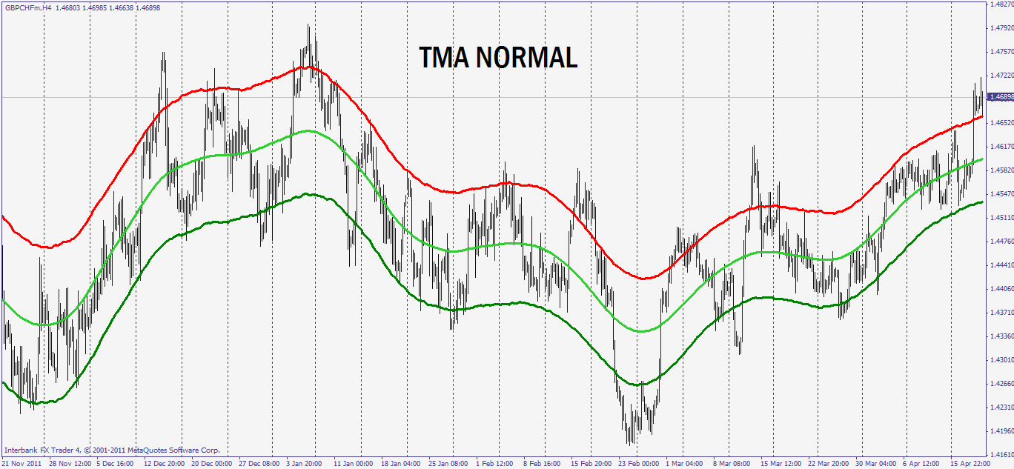

The chart below shows a TMA TRUE. The TMA lines remain whereever they painted in real time. It doesn’t allow the TMA to readjust its lines later to create the smooth image above. The time period is the same. It’s easy to see the choppiness, and that the extremes that look so easily tradable in the chart above, are no longer there!

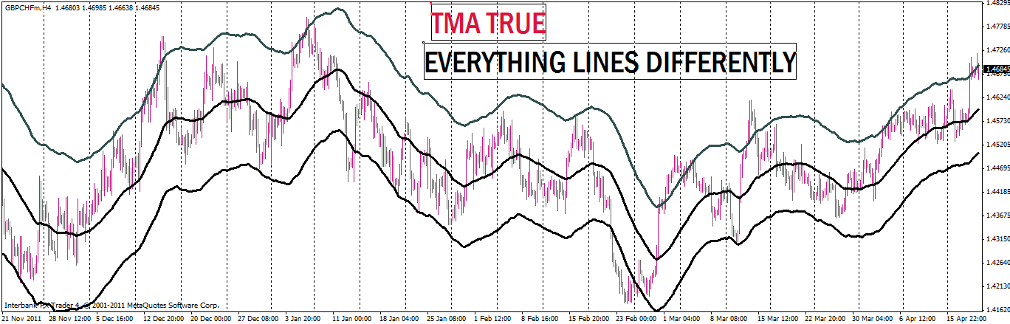

The higher the TF, the less pronounced the difference is. Now I’ll overlay one over the other, in order to make it easier to compare them directly.
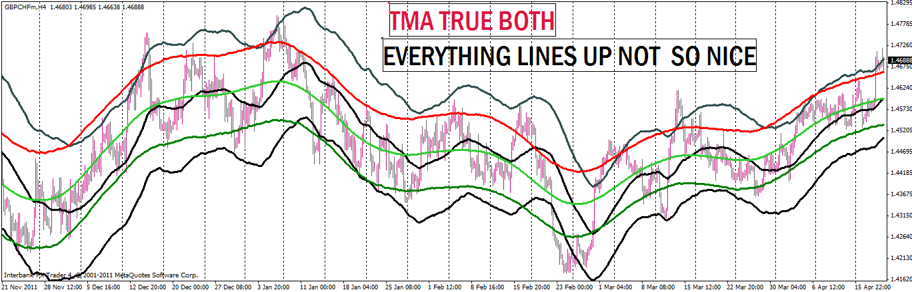

Next I’ll adjust the TMA TRUE and the TMA NORMAL so that the TMA TRUE is mostly inside the TMA NORMAL, with only the extremes of the TMA TRUE outside the bands of the TMA NORMAL.
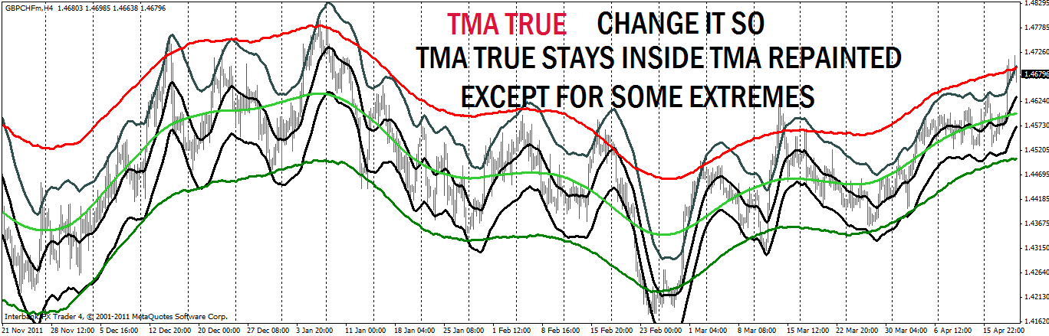

Now let us take the TMA Slope indicator 1.4 of the TMA NORMAL. Below is the familiar TMA Slope histogram that we are used to seeing from the repainting TMA NORMAL.
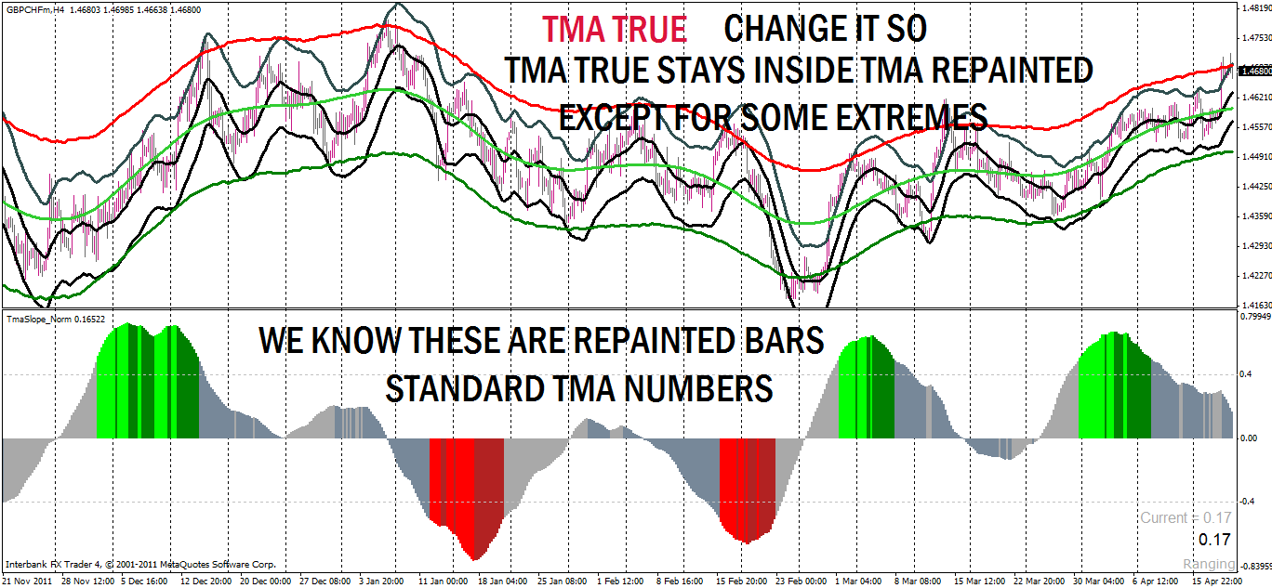

Using the numbers obtained from the TMA TRUE adjusted to stay mostly inside the TMA NORMAL, I can now insert them in the TMA slope indicator 1.4. This produces the histogram in the bottom panel below.
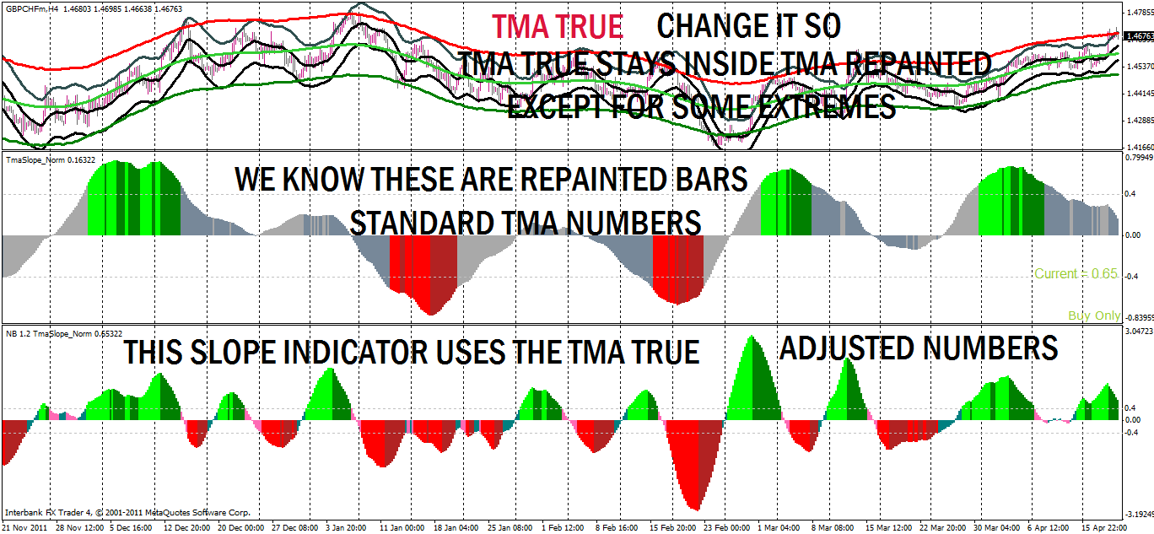

You can see the new SLOPE 1.4 reports changes in direction much more quickly than the original TMA slope indicator. But that is not all it can do. We can look at the size of the histogram and determine the strength of the move. This information is invaluable in deciding whether to take profit sooner, or ride the trade longer term.
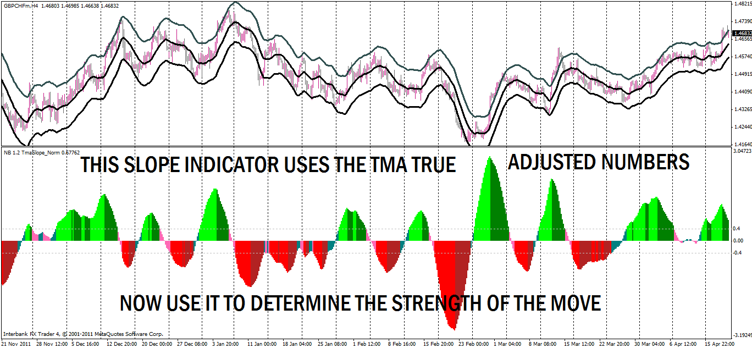

By doubling the range of the original strength lines at .4 and -.4 (in black below), I’ve extended the upper and lower limits to .8 and -.8. As you can see, the shorter term trades just clear the 0.8 strength lines while the trades that have more momentum shoot past the 0.8 lines easily.

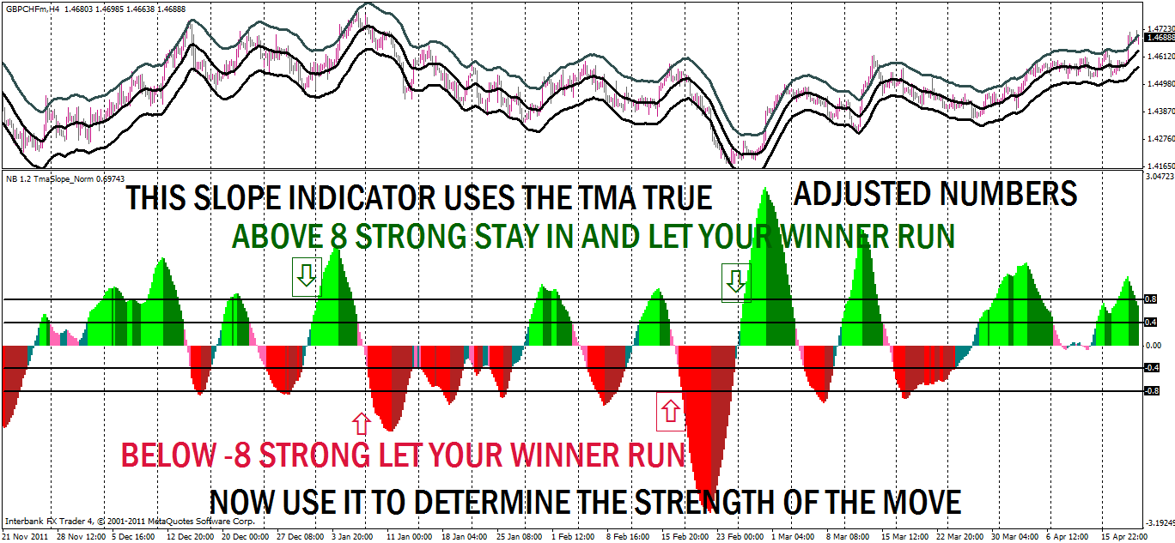
As shown on the next chart, when the histograms stay between the 8 and -8 price isn’t running, so bank your profit and look for your next trade. See the pink area below.

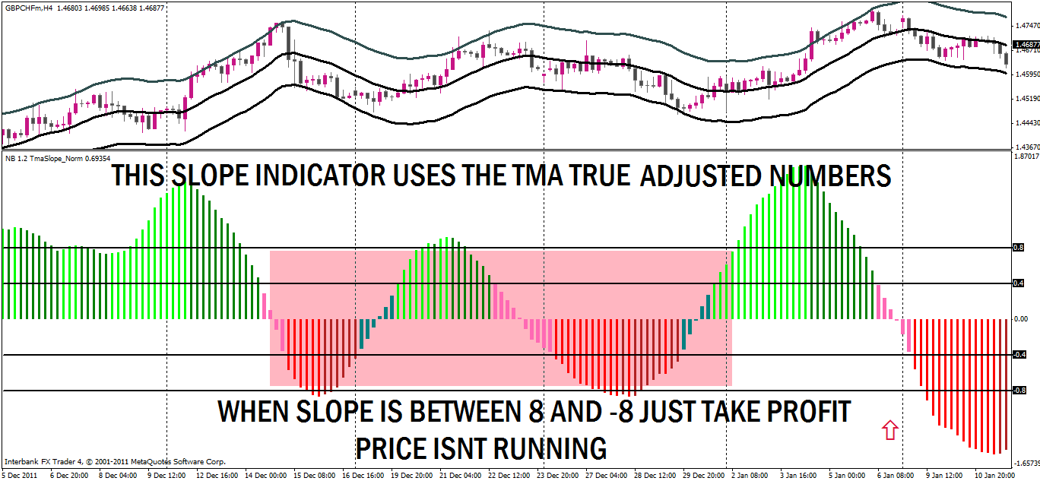

When the bars remains between the 0.4 strength lines, it isn’t going anywhere for a while, so find something else to do instead of trying to force a long term trade. You would be better off looking elsewhere, or perhaps, scalping on a lower TF. See the pink area below.
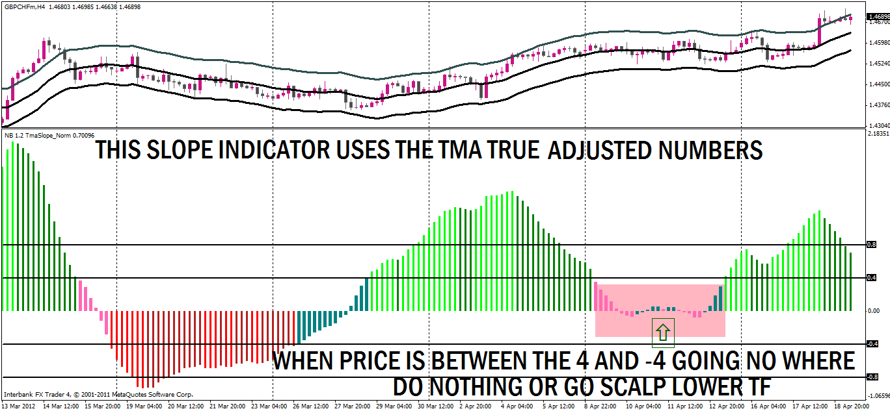

Below I’ve summarized the 5 main advantages in using the TMA slope indicator as I’ve modified it. The histogram now indicates: 1. Faster entry and exit signals. 2. Clear signals to look for long trades (any shade of green). 3. Clear signals to look for short trades (any shade of red). 4. When to take profit early (ranges between 0 and +/-0.8). 5. When to let the trade run (shoots past the +/-0.8). And when to stay out of a trade: ranges between 0 and +/-0.4!
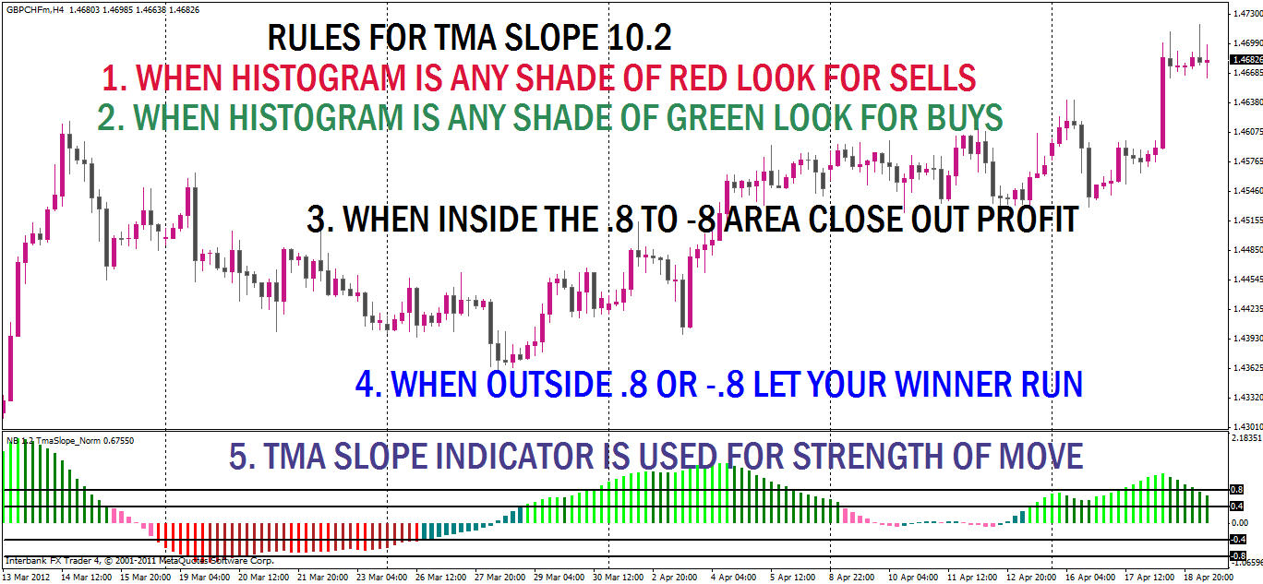

One last thing to note about the TMA Slope indicator using these new figures in the formula is its difference from other histogram indicators. I marked the center 0 line with a heavy green line in the chart below. When the histogram goes above that line that means the angle of the TMA center line is moving up. The greater the degree of angle the faster price is moving in that direction. If the bars go above the 0.4 you have a very good chance that price will break the upper level of resistance for a breakout trade. Look for the bars to go up in a nice move. If you see the bars go below the -0.4 look for it to break resistance for a breakout trade. If you see the bars go above 0.8 then you have a very strong move that could break several R lines. If you see the bars go below -0.8 price action will probably break several S lines. When price hits its peak and the bars start coming back down, THAT IS NOT A SIGNAL TO REVERSE DIRECTION.!!!!
It’s an indication that the rate of increase is decreasing, not that it’s changing direction.
In other words it does mean that the upward curve is beginning to slow down, not change direction. The signal to change direction only occurs at the 0 strength line. Some very good moves can still happen as the bars top and start down toward the 0 line. Going long is still possible while it is above 0.4, or short when it is below -0.4.
This is very important, so I’m going to repeat it:
the change in slope of the indicator does not show price reversal;
it shows the slowing down of the momentum of the price action.
Price reversal is signaled only when the bars of the histogram cross the 0 line.

When the histogram bars are bouncing between the 0.4 and -0.4, they’re showing that price is ranging, so look for exits to close your buy/sell trades. From the 0 line up to +0.4, the upward moves are likely to be a bit stronger than the downward moves. Likewise, when the bars are ranging between the 0 line and -0.4, the downward moves will likely be stronger. As the bars approach the 0.4 lines, either plus or minus, start looking for the possibility of a break out trade.
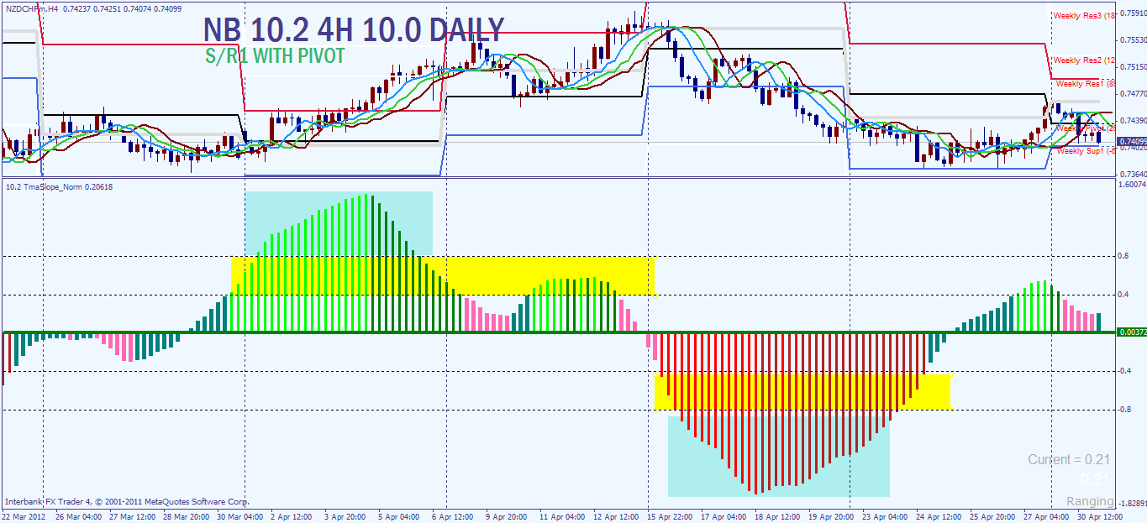

So my final comments are these:
1. We are going to use this indicator for its one really good quality, determining the present strength of the currency move. The direction and angle of the slope is what we use this for. The greater the angle of the slope, the bigger the move, the bigger the histogram bars.
2. I have adapted these numbers to the 4H chart and the daily chart. I have not tested it very much on other TF’s. There will be some repainting but it is minimized at the higher TF and by the quicker response numbers used instead of the original default numbers. In other words, we have cut the repainting issue to its minimum and will use the TMA Slope strength to its maximum.
3. Letting your winners run and reentering with extra positions on a run will now becomes possible, or at least it will put the odds of a successful attempt in your corner, which is about as good as it gets. When the bars move above/below that .8 line, look to run multiple positions with the trend.
4. If you are a multiple level trader, recovery trader, or a martingale trader, and you see the bars go above that 0.8, or below -0.8, you know you are in trouble and are in for the long haul.

Thank you,

Nanningbob
May 1, 2012

